**THE SECOND LAW OF THERMODYNAMICS**

**Exercises**

**Sections 19.2 and 19.3 The Second Law of Thermodynamics and Its Applications**

**13.** **Interpret** This problem requires us to calculate the efficiency of reversible heat engines that operate between the given temperatures.

**Develop** The maximum efficiency of a reversible engine, operating between two absolute temperatures, 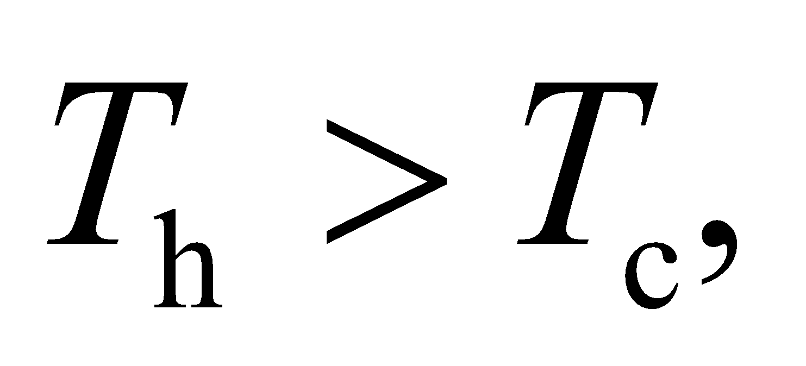 is given by Equation 19.3, *e*Carnot = 1 − *T*c/*T*h. Apply this to each part of this problem to find the corresponding efficiencies.

**Evaluate (a)** 

**(b)** 

**(c)** With room temperature at 

**Assess** The engine with the largest difference in reservoir temperature has the largest efficiency.

**14. Interpret** This problem is an exercise in calculating the thermal efficiency of a heat engine, given the temperature of the hot and cold reservoirs.

**Develop** Assuming this cosmic heat engine were a reversible engine, its efficiency would be that of a Carnot engine, given by Equation 19.3:

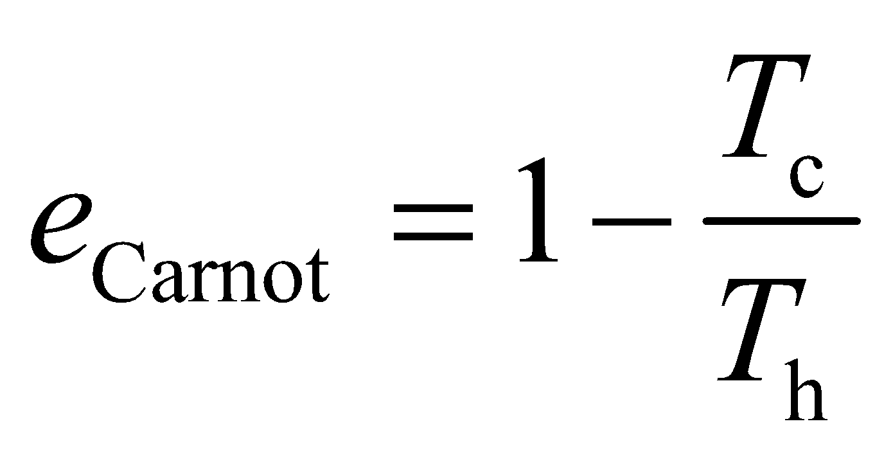

**Evaluate** Substituting the values given in the problem, we obtain

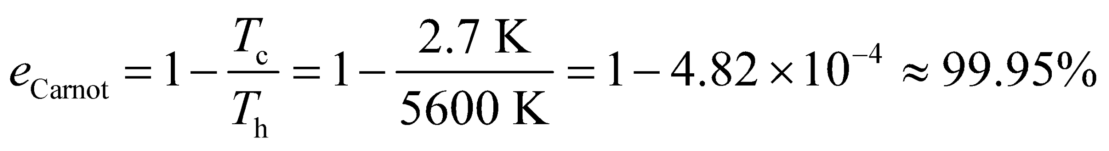

**Assess** The engine efficiency is almost 100%. This is too good to be true.

**15.** **Interpret** This problem involves a reversible Carnot engine that runs between the boiling and melting point of He. We are given the engine’s efficiency and are asked to find the temperature of its cold reservoir (i.e., the melting point of He).

**Develop** Apply Equation 19.3, which gives the efficiency of a Carnot engine. We are given *e*Carnot = 0.777 and *T*h = 4.25 K, so we can solve for *T*c, which will be the melting point of He.

**Evaluate** The melting point of He is

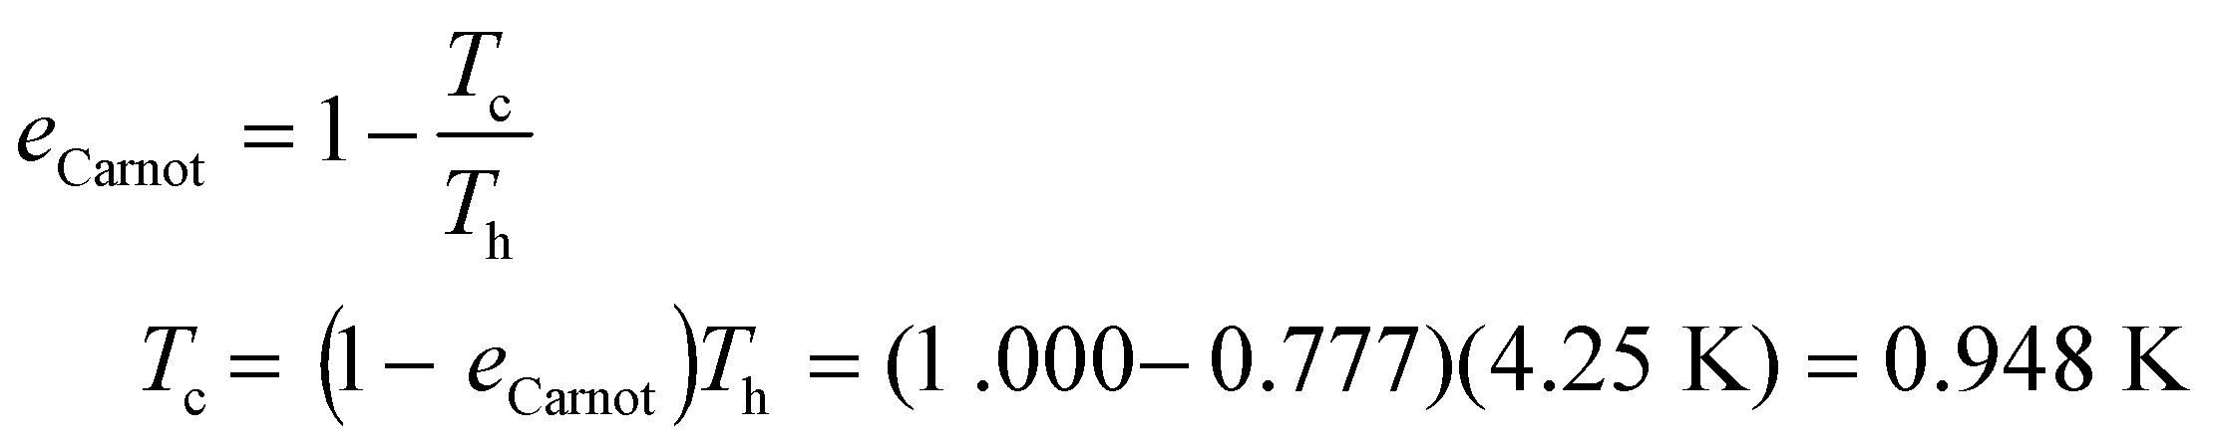

**Assess**  This agrees with the melting point of He found in the literature, so it seems to be a reasonable result.

**16. Interpret** This problem is about a Carnot engine that operates via the Carnot cycle. We are given the thermal energy absorbed per cycle and the work done per cycle by the engine, and we are asked to find its efficiency.

**Develop**  By definition, the efficiency of an engine is

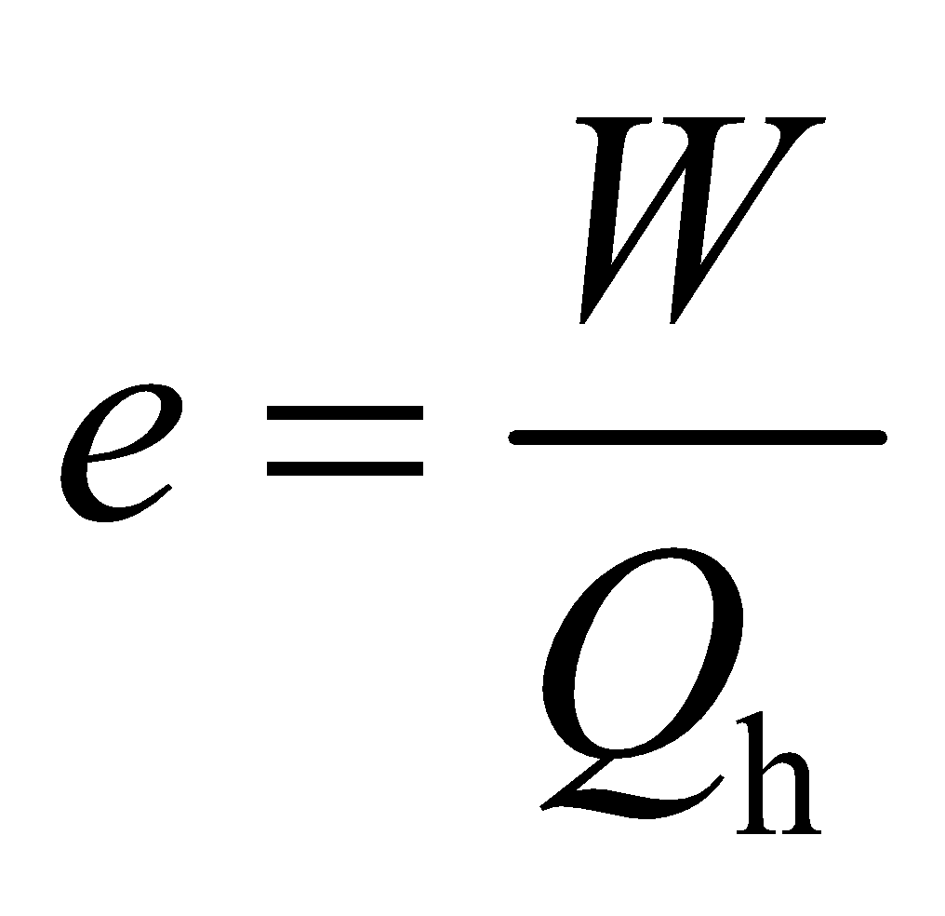

where *W* is the work done by the engine and *Q*h is heat absorbed from the hot reservoir per cycle. For part (b), the work *W* is defined as the work done *by* the gas, so *W* = 350 J in this case. The heat transferred is *Q* = *Q*h − *Q*c. Because the there is no net change in the internal energy of the engine over a cycle, the first law of thermodynamics gives (note that *W* in Chapter 19 is defined contrary to *W* in Chapter 18!)

*W* = *Q*h − *Q*c

For part (c), Equation 19.2 gives

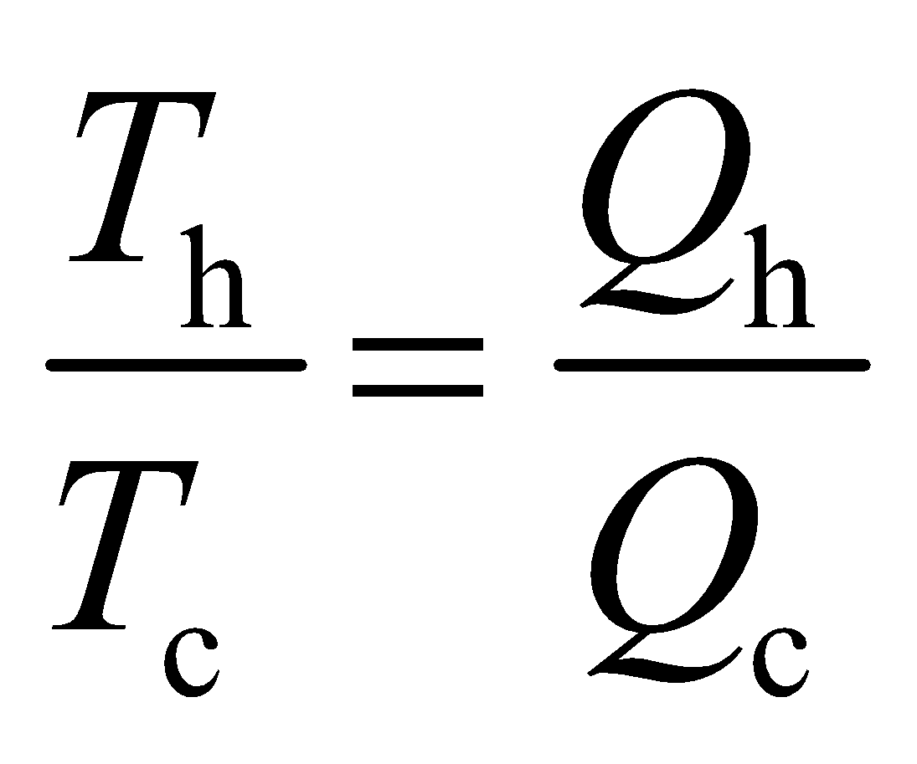

so we can solve for *T*h given that *T*c = 10°C = 283 K.

**Evaluate** **(a)** From the equation above, the efficiency of the engine is

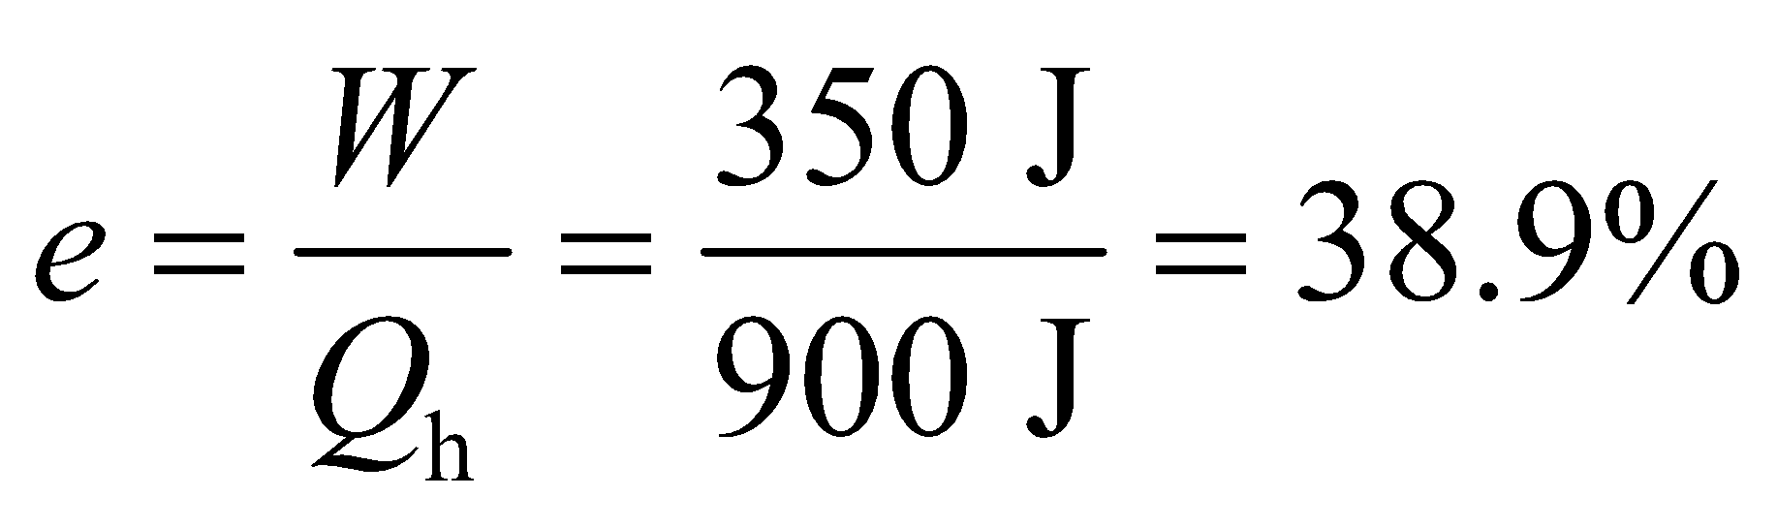

**(b)** The heat rejected each cycle is

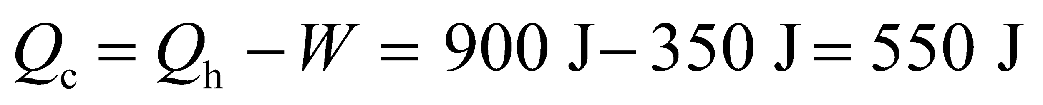

**(c)** The temperature of the hot reservoir is

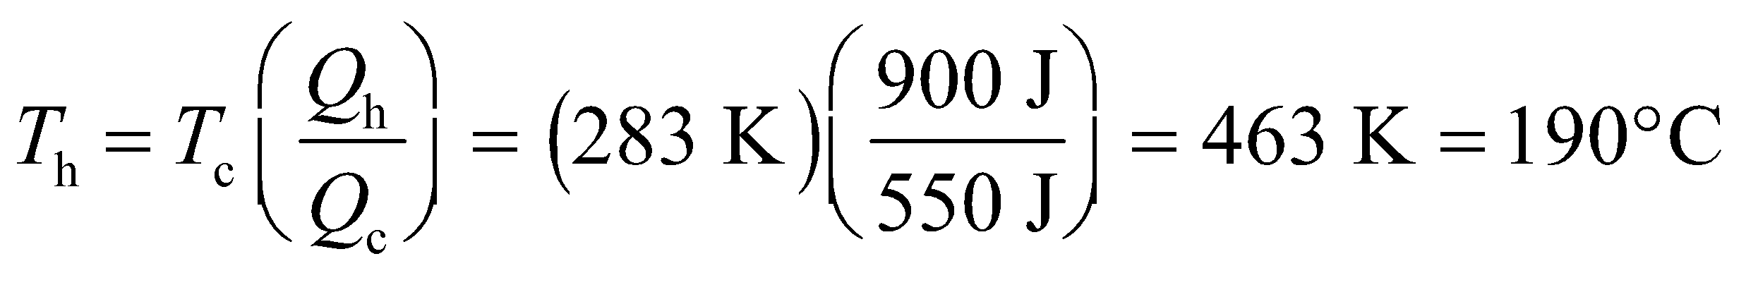

**Assess** The maximum temperature *T*h is greater than *T*c, as our calculation confirms. Note that Carnot’s theorem applies to the ratio of absolute temperatures.

**17.** **Interpret** We are to find the coefficient of performance of a reversible refrigerator that operates between 0°C and 30°C.

**Develop** For a refrigerator, the coefficient of performance is given by Equation 19.4,

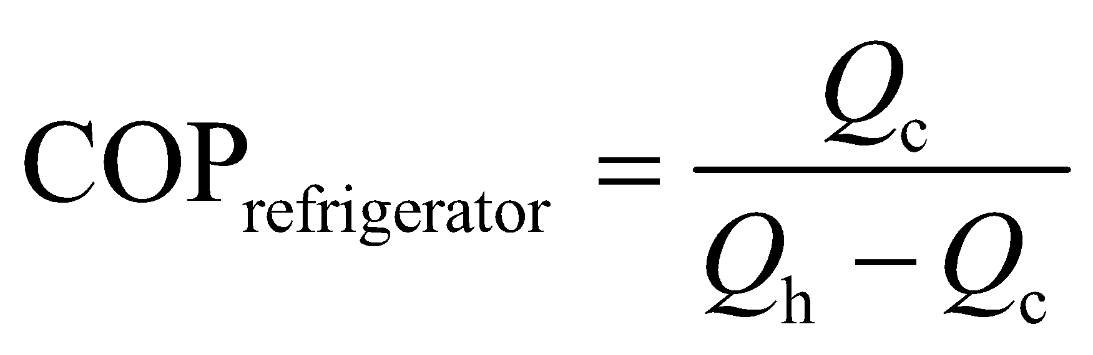

Use Equation 19.2, *Q*c/*Q*h = *T*c/*T*h to convert this to an expression involving temperature:

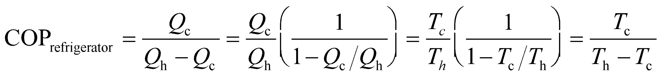

which we can solve given that *T*c = 0°C = 273 K and *T*h = 30°C = 303 K.

**Evaluate** Inserting the given quantities into the expression for the COP gives

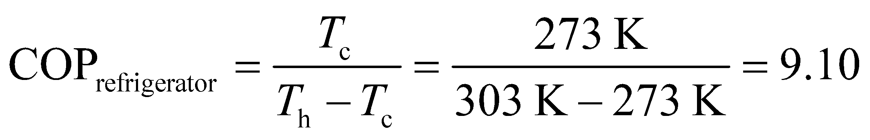

**Assess** Notice that the temperatures are absolute temperatures (i.e., Kelvin).

**18. Interpret** This problem requires us to find the work done by a refrigerator to freeze the given quantity of water. The heat of transformation (Chapter 17) is involved in the liquid-to-solid phase change.

**Develop** The amount of heat that must be extracted in order to freeze the water is (Equation 17.5)



The work consumed by the refrigerator while extracting this heat is given by Equation 19.4, 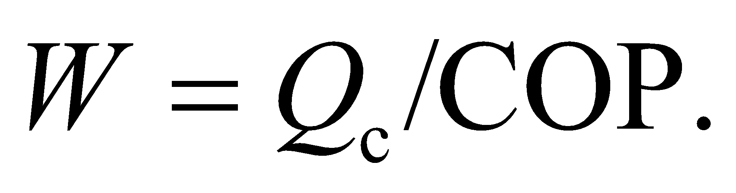

**Evaluate** Inserting the given values, we obtain

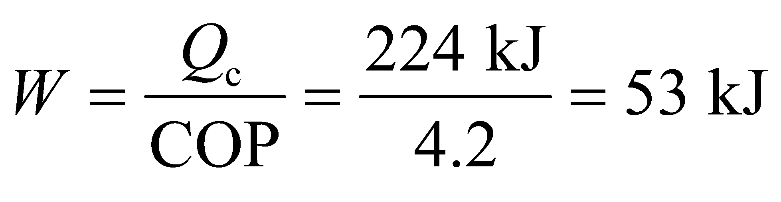

**Assess** A COP of 4.2 means that each unit of work can transfer 4.2 units of heat from inside the refrigerator. A smaller COP would mean that more work is required to freeze the water.

**19. Interpret** We want to know if the human body can be considered as a heat engine, which has stringent limits on its efficiency.

**Develop** If the human body were a heat engine, the maximum efficiency it could attain would be given by the efficiency for a Carnot engine (Equation 19.3): 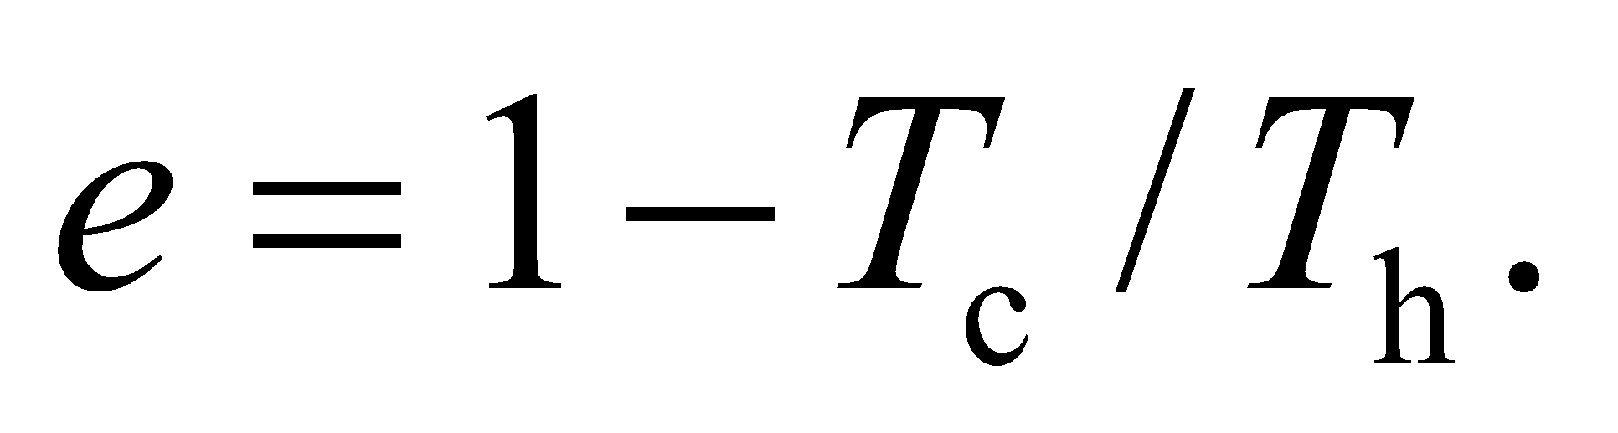

**Evaluate** Body temperature is 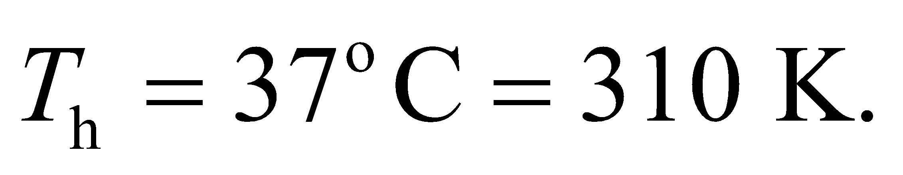 So if we assume the ambient temperature is 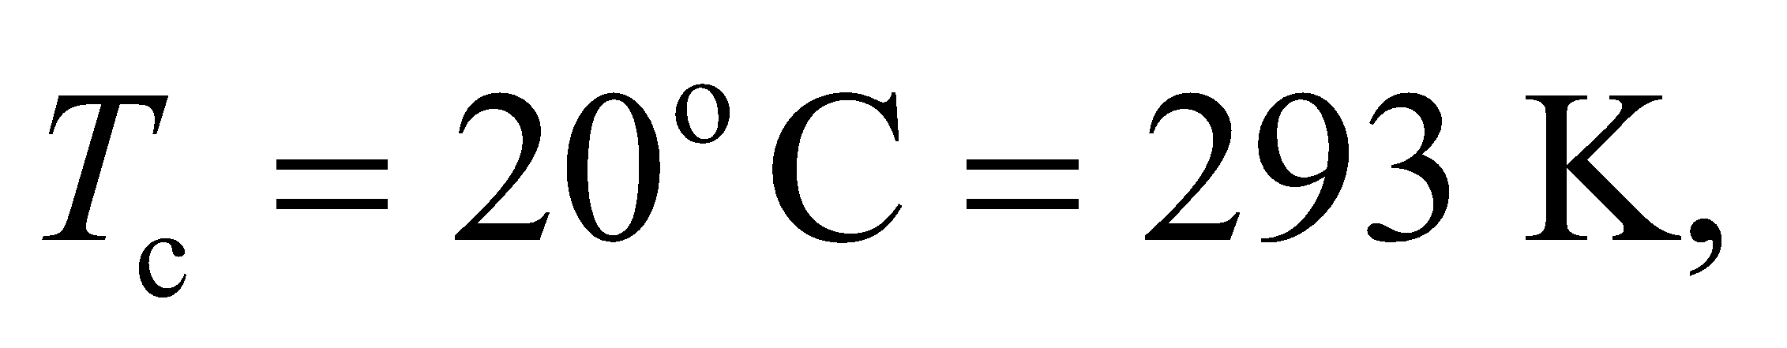 the maximum efficiency would be

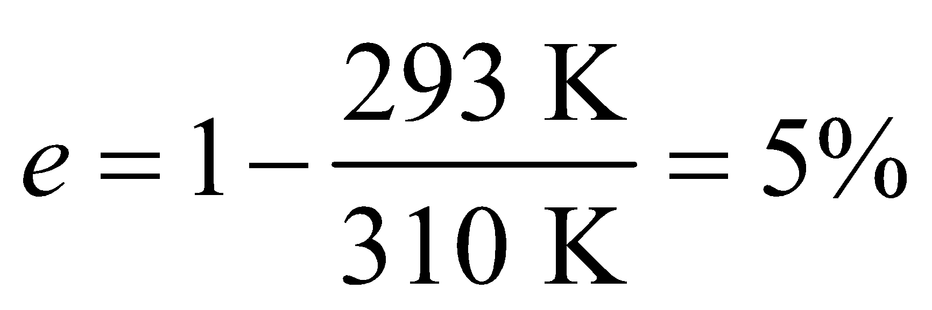

So under normal circumstances, the human body is far too efficient at 25% to be a heat engine.

**Assess** We often say the body "burns" calories, which sounds like it's just releasing random heat from the food we eat. But actually the process is more specific. Energy-storing molecules interact with other molecules to cause precise chemical reactions that result in, for example, a muscle contracting or a neuron producing a current. Not all of the stored energy is converted to useful work, however. Some of it ends up as heat.

**Section 19.4 Entropy and Energy Quality**

**20.** **Interpret** This problem requires us to calculate the entropy change involved with melting the given quantity of ice at 0°C.

**Develop** Because the ice is at 0°C, no temperature change is involved in melting it. Therefore, Equation 19.6 takes the form

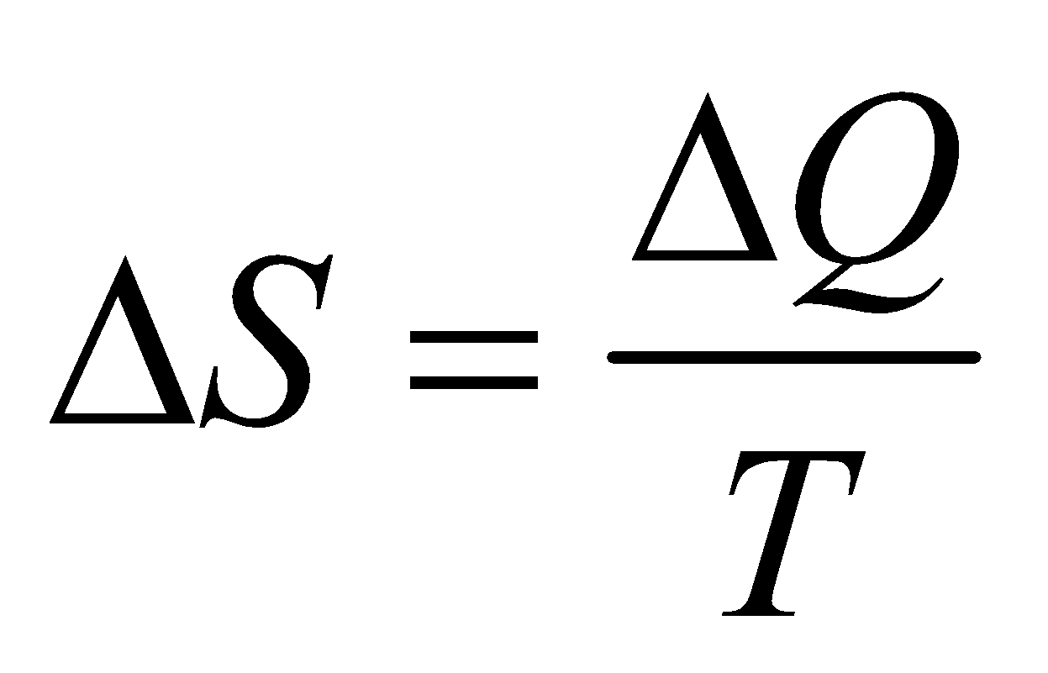

The change in heat is just the latent heat of water, which is given by Equation 17.5 (*ΔQ* = *mL*f) and Table 17.1 (*L*f = 334 kJ/kg). The temperature is *T* = 0°C = 273 K.

**Evaluate** Inserting the given quantities into the expression for entropy change gives

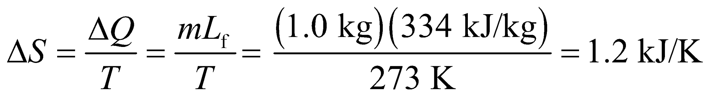

**Assess** Thus the water has more entropy than the ice, so it has a greater capacity to do work.

**21. Interpret** The problem concerns the entropy increase associated with metabolizing a hamburger.

**Develop** We'll assume the energy in the burger, *Q*, flows into the body as heat. Therefore, the entropy change from state 1 (burger ingested) and state 2 (burger metabolized) is given by Equation 19.6: 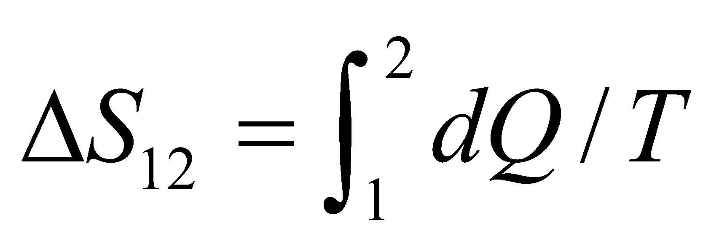.

**Evaluate** The body temperature, 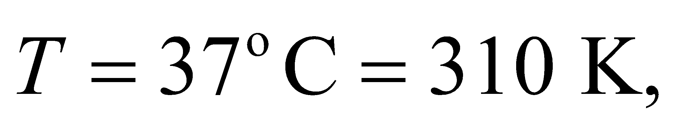remains constant throughout, so

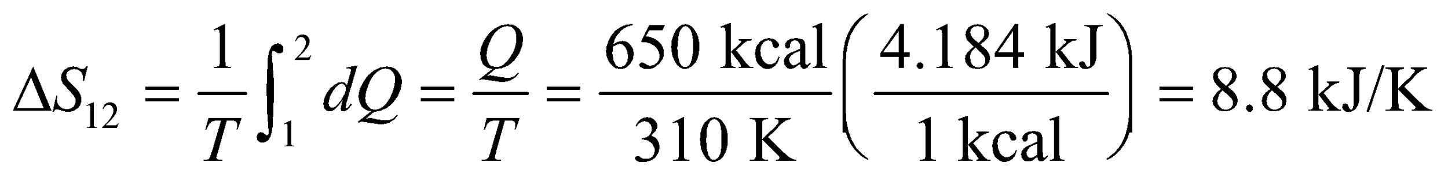

**Assess** Although we assumed the burger's energy went into heat, the answer would be the same if the body used some of the energy to do work. In either case, the burger's energy is no longer available to do work once it has been metabolized.

**22. Interpret** This problem asks us to calculate the entropy increase upon heating up a given mass of water from 10°C to 95°C.

**Develop** The change in heat content of the water is given by Equation 16.3, *Q* = *mcΔT*, where *c* = 4.184 kJ/(kg·K) for water (see Table 16.1). For a substance like water with constant specific heat (in this case at constant pressure), we can differentiate this expression to find *dQ* = *mcdT*, so (from Equation 19.6) the change in entropy is

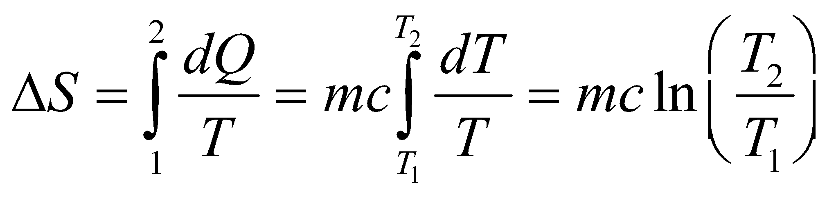

The initial and final temperatures are *T*1 = 10°C = 283 K and *T*2 = 95°C = 368 K, respectively.

**Evaluate** Inserting the given values, we have

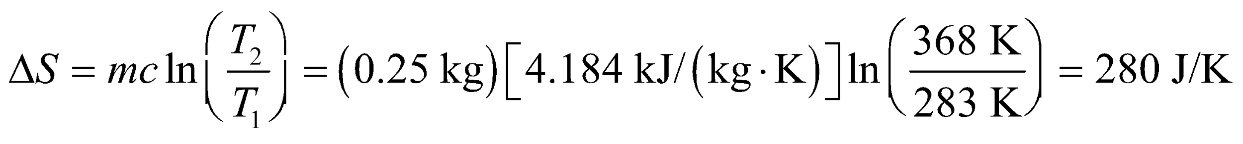

to two significant figures.

**Assess** The final entropy of the system has increased.

**23. Interpret** This problem requires us to find the mass of a block of lead given its entropy increase associated with its solid-to-liquid phase transition (i.e., melting it).

**Develop** The lead starts at its melting-point temperature, so there is no change in temperature associated with the solid-to-liquid phase change. Therefore, Equation 19.6 for entropy change takes the form



The heat change is given by Equation 17.5, *ΔQ* = *mL*f, where *L*f = 24.7 kJ/kg (see Table 17.1). Insert this into the expression for entropy change and solve for the mass *m*.

**Evaluate** From the above equation, we find the mass of lead to be

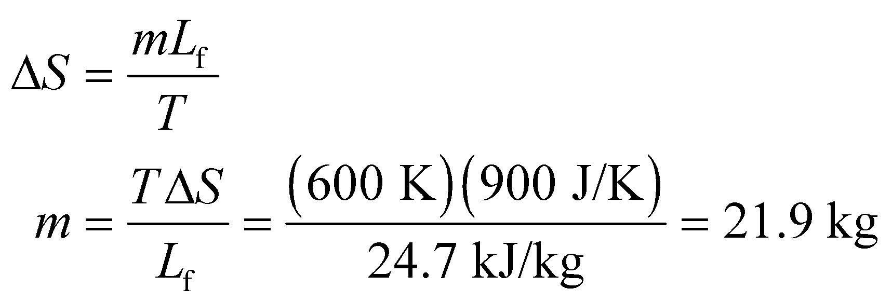

**Assess** As expected, the mass of the block is proportional to the change in entropy.

**24. Interpret** We are to find the energy that becomes unavailable during an irreversible isothermal process given the entropy increase.

**Develop** The energy that becomes unavailable is given by 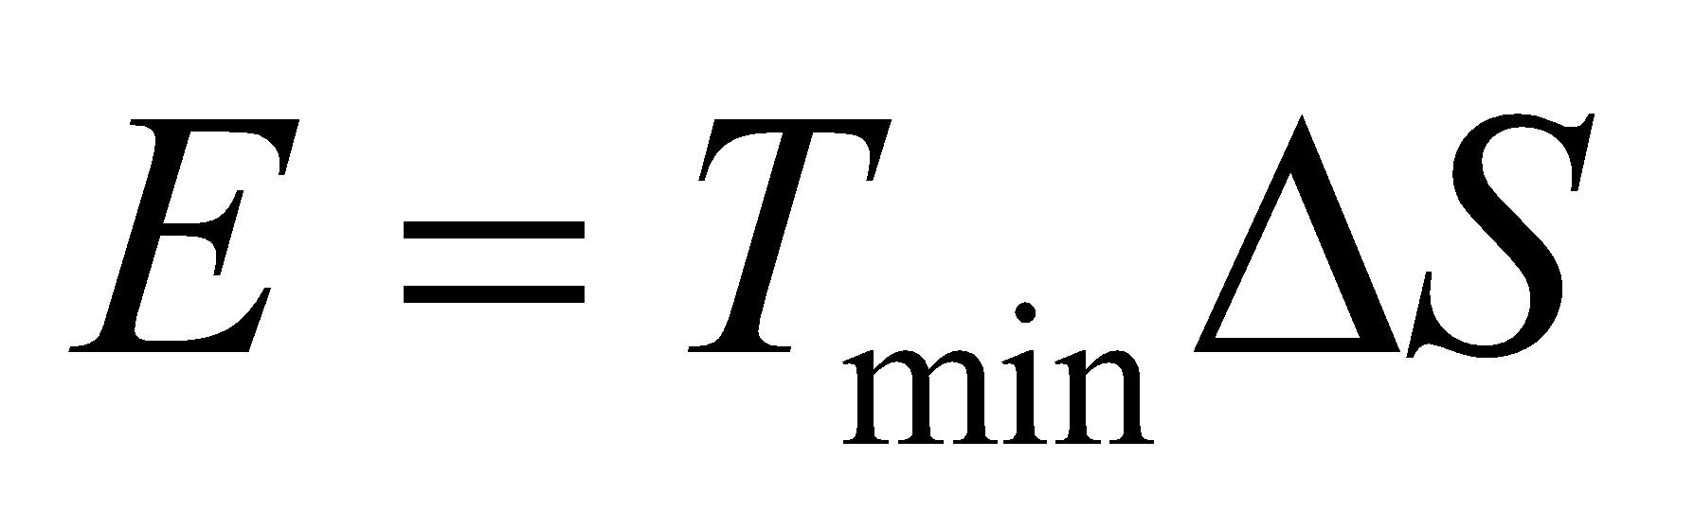(see section Entropy and the Availability of Work), where 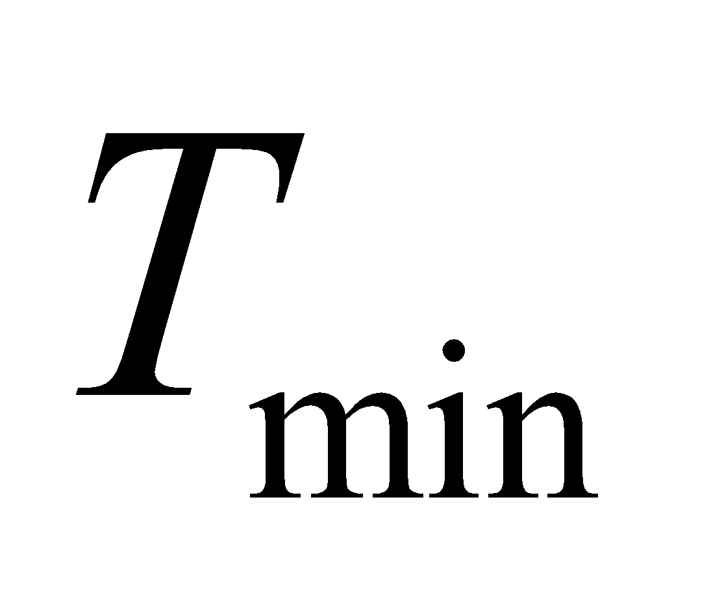 is the lowest temperature available to the system. The change in entropy *ΔS* is 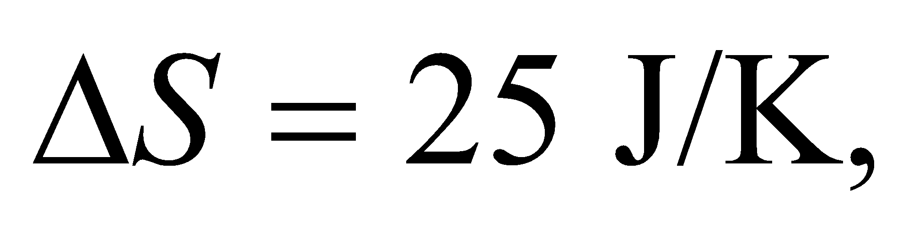 and the temperature is 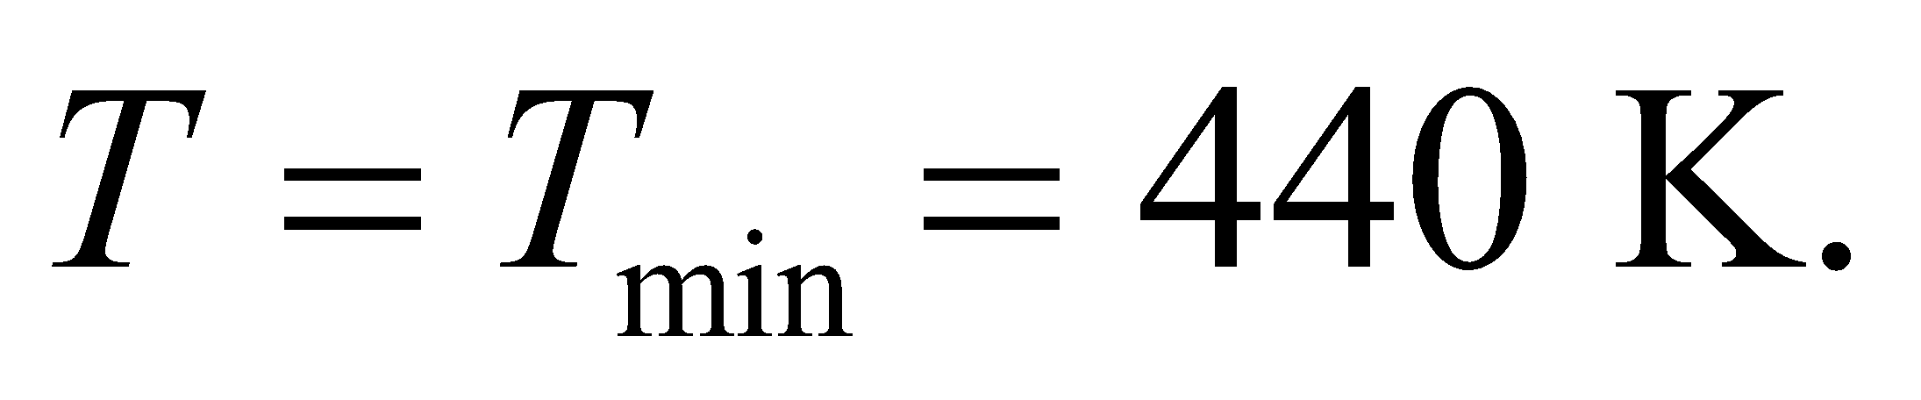

**Evaluate** Inserting the given quantities in the expression for unavailable work gives

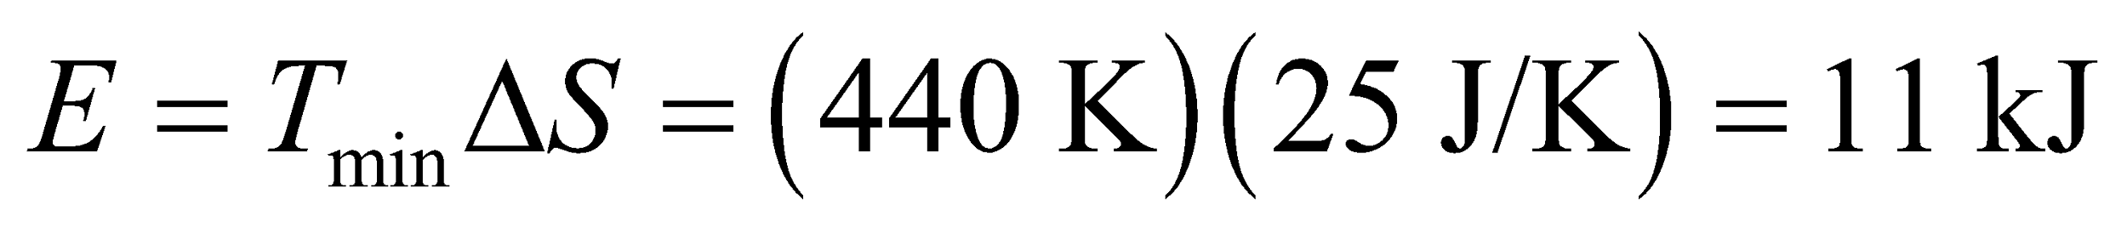

**Assess** Since this is an isothermal process, the minimum temperature is the maximum temperature is the temperature.

**25. Interpret** We’re asked to find the probability that 6 molecules are distributed in different ways inside a box. This has relevance to the statistical interpretation of entropy.

**Develop** Considering a single molecule, the probability that it is located on the left-side or the right side of the box is ½. Considering 2 molecules, the probability for one particular left-right arrangement (microstate) is ¼. Another way to say this is that there are 4 different ways to sort the molecules between the two sides. For 6 molecules, there are 26=64 ways to sort, so the probability for one particular arrangement (microstate) is 1/64. We now have to count how many of these microstates match the following macrostates (see Figures 19.18 and 19.19).

**Evaluate**  (a) There's only one microstate in which all of the molecules are found on one side of the box, so the probability of this macrostate is 1/64.

(b) It's a bit harder to find the number of microstates with half the molecules on one side, half on the other. So let's label the molecules A, B, C, D, E, and F, and let's identify a microstate by the 3 molecules on the left-hand side. So for example, (ABC) is the microstate with A, B, C on the left-hand side, and the others on the right. We can switch out C in three different ways: (ABD), (ABE) and (ABF). Similarly we can switch out B in three different ways and switch out A in three different ways. That gives us 10 microstates. We count another 10 microstates if we start with (DEF), and switch out D, then E, then F. The total number is 20 microstates.

So the probability of the macrostate with the molecules split evenly between the sides is 20/64.

**Assess** It is 20 times more likely that the 6 molecules will be spread out evenly between the two sides of the box vs. all on one side. In general, if there are *n* molecules, the probability that *k* of them will be on one side and (*n*–*k*) on the other side is given by the coefficients from the binomial theorem:

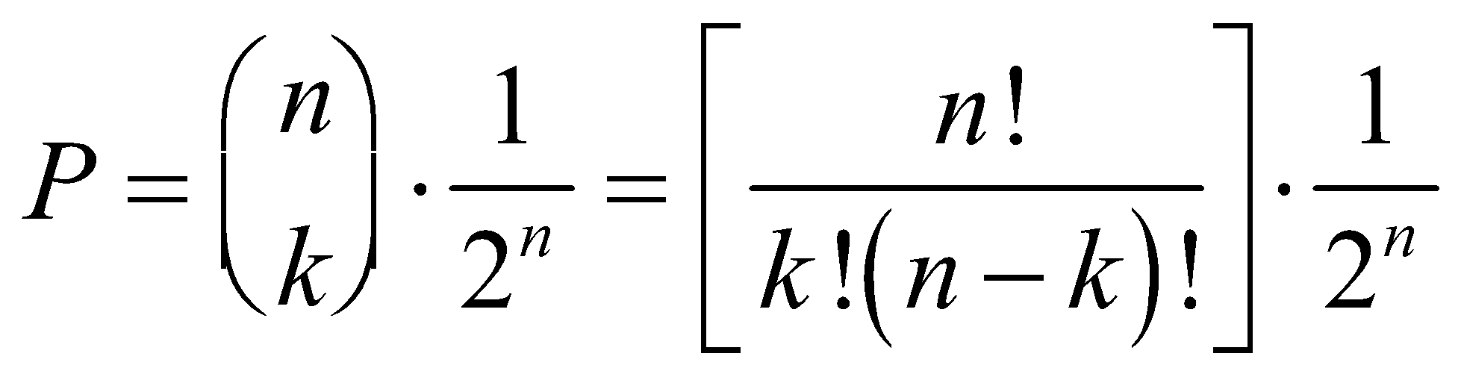

In the case above, 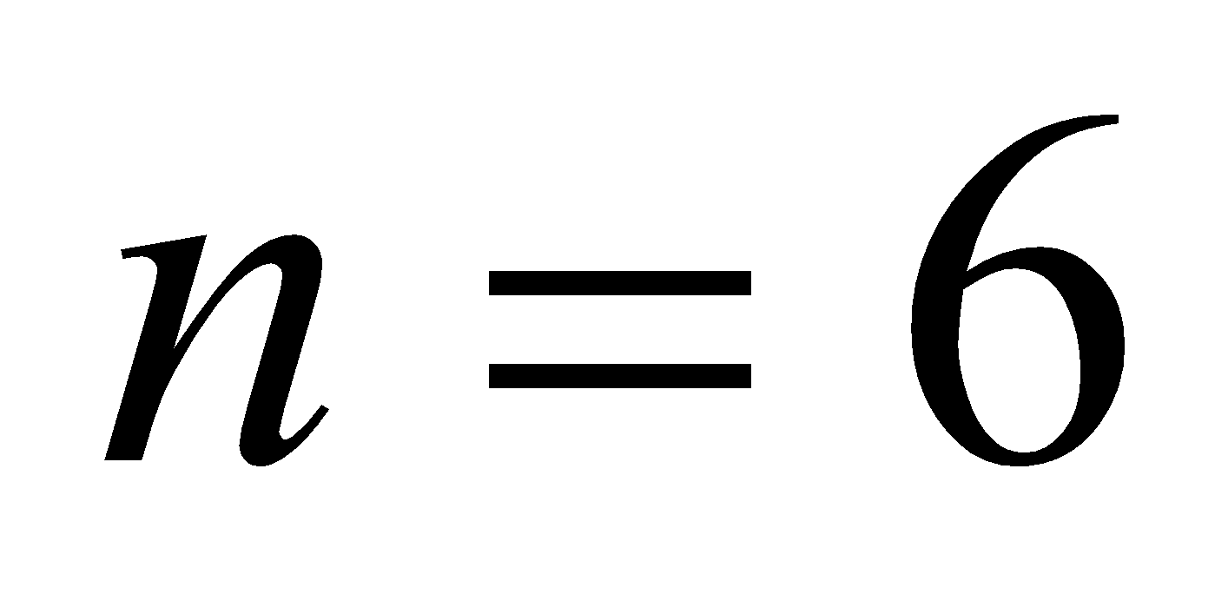 and 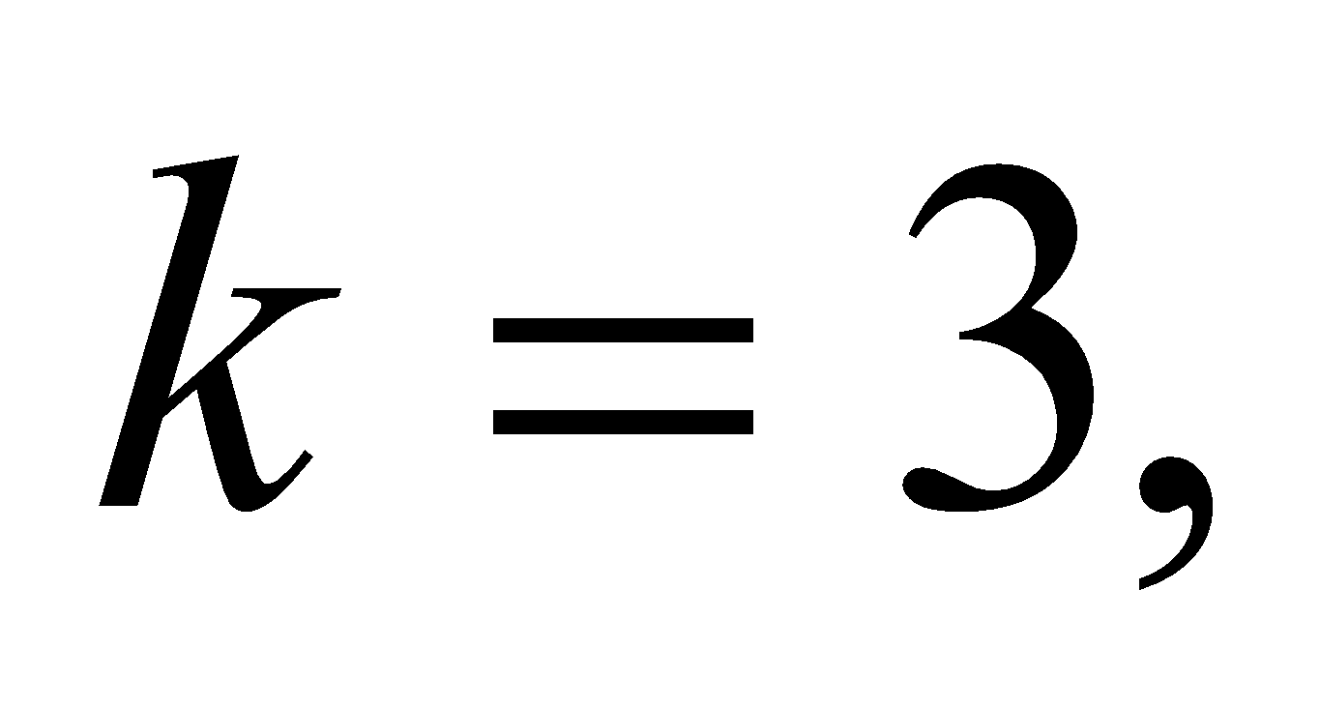 so the probability is 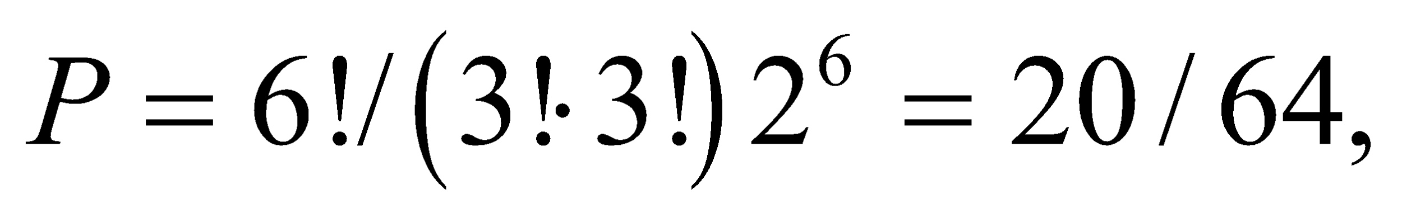as we found.

**Problems**

**26. Interpret** This problem is about a Carnot engine, its work, efficiency and power output.

**Develop** For a cyclic operation, the change in internal energy is zero,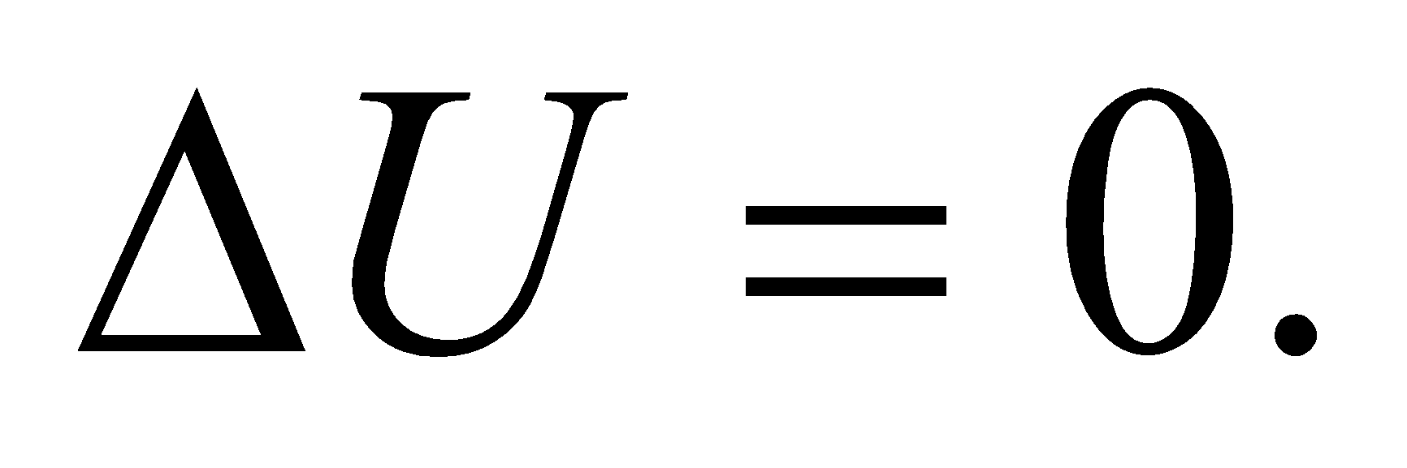 From the first law of thermodynamics, we have 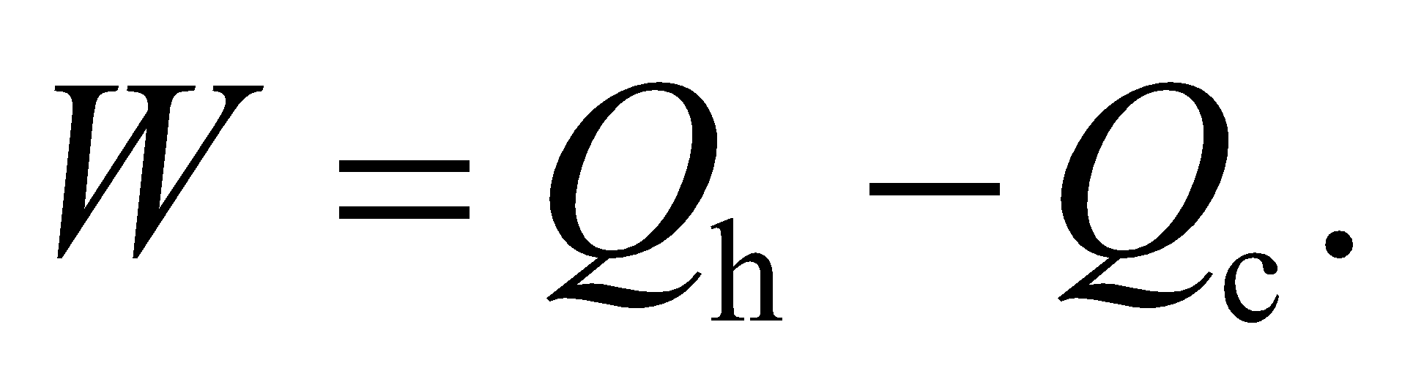Once the work *W* is known, its efficiency can be obtained as 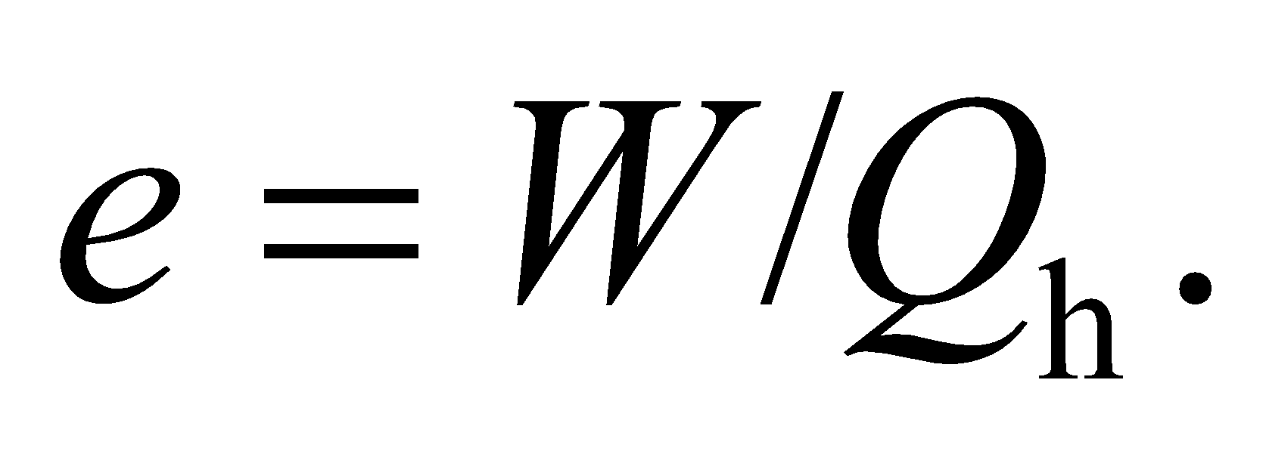 For a Carnot engine,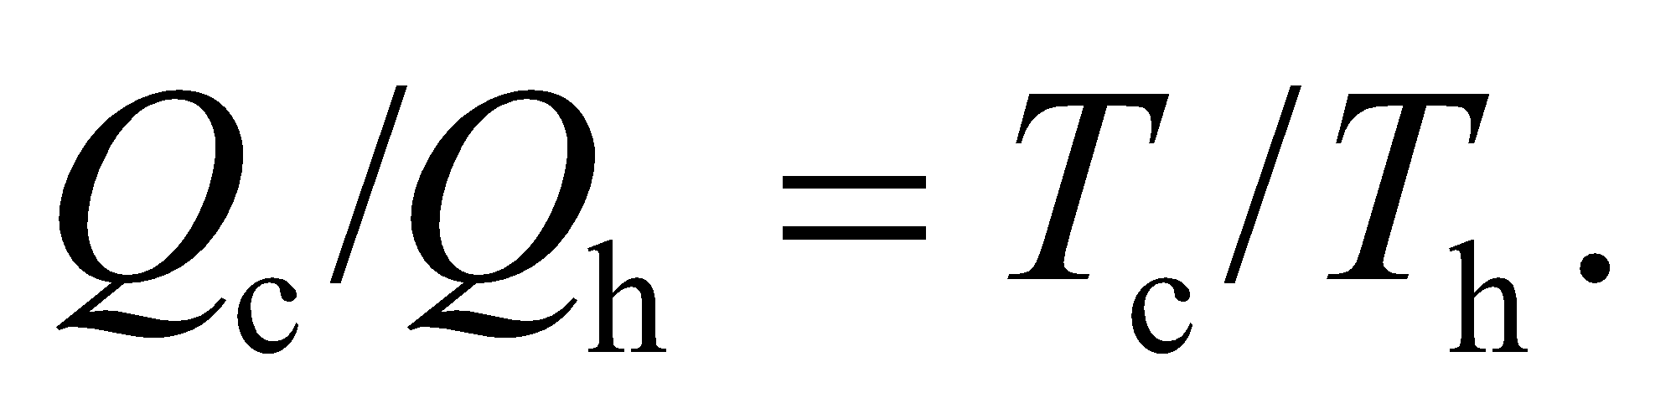

**Evaluate**  (a) The work done by the engine during each cycle is

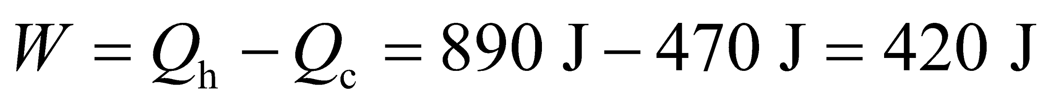

(b) The efficiency of the engine is

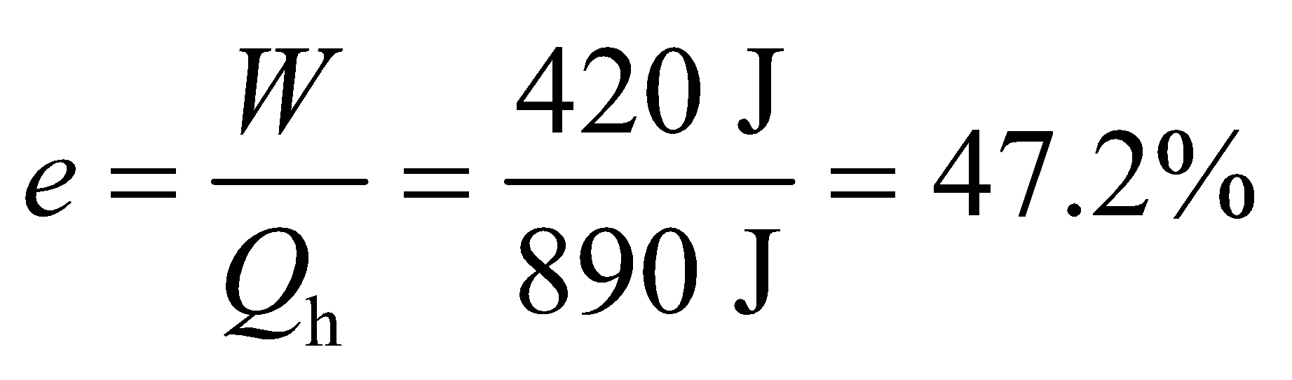

(c) For a Carnot engine,

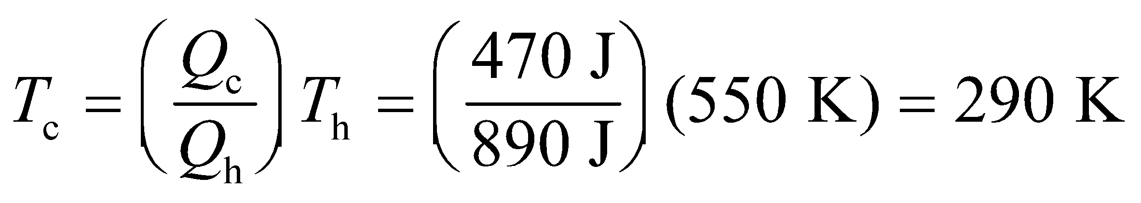

(d) The work from (a) is per cycle, so the mechanical power output of the engine is this divided by the cycle period, which is equivalent to multiplying by the frequency 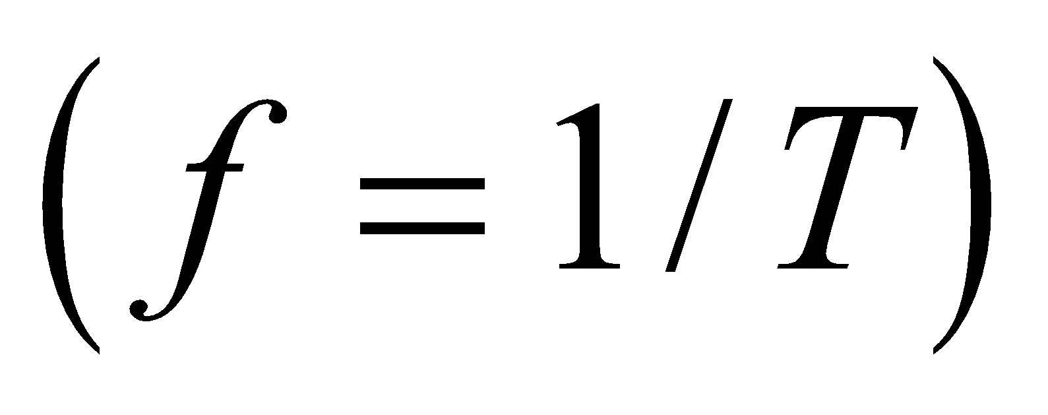:

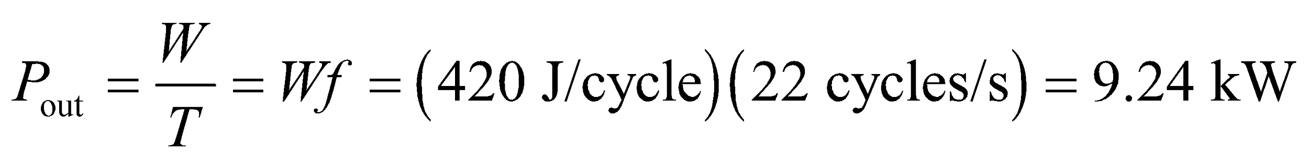

**Assess** The cool reservoir temperature is cooler than the hot reservoir temperature 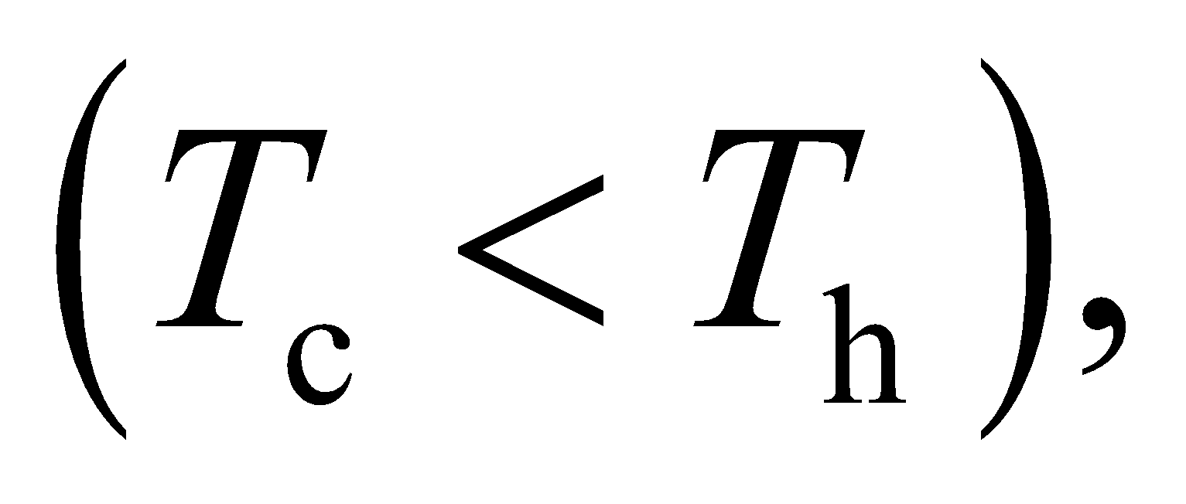as expected. And the efficiency can be verified by using Equation 19.3: 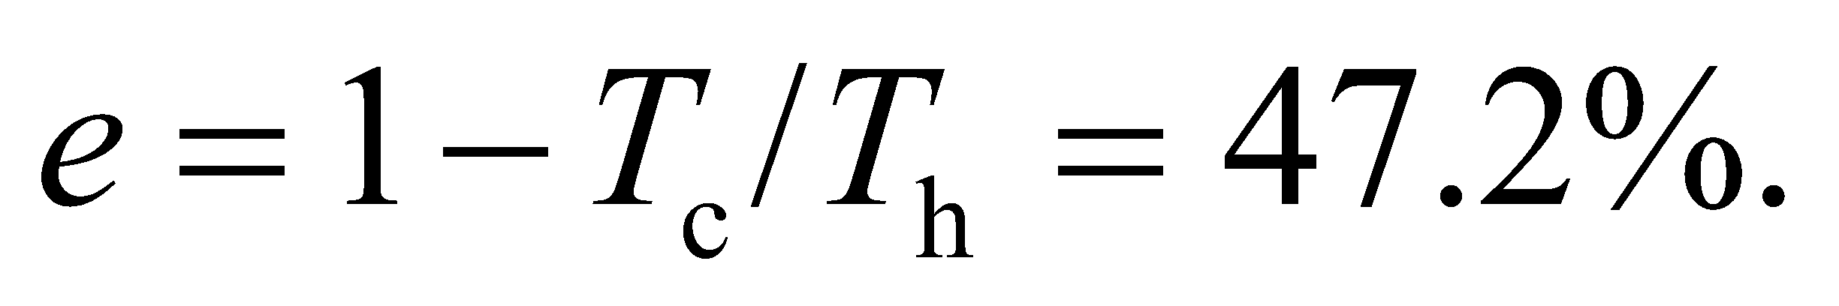

**27.** **Interpret** This problem requires us to find the thermodynamic efficiency of a nuclear power plant in winter and in summer, when the temperature of its cold reservoir is 0°C and 25°C, respectively.

**Develop** From Equation 19.3, the thermodynamic efficiency of a Carnot engine is



where the temperatures are in Kelvin.

**Evaluate** Inserting the given temperatures for summer and winter gives

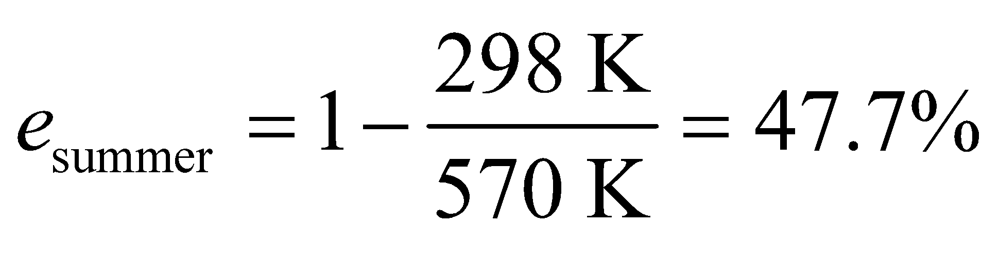

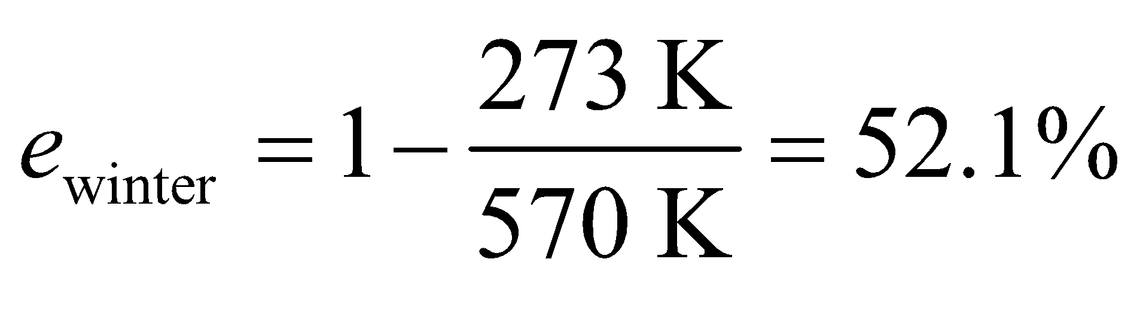

**Assess** The plant is more efficient in winter than in summer because there is a greater heat difference. However, as explained in Section 19.3, irreversible processes, transmission losses, etc., make actual efficiencies less than the theoretical maxima.

**28. Interpret** You want to calculate the minimum coefficient of performance for a heat pump that's to be installed in a new house.

**Develop** For a heat pump, what you want is heat, and what you put in is work in the form of electricity, so 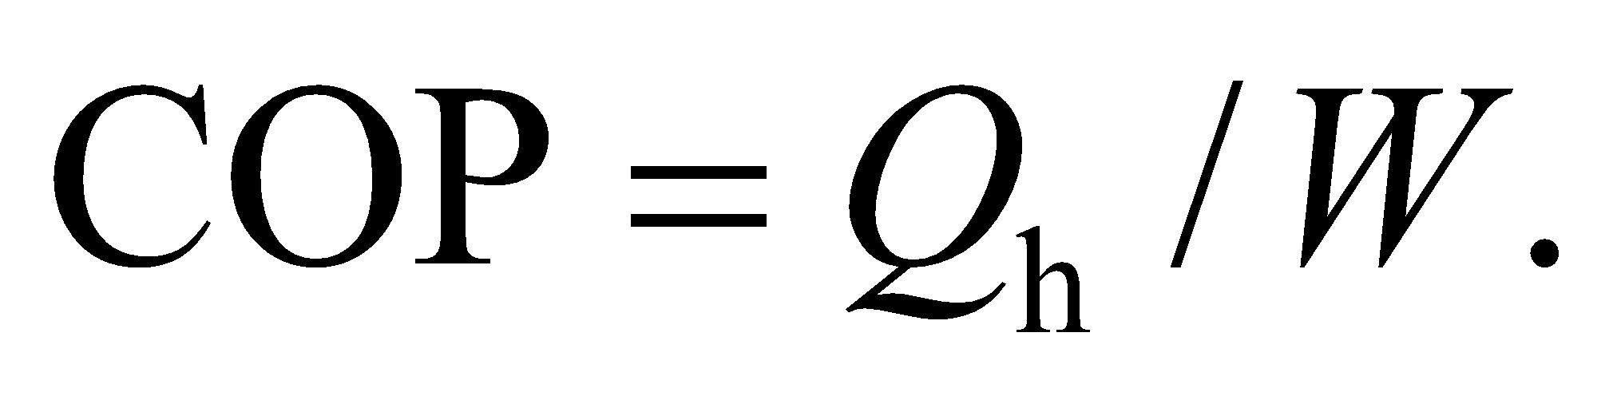In this case, you are dealing with rates, i.e., the rate that the house needs to be heated, *H*, and the electric power, *P*, that the solar voltaic system supplies to the heat pump. The coefficient of performance can therefore be written as 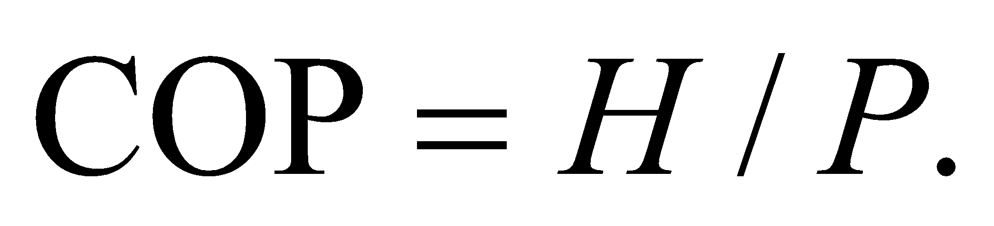

**Evaluate** The minimum COP needed to keep the house warm on a cold day is

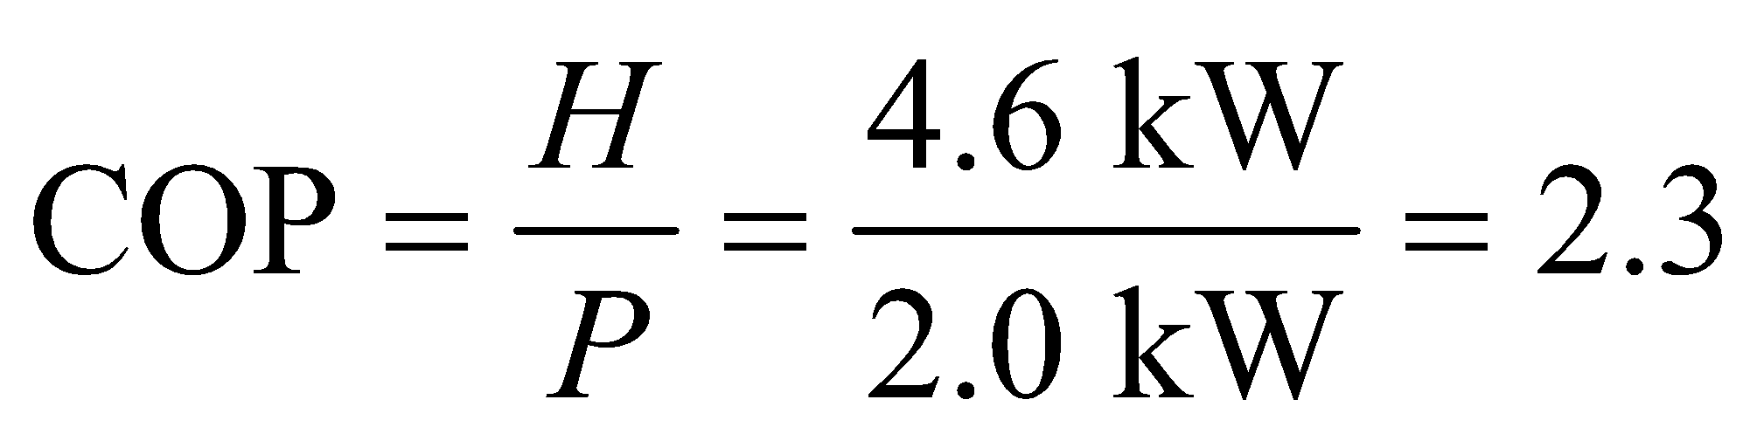

**Assess** This is entirely reasonable for a heat pump. It might seem impossible to obtain more heat energy than you put in, but the heat pump is not generating heat but only "moving" it from outside to inside. (see Figure 19.12).

**29. Interpret** This problem involves a nuclear power plant and asks us to calculate the rate of energy extraction, the efficiency, and the highest temperature the plant attains.

**Develop** From Equation 16.3, 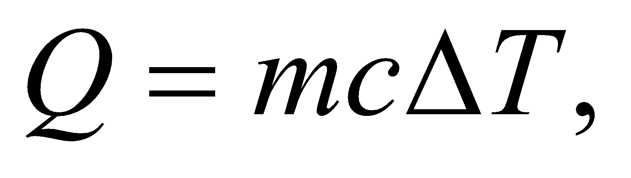 we see that to raise the temperature of the cooling water by 8.5 K, heat must be exhausted to it at a rate of



We take this to be the rate of all the heat rejected by the power plant. Since the rate of work output *dW*/*dt* is also given, the heat input to the plant (extracted from its fuel) is

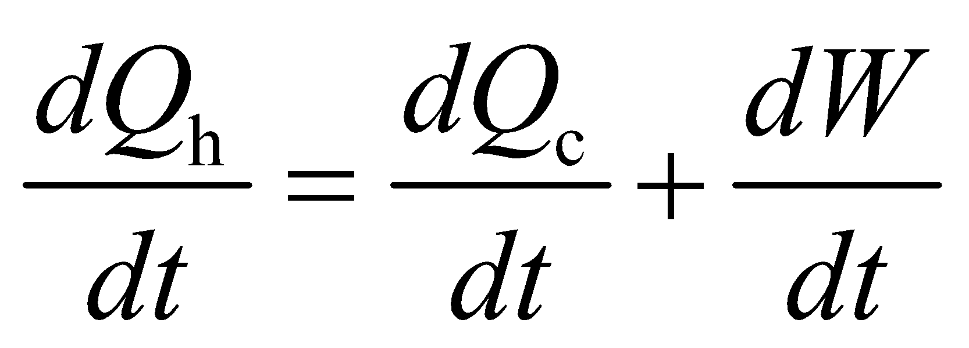

where we have used the first law of thermodynamics (see Problem 19.16). In terms of the rates, the efficiency of the plant is

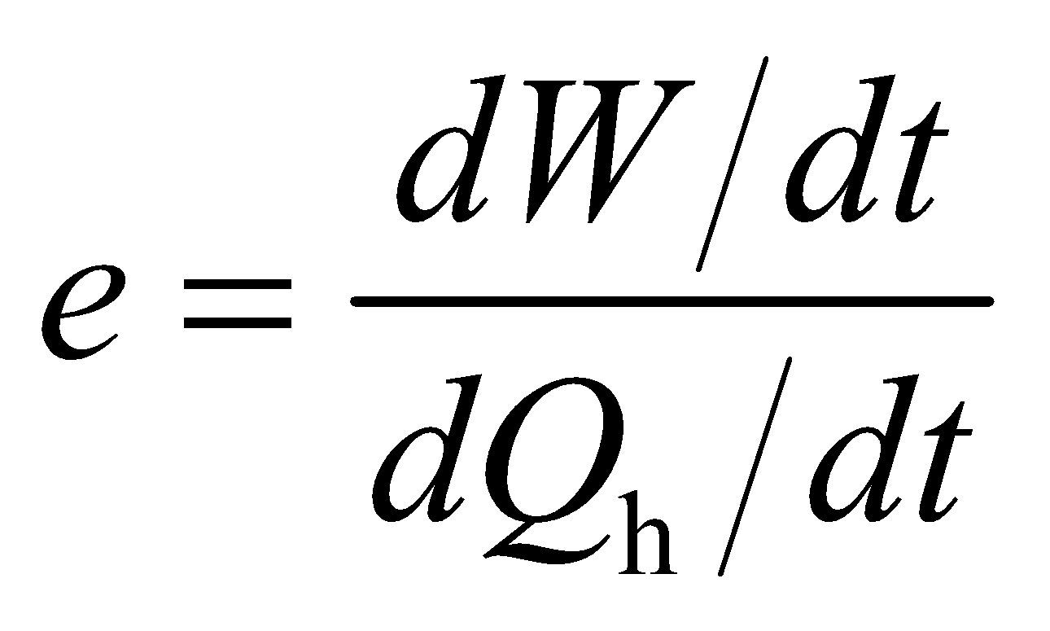

If we consider the plant to operate like a Carnot engine, then its highest temperature can be calculated using 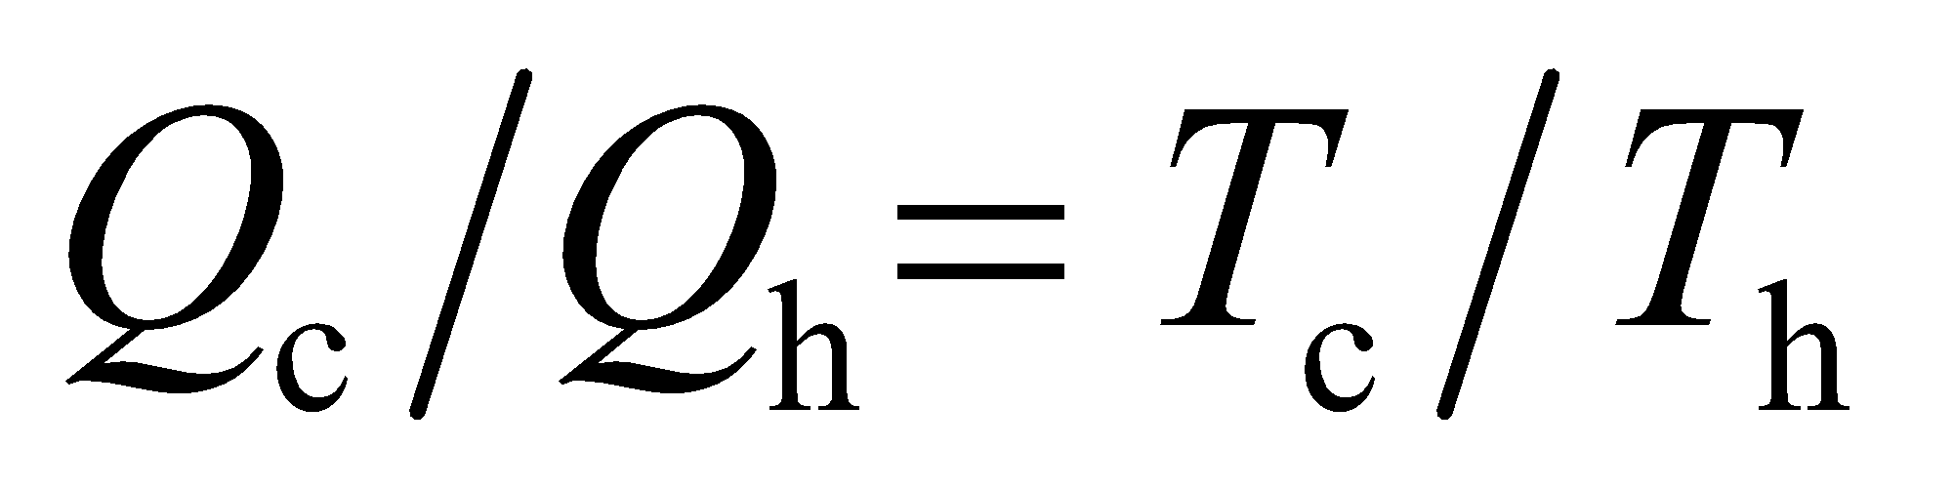 (from Equation 19.2).

**Evaluate** **(a)** Substituting the values given, we obtain

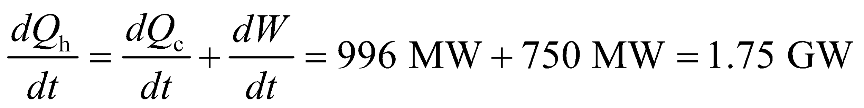

where the negative sign corresponds to the energy being extracted from the fuel.

**(b)** The plant’s efficiency (from the definition of efficiency in terms of rates) is

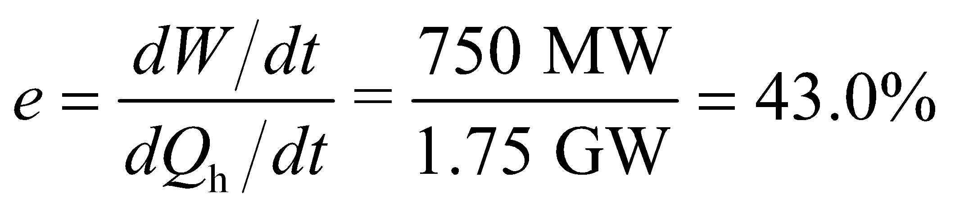

**(c)** With the assumption that the plant operates like an ideal Carnot engine, then

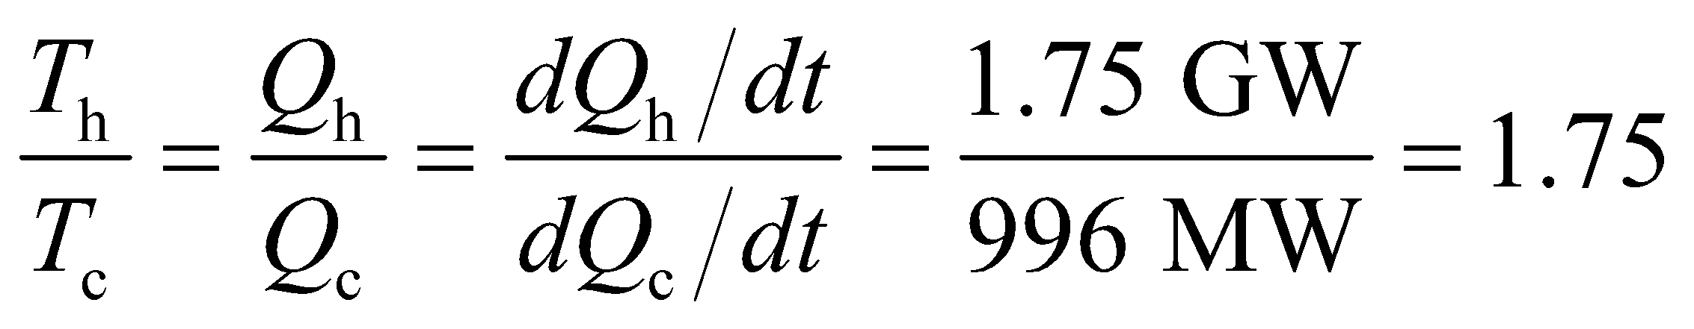

(Note that the energy rate per cycle and the energy rate per second are proportional.) If 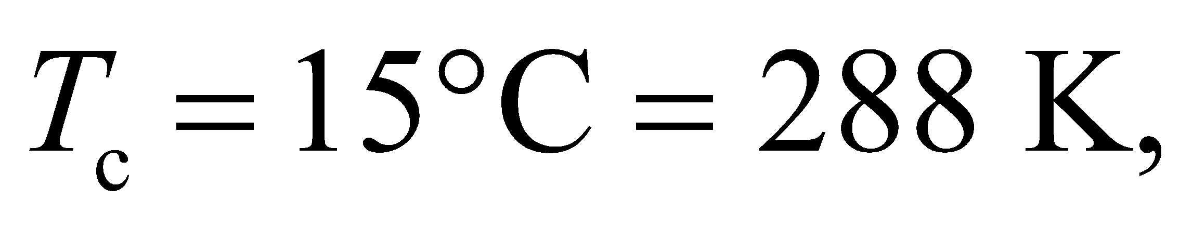 then



**Assess** The actual highest temperature would be somewhat greater than this, because the actual efficiency is always less than the Carnot efficiency.

**30.** **Interpret** This problem requires us to calculate the efficiency of an electrical power plant, given the temperature of its hot and cold reservoirs. From this, we are to find the power discharged as waste heat and the number of houses we could heat with this waste heat.

**Develop** The maximum efficiency of the plant as a function of the temperature of its hot and cold reservoirs is given by Equation 19.3



which we are to compare with the actual efficiency which is

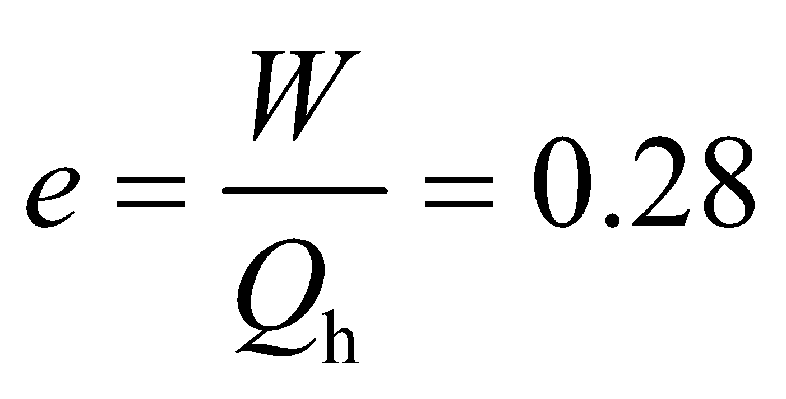

The actual efficiency may also be expressed as *e* = 1 − *Q*c/*Q*h (Equation 19.1). In this chapter, *W* is defined as the work done *by* the system (as compared to *W* in the first law of thermodynamics, Equation 17.1, which is the work done *on* the system). Thus, W is equal to the net heat,

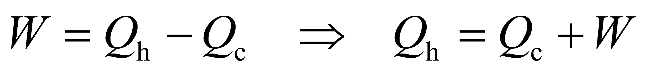

where *Q*c is the heat rejected by the system to the cold reservoir and *Q*h is the heat absorbed by the system from the hot reservoir. Using this result to eliminate *Q*h in the expression for the plant’s actual efficiency gives

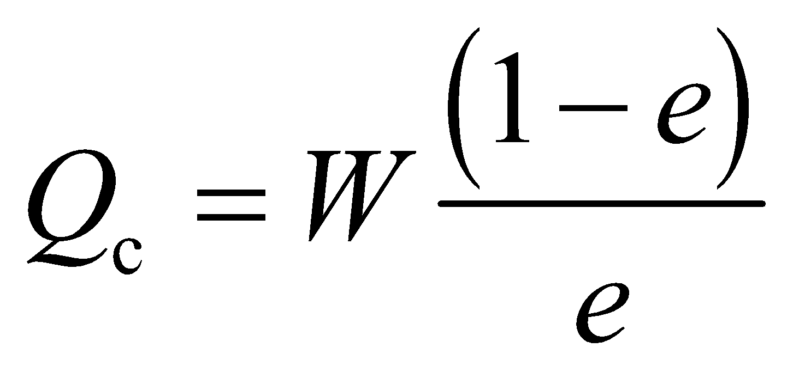

Differentiating this with respect to time gives the waste power *dQ*c/*dt* in terms of the power output *dW*/*dt* = 800 MW and the actual efficiency of the plant *e*:

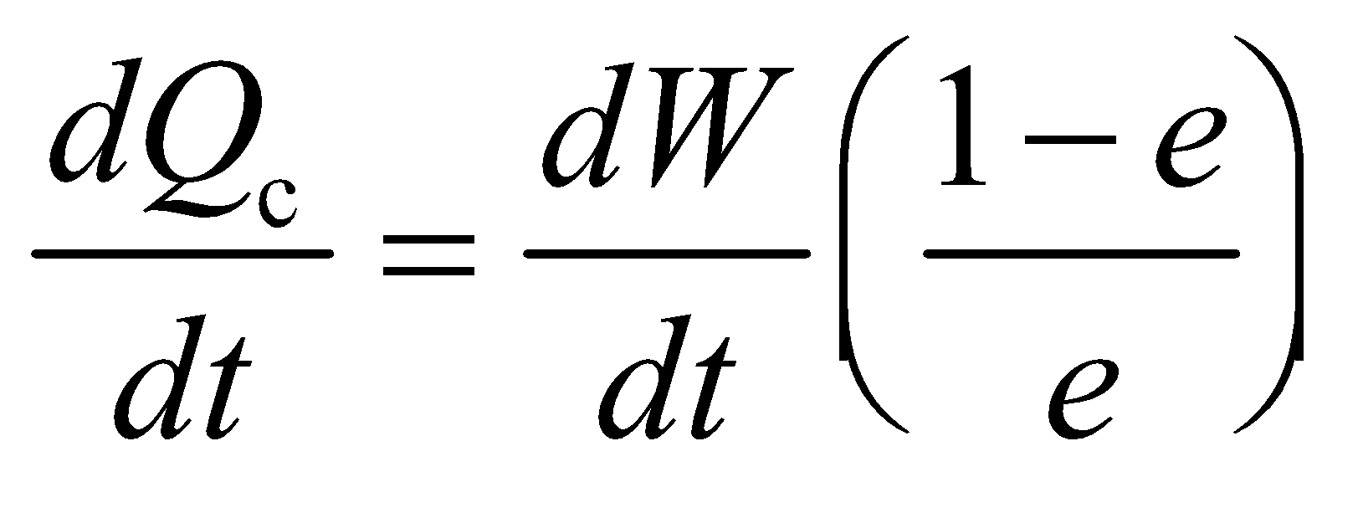

Finally, the number of houses that can be warmed with this waste power is simply the waste power divided by the power requirement of a single house, or

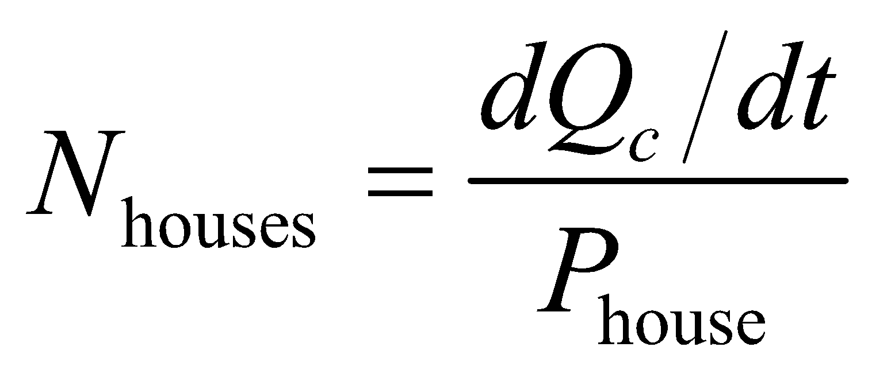

where *P*house = 18 kW.

**Evaluate** (a) The maximum possible efficiency for the power plant is

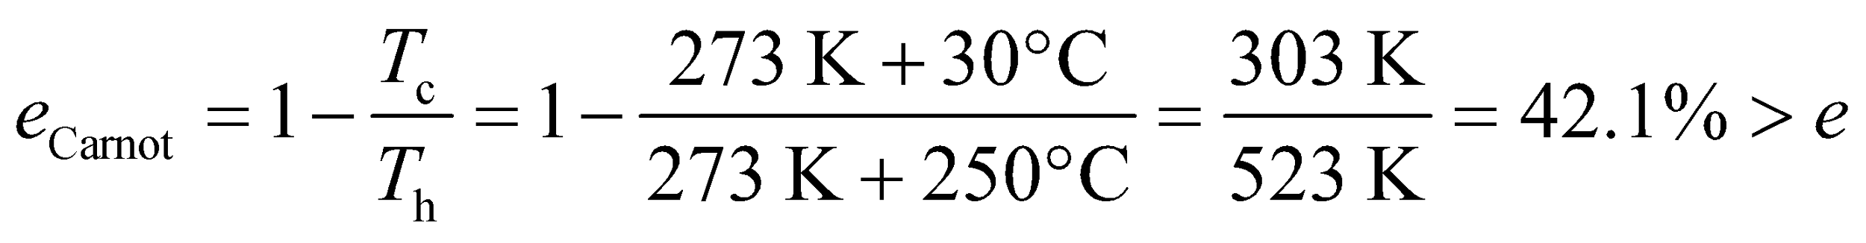

(b) The waste power is

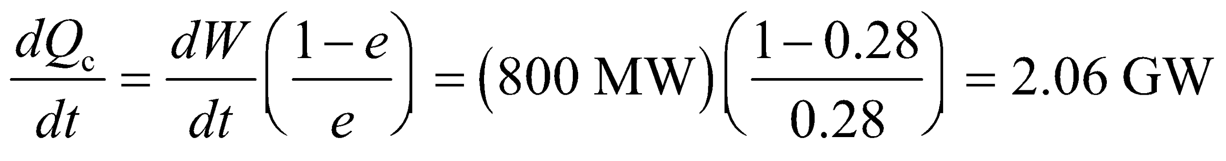

(c) The number houses that could be heated by the waste power is

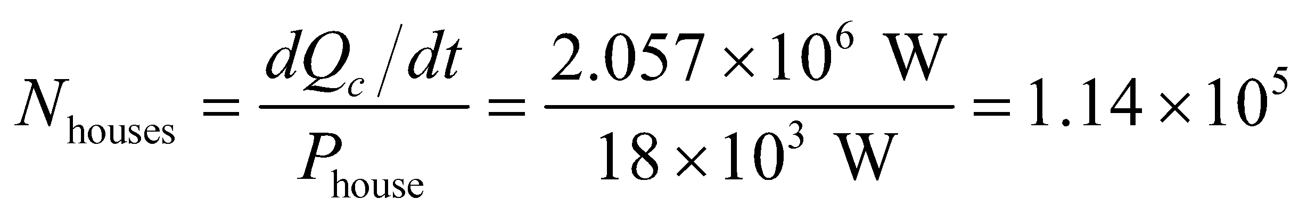

**Assess** As expected, the maximum efficiency *e*Carnot is greater than the actual efficiency *e*.

**31. Interpret** This problem asks us to find the rate (i.e., kg/s) at which all the power plants in the USA use cooling water. We are given the actual efficiency of the power-plants and the temperature rise in the cooling water.

**Develop** For a cyclic operation, the change in internal energy is zero, From the first law of thermodynamics, we have 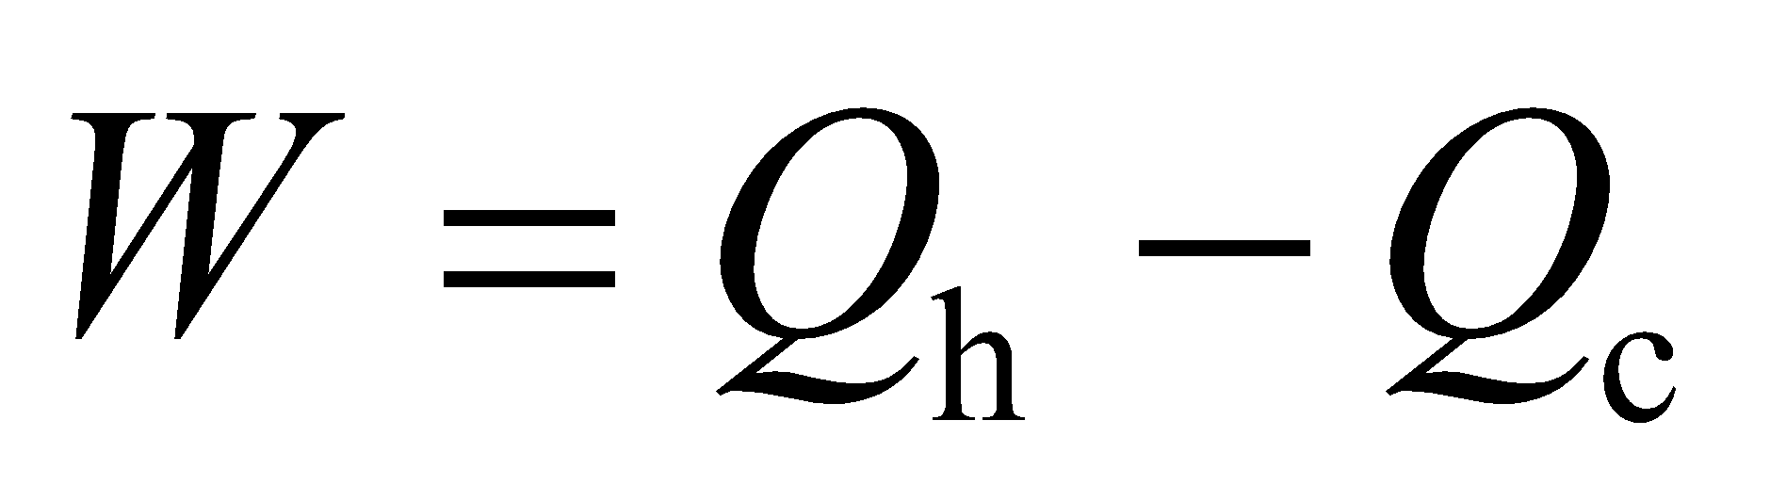, where *W* is the work done by the system (contrary to the definition of *W* in Chapter 18), *Q*h is the heat absorbed by the system, and *Q*c is the heat rejected by the system. Therefore, the total rate at which heat is exhausted by all the power plants is



The mass rate of flow at which water could absorb this amount of energy, with only a 5°C temperature rise, is

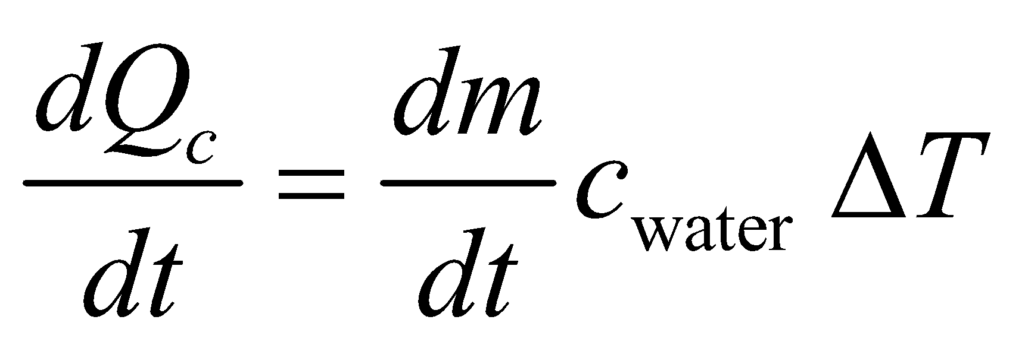

where *c*water = 4184 J/(kg·K) (see Table 16.1). This equation can be solved to give the mass rate of cooling water used.

**Evaluate** Solving the equation above for *dm*/*dt*, we obtain

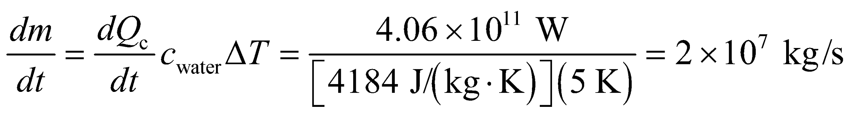

or about 1 Mississippi (a self-explanatory unit of river flow).

**Assess** To absorb the power output of 2 × 1011 W with only an increase of temperature of 5°C, we expect the mass flow rate to be large.

**32.** **Interpret** For this problem, we are to show that the overall efficiency of a two-stage heat engine is the same as a single-stage engine operating between *T*h and *T*c of the two-stage engine.

**Develop** Let the heat exhausted Qi by the first engine equal the heat input to the second. Then, 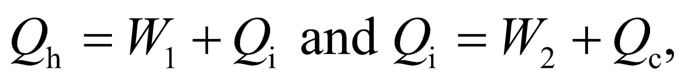 where *Q*c is the heat exhausted to the environment. For a single-stage engine operating between *T*h and *T*c, the actual efficiency is the total work *W*1 + *W*2 divided by *Q*h, (Equation 19.1), which we can evaluate to compare with the Carnot efficiency of the two-stage engine, which is *e* = 1 − *T*c/*T*h (Equation 19.3).

**Evaluate** The actual efficiency of the single-stage engine is

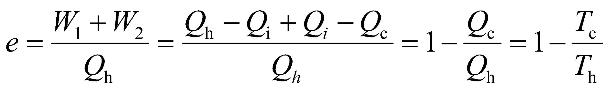

which is the Carnot efficiency of the two-stage engine.

**Assess** In the last equality, we used Equation 19.2, *T*c/*T*h = *Q*c/*Q*h.

**33. Interpret** This problem involves finding the COP of a freezer for which the highest and the lowest temperatures are 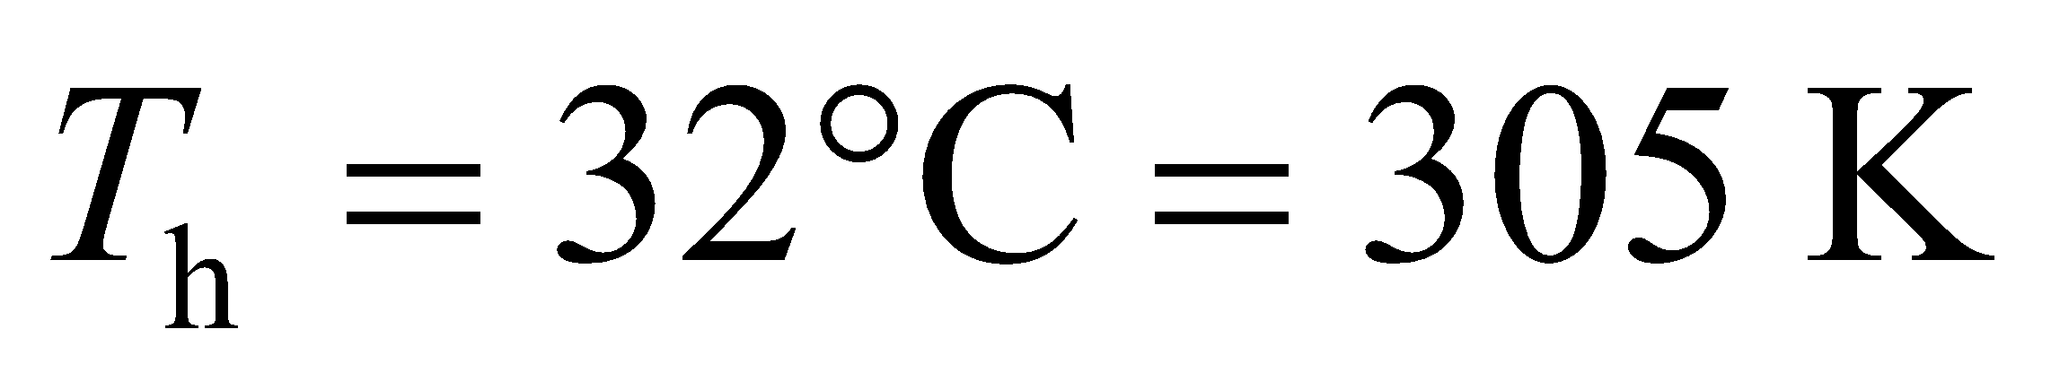 and 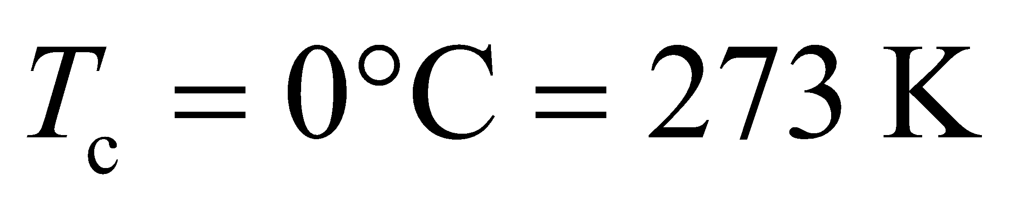. In addition, we are to find how much water at 0°C the freezer can freeze in one hour.

**Develop** The coefficient of performance (COP) of a reversible freezer is given by Equation 19.4:

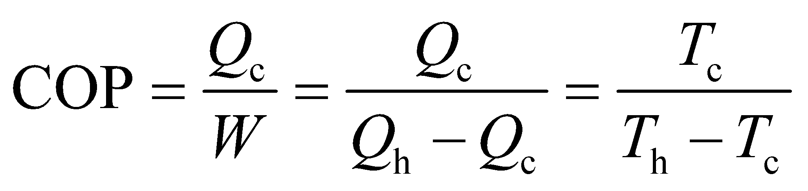

where we have used Equation 19.2, *T*c/*T*h = *Q*c/*Q*h for the last equality. Once the COP is known, we can solve for *Q*c and the amount of water the freezer can freeze in one hour, which is 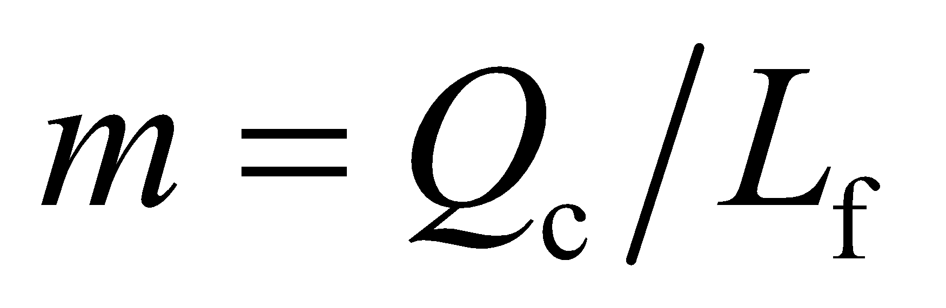 with Lf = 334 kJ/kg (see Equation 17.5 and Table 17.1).

**Evaluate** **(a)** The COP of the freezer is

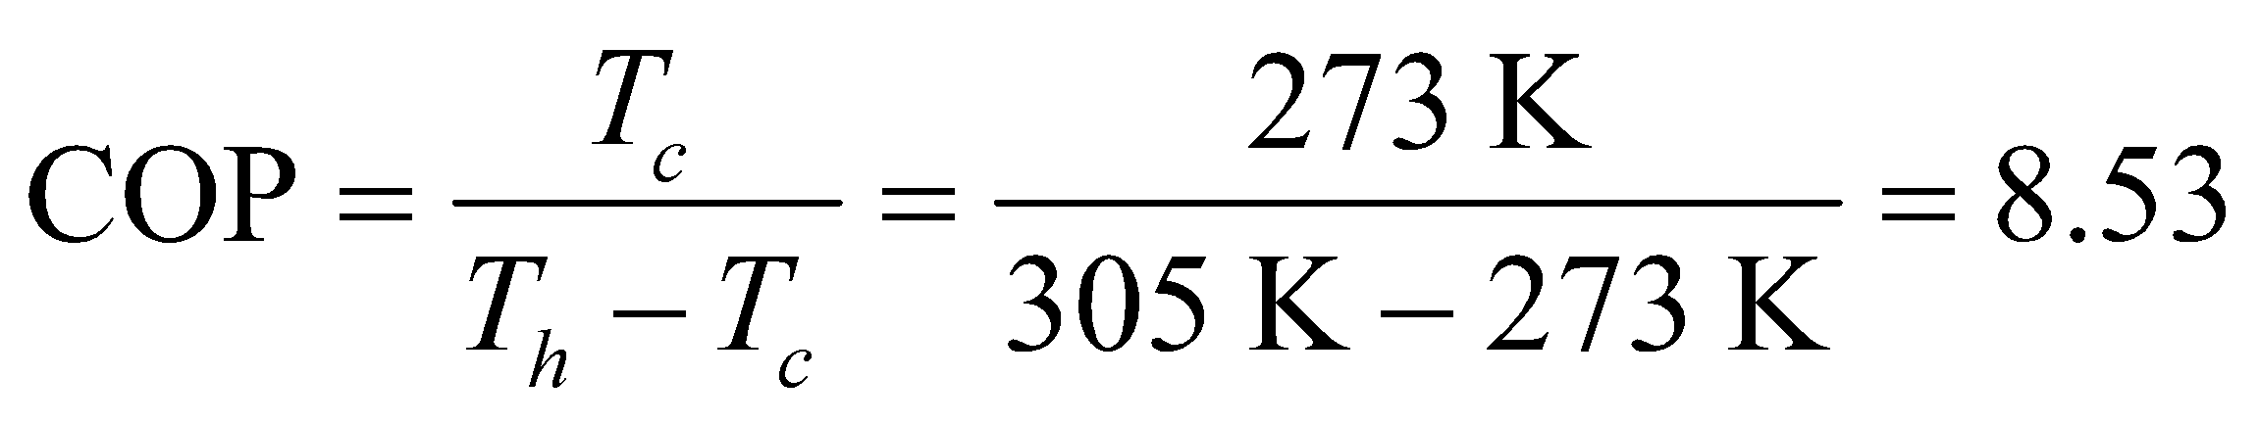

**(b)** The heat rejected in one hour is , so the water we can freeze is

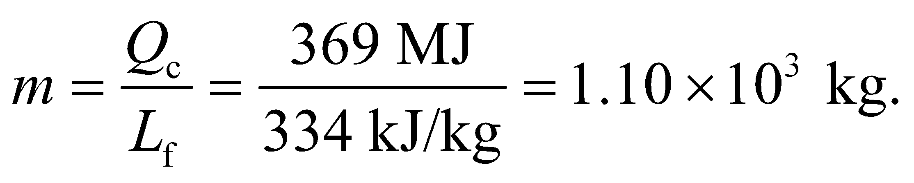

**Assess** Typical freezers have a COP lower than 8.53. Thus, more electrical energy is needed to freeze the same amount of water.

**34. Interpret** We are to use an energy-flow diagram to analyze whether using a refrigerator to cool the low-temperature reservoir of a Carnot can increase its overall efficiency.

**Develop** In order to lower the temperature of the cold reservoir, the combination must remove more heat from the cold reservoir than it puts into the reservoir. Since both the engine and the refrigerator are at the Carnot efficiency, they are reversible.

**Evaluate** As shown in the figure below, the *best* that this can do is zero work output while the temperatures stay the same. If the temperature of the cold reservoir is to become lower, then the heat extracted from the cold reservoir must be larger, which will require more work than the engine produces.



**Assess** Might as well do nothing at all!

**35.** **Interpret** This problem requires us to find the monthly cost of using all the incoming electrical energy to power a heat pump with COP = 3.1 to heat a house. We are given that the electrical energy costs $180 per month in the winter.

**Develop** The same electrical energy *W* used for direct conversion in electric heating would produce heat 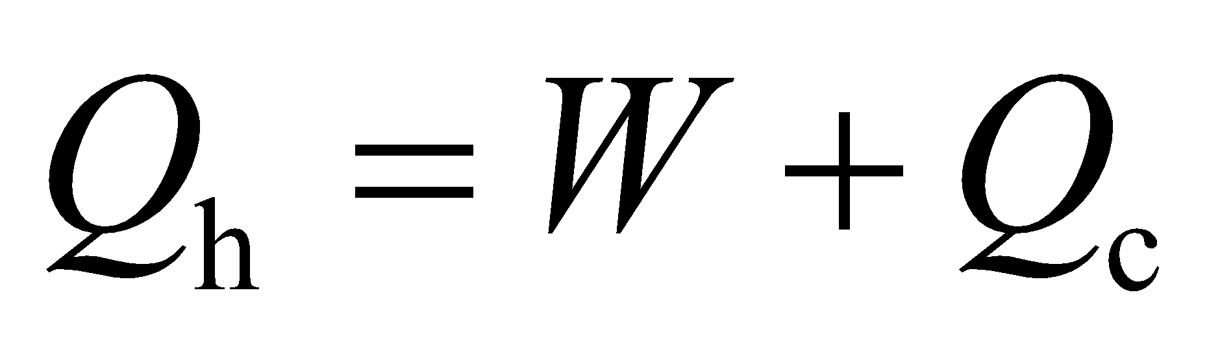. Using Equation 19.4 allows us to express this as

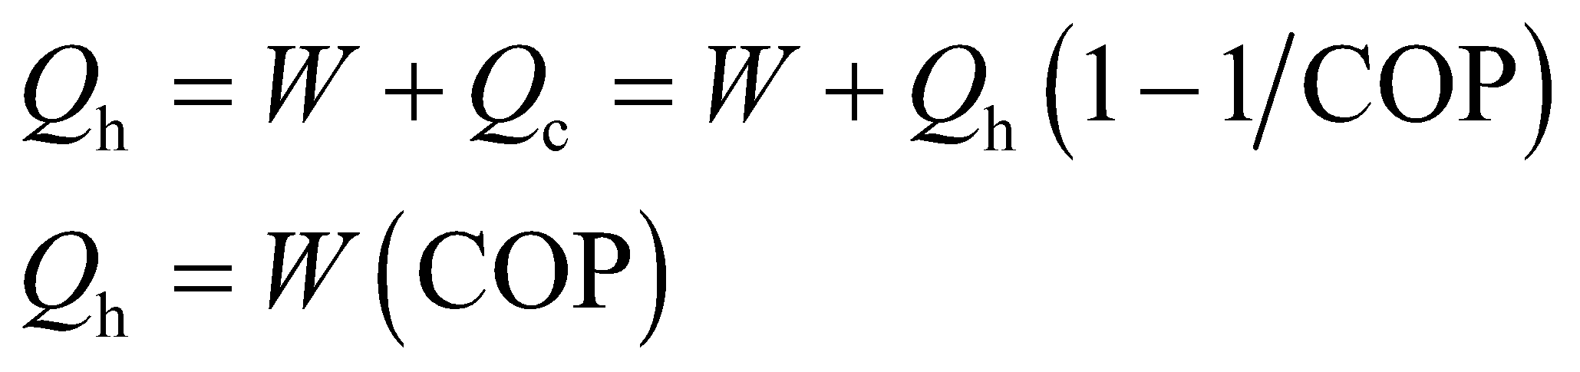

Thus, the heat pump can produce a factor COP more heat than if the electrical energy is converted directly to heat.

**Evaluate** Because the heat pump is a factor COP more efficient, the cost will be reduced by this same factor, so the monthly heating bill would be

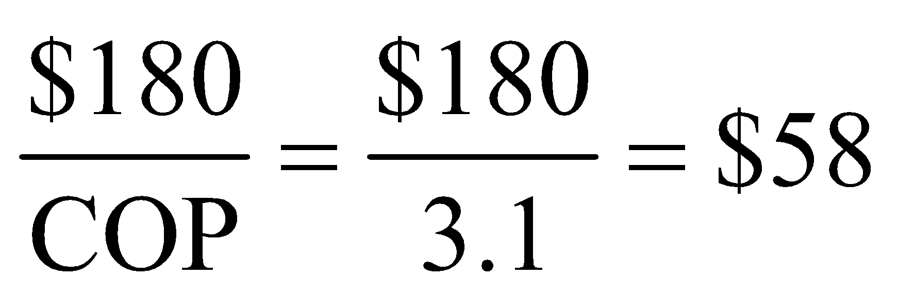

**Assess** The savings are significant, which is why electrical heating is not recommended.

**36.** **Interpret** This problem requires us to find the power needed to run a refrigerator that leaks heat at the given rate to its cold reservoir (i.e., the environment). The refrigerator operates as a reversible heat engine, so we know its COP.

**Develop** The rate at which heat leaks from the refrigerator is 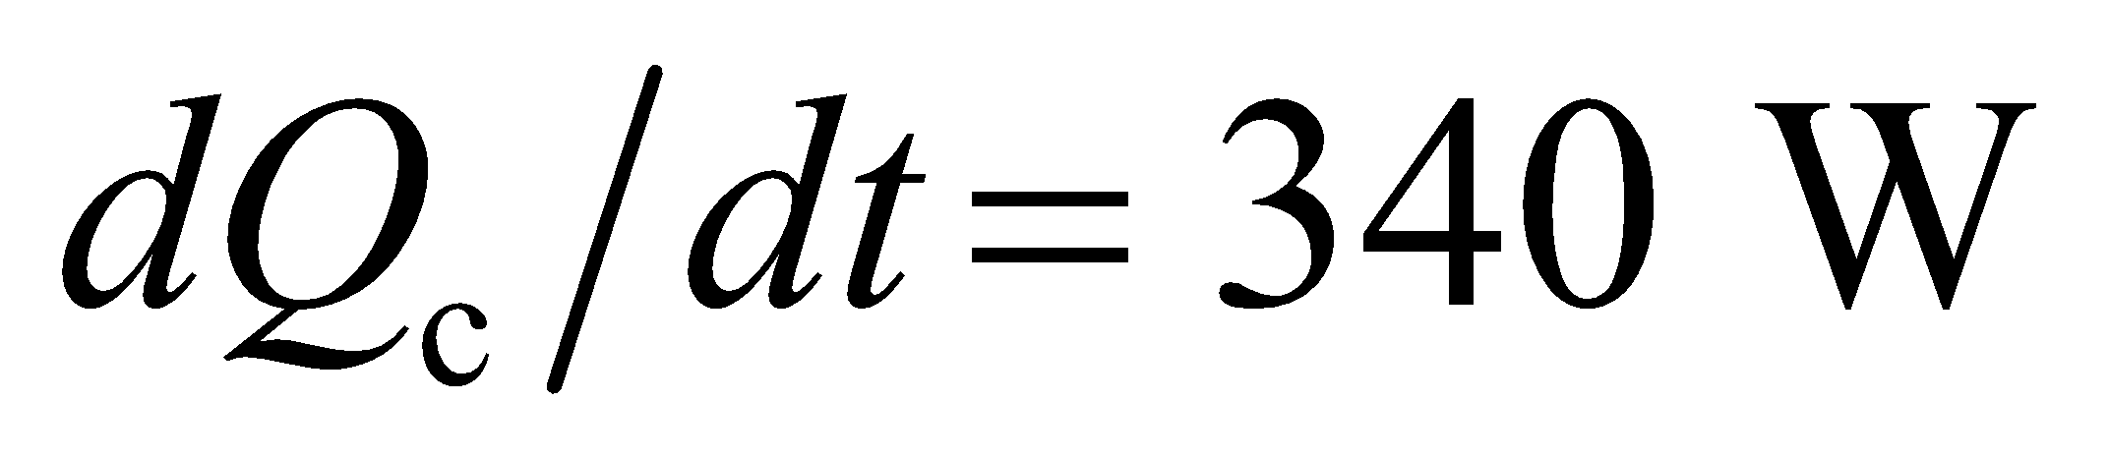. For a reversible refrigerator, the COP is given by Equation 19.4:

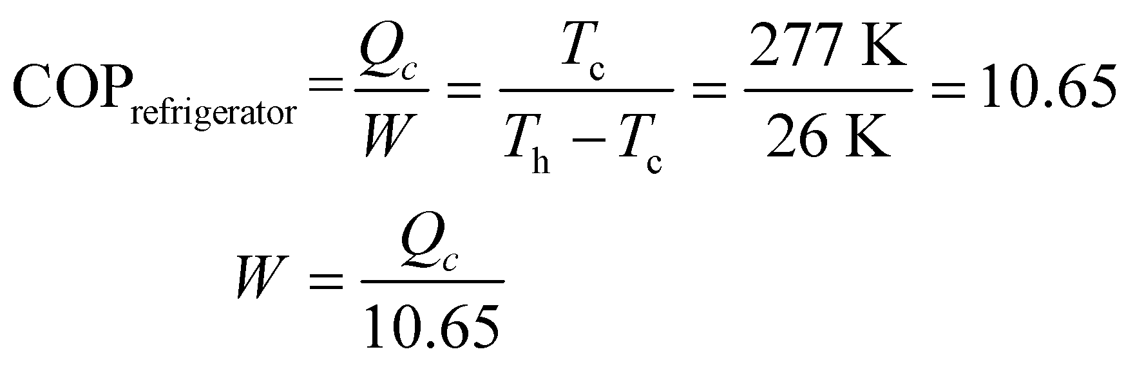

Differentiating this expression with respect to time gives the power needed to run the refrigerator.

**Evaluate** The power needed to run the refrigerator is

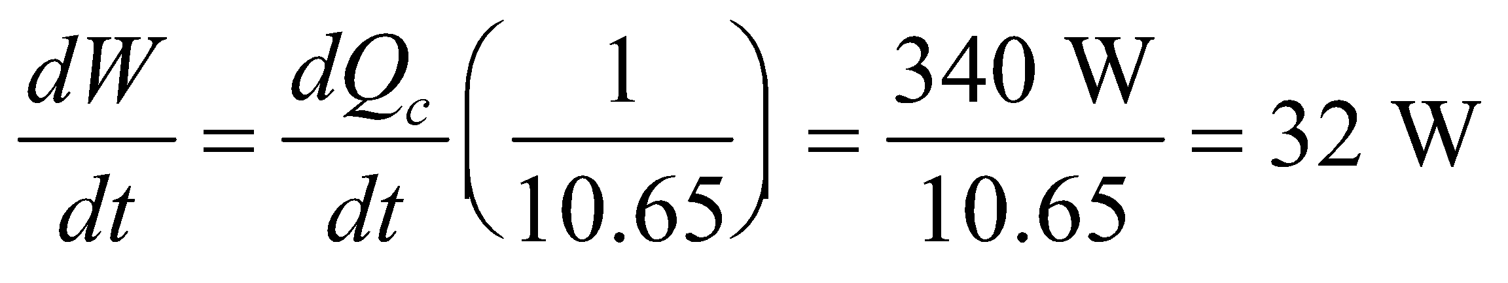

**Assess** The cooling capacity of the refrigerator is not given, so 340 W is the minimum heat leakage, which means that this power is the minimum power required to run the refrigerator.

**37. Interpret** We are to find the minimum COP required to save money if we switch from an oil furnace to an electrically powered heat pump, considering the cost of oil and of electricity. We will do this by calculating the cost of the heat delivered by both the oil-burning heater and the electric heat pump.

**Develop** The coefficient of performance (COP) is the relationship between the heat sent to the cold reservoir and the work done. Set the heat *Q*c to be the same for both heating mechanisms, and solve for COP. The cost of oil is 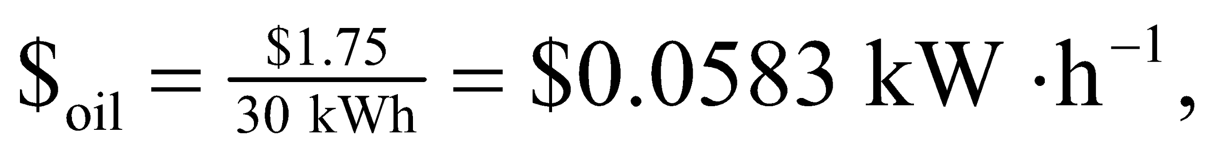 and the cost of electricity is 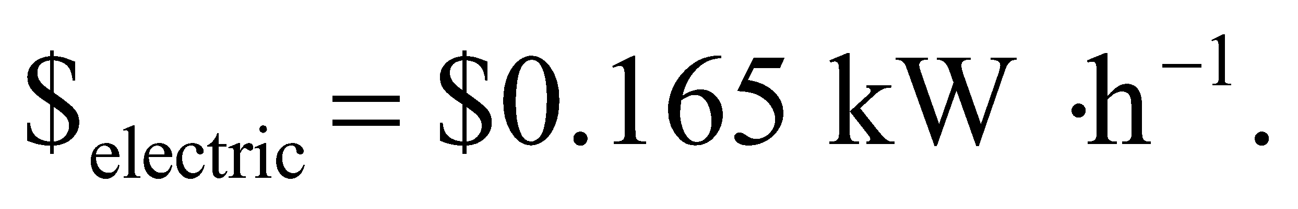 The heat delivered is

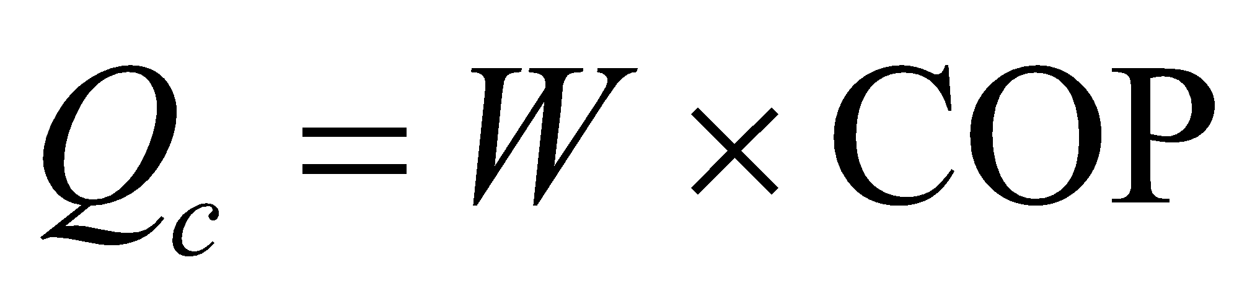

(see derivation of Equation 19.4), and we are paying for the work done, so the COP must exceed the ratio of the costs (COP > $electric/$oil).

**Evaluate**The COP must satisfy

COP > $electric/$oil = 2.83

So in order to be cost-effective, the heat pump must have a COP of greater than 2.83.

**Assess** Most heat pumps have a COP much higher than this value, so it’s probably a good idea to switch.

**38.** **Interpret** For this problem, we are to show that the Clausius statement (i.e., the second law of thermodynamics) would be violated by the existence of a perfect heat engine, which would allow the construction of a perfect refrigerator.

**Develop** If it were possible to construct a perfect heat engine (one which would extract heat and perform an equivalent amount of work), then it could be coupled to a real refrigerator in such a way that the work output of the engine equals the work input to the refrigerator, as shown in the figure below.



**Evaluate** The net effect of this arrangement is to produce a perfect refrigerator (a cyclic device whose sole effect is the transfer of heat, 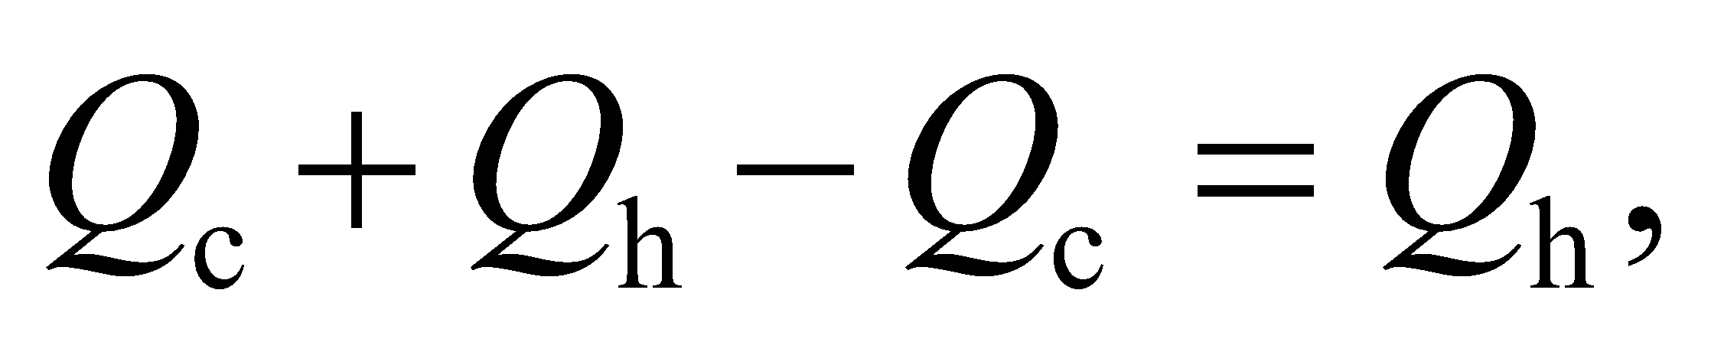 from a cold reservoir to a hot one), in violation of the Clausius statement of the second law.

**Assess** This completes the proof of the equivalence of the Kelvin-Planck and Clausius statements in Section 19.2.

**39. Interpret** We are asked to find the COP, power usage, and operating cost compared to that of an oil-burning heater of a heat pump. We will assume that the heat pump is a Carnot heat pump.

**Develop** The maximum COP of a heat pump (when its heating, not cooling) is given in Equation 19.4b: 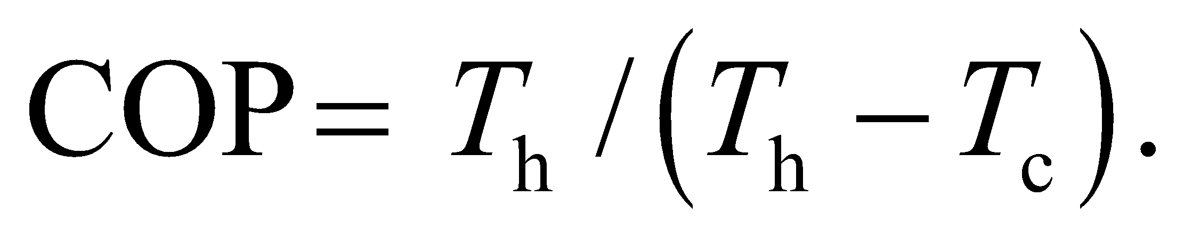 In this case, 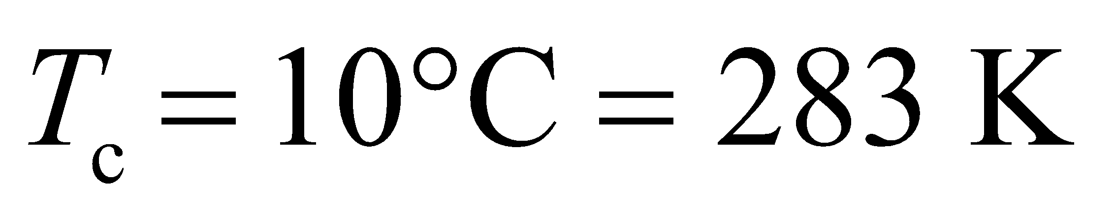 and 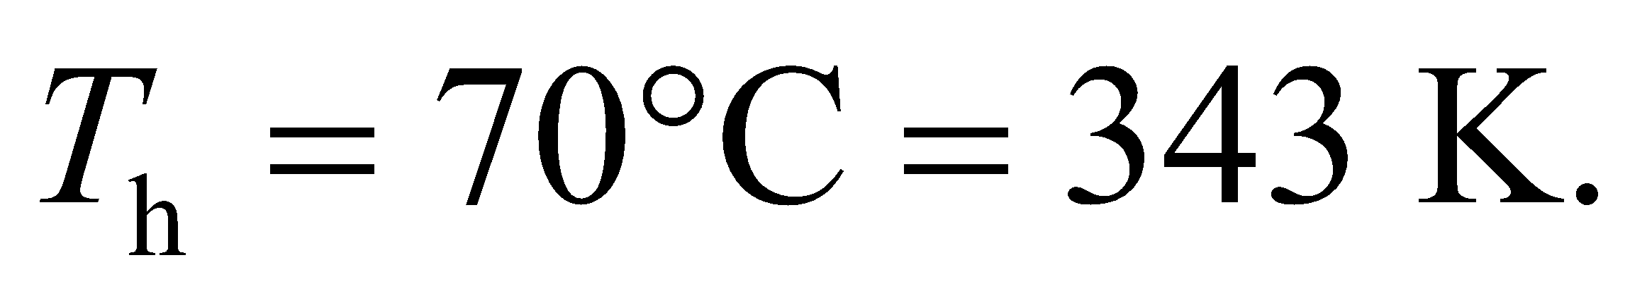 In general, the COP for a heat pump is the heat supplied divided by the work input. In terms of rates, that can be written as 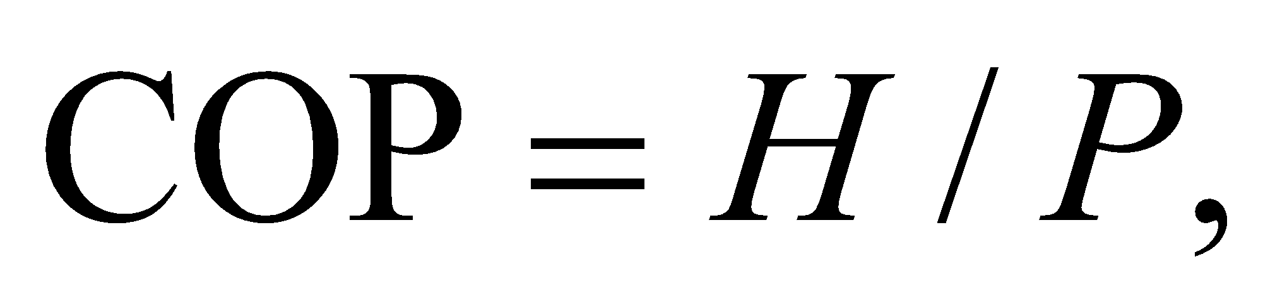where *H* is the supplied heat rate and *P* is the electric power consumption.

**Evaluate**  (a) Assuming the heat pump is maximally efficient,

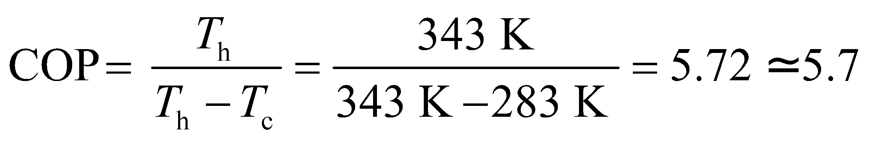

(b) The power consumption needed to supply heat at 20 kW is

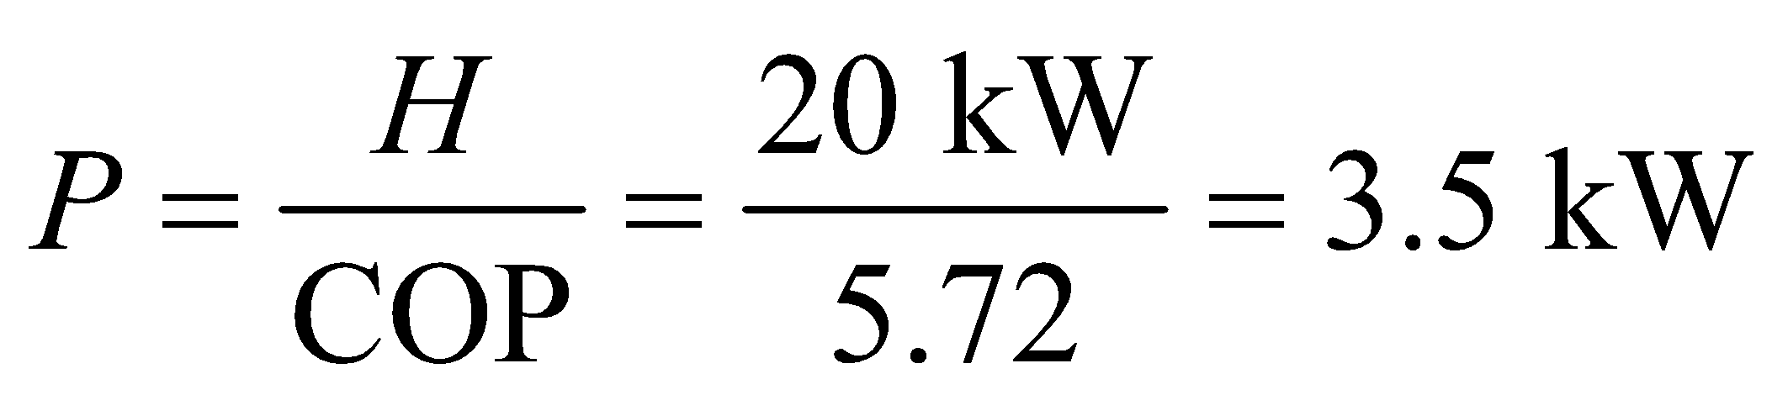

(c) Given the utility rate for electric power, the heat pump's hourly operating cost is



In comparison, an oil furnace, supplying the same heat, would have an hourly operating cost of

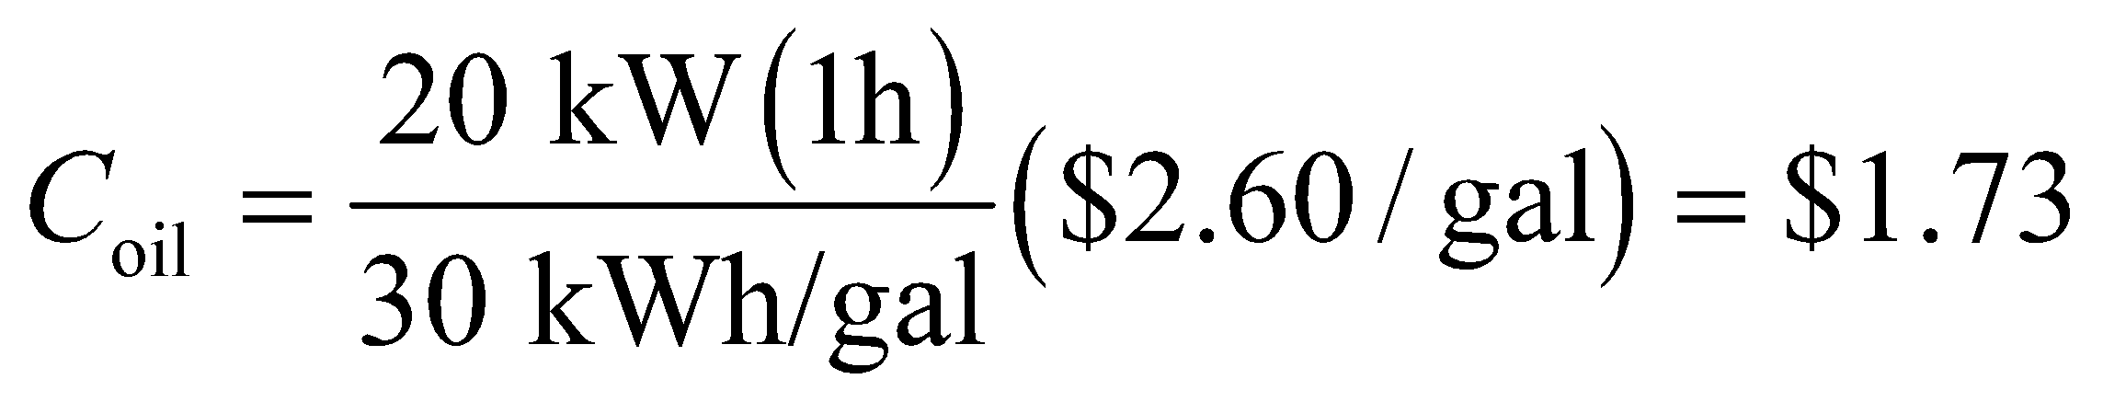

**Assess** The cost per kWh of oil is actually less than that of electricity: 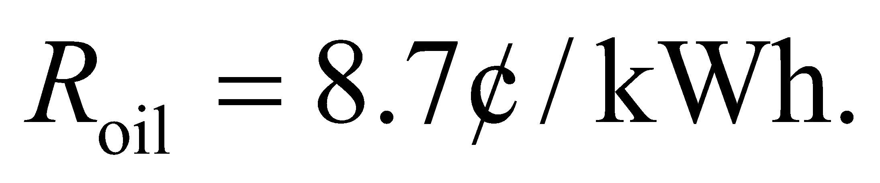But the heat pump has such a high COP that it cost three times less to heat the house.

**40.** **Interpret** This problem involves a reversible engine that contains a given volume of monatomic gas. The system goes through the four thermodynamics processes indicated in the problem statement, and we are to find net work done by the system and the net heat added to the system over a complete cycle, and the engine’s efficiency as defined by the ratio of the work done by the engine to the heat absorbed over a complete cycle.

**Develop** The *pV* diagram for the cycle is as shown below. Let us calculate the work and heat absorbed for each stage of the cycle. For the isothermal expansion *AB* the change in internal energy of the system is zero (*ΔU* = 0), so the first law of thermodynamics gives



where *Q*AB is the heat absorbed and *W*AB is the work done by the system (note that this definition of W is contrary to the definition used in Chapter 18). The second equality above is from Equation 18.4. For the isovolumic cooling *BC*, the volume does not change so no work is done. The heat absorbed is given by Equation 18.5 and 18.13, which give

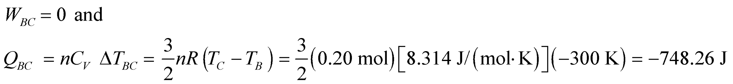

For the isothermal compression *CD*,



and for the isovolumic heating *DA*,

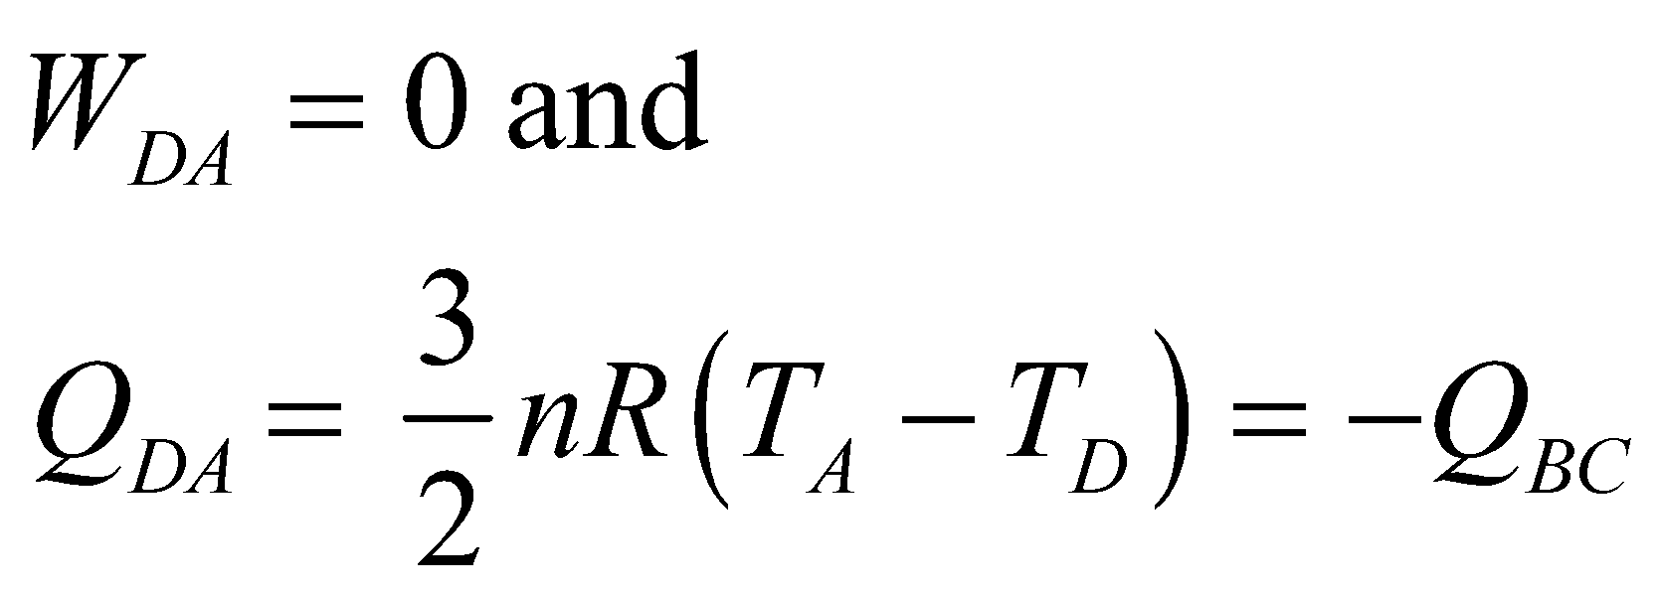

For these processes, we are given that  and 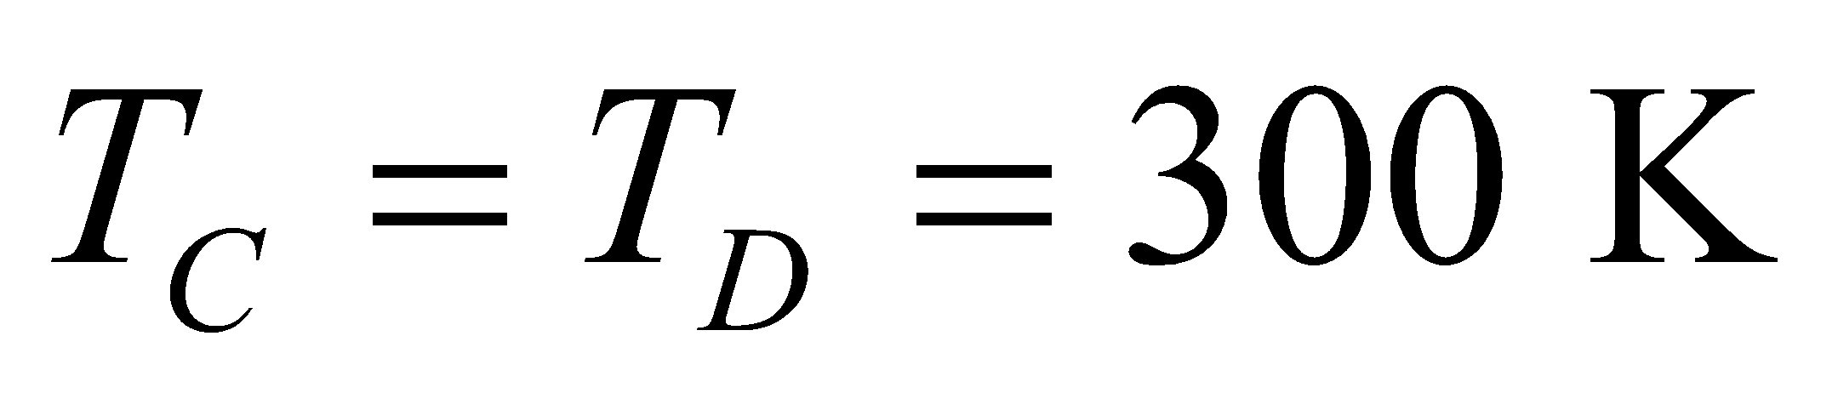, so we can sum up the contributions to work and heat to find the total for each for a complete cycle.



**Evaluate** (a) The net heat added to the system is

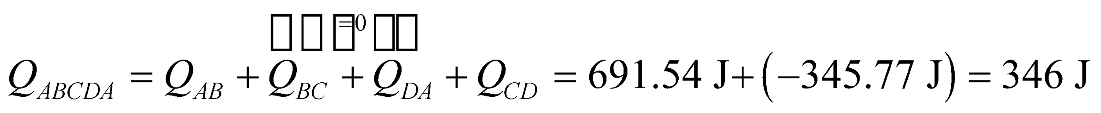

The net work done by the system is

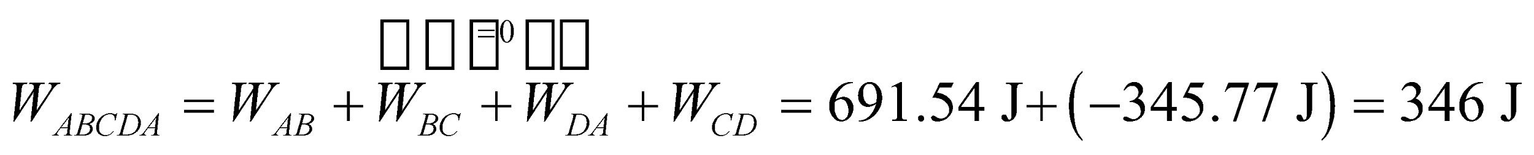

(b) The ratio of the work done to the heat absorbed is

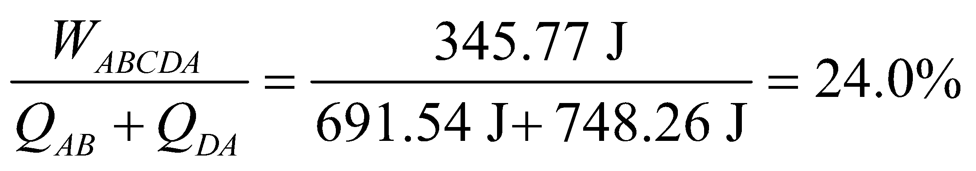

**Assess** A Carnot engine operating between  and  has efficiency 1 − 300/600 = 50%. This is not a contradiction of Carnot’s theorem, because the engine in this problem does *not* absorb and exhaust heat at constant temperatures.

**41. Interpret**Our engine cycle consists of four paths, two of which are isochoric and two of which are isobaric. We are to determine the efficiency, defined as the work done per unit heat absorbed, and compare the result with the efficiency of a Carnot engine operating between the same temperatures. Finally, we need to explain any difference between the two efficiencies.

**Develop** Label the states in Fig. 19.22 *A*, *B*, *C*, and *D* going clockwise from the upper left corner. The work done and the heat absorbed during the isobaric segments *AB* and *CD* are

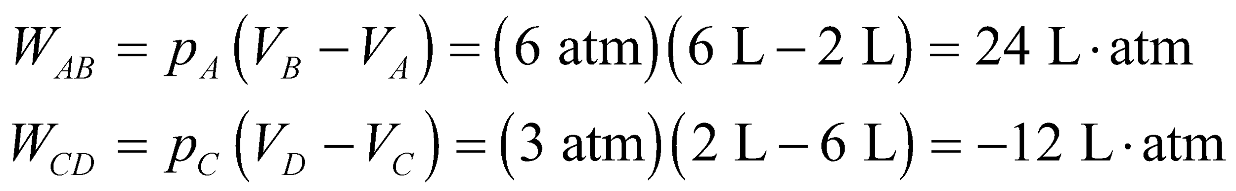

and

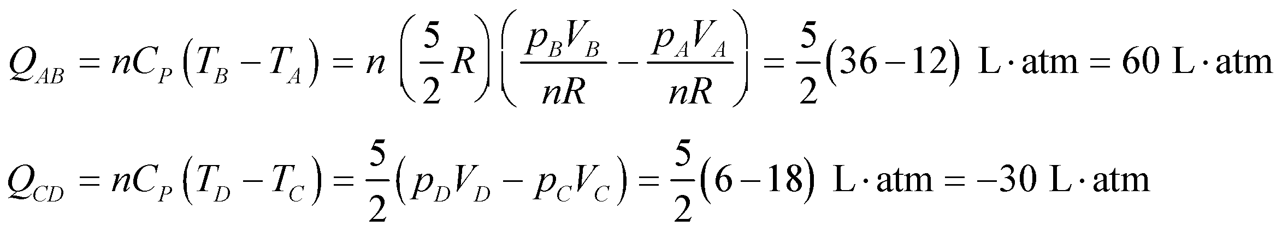

where we have assumed an ideal monatomic gas (see Equation 18.13).

For the isochoric segments, we have

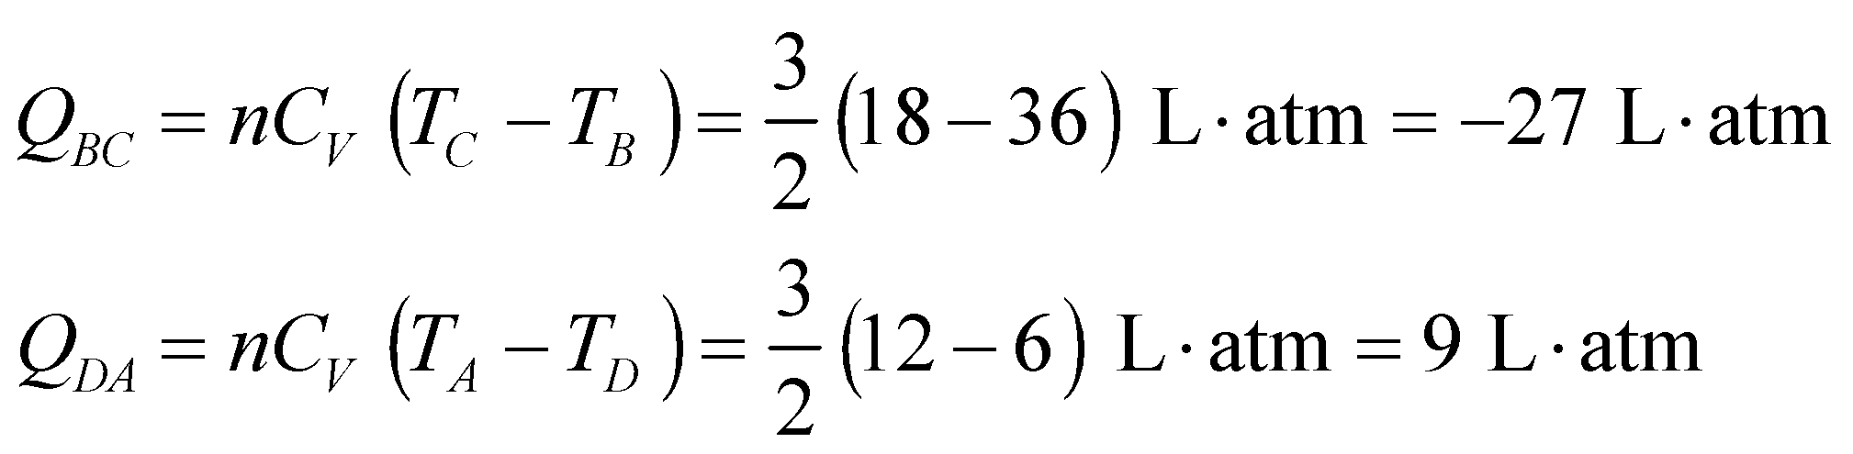

and 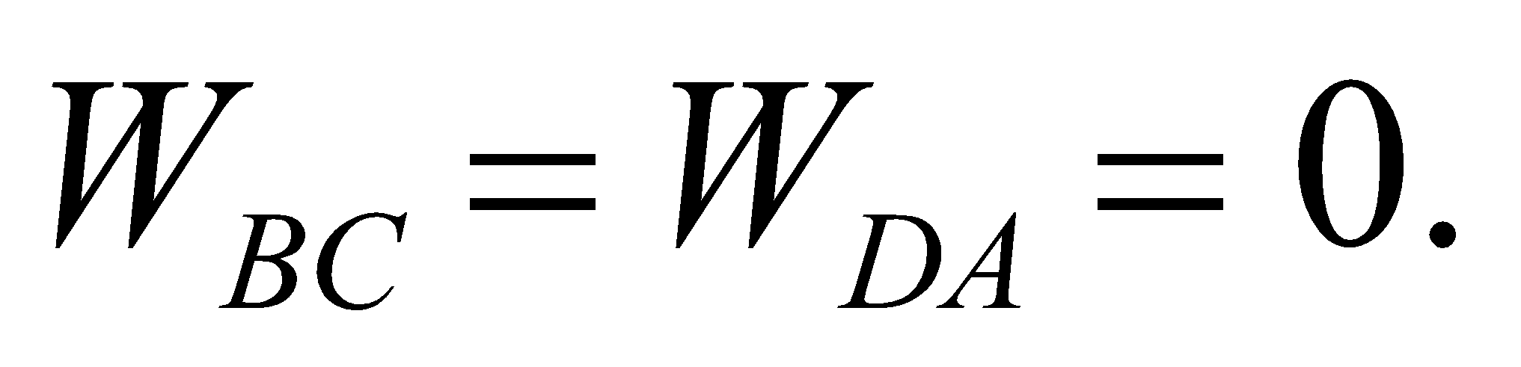 The net heat added for one cycle is therefore



and the net work done is . Note that the first law of thermodynamics, applied to a cyclic process, requires that *W* = *Q* when using the definition that *W* is the work done by the system (which is opposite to the definition used in Chapter 18).

**Evaluate** **(a)** Since the heat absorbed is 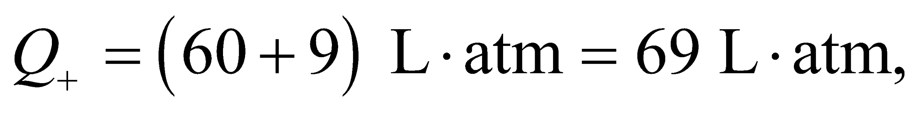 the efficiency is

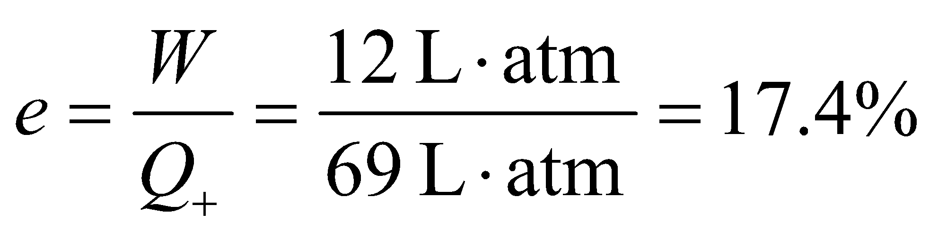

**(b)** The maximum and minimum temperatures are 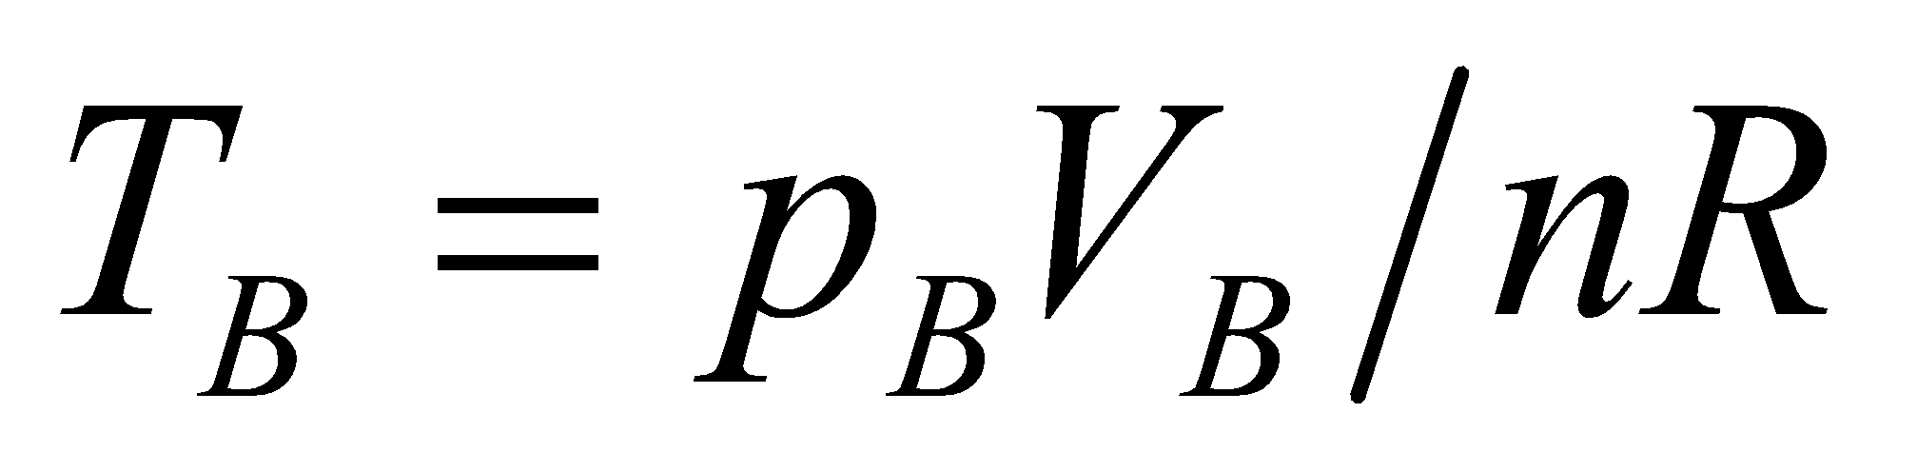 and 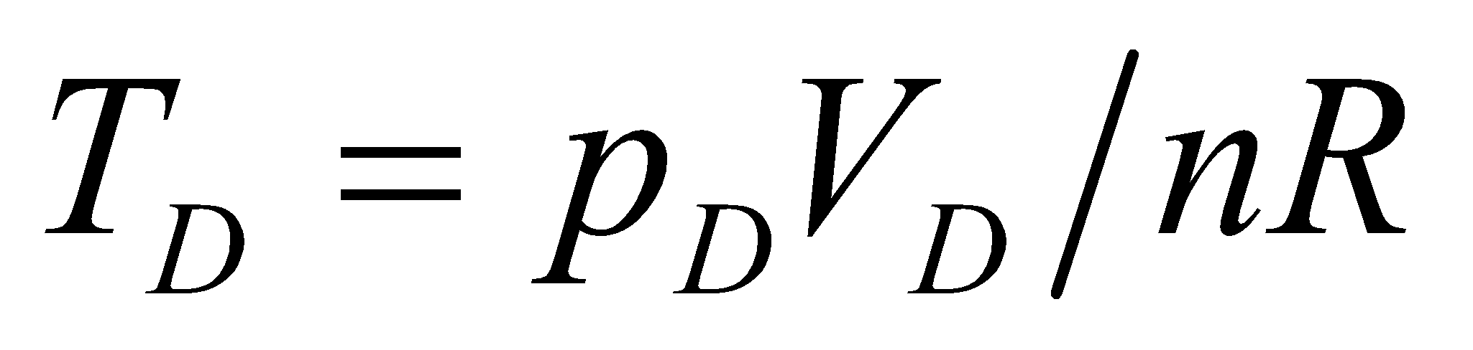 so the efficiency of a Carnot engine operating between these temperatures is

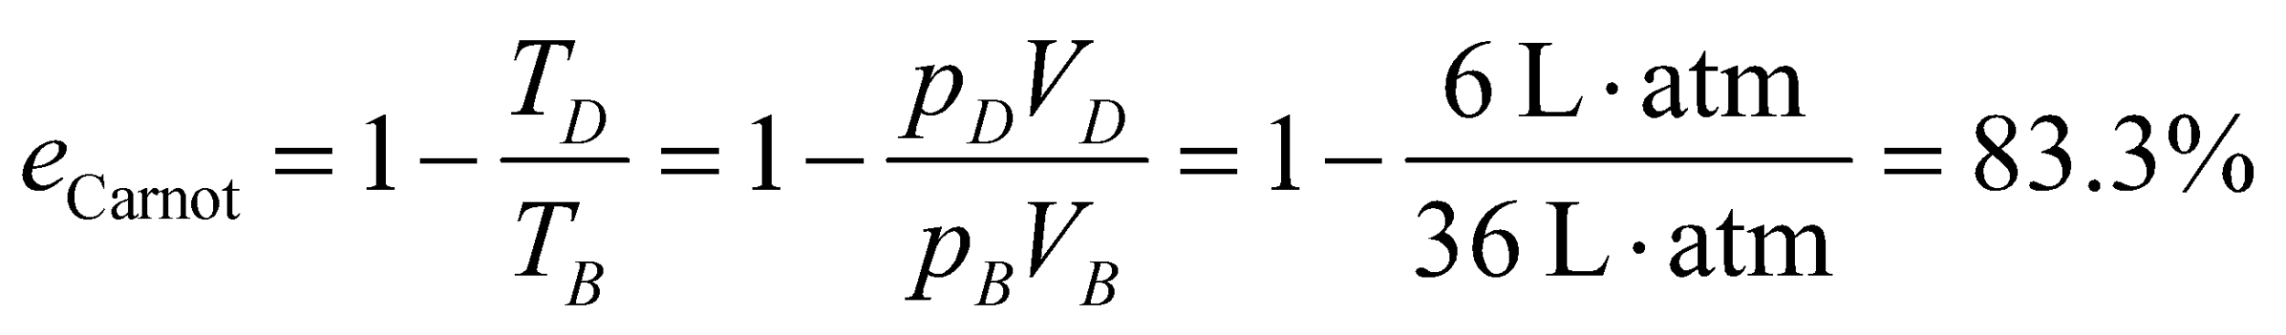

This is not a contradiction of Carnot’s theorem, because the given engine does not operate between two heat reservoirs at fixed temperatures.

**Assess** The efficiency of a real engine is always less or equal to that of a Carnot engine.

**42.** **Interpret** For the given Carnot cycle, we are to find the heat absorbed, the heat rejected, and the work done per cycle. We are then to find the efficiency of the engine and the maximum and minimum temperatures, and show that the efficiency as given in Equation 19.1 equates to the Carnot efficiency of Equation 19.3.

**Develop** See Figure 19.5 and the accompanying discussion of the Carnot engine. The heat absorbed is in the isothermal expansion is

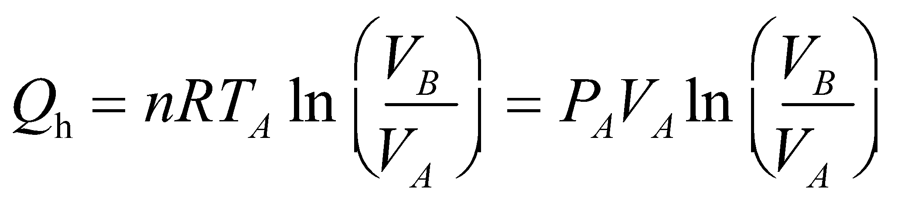

where we have used the ideal-gas law (Equation 17.2) *pV* = *nRT* for the last equality, state *A* = (8.000 atm, 1.000 L), and state *B* = (4.000 atm, 2.000 L). The heat rejected during isothermal compression is

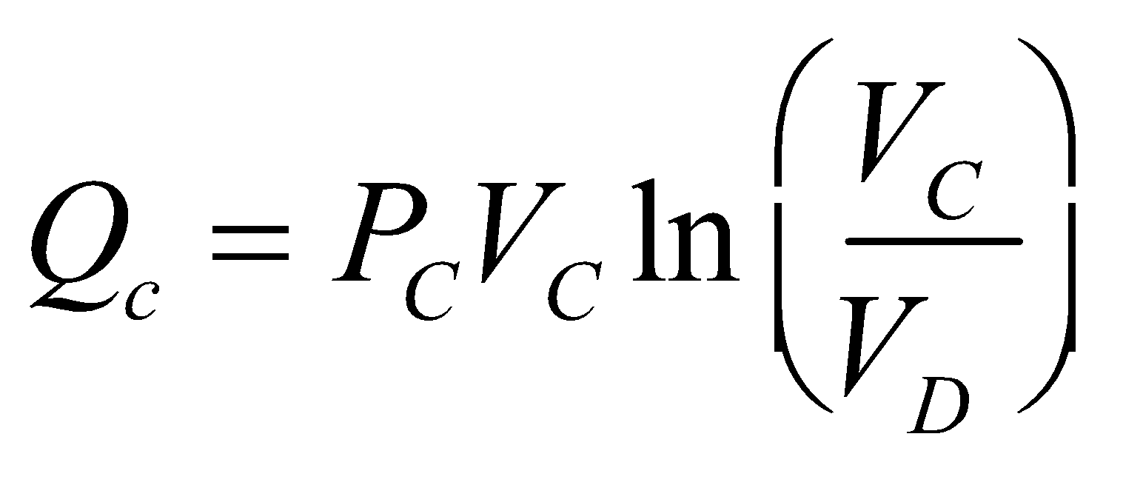

where state *C* = (2.050 atm, 3.224 L) and state *D* = (4.100 atm, 1.612 L). Because the internal energy of the engine does not change, *ΔU* = 0, so the first law of thermodynamics states that



where *W* is the work done by the system. From these results, we can calculate the efficiency using Equation 19.1, *e* = *W*/*Q*h. The maximum and minimum temperatures may be found from the ideal-gas law (Equation 17.2),

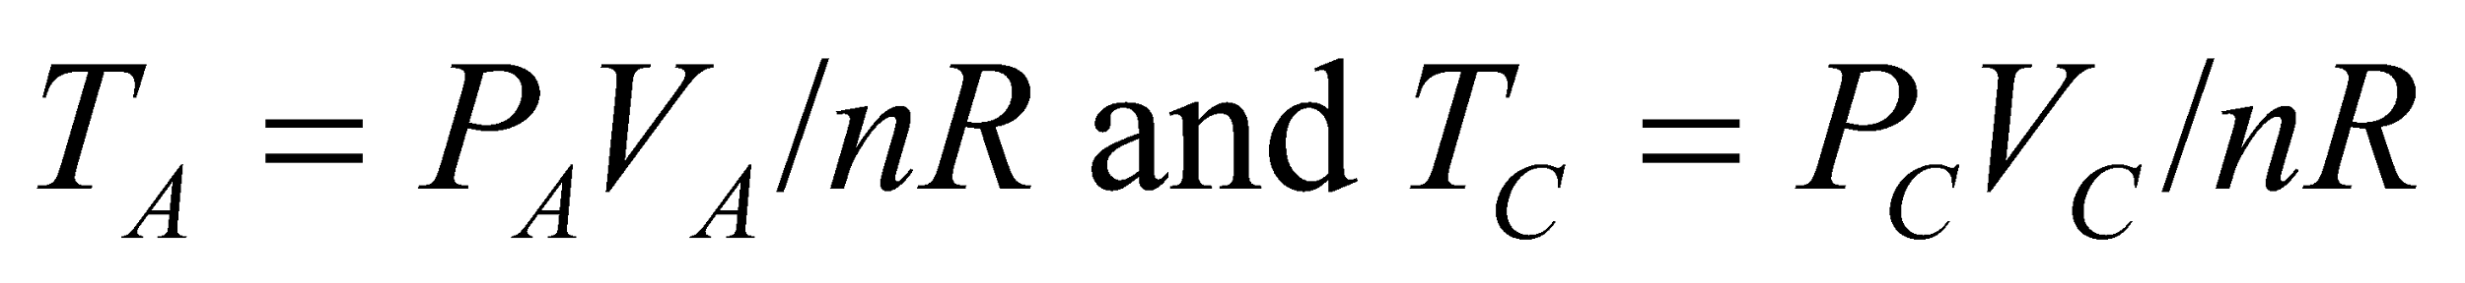

**Evaluate** (a) The heat absorbed is



(b) The heat rejected is



(c) The work done by the engine is



(d) The efficiency is

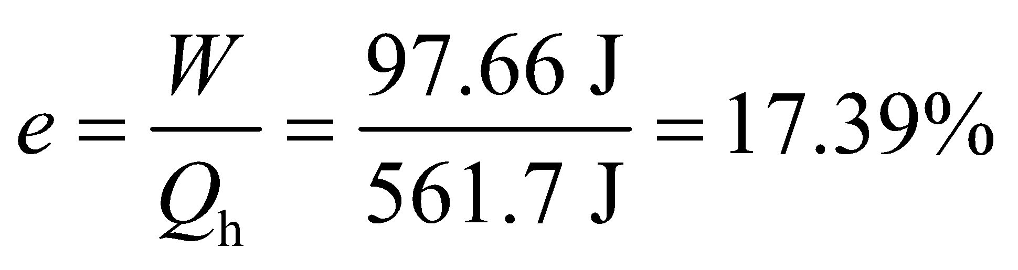

(e) The maximum and minimum temperatures are

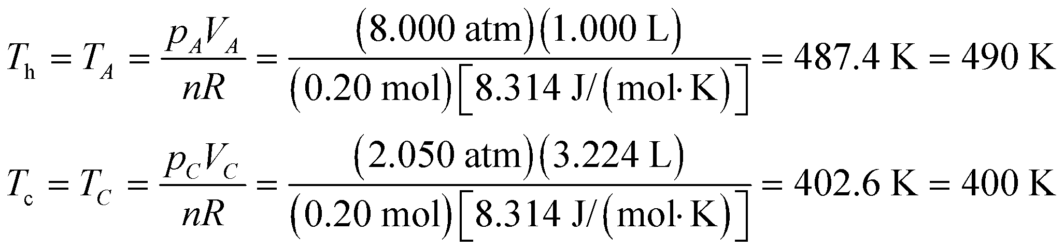

to two significant figures. The Carnot efficiency is thus

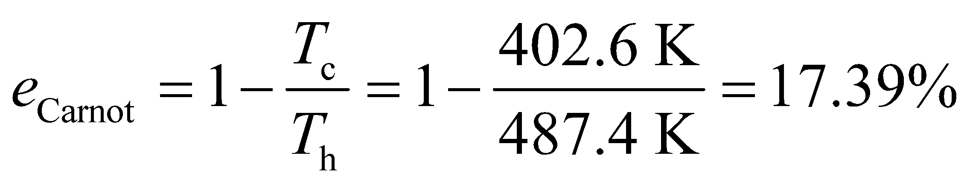

which is the same result as for part (d).

**Assess** For a Carnot engine, the actual efficiency is the Carnot efficiency.

These imply a Carnot efficiency of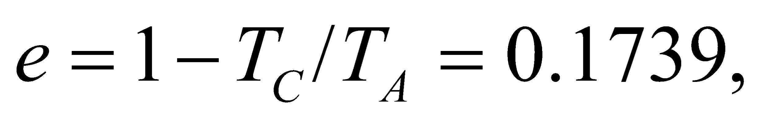exactly as before. Equation 19.1 and Equation 19.3 are identical because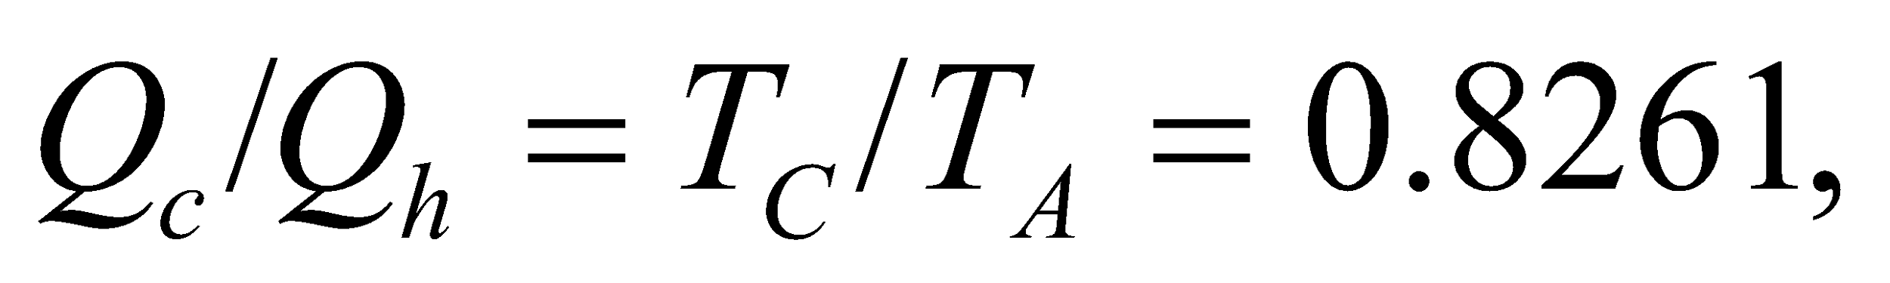explicitly.

**43. Interpret** This problem is about the increase in entropy as the ice is melted and heated up.

**Develop** The entropy increase is given by Equation 19.6: .We consider the entropy increase in two steps. First, the heat needed to melt the lake ice is 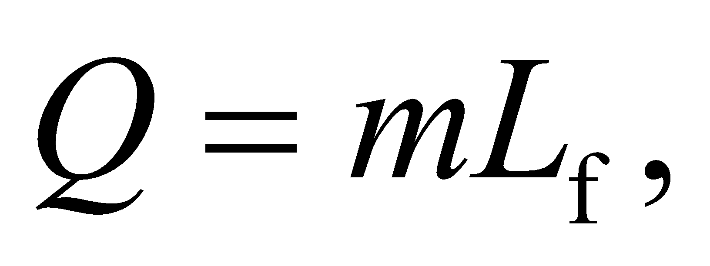where 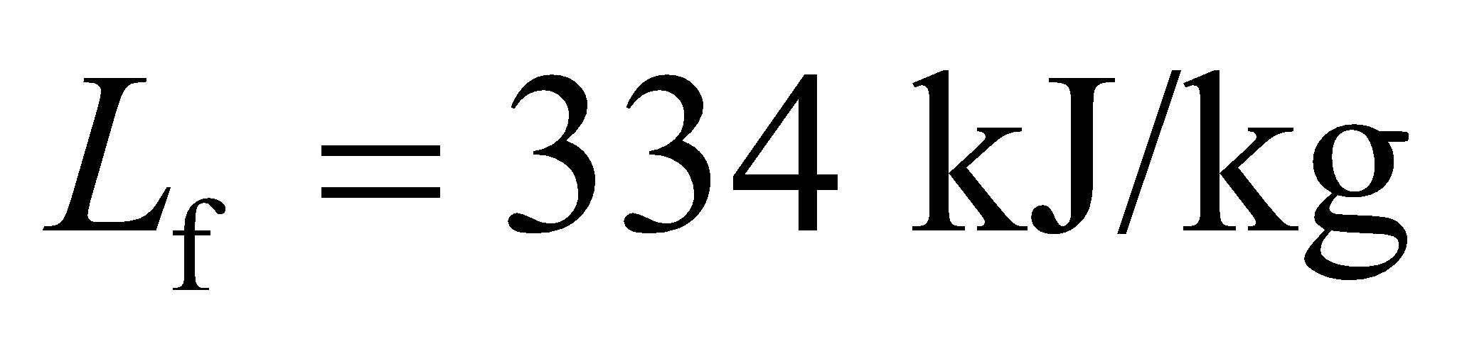from Table 17.1. The temperature is constant during the melting, 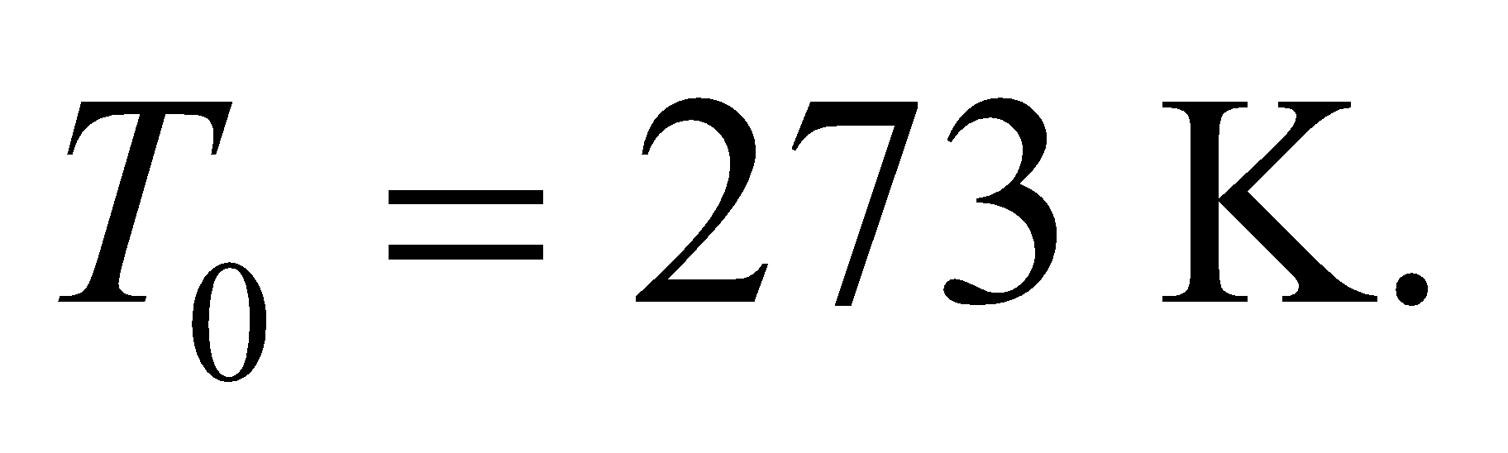 In the second step, the heat input raises the water temperature according to 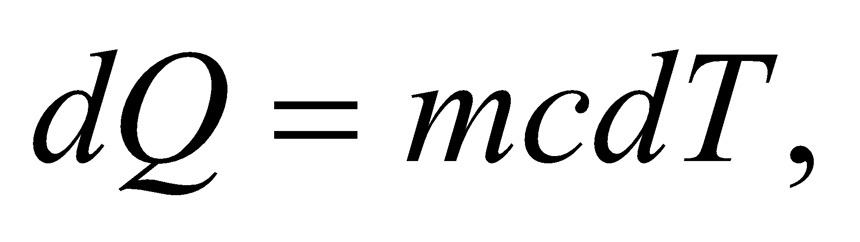where 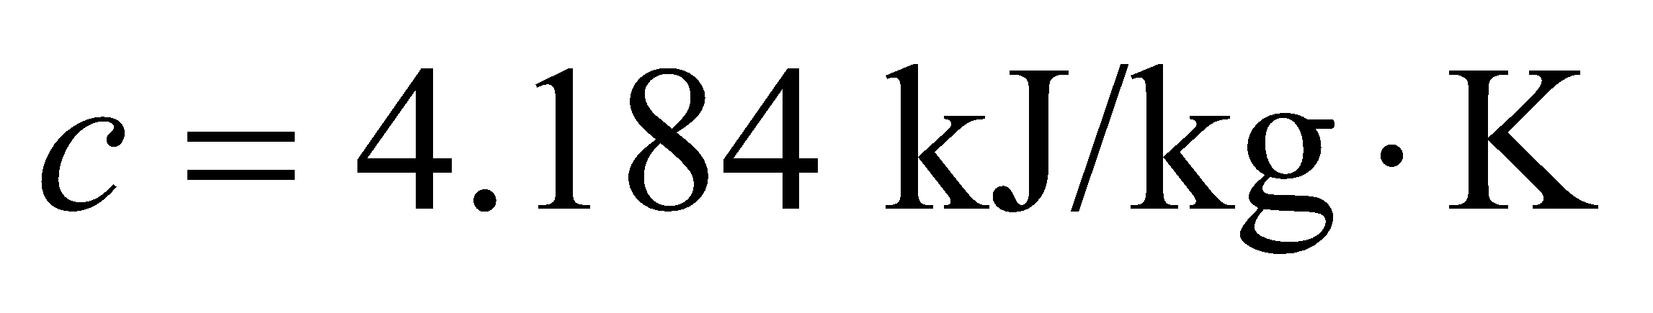from Table 16.1. Here, the temperature is not constant, so we will have to integrate.

**Evaluate** The entropy increase during melting is

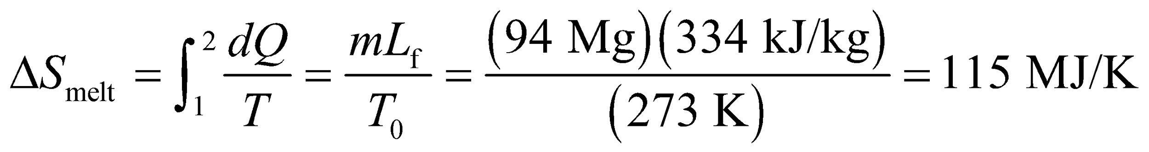

The entropy increase during warming is



So the total entropy increase is



**Assess** As expected, the entropy change is positive in both melting and warming processes.

**44. Interpret** You want to know the rate at which your body's entropy increases during normal metabolism.

**Develop** The normal calorie intake is about 2000 kcal/day for women and about 2500 kcal/day for men. We'll split the difference and assume a metabolic rate of 2250 kcal/day. Temperature of metabolism rate (or basal metabolic rate) for males is about 1300 kcal/day and for females is about 1200 kcal/day. *Q* flows into the body as heat. Therefore, the entropy change from state 1 (burger ingested) and state 2 (burger metabolized) is given by Equation 19.6: .

**Evaluate** The body consumes food energy and converts it to work and heat at a constant body temperature of  so the rate of entropy increase is

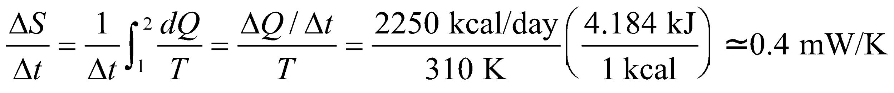

**Assess** One could say this is the rate at which we create disorder.

**45.** **Interpret** We are to derive the formula given in the problem statement that describes the entropy change for *n* moles of an ideal gas that undergoes an isovolumic temperature change from *T*1 to *T*2.

**Develop** From the first law of thermodynamics 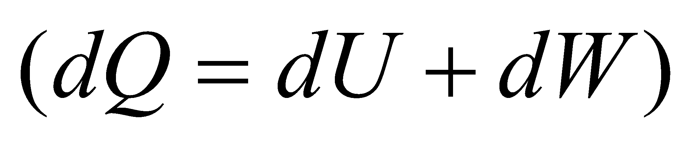 and the properties of an ideal gas 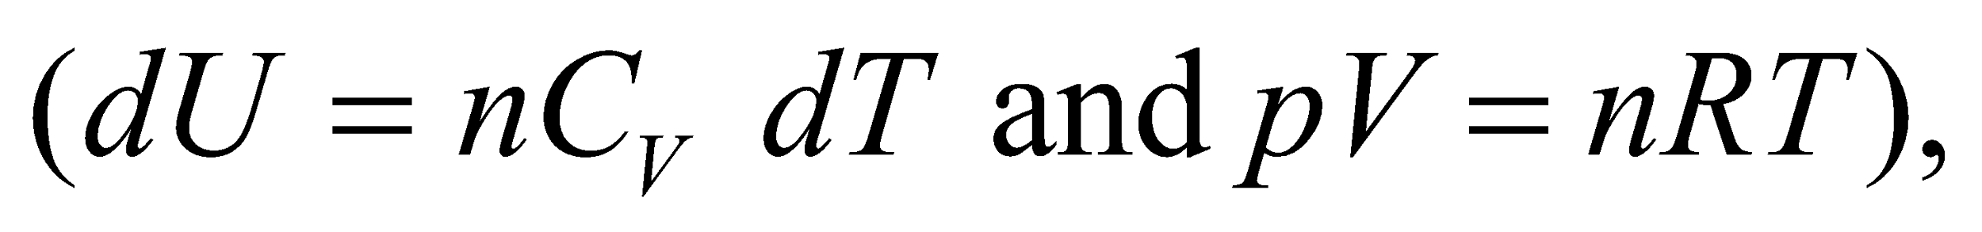 an infinitesimal entropy change is

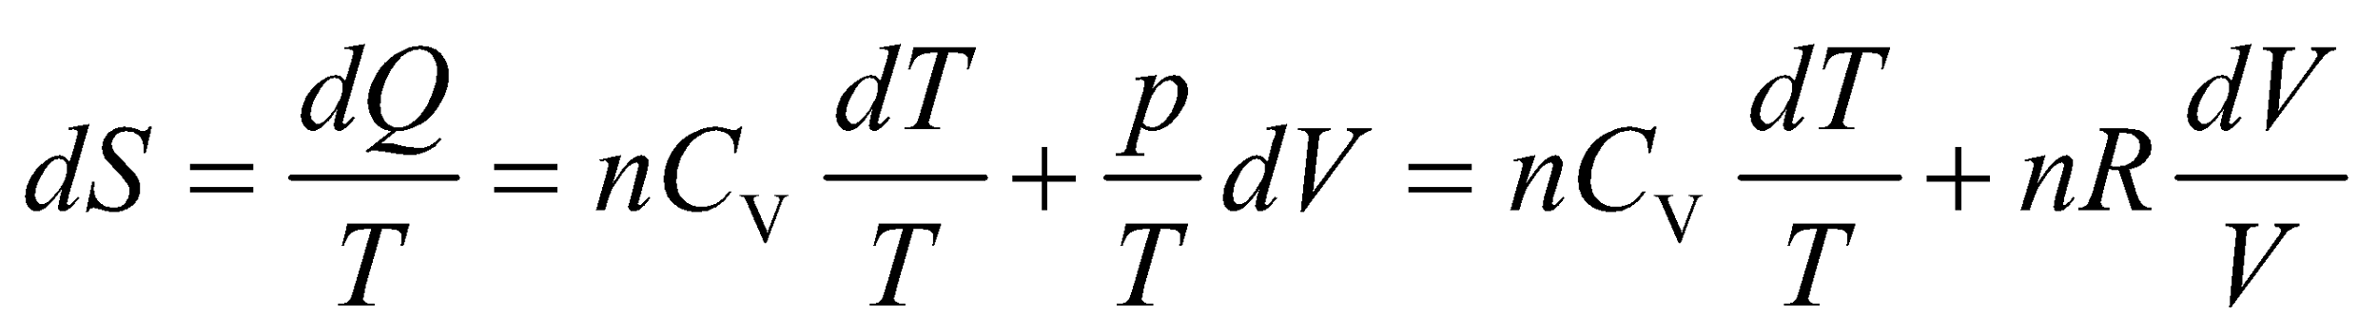

Integrate from state 1 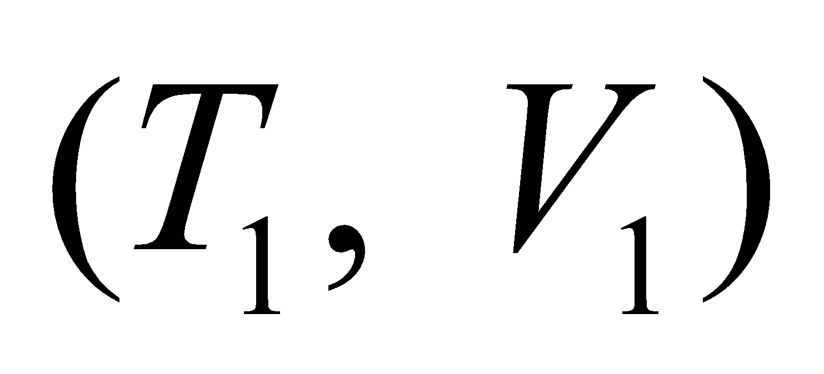 to state 2 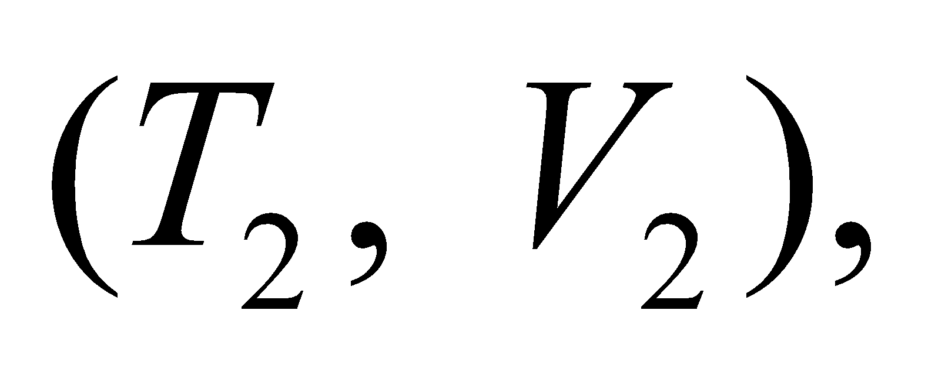 and apply the isovolumic constraint to obtain the given formula.

**Evaluate** Integrating the expression above gives

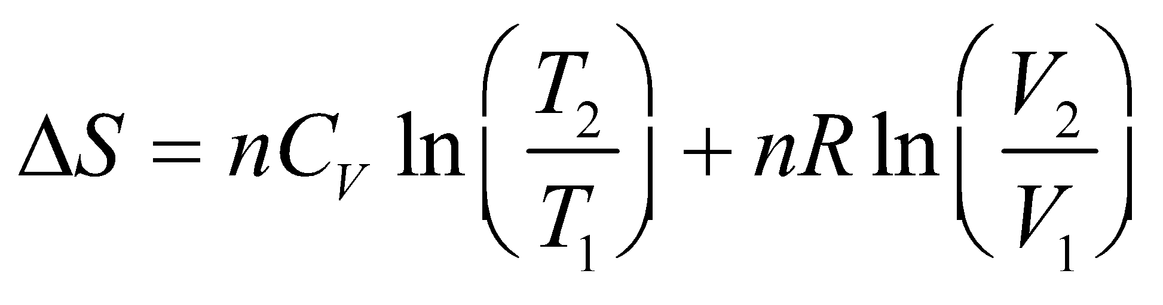

For an isovolumic process *V*1 = *V*2 so 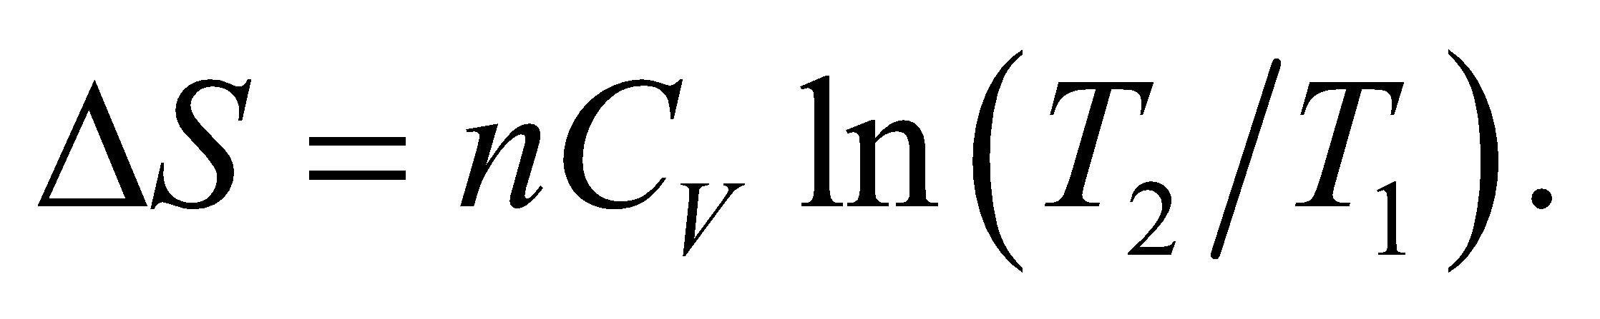

**Assess** Of course, we could have started with 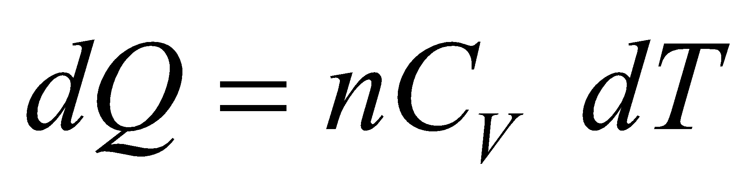at constant volume, but we wanted to displayfor a general ideal-gas process, for use in other problems.

**46. Interpret**  We are to derive the formula given in the problem statement that describes the entropy change for *n* moles of an ideal gas that undergoes an isobaric temperature change from *T*1 to *T*2.

**Develop** From the first law of thermodynamics  and the properties of an ideal gas 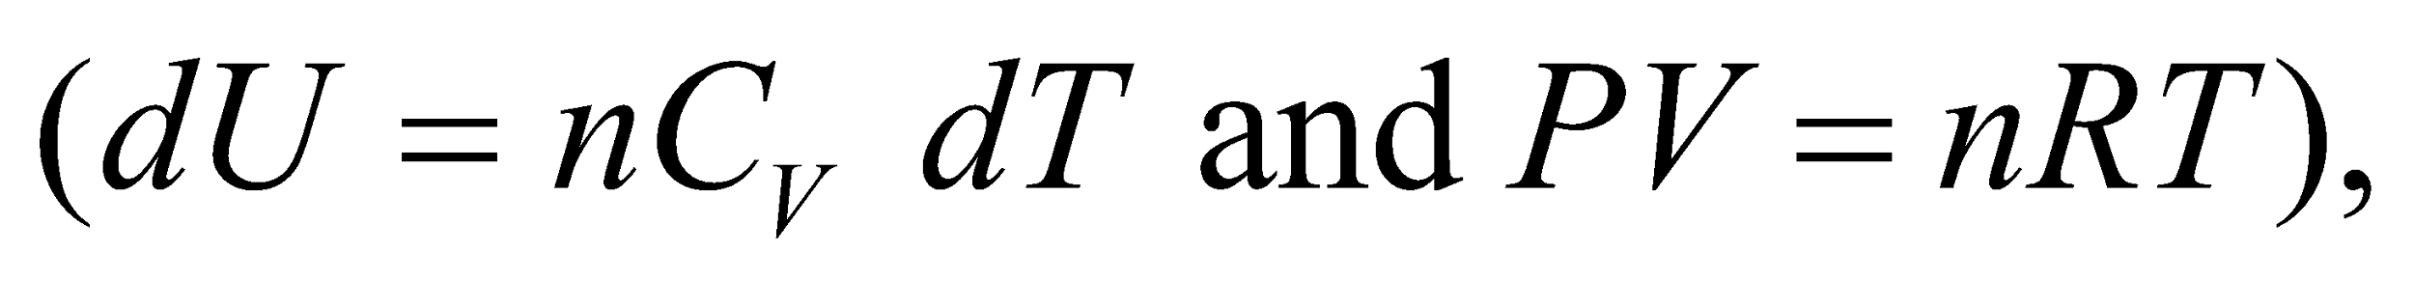 an infinitesimal entropy change is



Integrate from state 1  to state 2  and use Equation 18.9, *CP* = *CV* + *R*, to obtain the given formula. Note that when the pressure is constant, the ideal-gas law gives 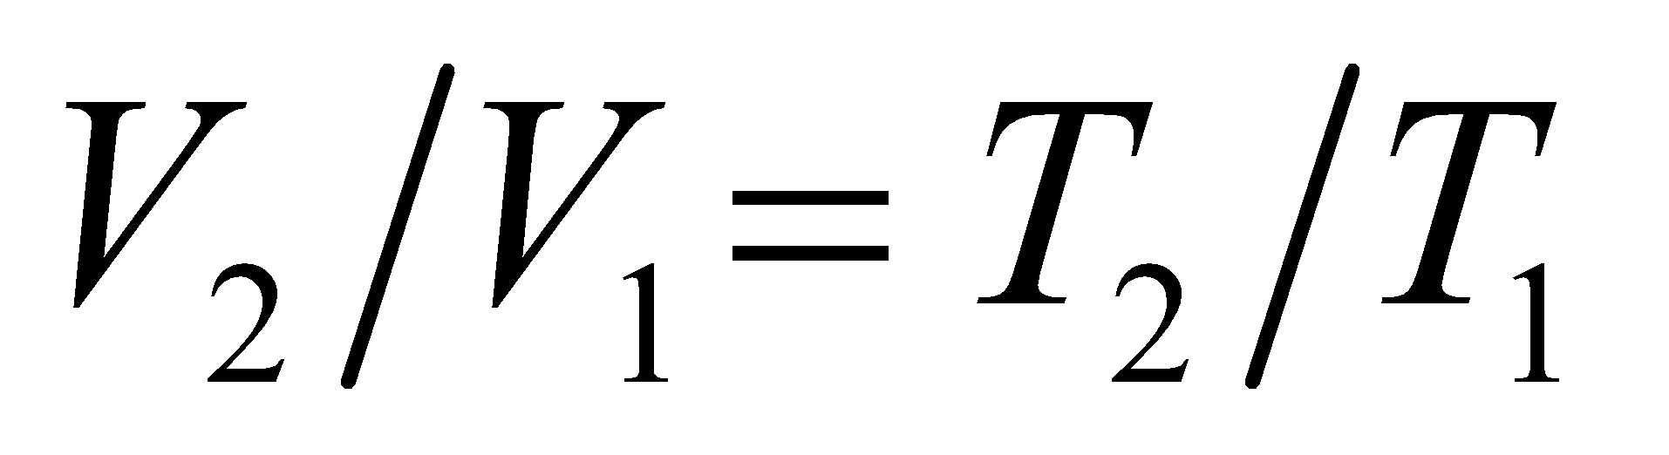.

**Evaluate** Substituting the second equation into the first one yields

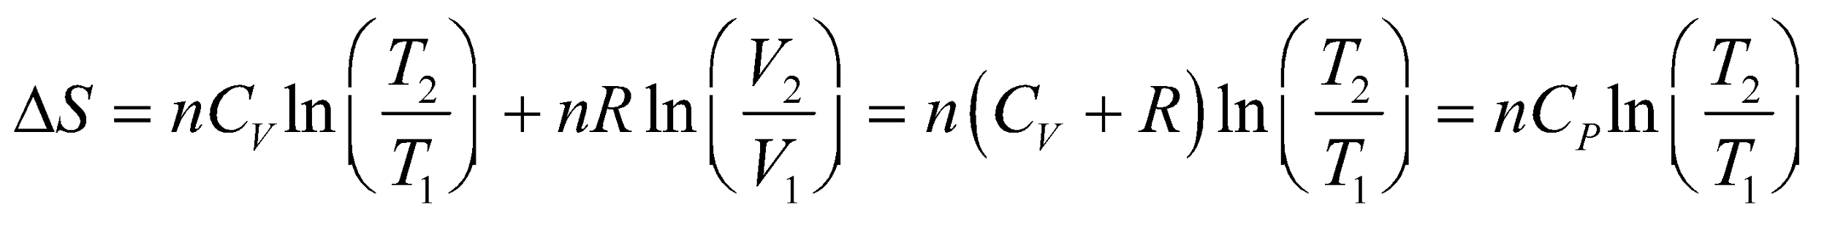

**Assess** The same expression can also be obtained by using 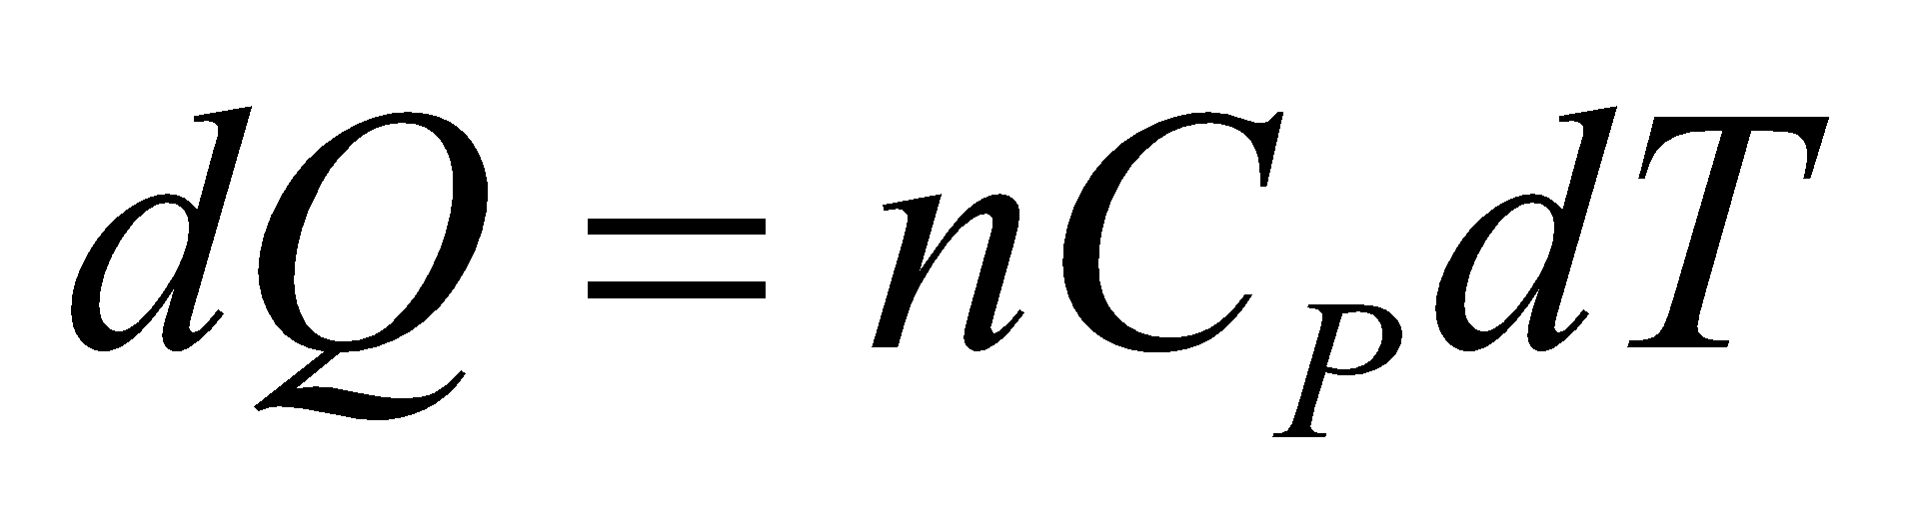 at constant pressure. Note that 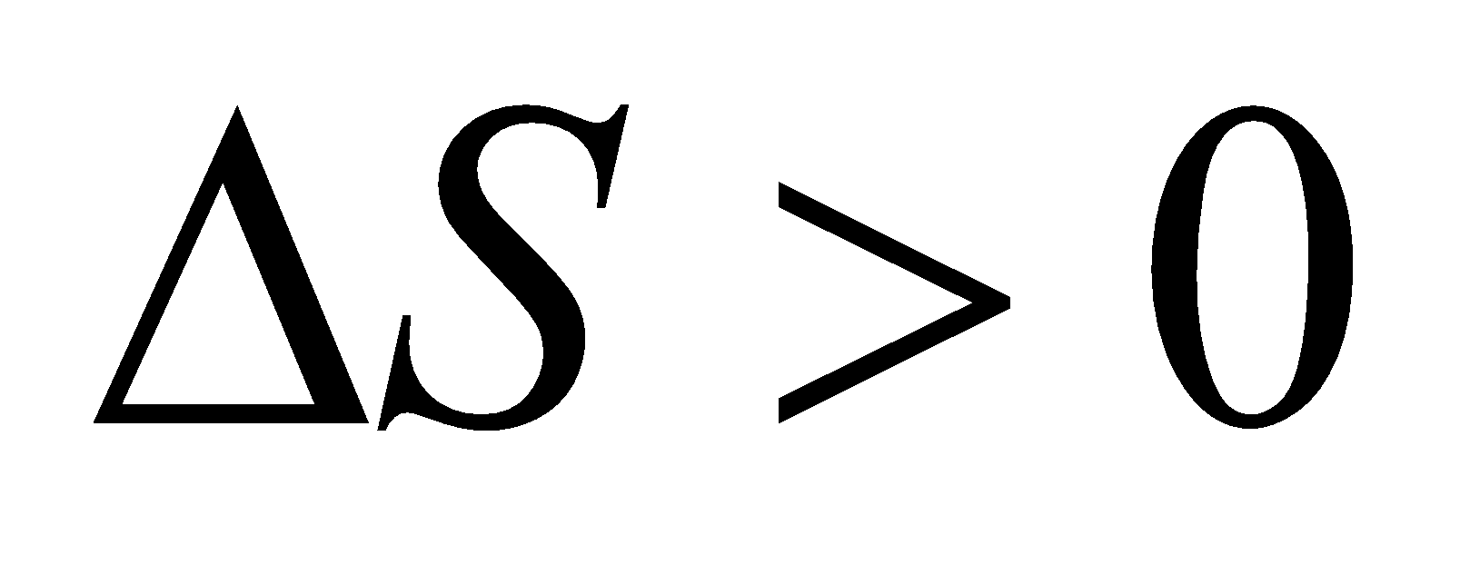 if 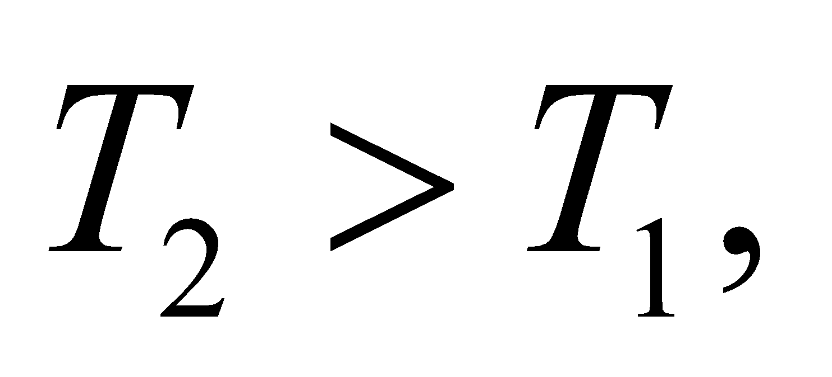 as expected.

**47.** **Interpret** This problem involves the entropy change in an ideal diatomic gas heated under three different conditions: constant volume, constant pressure, and adiabatically.

**Develop** From Problem 19.45, the entropy change at constant volume is 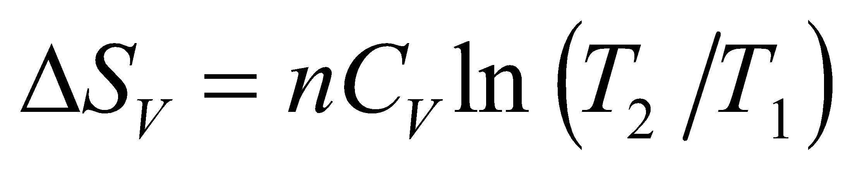, where *C*V = 5*R*/2 for a diatomic gas (see discussion after Equation 18.13). From Problem 19.46, the entropy change at constant pressure is



For an adiabatic process, consider the discussion accompanying Figure 19.16. The entropy change is

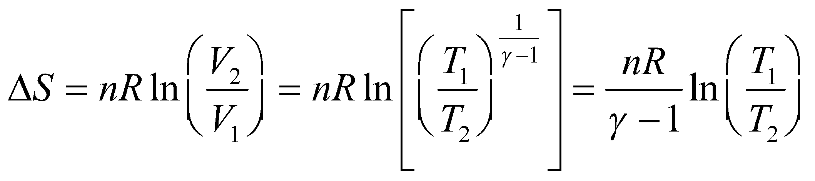

where we have used the relation for an adiabatic process 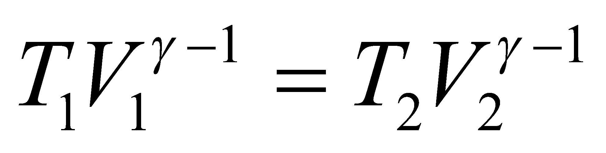 (Equation 18.11b). For a diatomic gas,

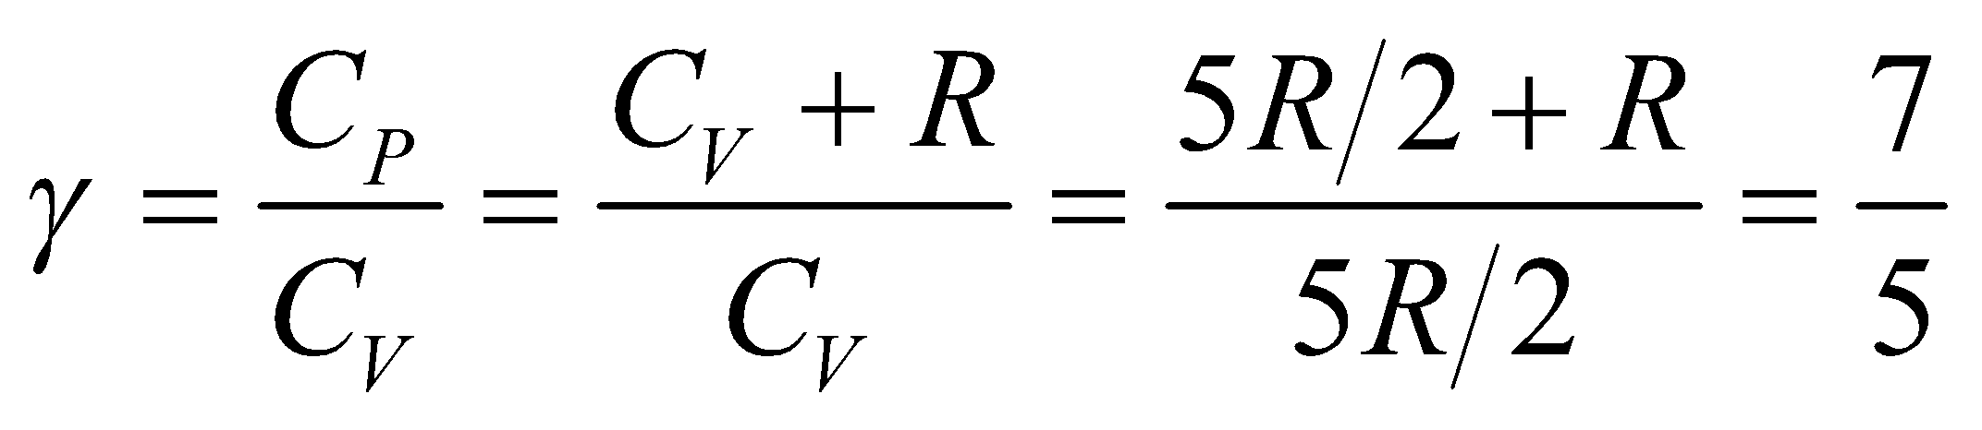

**Evaluate** (**a**) At constant volume, the entropy change is

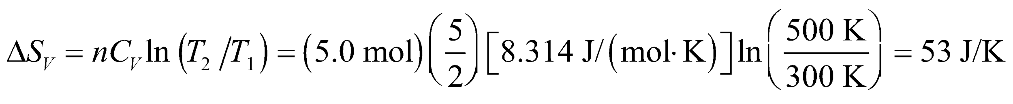

(**b**) At constant pressure, the entropy change is



(**c**) For an adiabatic process, the entropy change is

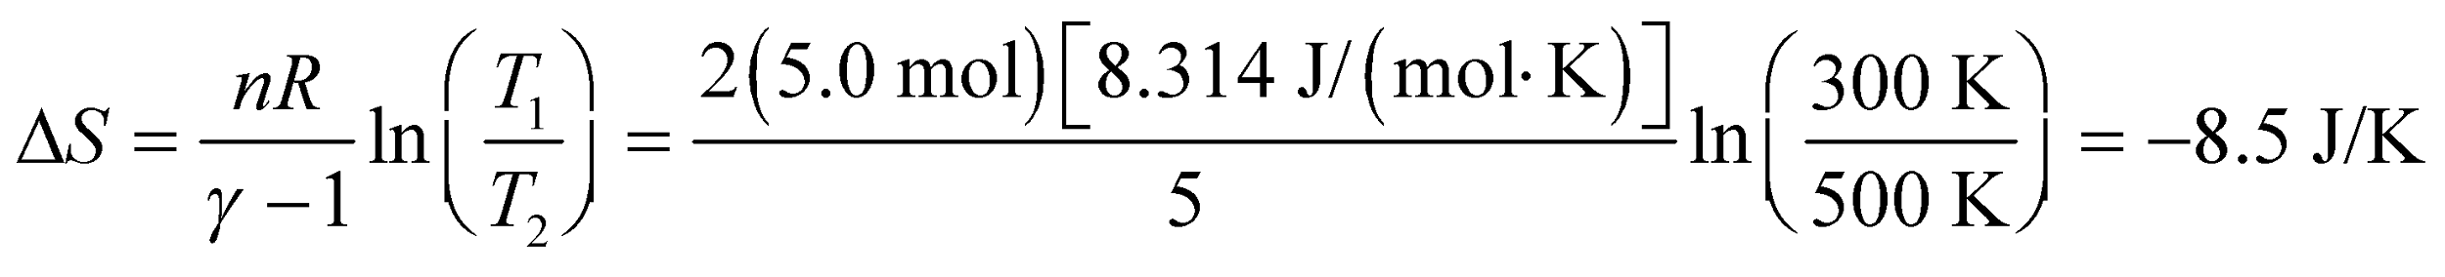

**Assess** For the adiabatic process, the final volume is less than the initial volume because the final temperature is greater than the initial temperature (see, e.g., Table 18.1), so the entropy decreases, in agreement with the result of the discussion of Figure 19.16.

**48.** **Interpret** This problem involves the entropy change that results from mixing the given amount of hot and cold water. We are to find the entropy change for the hot water, the cold water, and the entire system.

**Develop** When mixing two liquids that are initially at different temperatures, the thermal energy change in both liquids must be the same, assuming all the thermal energy lost by the hot liquid is gained by the cold liquid. Thus,

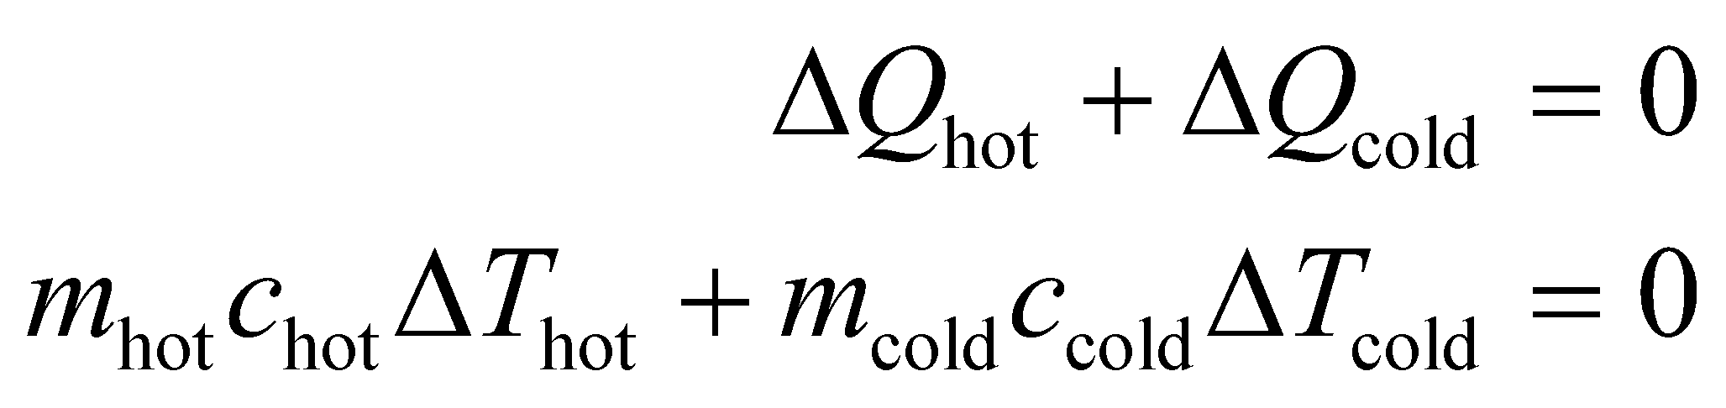

For this problem, *m*hot = *m*cold and *c*hot = *c*cold, because the hot and cold liquids are both water. Thus,

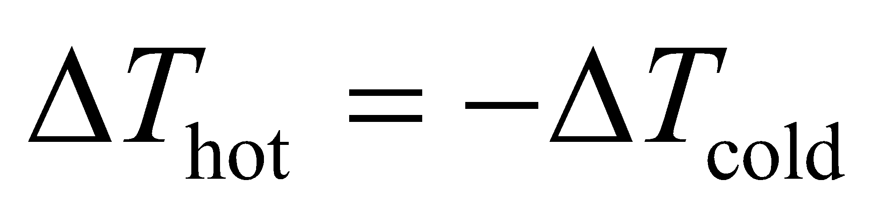

Because the equilibrium temperature of the mixed liquid is the same for the (previously) hot and cold portions, we also have

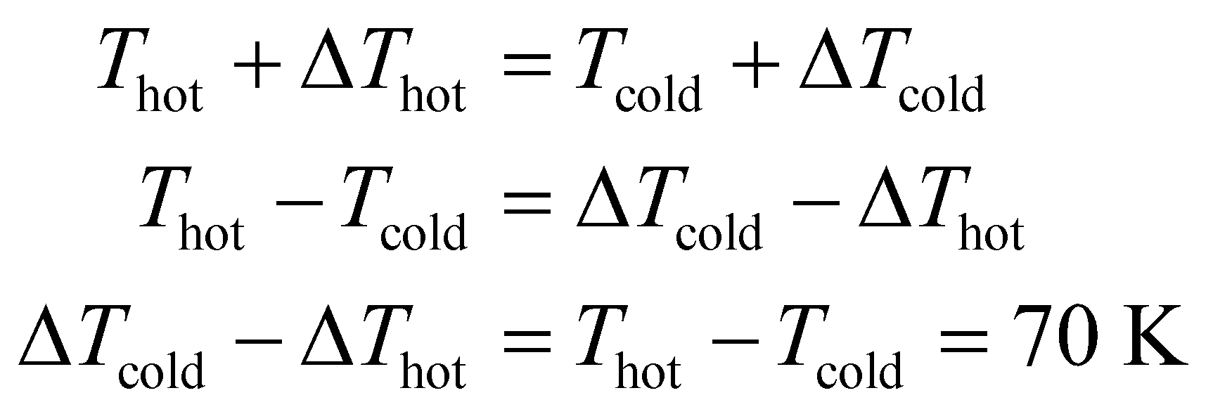

Combined with the previous expression gives *ΔT*cold = − *ΔT*hot = 35 K and the equilibrium temperature is *T*cold + *ΔT*cold = (10°C + 273 K) + 35 K = 318 K. For this problem, the entropy change given by Equation 19.6 takes the form

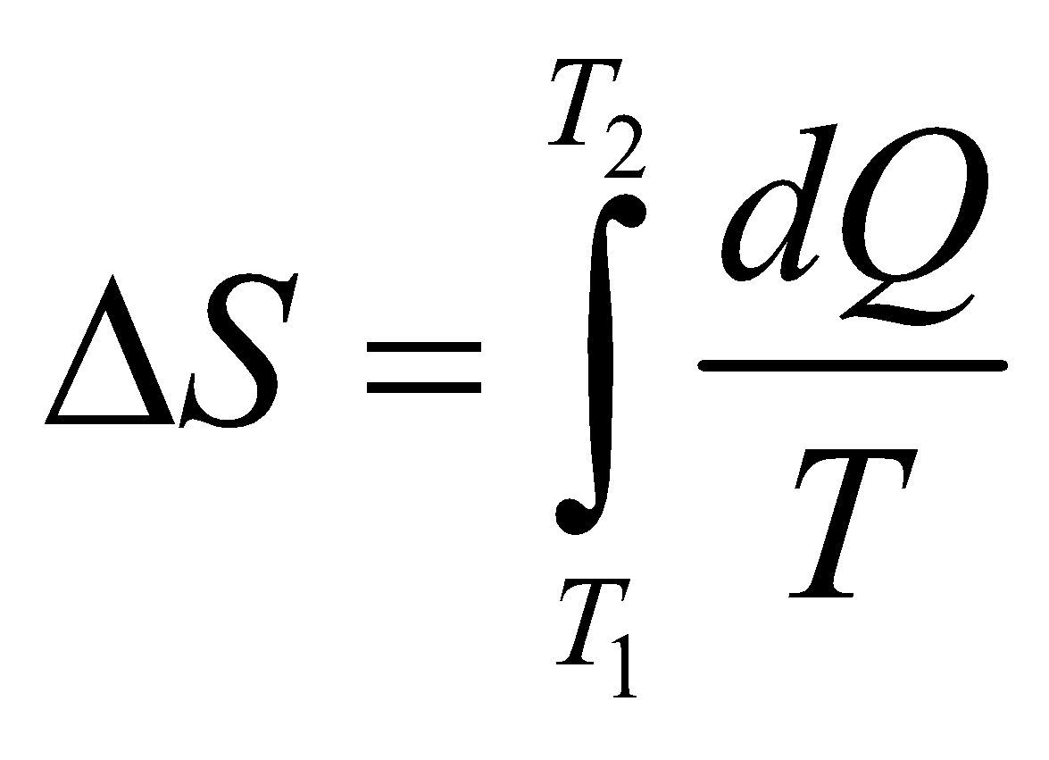

From the argument above, we have *dQ* = *mcdT*, so Equation 19.6 gives

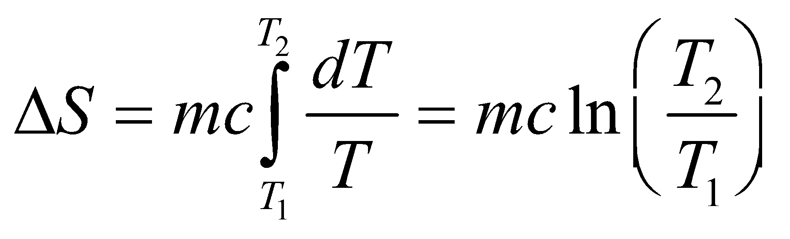

where *m* = 0.250 kg and *c* = 4184 J/kg, so we can solve for the entropy change for each case.

**Evaluate** (a) For the hot water, *T*1 = 353 K and *T*2 = 318 K, so the entropy change is

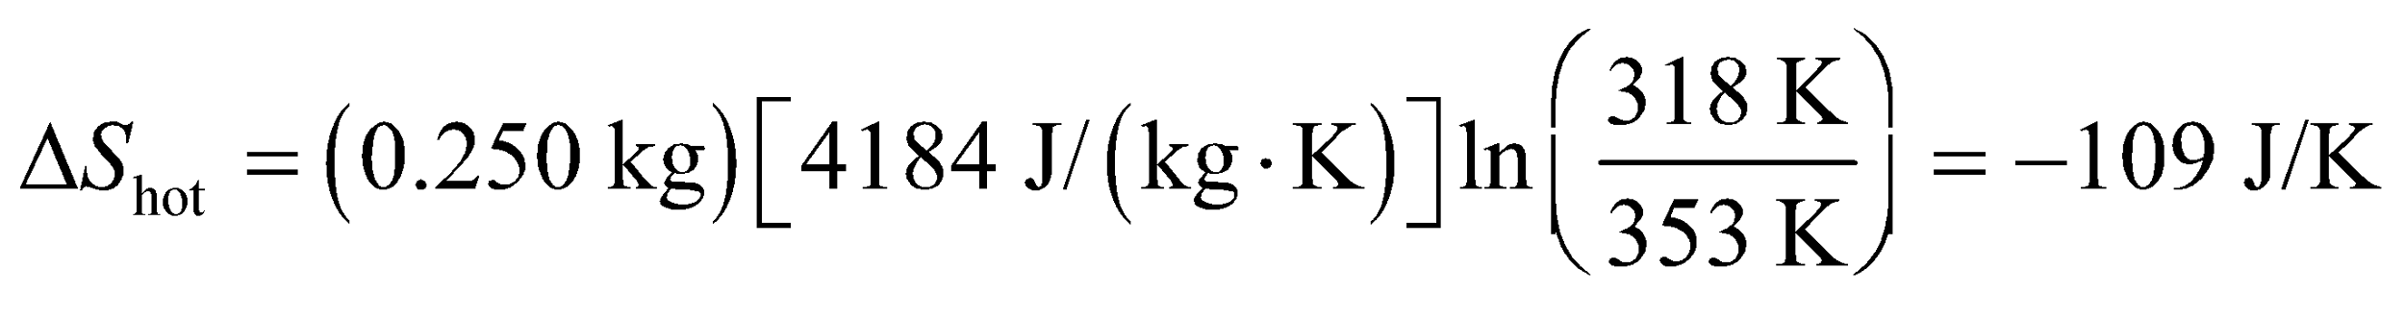

(b) For the cold water, *T*1 = 283 K and *T*2 = 318 K, so the entropy change is

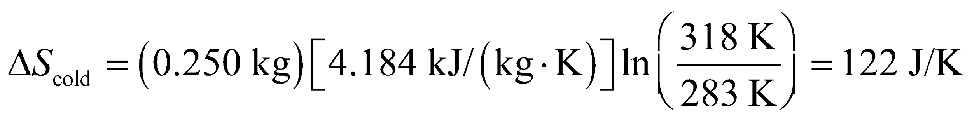

(c) The total entropy change is the sum of these two, so



**Assess** Note that the results are given to three significant figures because we assumed the data were valid to three significant figures. The total entropy of the system has increased, which conforms with the second law of thermodynamics.

**49. Interpret** You want to find the entropy change in going from one state to another state that lie on the same adiabat.

**Develop** We're told that the system goes from state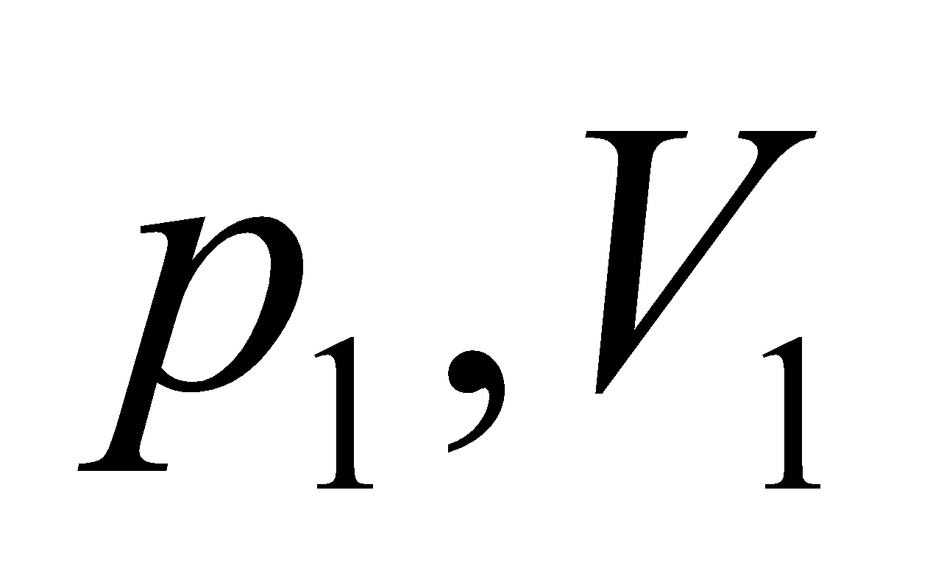 to state 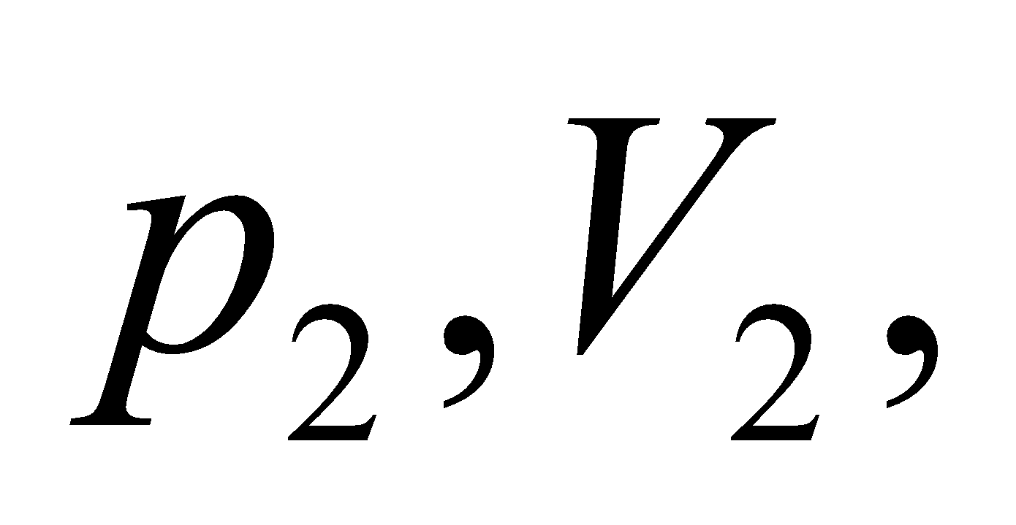where the two states are related by the adiabatic equation: 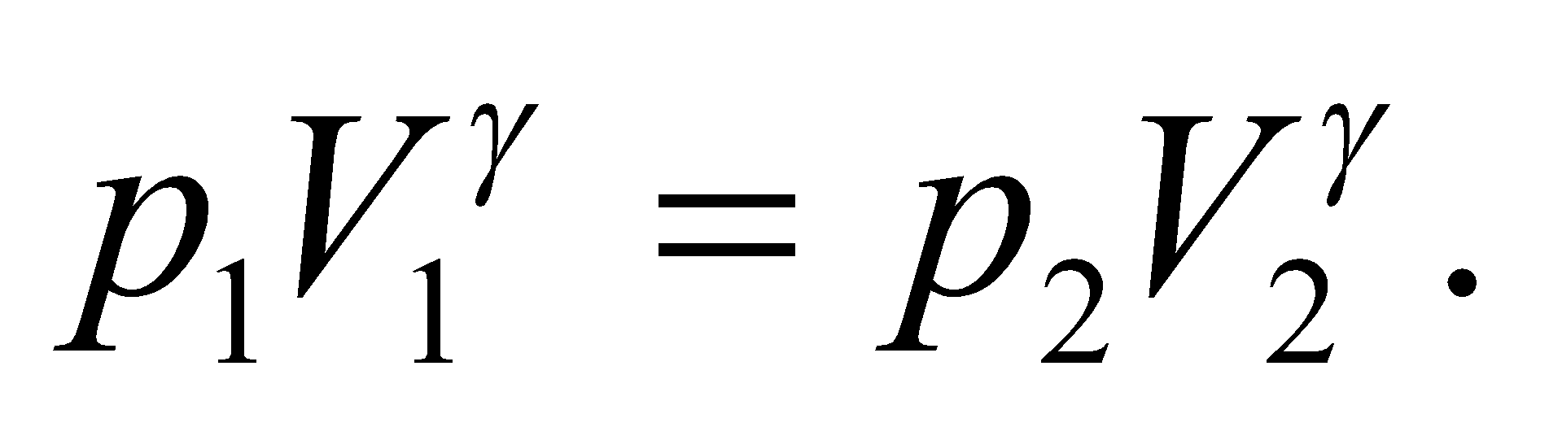Our first inclination would be that the entropy change would be zero, since there is no heat exchange in the adiabatic process that connects these two states. However, we're told that the system goes between the two states in two segments: one a constant pressure process (going from  to 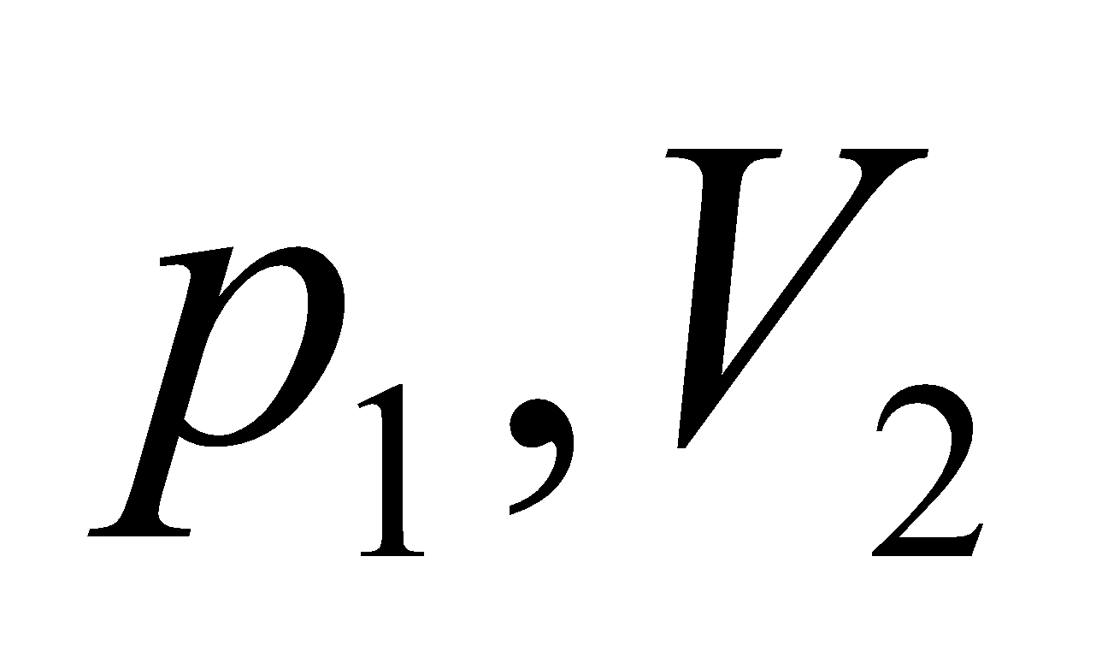) and the other a constant volume process (going from  to 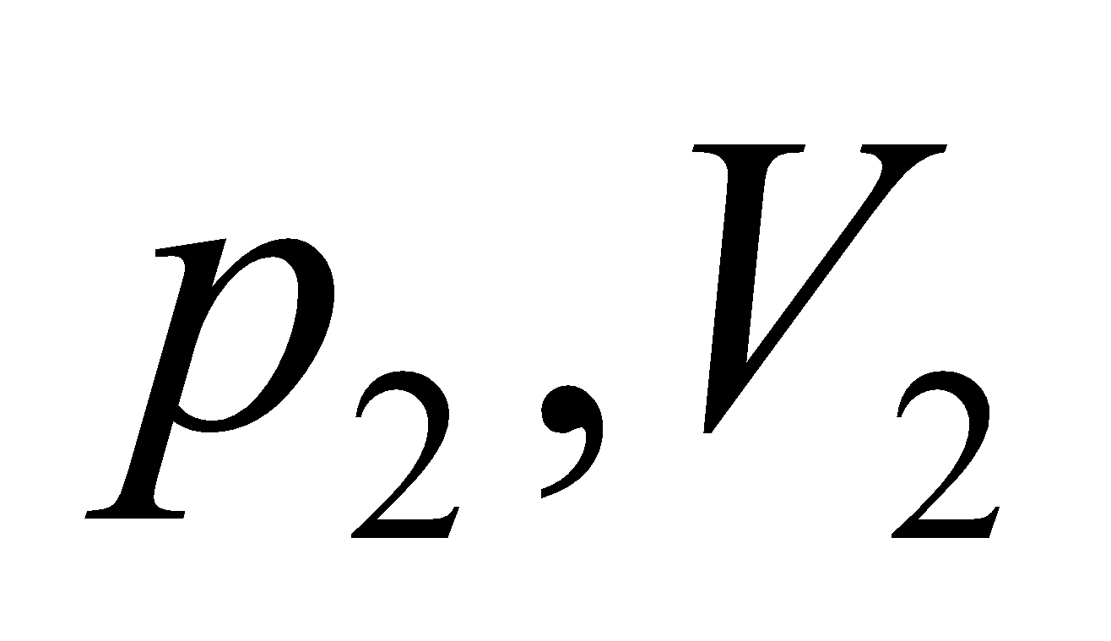). See the figure below.



This is an ideal gas, so the temperatures of the three endpoints are: 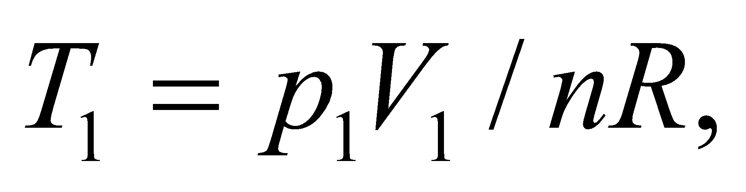 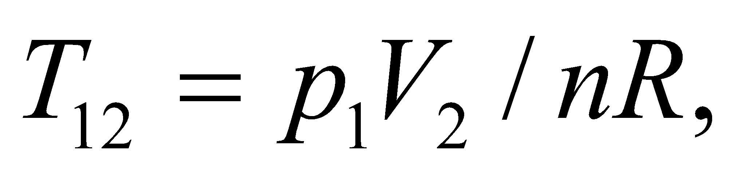and 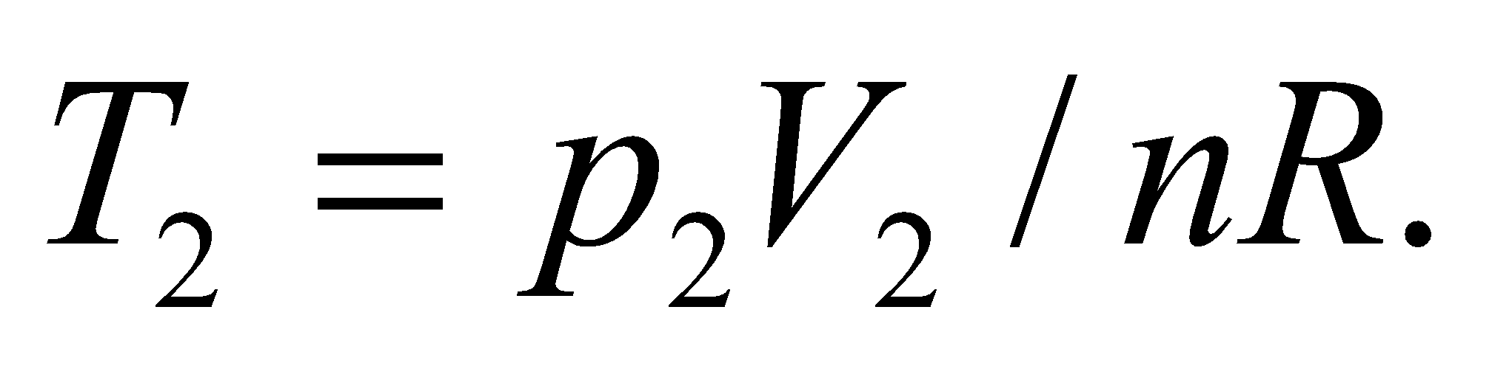 From Table 18.1, the differential heat flows for these two processes are:

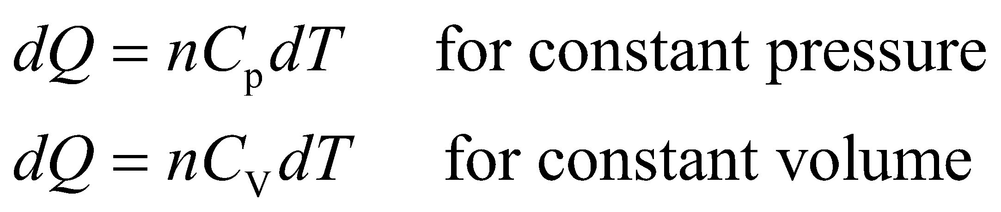

Recall that 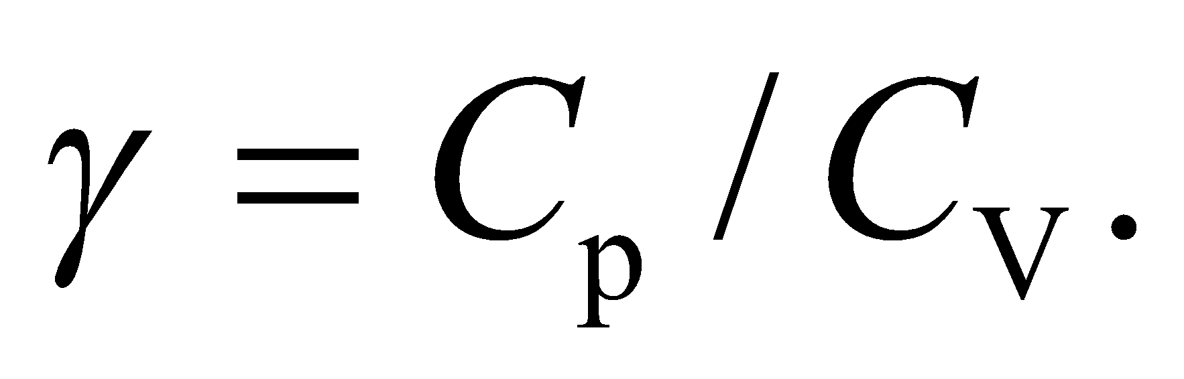

**Evaluate** For the constant pressure process, the entropy change is

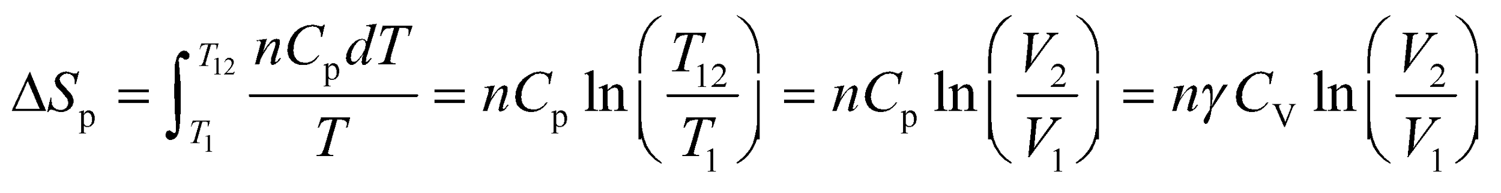

For the constant volume process, the entropy change is

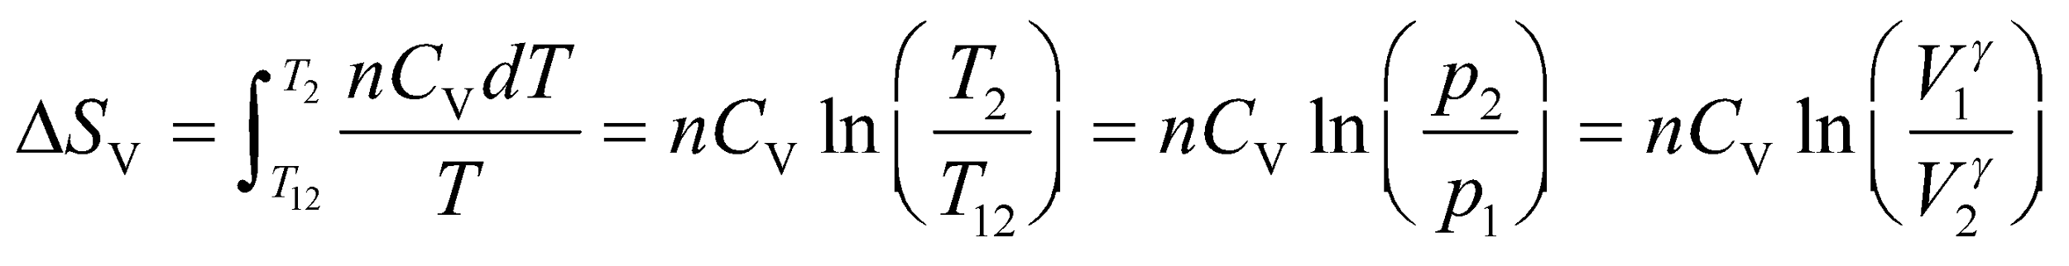

The total entropy is the sum:

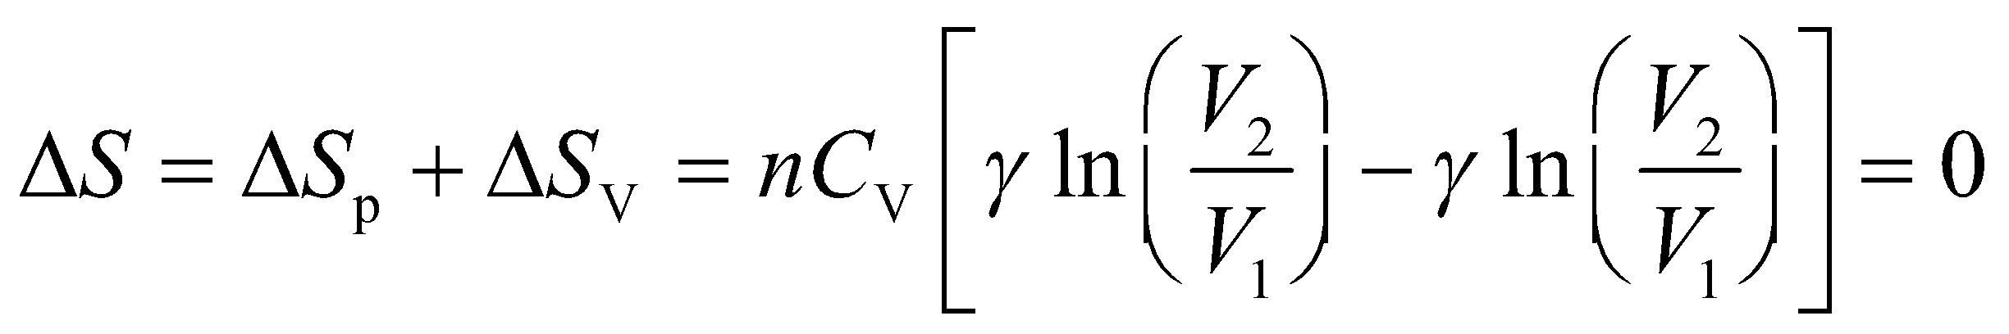

where we have used the mathematical identity: 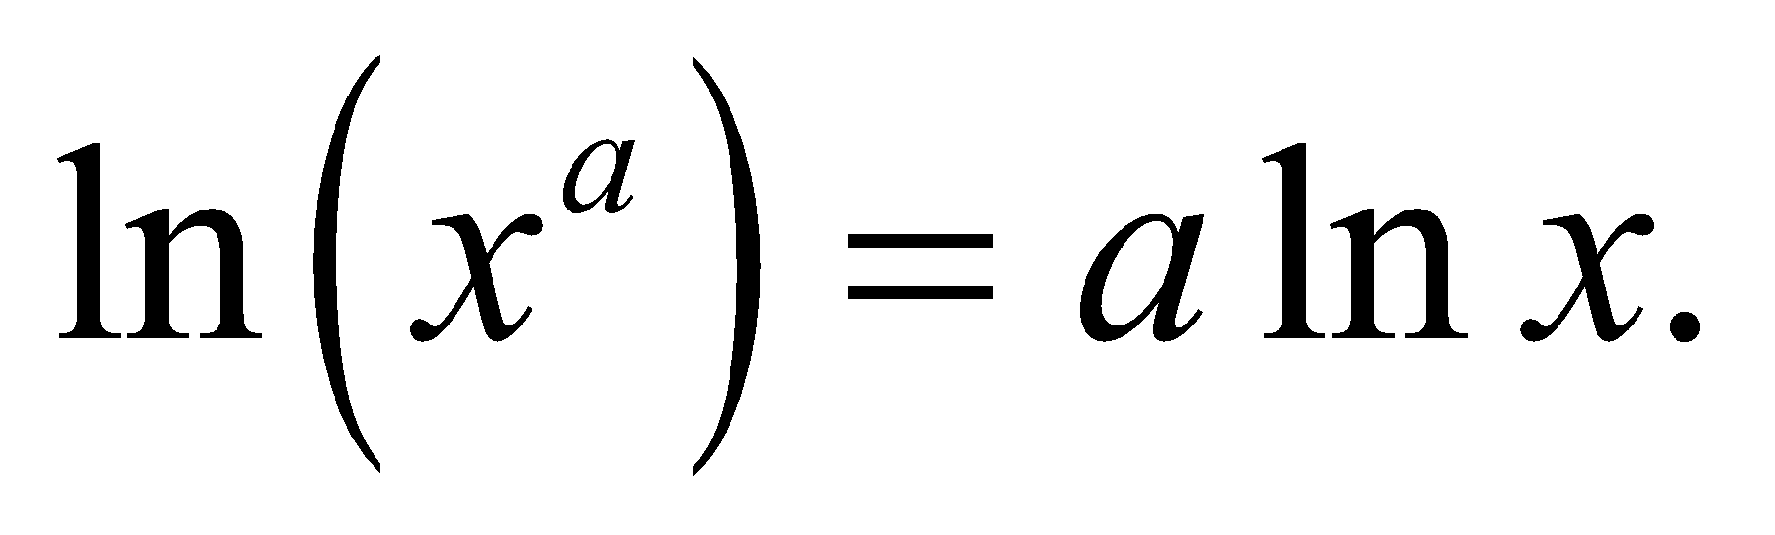 The total entropy change is zero as we expected, since the system could have gone from state 1 to state 2 by an adiabatic process for which 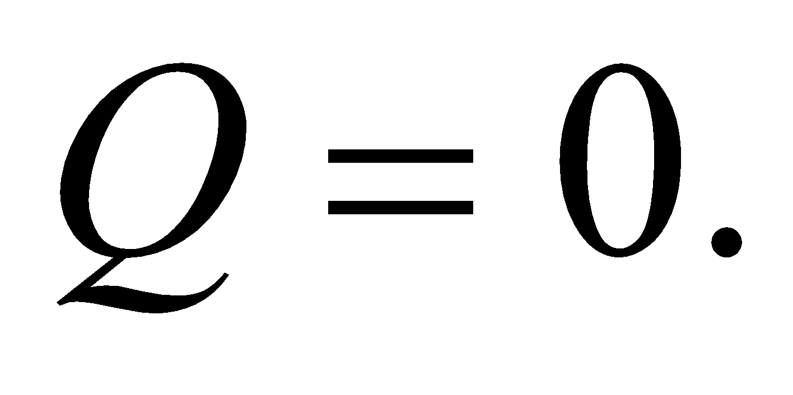

**Assess** As explained in the text, the entropy is a state variable, which doesn't depend on how a system arrived at a particular state. Note that this separates entropy from the heat, *Q*, absorbed or expelled by a system. You can't say that a system contains a particular amount of heat, but you can say that it contains a particular amount of entropy.

**50. Interpret** This problem asks about the energy quality resulting from a thermodynamic process (an adiabatic free expansion in this case) during which entropy has increased. The system consists of a given quantity of ideal gas, and we are given the initial and final volume occupied by the gas.

**Develop** From the discussion accompanying Figure 19.16, we know that the change in entropy during the adiabatic free expansion is

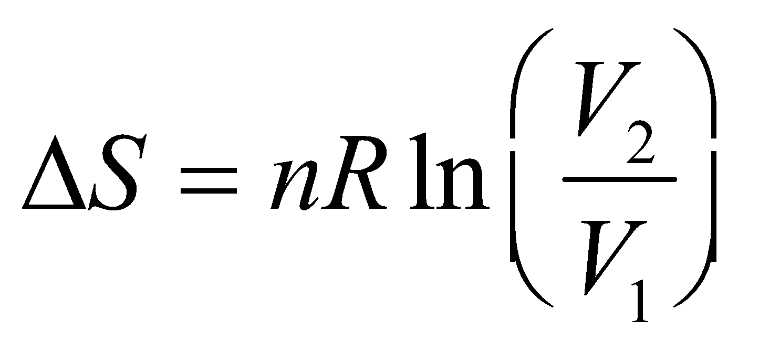

where *V*2 = 10*V*1. The energy made unavailable is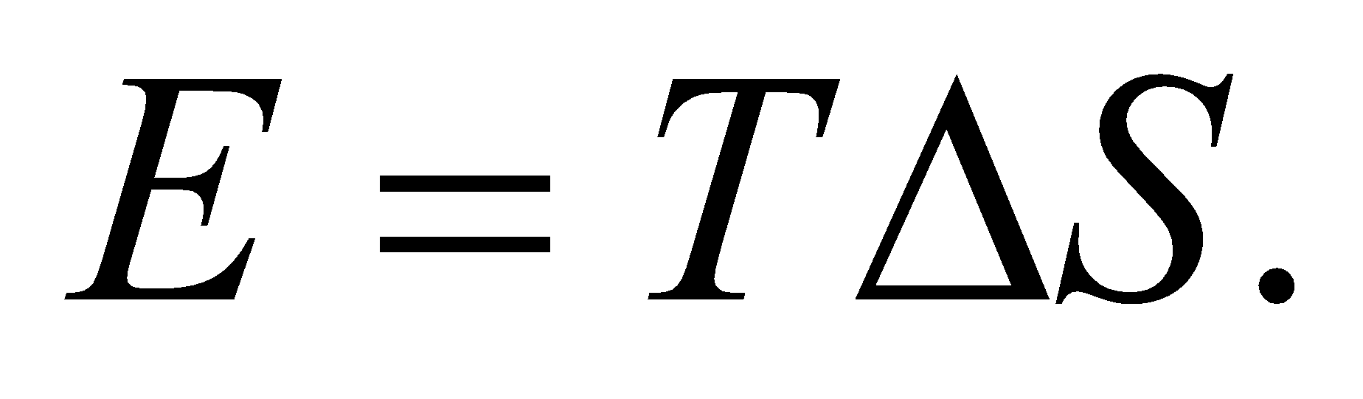

**Evaluate** Substituting the values given in the problem statement, the energy that becomes unavailable to do work in the free expansion of an ideal gas (*T* remains constant), is

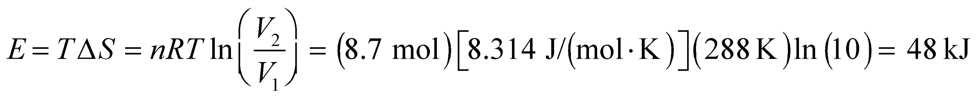

**Assess** This is the work that could have been recovered from a reversible isothermal expansion. However, due to the irreversible nature of the process, we give up the possibility of extracting this work.

**51. Interpret** This problem asks for the entropy change of the pan-water system, when thermal equilibrium has been reached after a hot pan has been plunged into the given amount of cold water.

**Develop** Assume all the heat lost by the pan is gained by the water. The equilibrium temperature is given by Equation 16.4, or

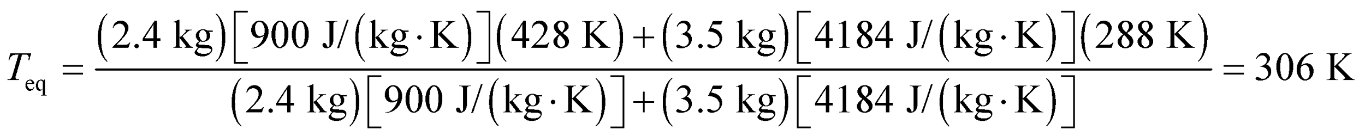

Using the result of Exercise 48, the change in entropy for the pan is

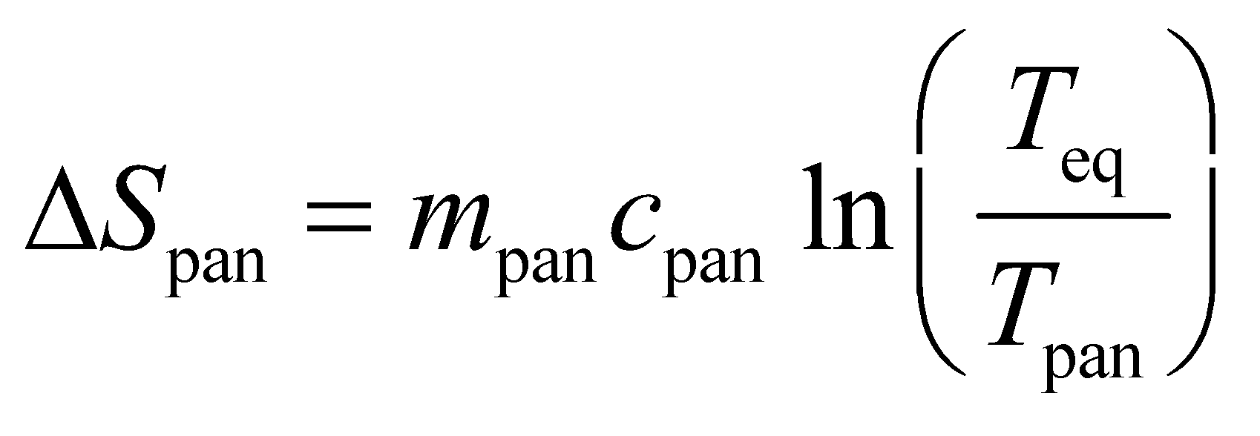

Similarly, the change in entropy for the water is

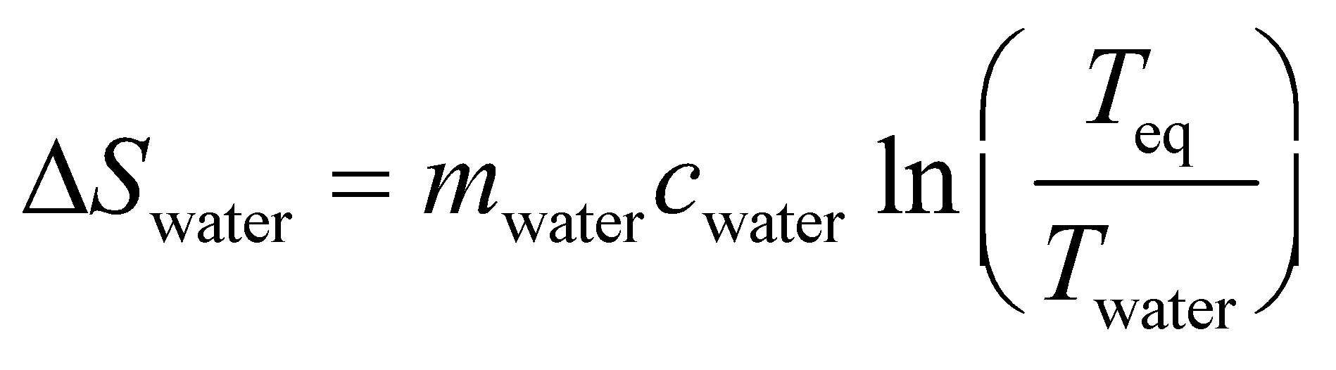

The sum of these two terms is the change of entropy of the pan-water system.

**Evaluate** The entropy change of the pan and water together is

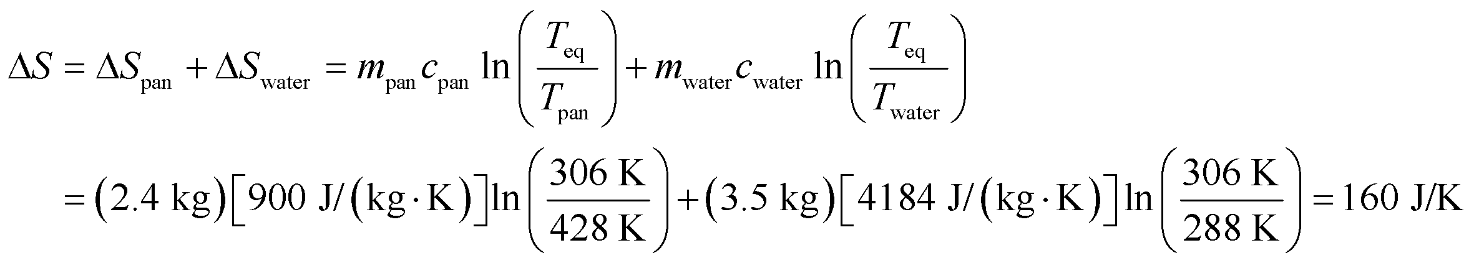

to two significant figures.

**Assess** The entropy change for the pan is negative, while that of the water is positive. The total entropy change is positive, in accordance with the second law of thermodynamics.

**52. Interpret** This problem is about the efficiency of an engine operating between two temperatures.

**Develop** We assume the engine is reversible and operates between the two given temperatures (*T*h = 420 K and *T*c = 273 K). The efficiency can then be computed using Equation 19.3, 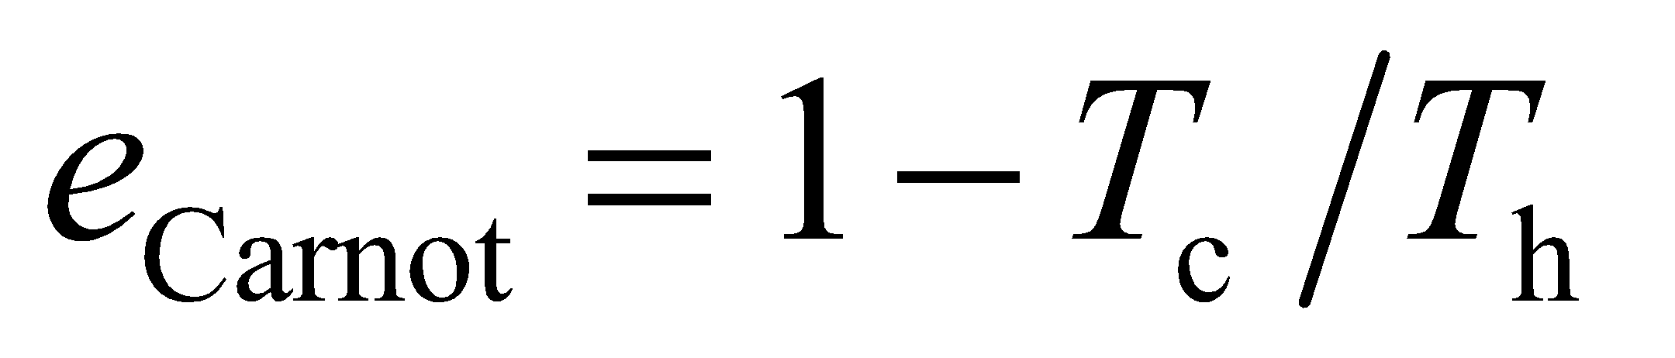.

**Evaluate** **(a)** Substituting the values given in the problem statement, we find the efficiency to be

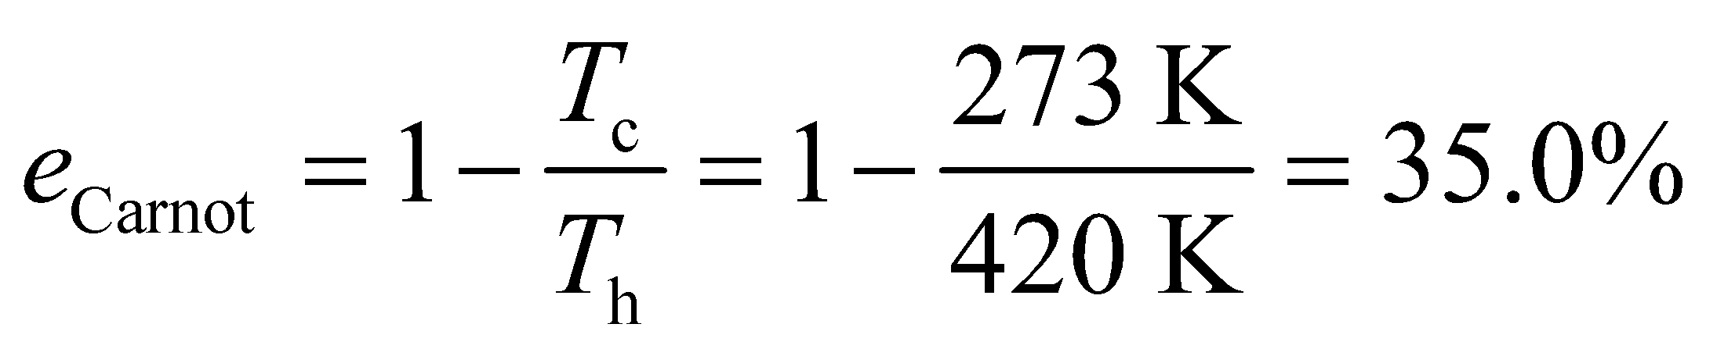

**(b)** The total heat the block of ice can absorb as it melts at 273 K is



Then the melt-water temperature will rise and the engine’s efficiency will drop. While running at the original efficiency, the engine exhausts heat at the rate

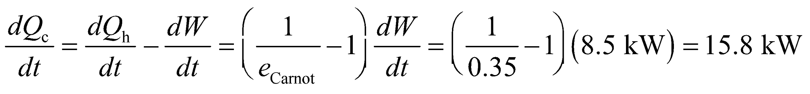

(combine the first law with the definition of efficiency). Thus, it can operate between the original temperatures for a time

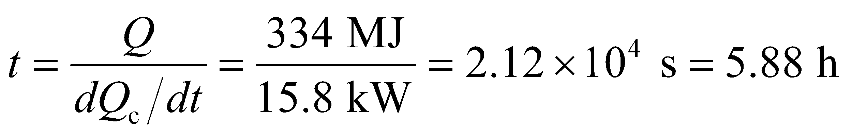

**Assess** For real engines in which 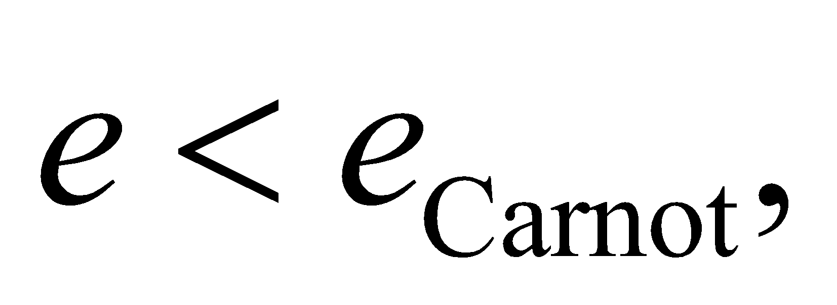 heat is exhausted at a greater rate. This shortens the duration for which the engine can maintain its efficiency.

**53. Interpret** We will calculate the efficiency of the Otto cycle, on which gasoline engines are modeled.

**Develop** The engine absorbs heat 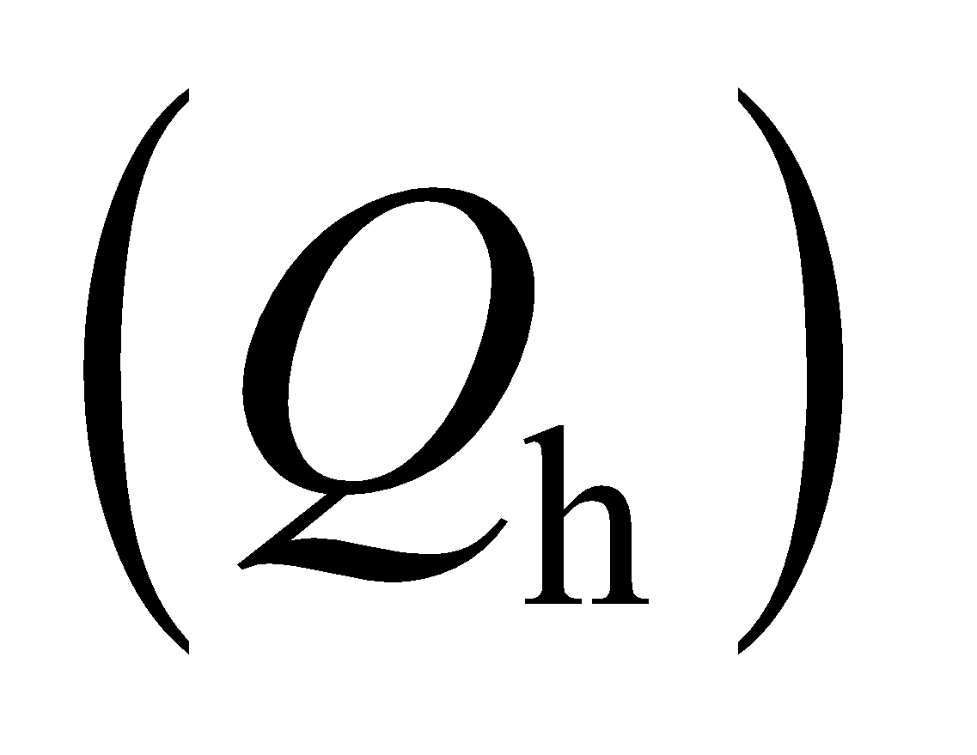during combustion, and expels heat to the environment 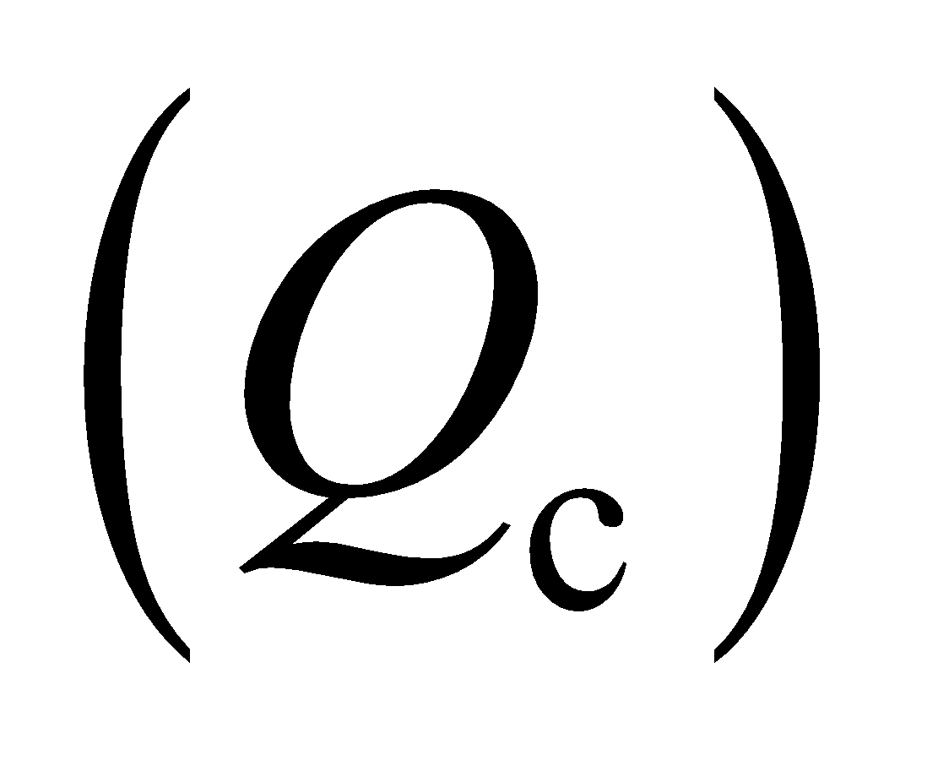during the exhaust segment. Both these processes are at constant volume, so 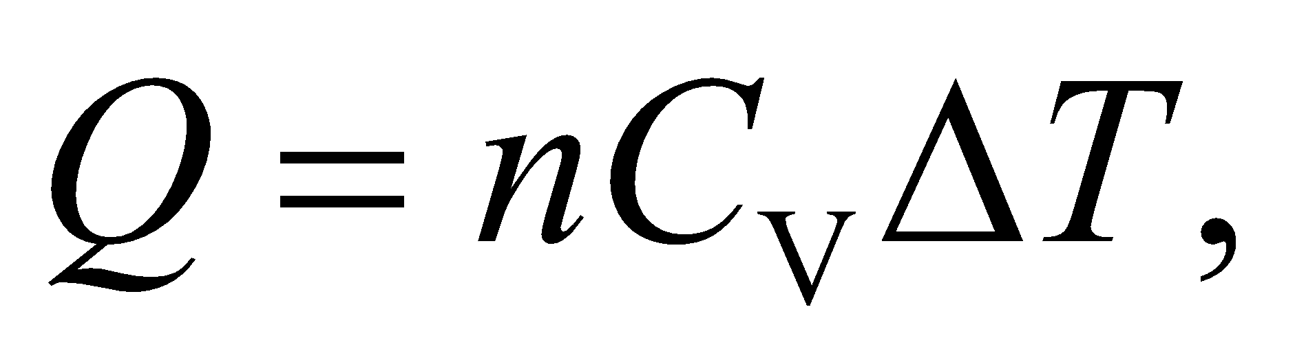and the efficiency is:

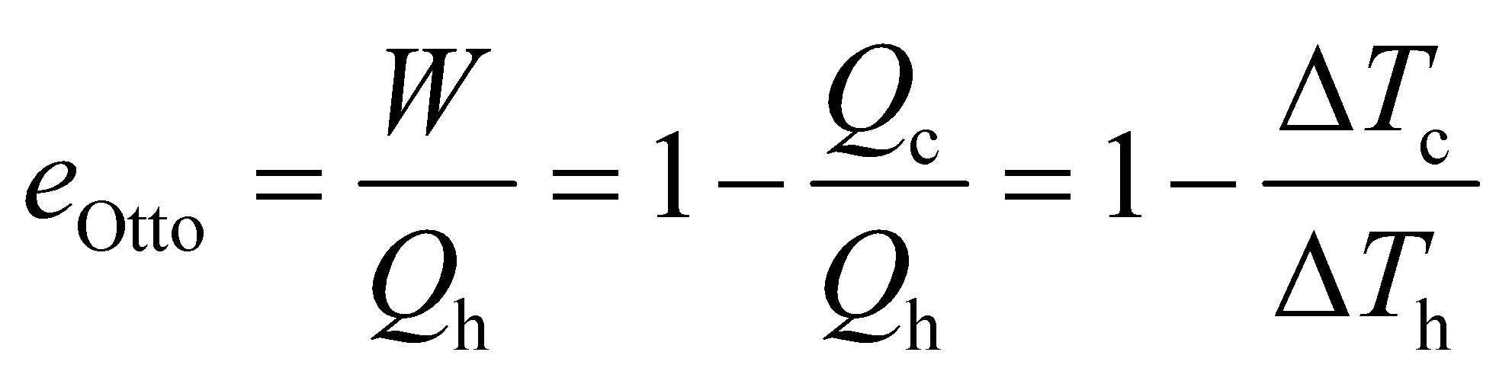

We can find the respective temperature changes assuming the gas mixture in the engine is ideal: 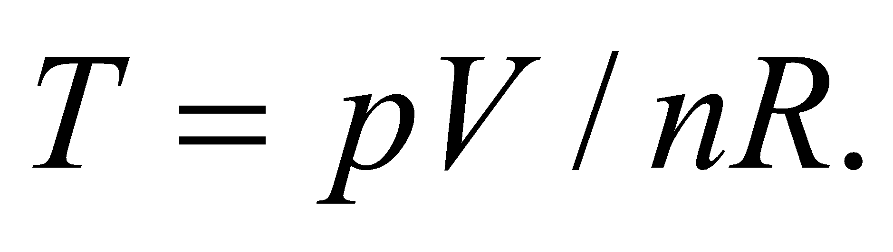

**Evaluate**  (a) The hot temperature change is between point 2 and point 3 in Figure 19.24:

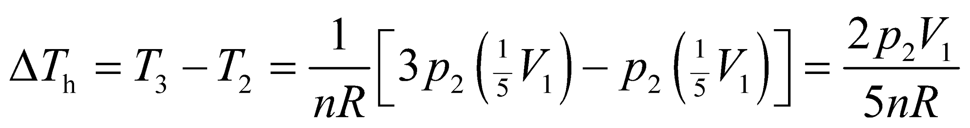

where we use the values for the pressure and volume given in the figure. The cold temperature change is between point 1 and point 4 in the figure, but the pressures aren't given in this case. However, point 1 and point 2 are on the same adiabat 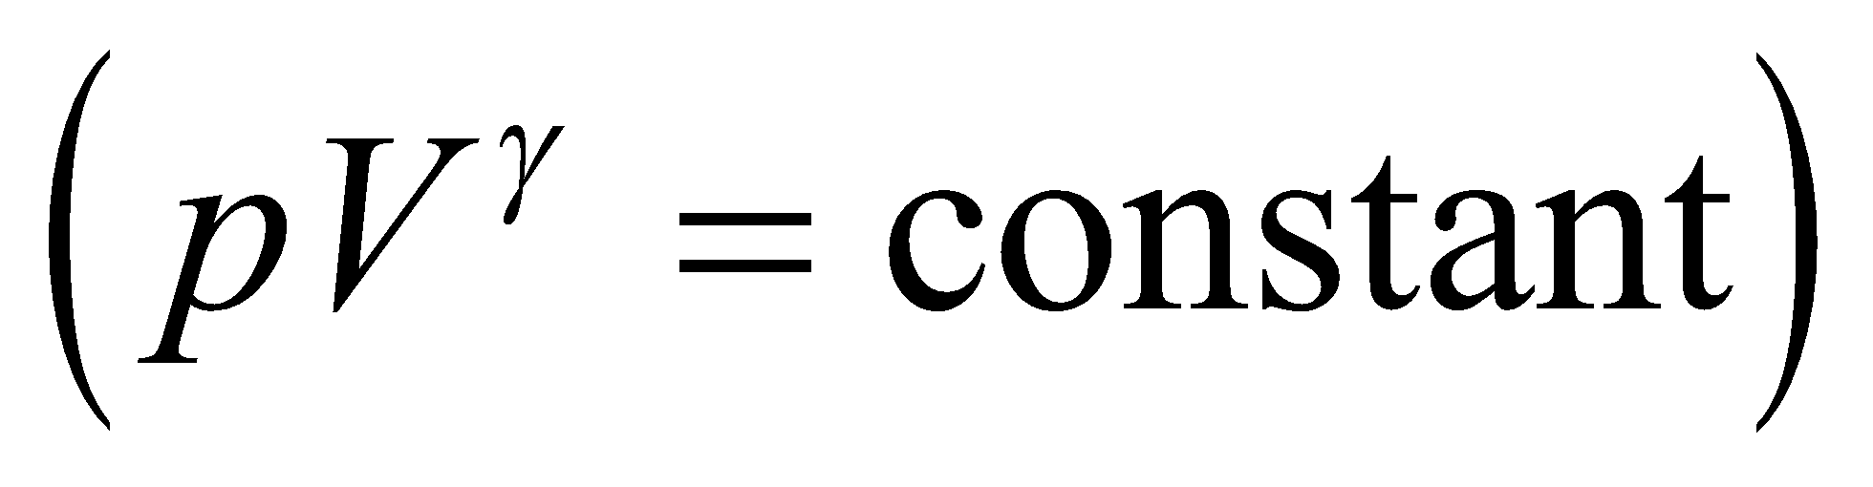, so: 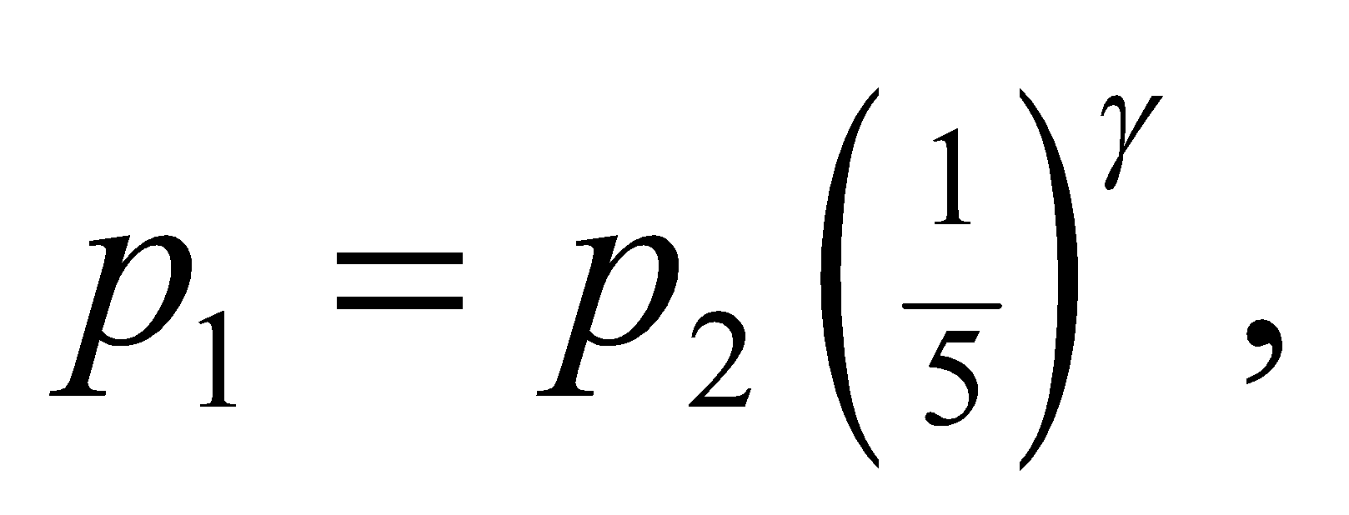and similarly for point 4 and point 3: 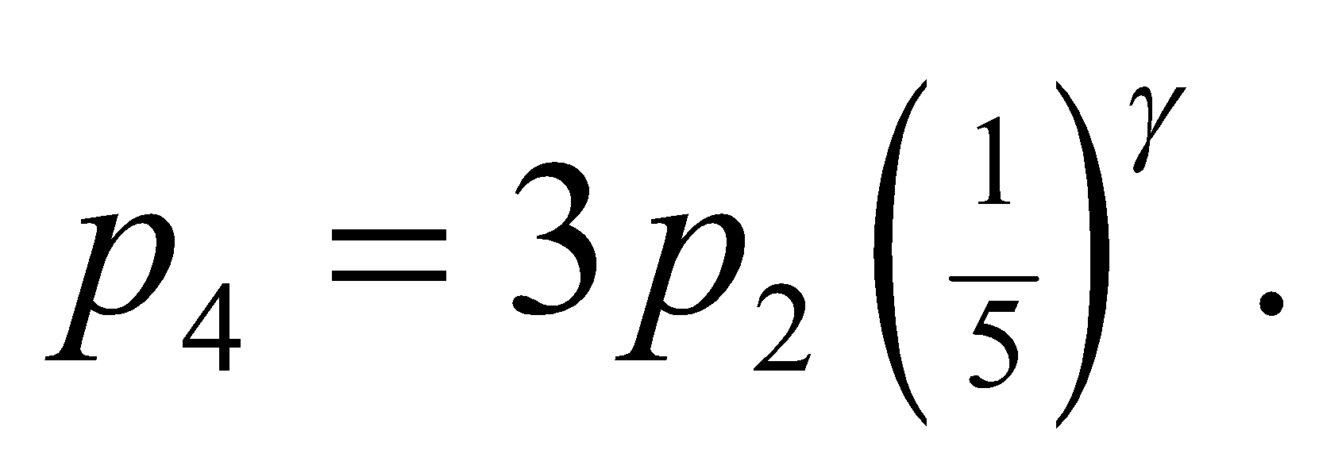 Therefore, the cold temperature change can be written:

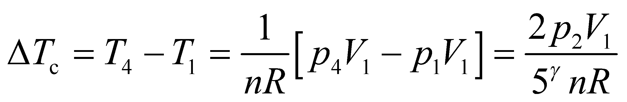

From these temperature changes, the efficiency of the Otto cycle is:

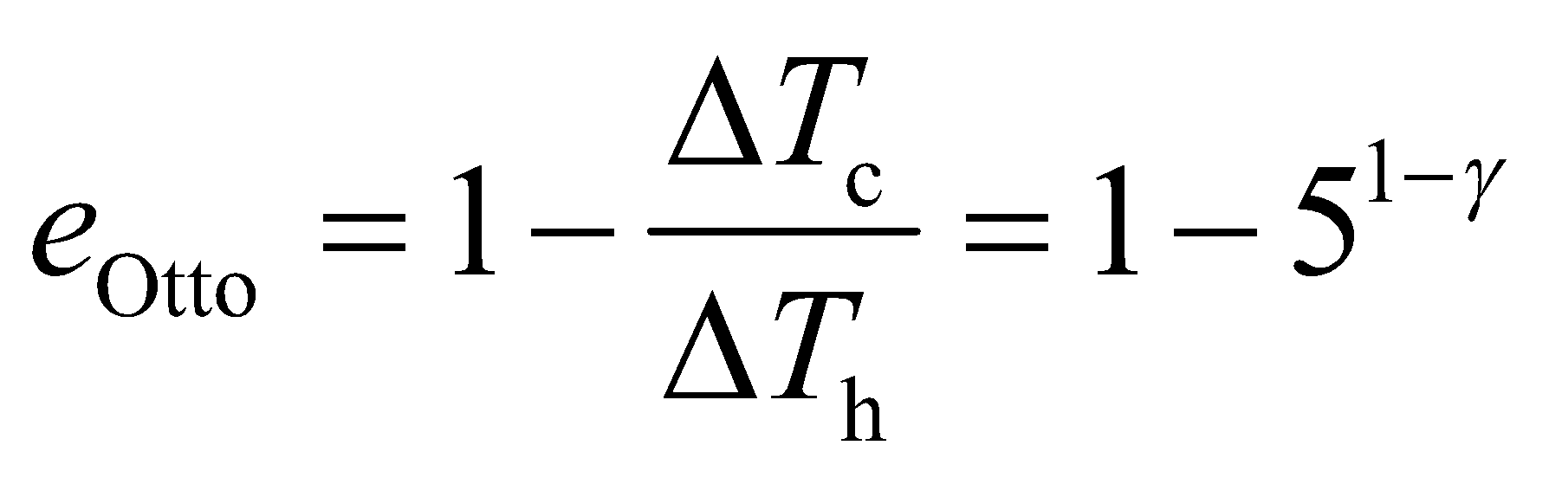

(b) The minimum temperature occurs at point 1 at the end of the exhaust segment:

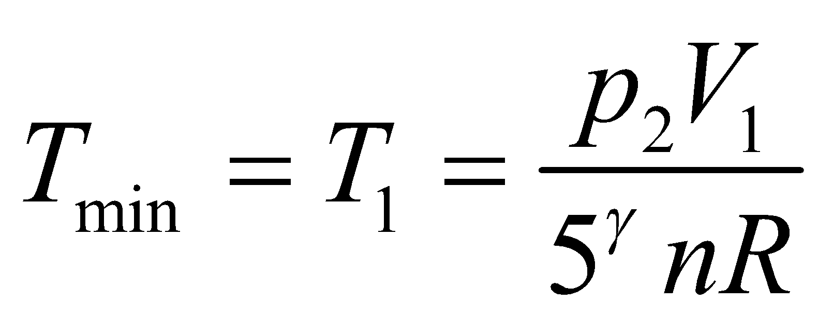

The maximum temperature occurs at point 3 at the end of combustion:

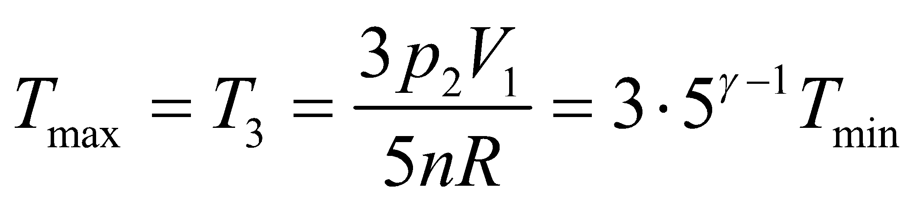

(c) A Carnot cycle working between minimum and maximum temperatures would have an efficiency of (Equation 19.3):

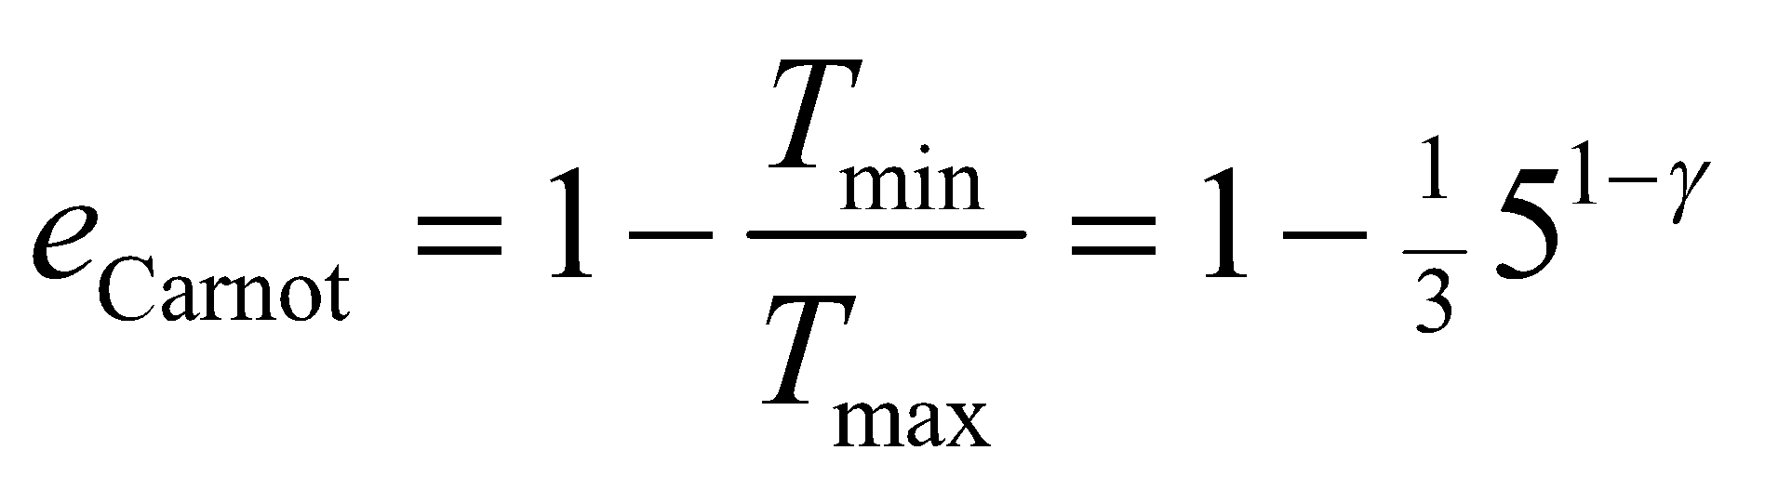

So, the Carnot cycle efficiency is greater than that of the Otto cycle: 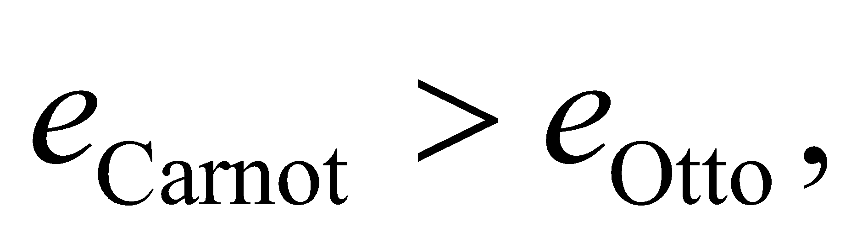as we'd expect since the Carnot cycle has the maximum efficiency for an engine.

**Assess** If we assume 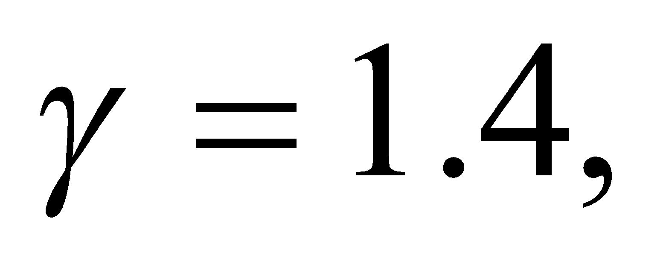just for argument sake, then 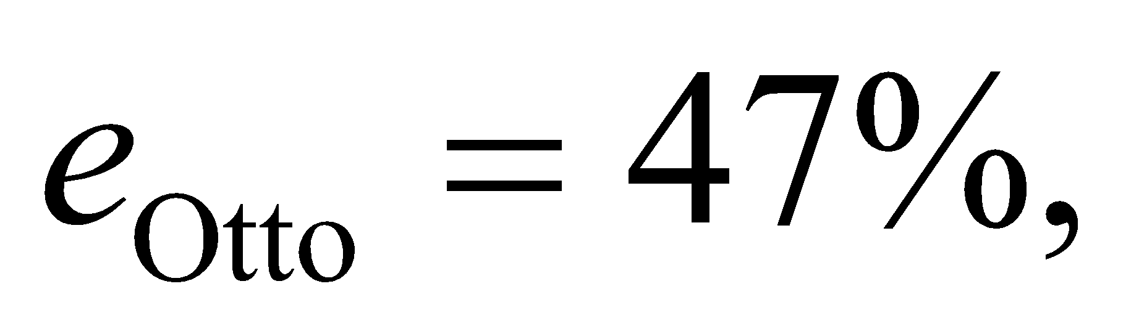 while 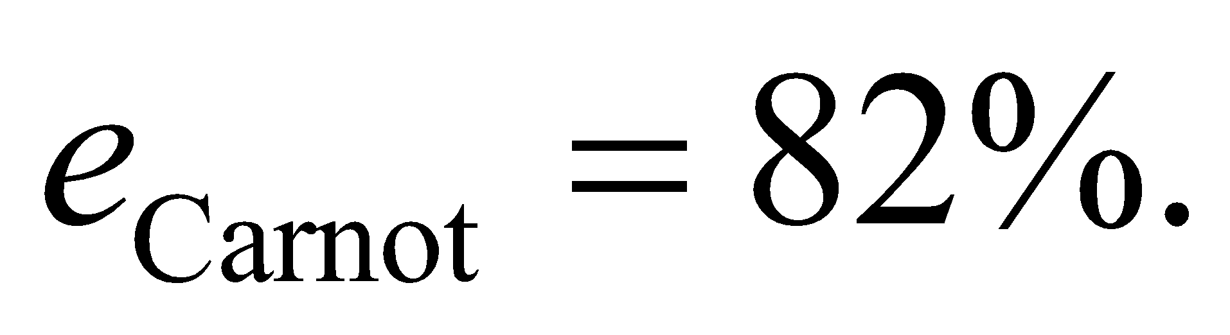 In this light, gasoline engines are woefully inefficient. Much of the combustion energy is lost as exhaust heat.

**54. Interpret** This problem is about the efficiency of the Otto cycle as a function of the compression ratio.

**Develop** As argued in the previous problem, the efficiency of the Otto cycle is: 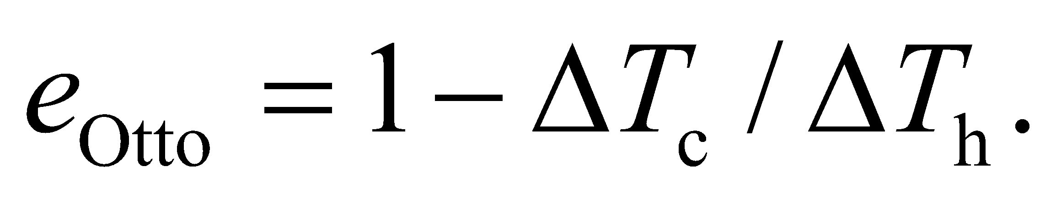We will write this in terms of the compression ratio, 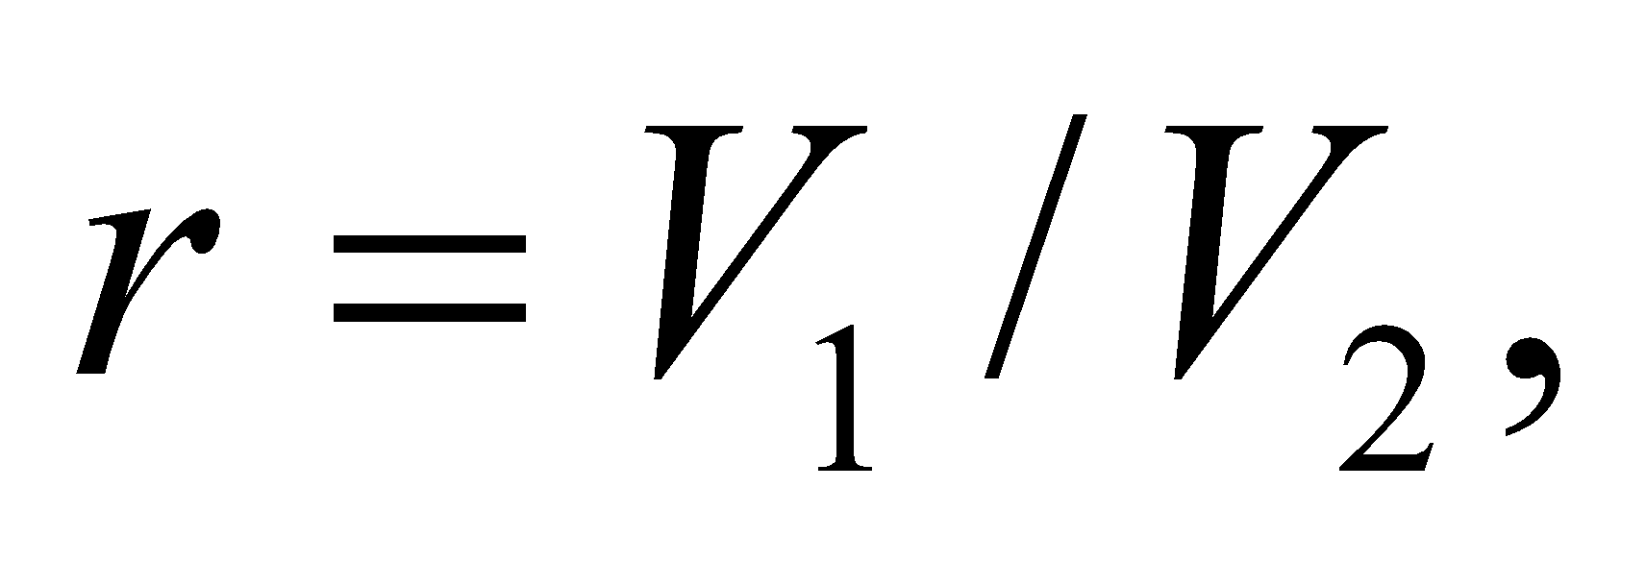where 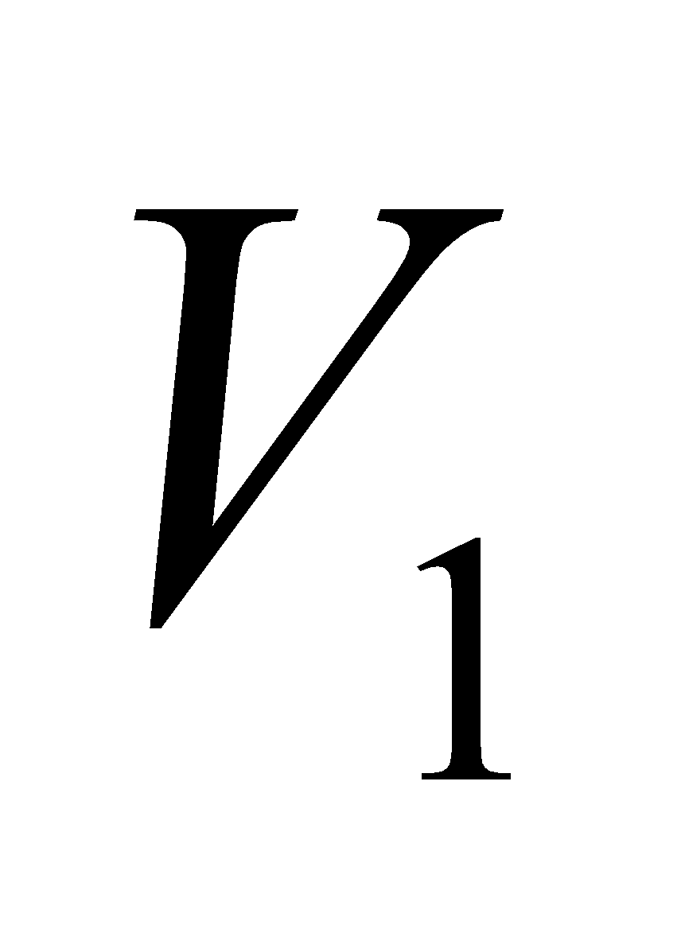 and 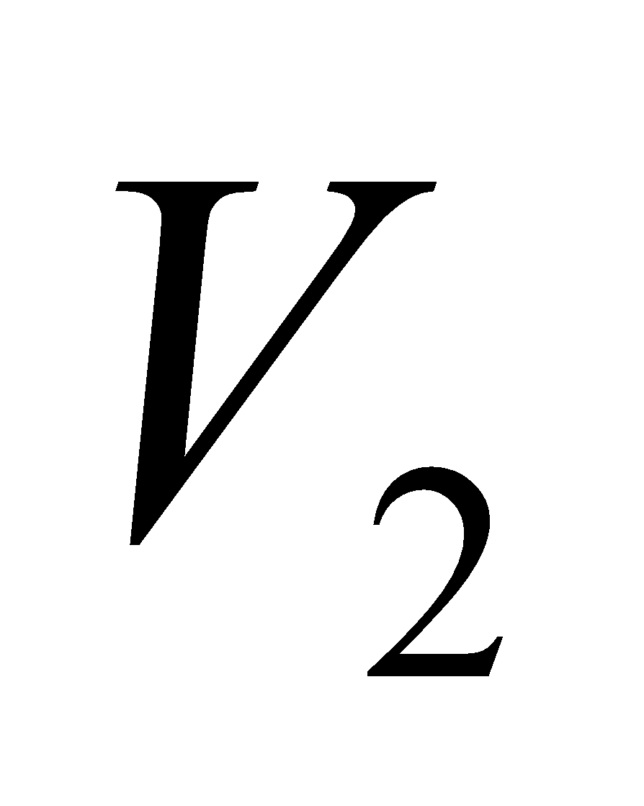 are the volumes before and after the adiabatic compression in Figure 19.24. In this case 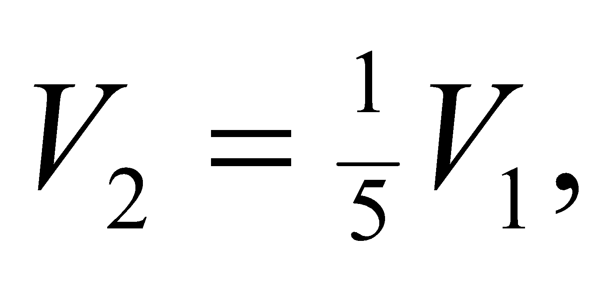but we'll derive the expression for the general case first.

**Evaluate** The hot temperature change is between point 2 and point 3 in the figure:

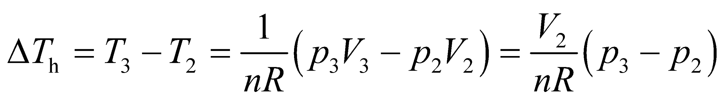

The cold temperature change is between point 1 and point 4 in the figure:

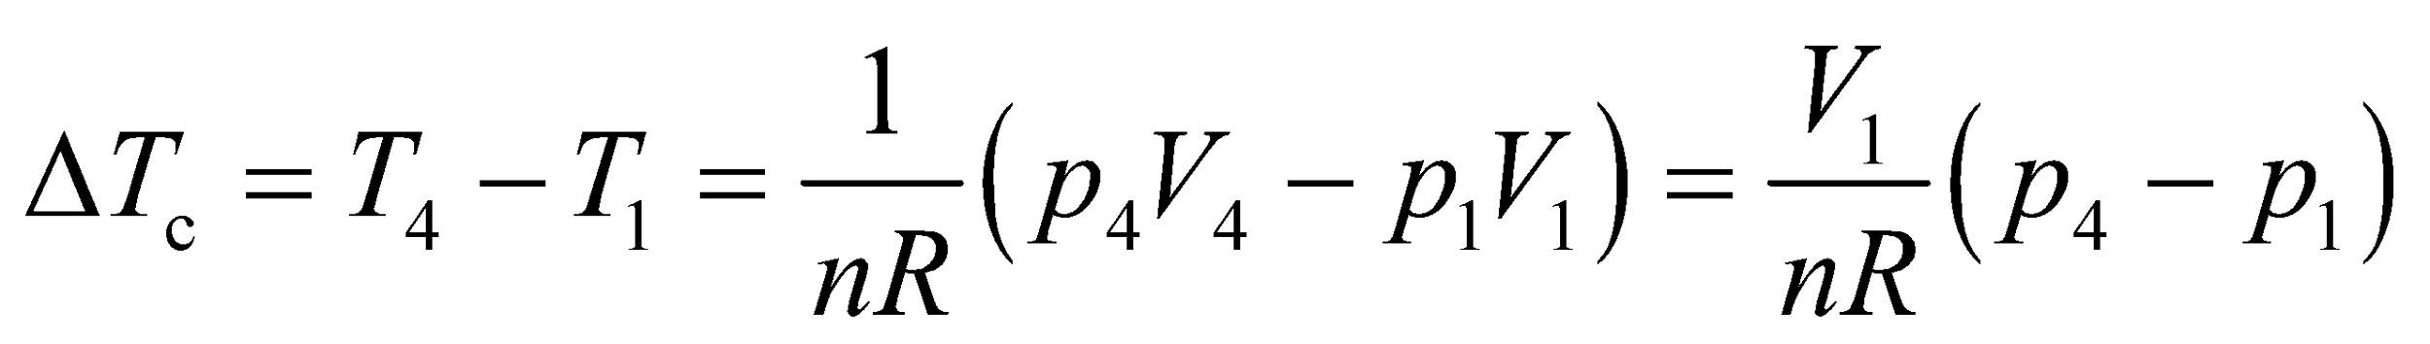

Since 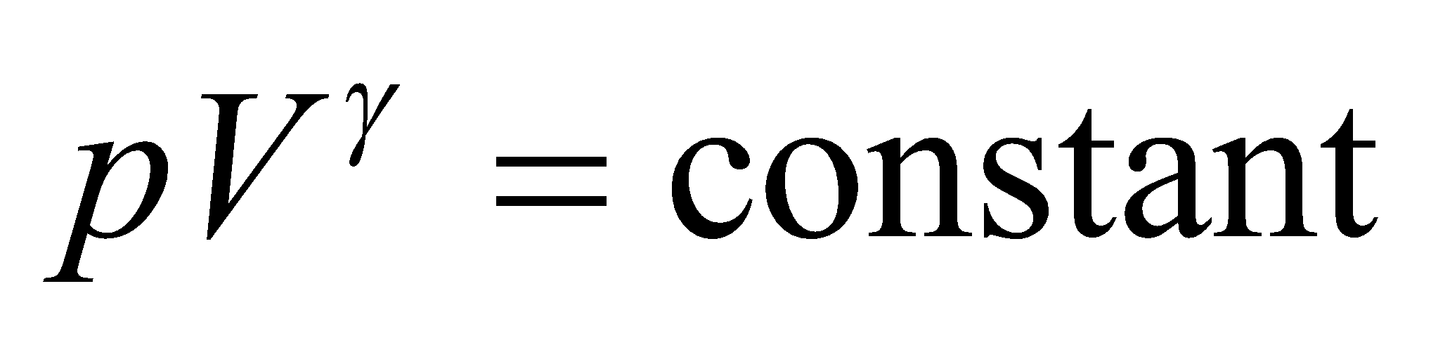for points 1 and 2 and for points 3 and 4, we have 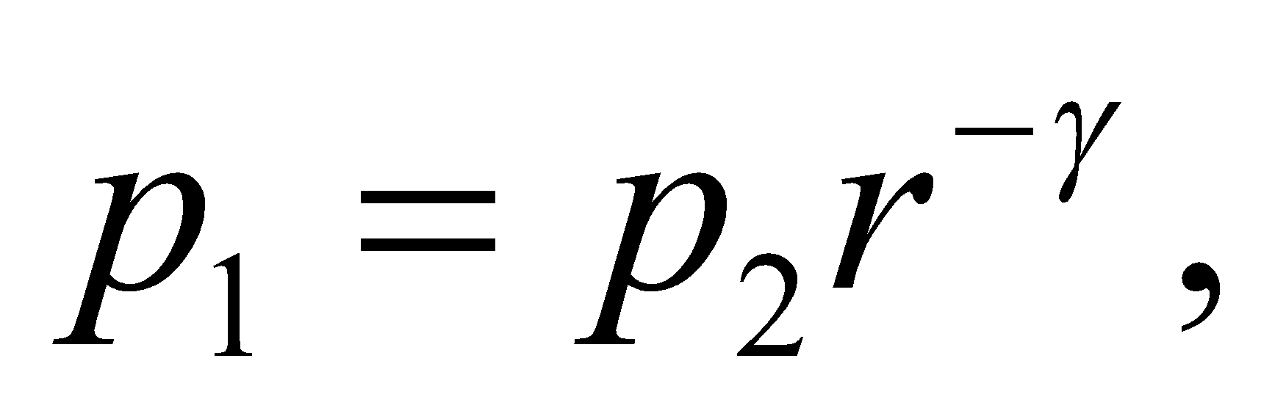and 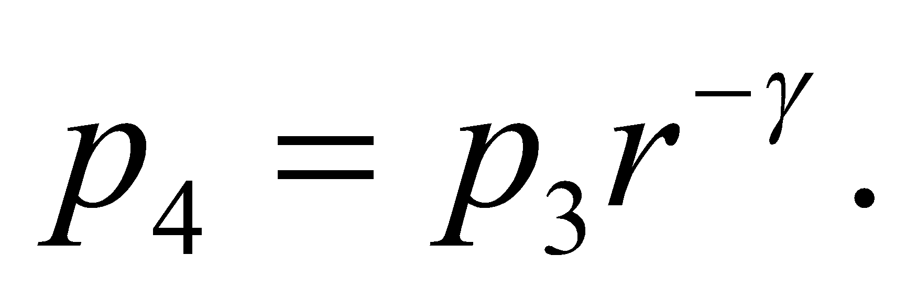 Therefore, the efficiency reduces to

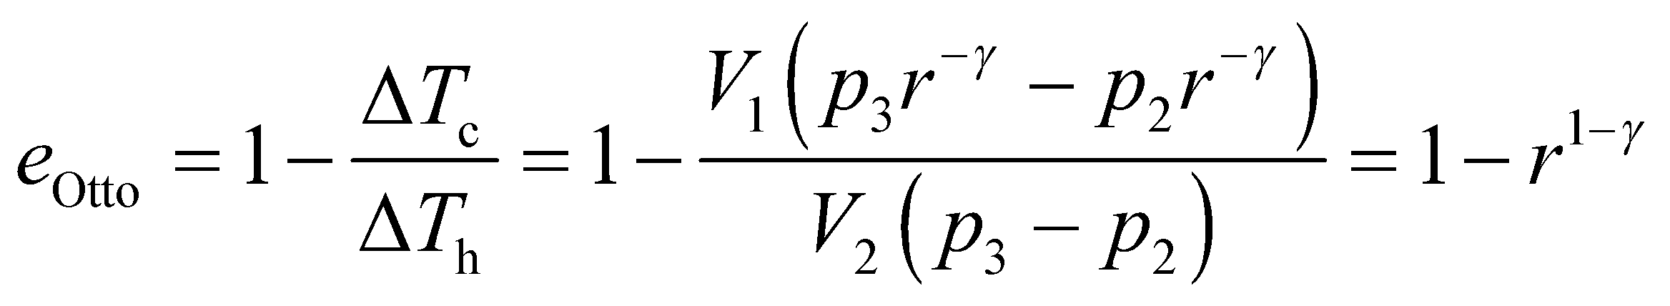

**Assess** Since the efficiency increases for larger *r*, one might assume engineers would try to maximize the compression ratio. In practice, however, the compression ratio cannot be too large, otherwise the fuel pre-ignites, which results in "knocking" that reduces engine performance.

**55. Interpret** Find the maximum efficiency of a power plant, given the temperature range of its cycle. We will calculate the Carnot efficiency, and compare this with the actual efficiency.

**Develop** The high temperature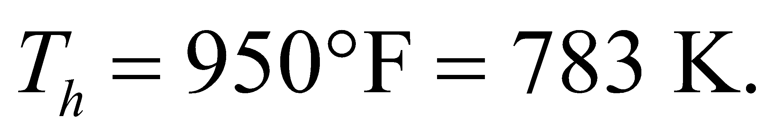The low temperature is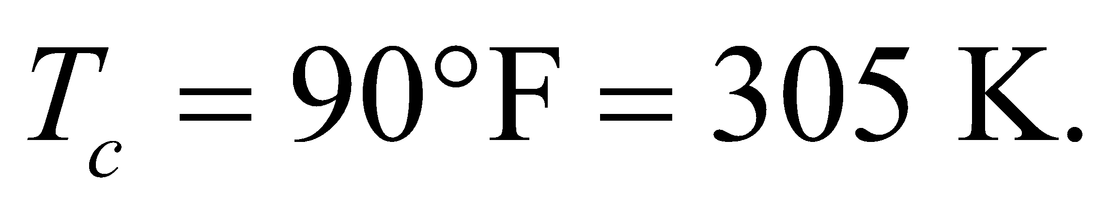The Carnot efficiency is given by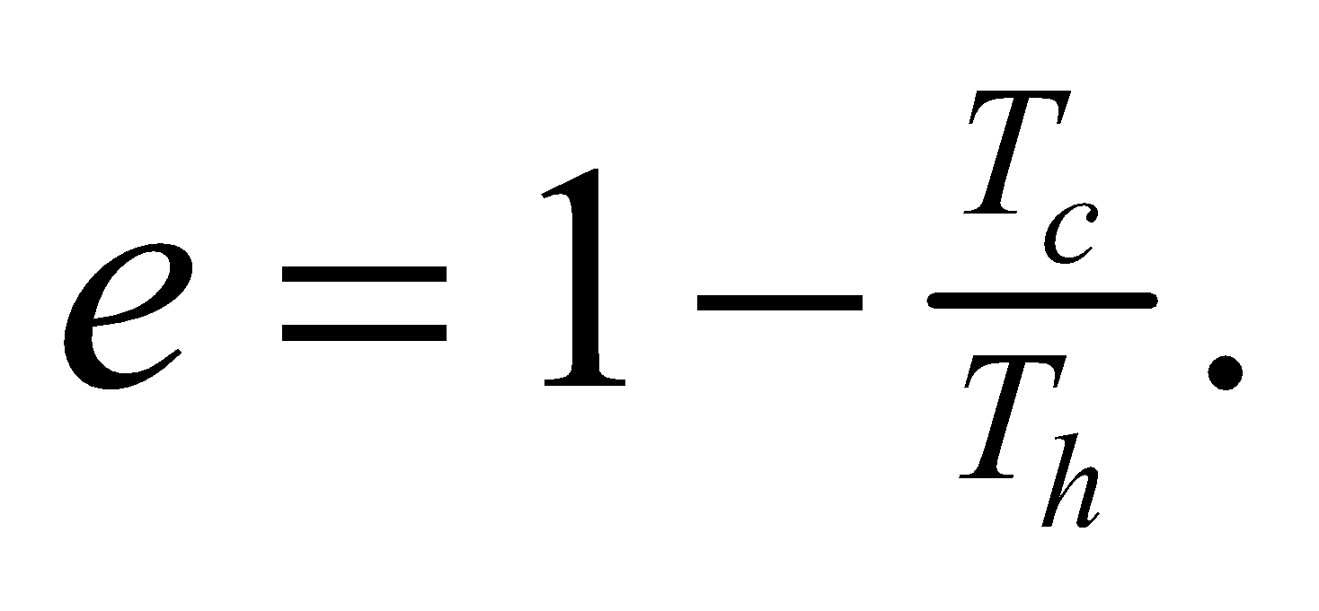

**Evaluate** The maximum efficiency is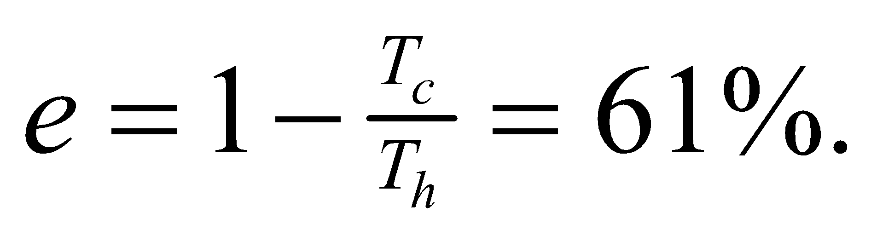

**Assess** The actual efficiency of this plant is given as 25%, which is considerably lower due (at least in part) to having to evaporate moisture out of the wood-chip fuel.

**56. Interpret** We are to find the final temperature and entropy change for a system in which two objects at different temperatures are brought into thermal contact and allowed to come to thermal equilibrium.

**Develop** To find the final temperature, use Equation 16.4, which may be expressed as

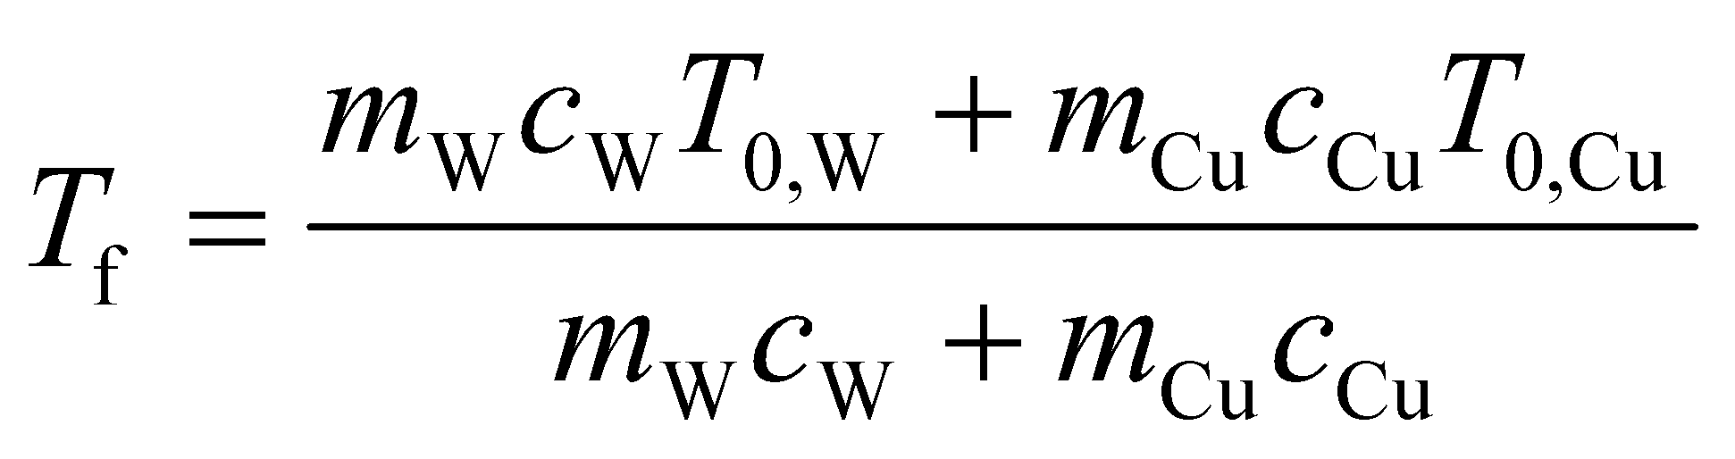

The entropy change is 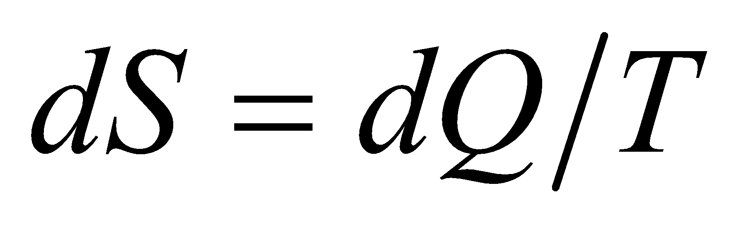 (Equation 19.6), so we can integrate to find the change in entropy for the water and for the copper. The initial temperature and the mass of the copper are 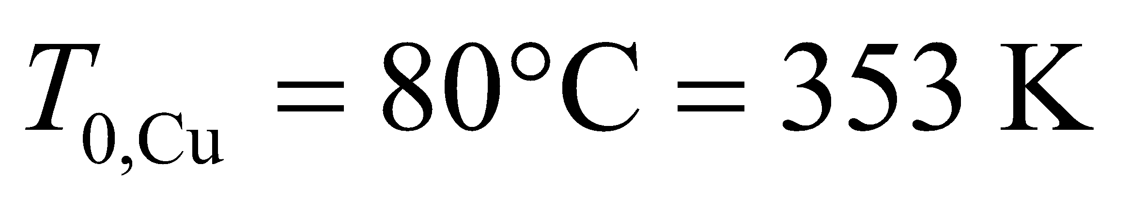 and 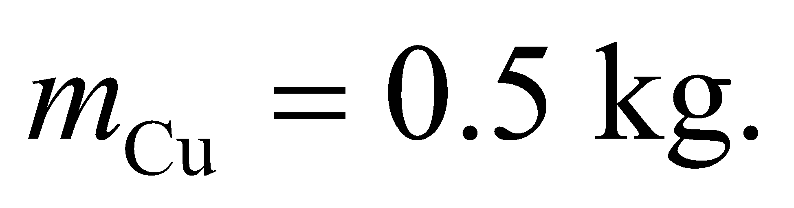 The initial temperature and the mass of the water are 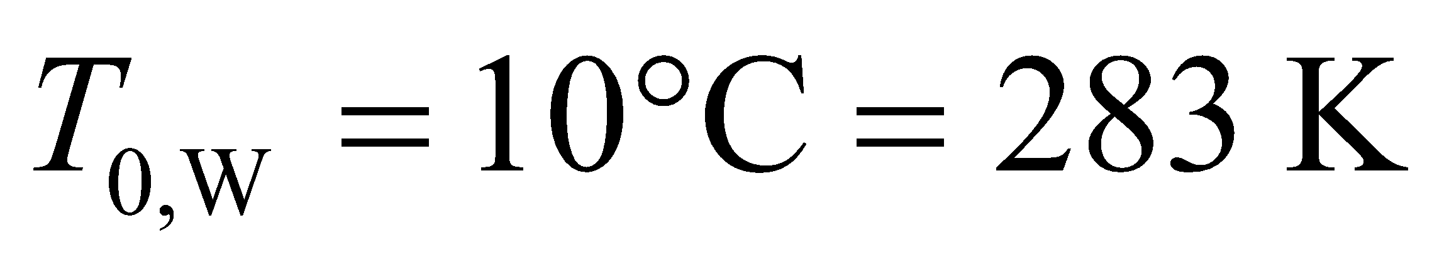 and 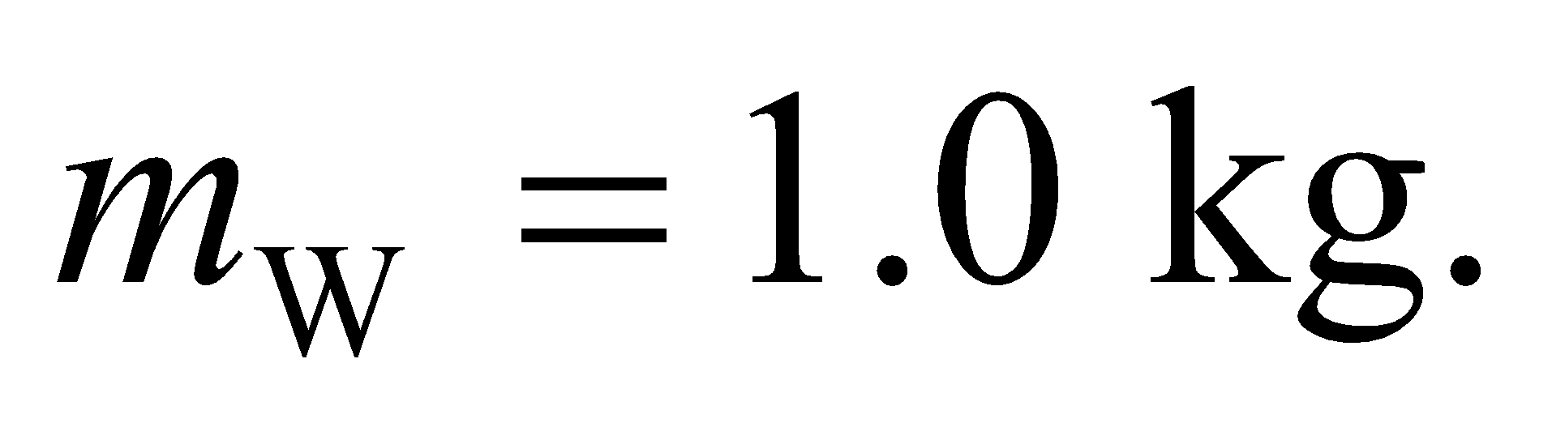 The specific heats *c*W and *c*Cu can be found in Table 16.1.

**Evaluate** **(a)** Inserting the given quantities gives

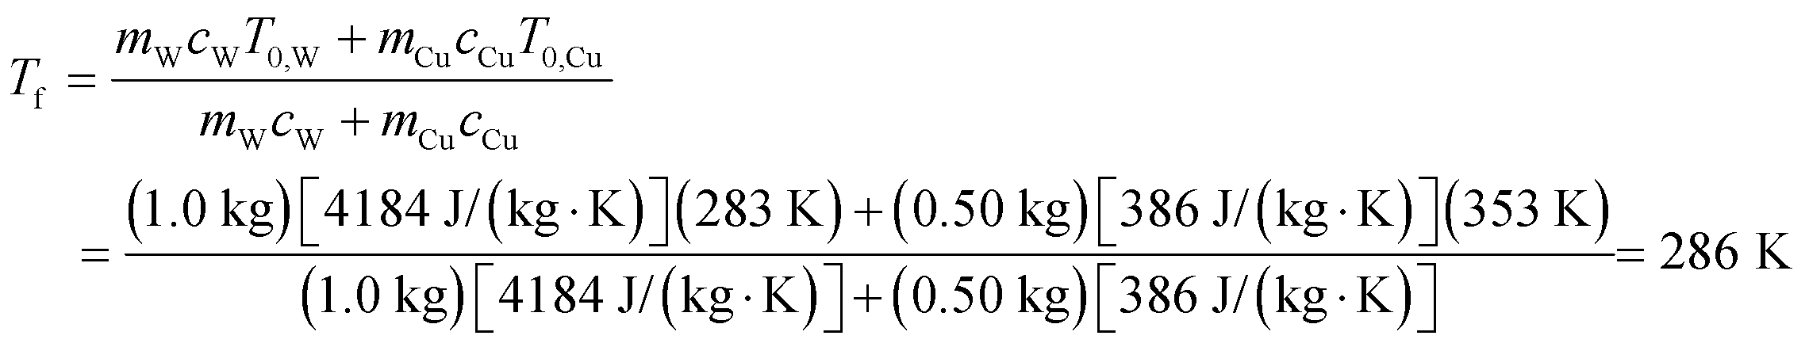

**(b)** The change in entropy for the water and copper are, respectively:

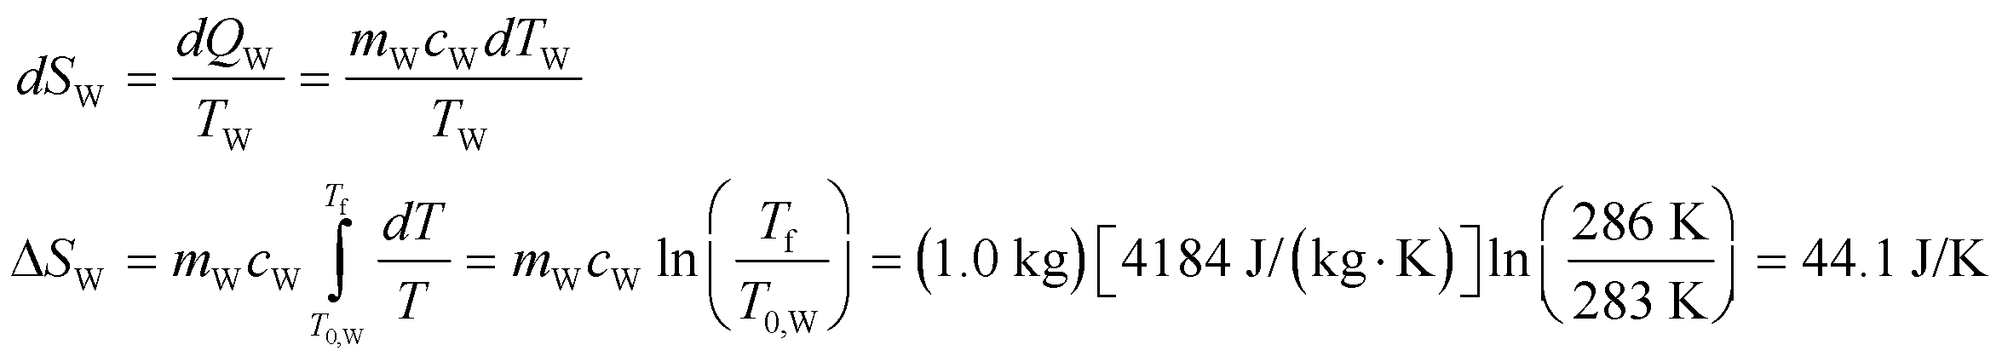

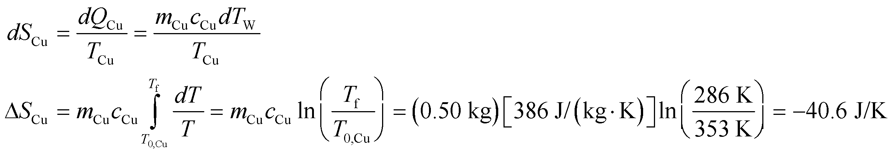

The total change in entropy is 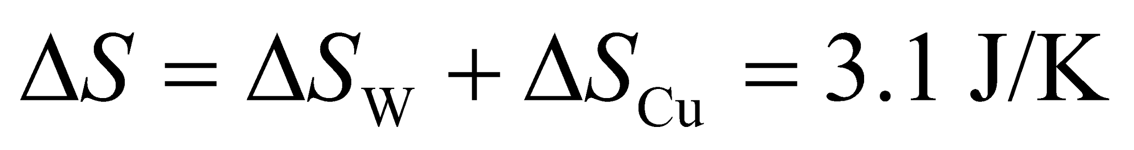.

**Assess** The entropy of the copper actually decreases, but this decrease is more than offset by the increase in entropy of the water. This is an irreversible process, and entropy always increases in irreversible processes.

**57. Interpret** We are asked to calculate the entropy change in an object whose heat capacity is inversely proportional to its temperature.

**Develop** By definition, the heat capacity relates the heat flowing into an object to the change in its temperature: 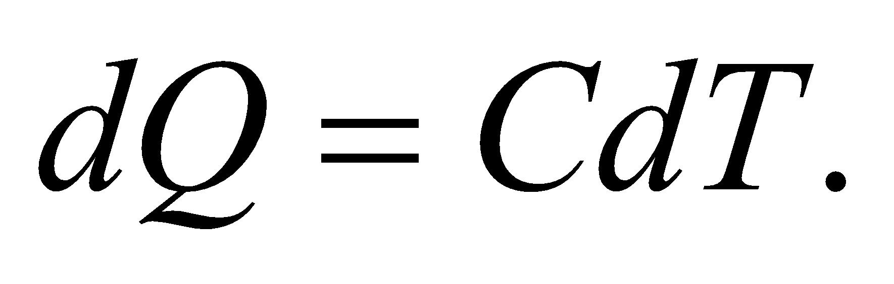In this case, 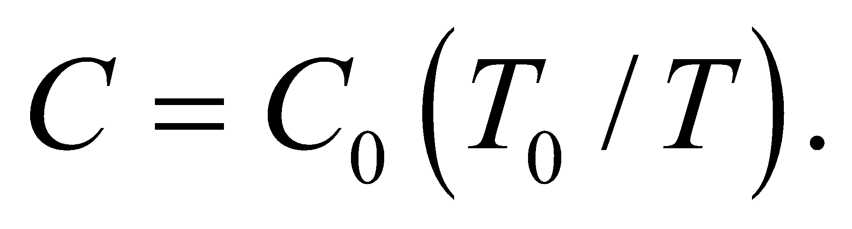We can plug this into Equation 19.6 for the entropy change: 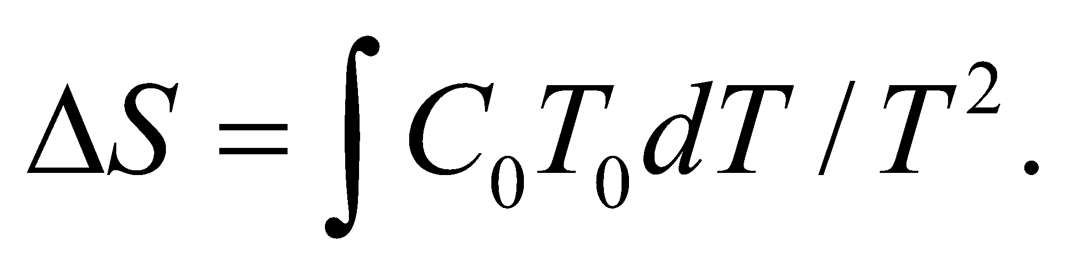

**Evaluate** Performing the integration from 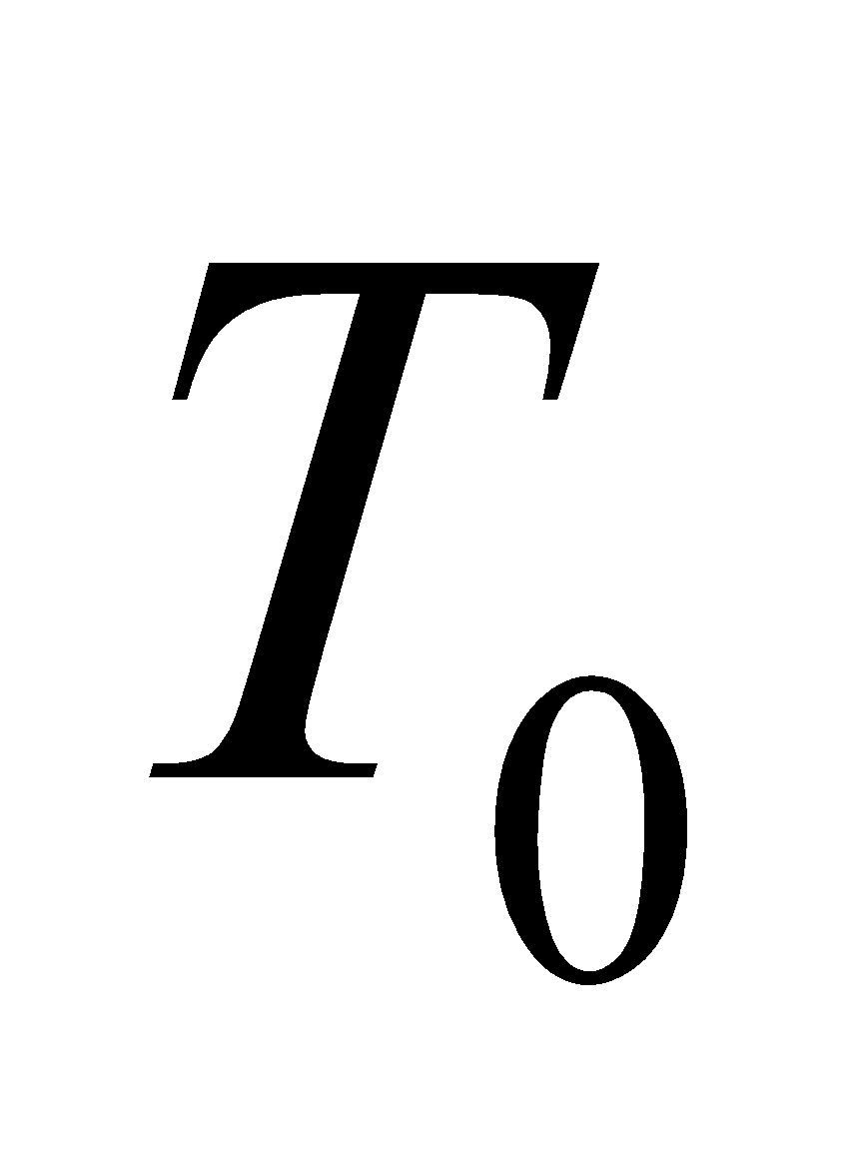 to 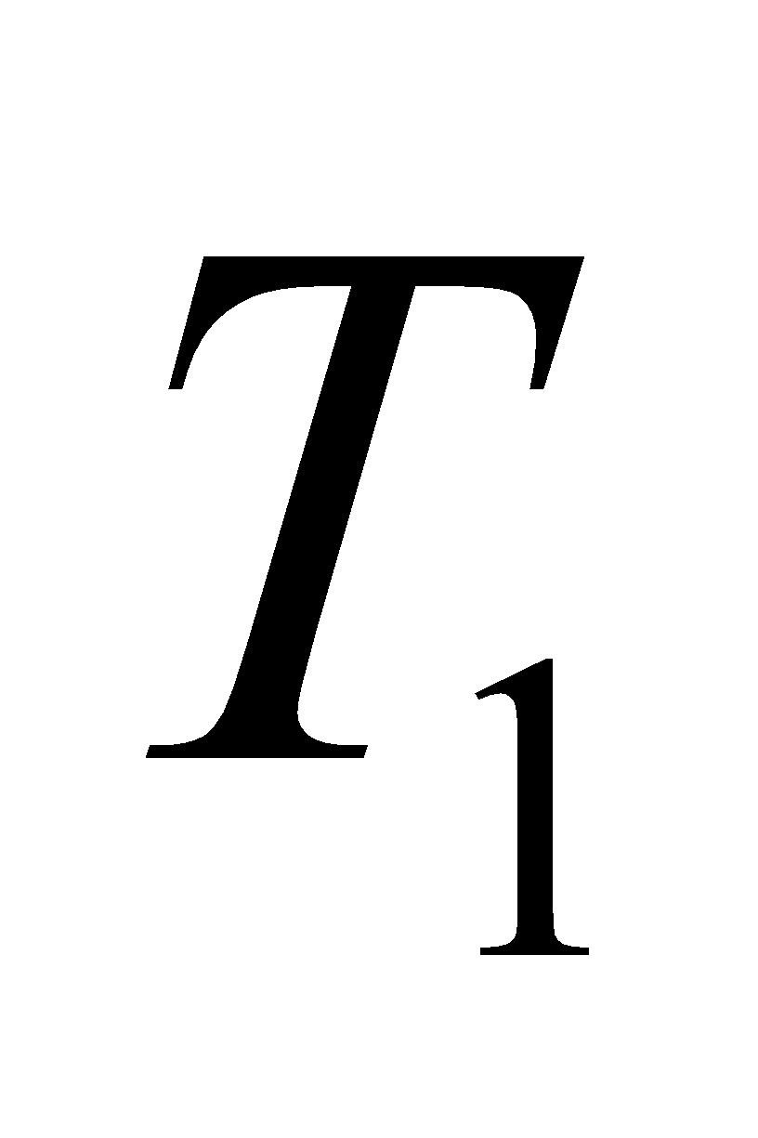:

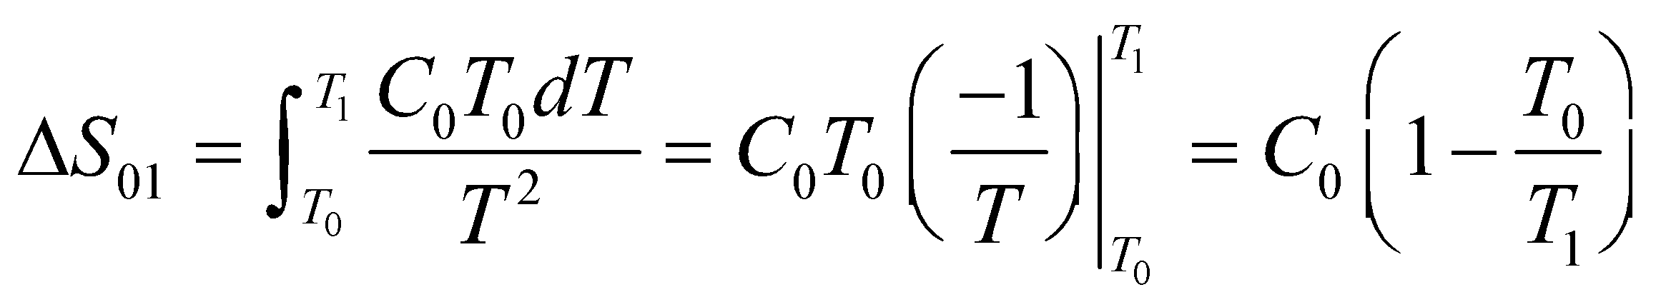

**Assess** For 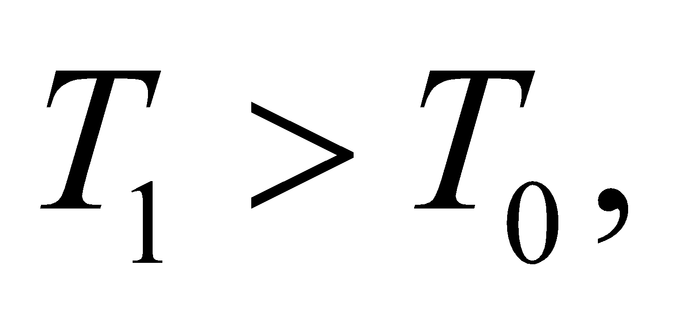 the entropy change is positive. For 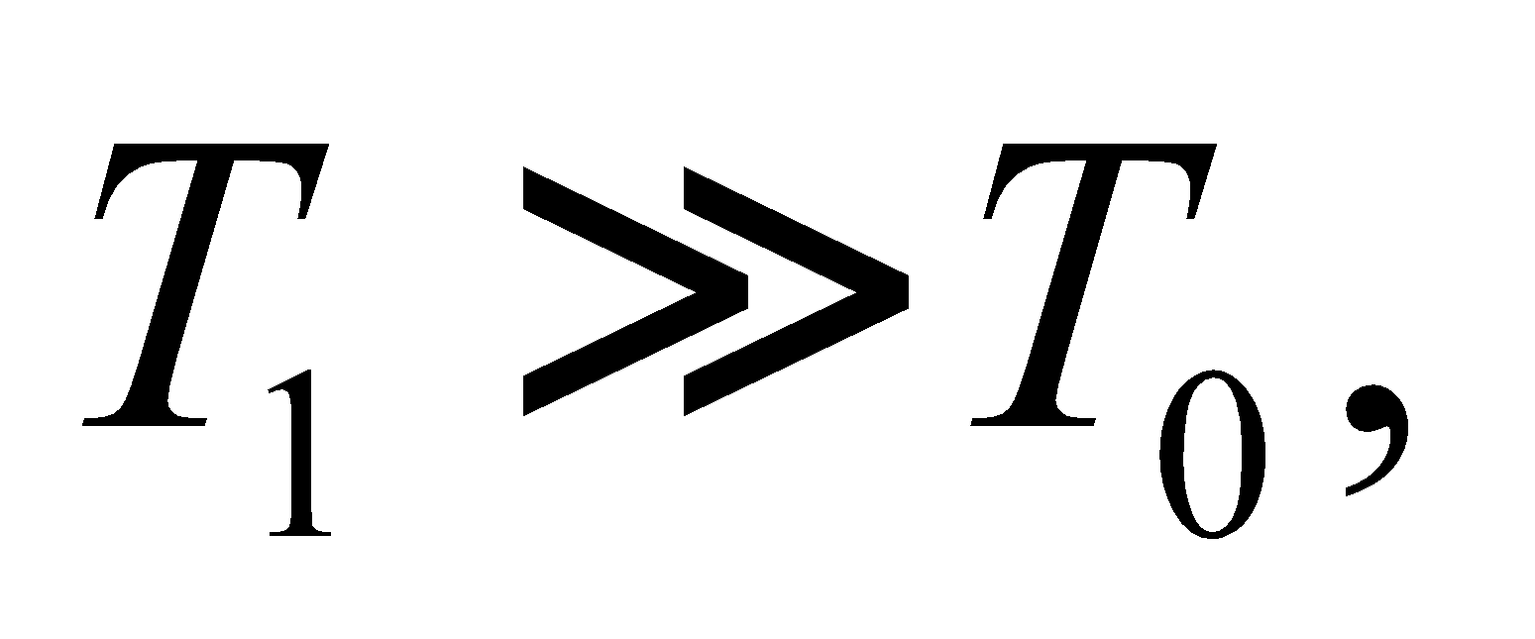the entropy change becomes constant: 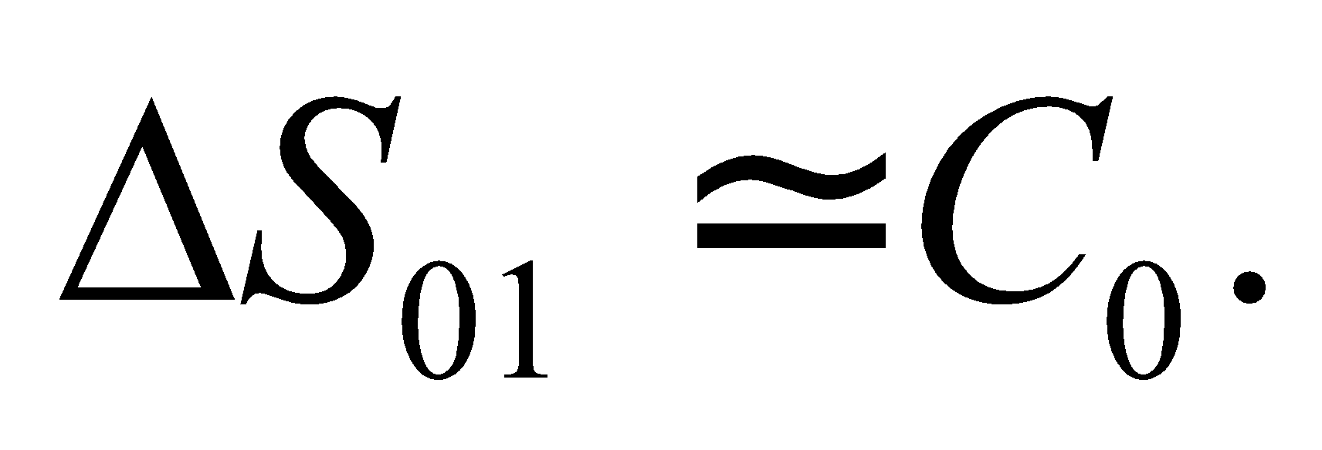

**58. Interpret** This problem deals with a Carnot engine for which the temperature of the heat reservoir varies with time. We are to express instantaneous temperature of the hot reservoir as a function of time and find the time it takes for the engine’s power to reach zero.

**Develop** In time *dt*, the engine extracts heat 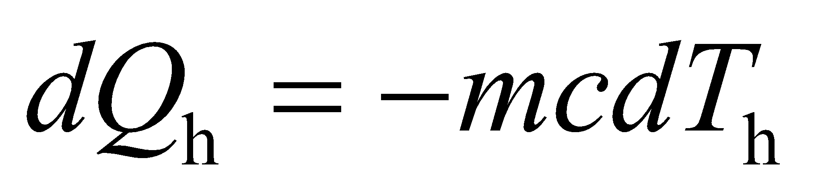 from the block, and does work *dW* = *Pdt*. Equation 19.1 gives the definition of the actual efficiency *e*:

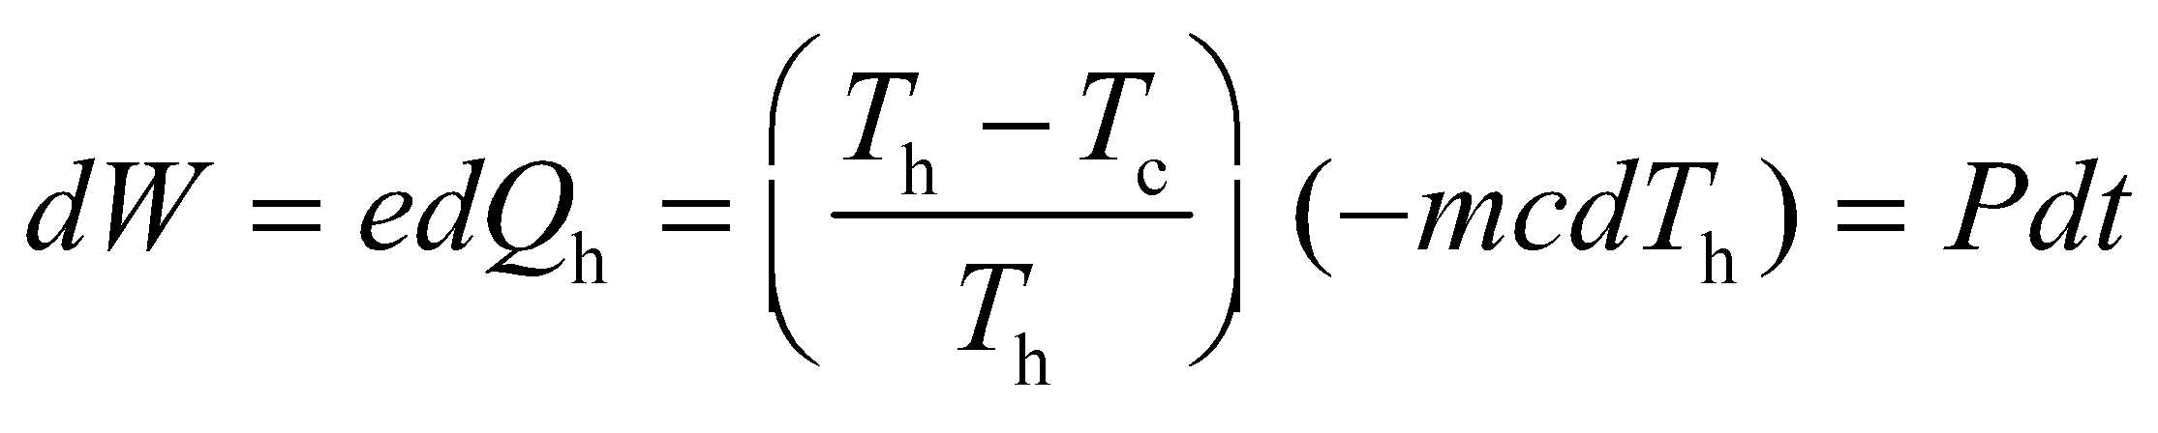

where for the second equality we have used *e* = *e*Carnot = 1 − *T*c/*T*h. The power is also assumed to be proportional to *T*h − *T*c, so this equation becomes

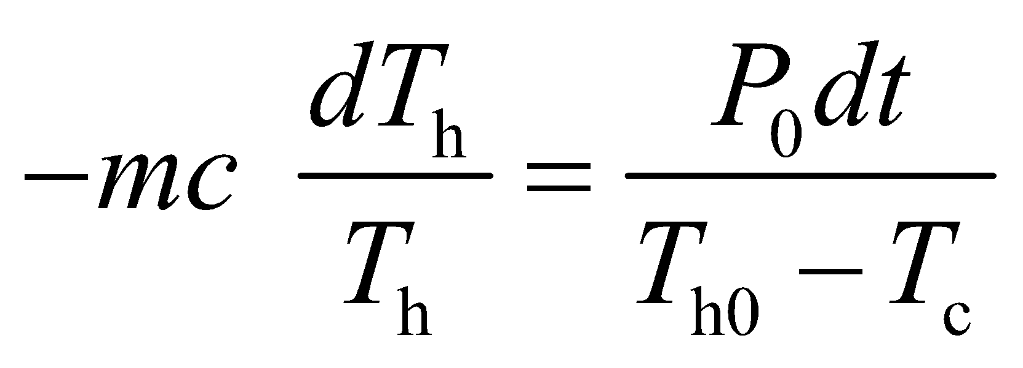

Integrating this expression yields *T*h as a function of time *t*. For **(b)**, note that the power output becomes zero when *T*h = *T*c.

**Evaluate** **(a)** Integrating from *t* = 0 and *T*h0 to *t* and *T*h gives

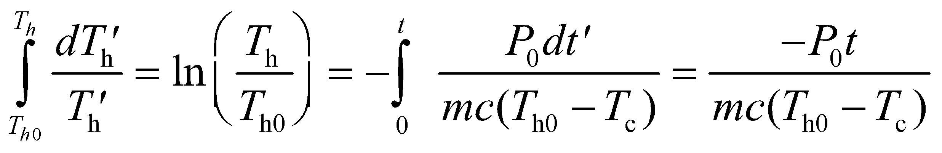

or

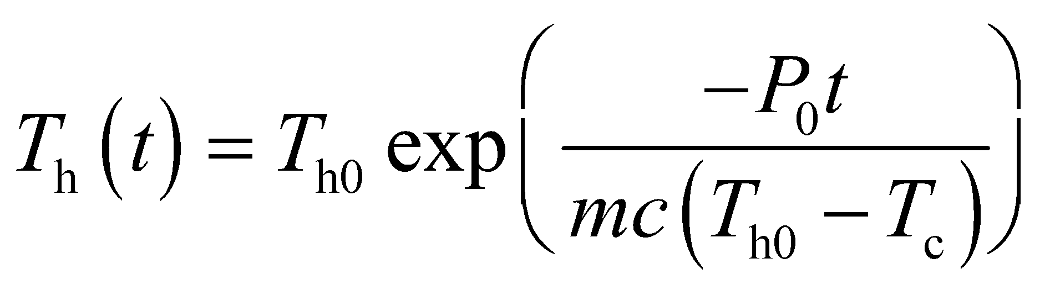

**(b)** The power output is zero for *T*h = *T*c. This occurs at time

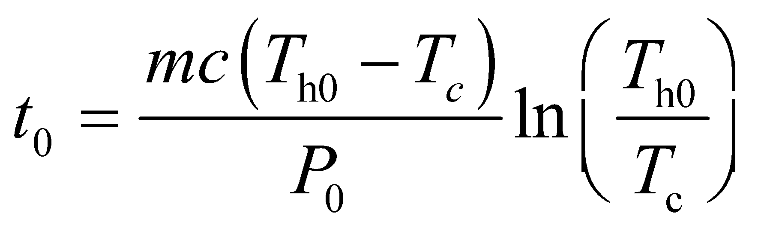

**Assess** We find the instantaneous temperature of the hot block to decrease exponentially with time. At t = 0, 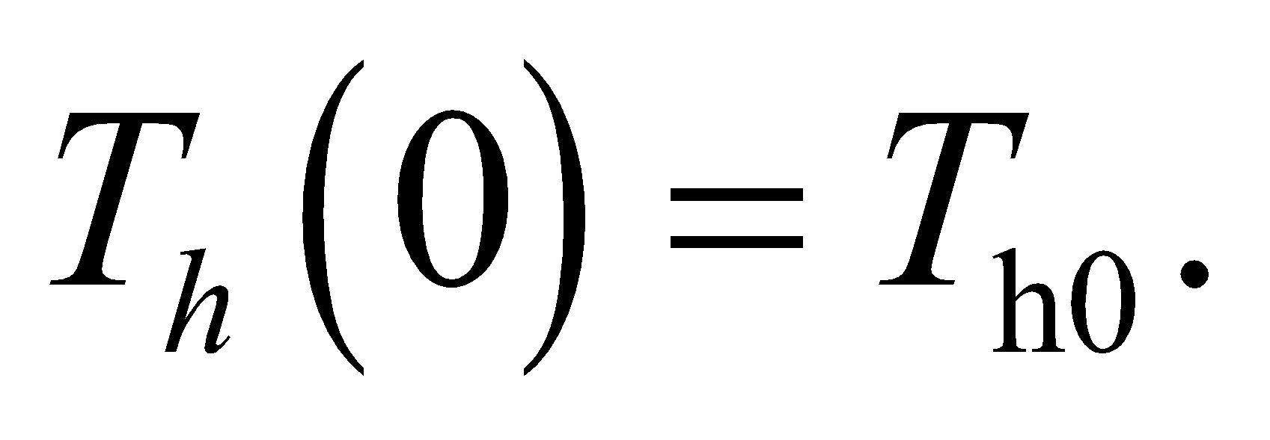 However, for 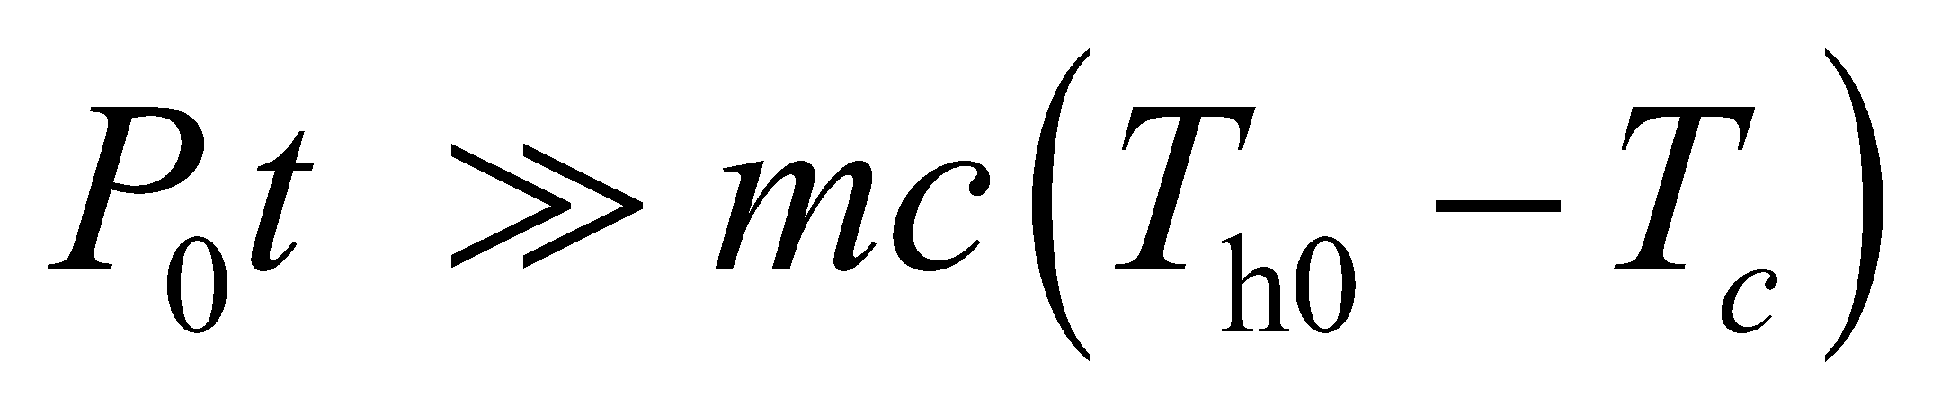 *T*h becomes very small. Note that the expression forwas originally assumed to be valid for 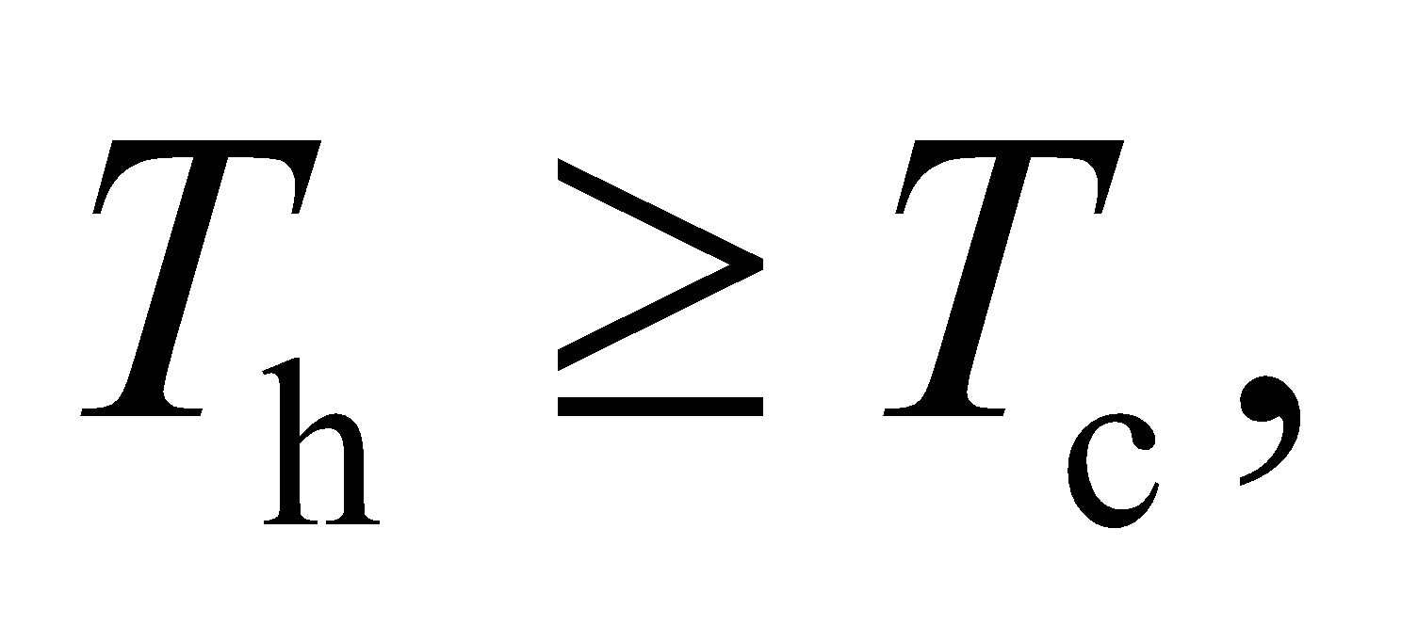 or for times 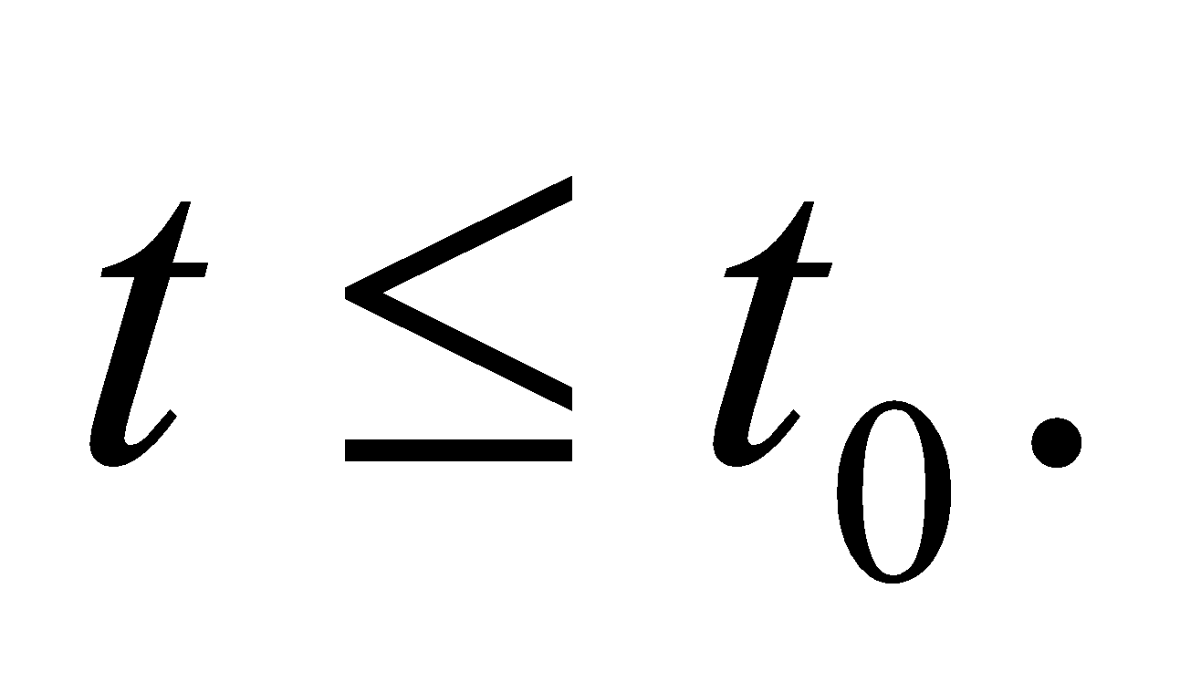 If we allow 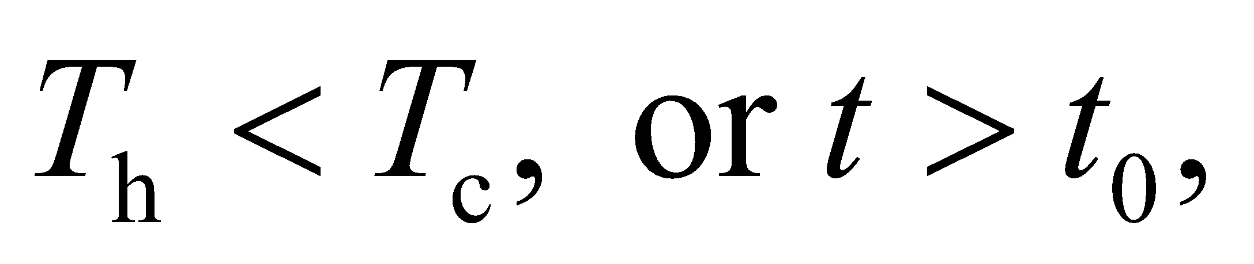 then 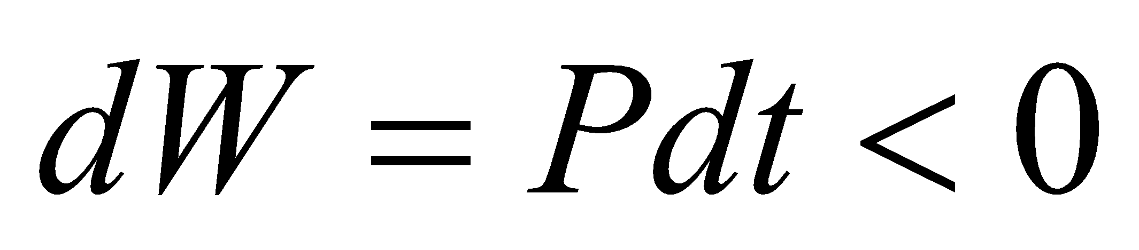 becomes work input to an “engine” which acts like a refrigerator that cools the block.

**59. Interpret** You have an infinite heat reservoir, but a finite cool reservoir. The question is how much work can you obtain with an engine placed between the reservoirs before the cool reservoir is "exhausted."

**Develop** The infinite heat reservoir will maintain its temperature, 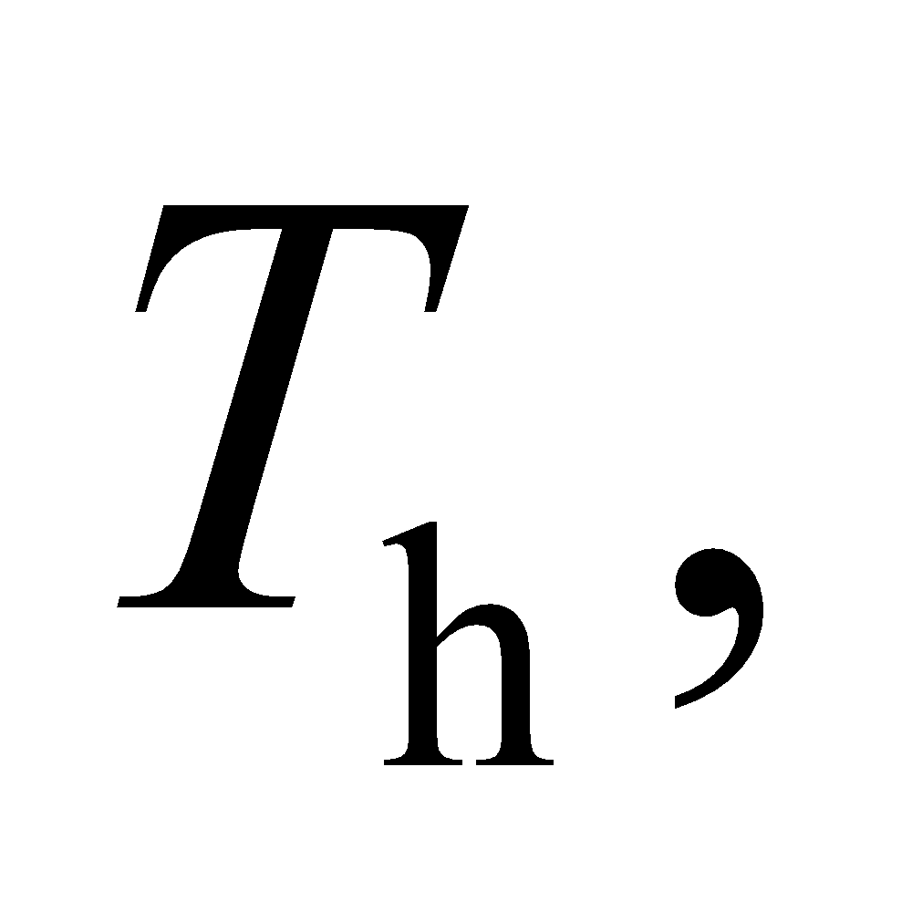no matter how much heat, 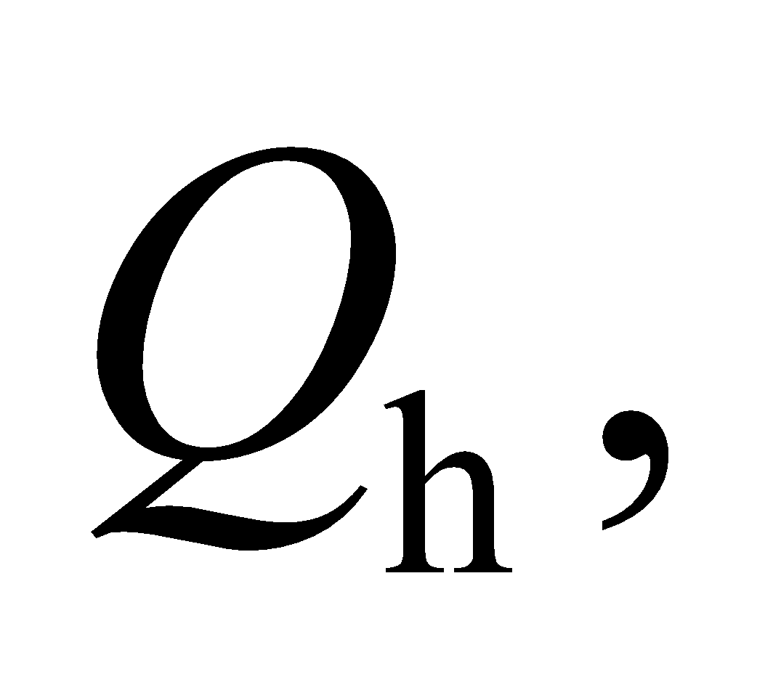 you extract from it. The cool reservoir, on the other hand, will not maintain its initial temperature, 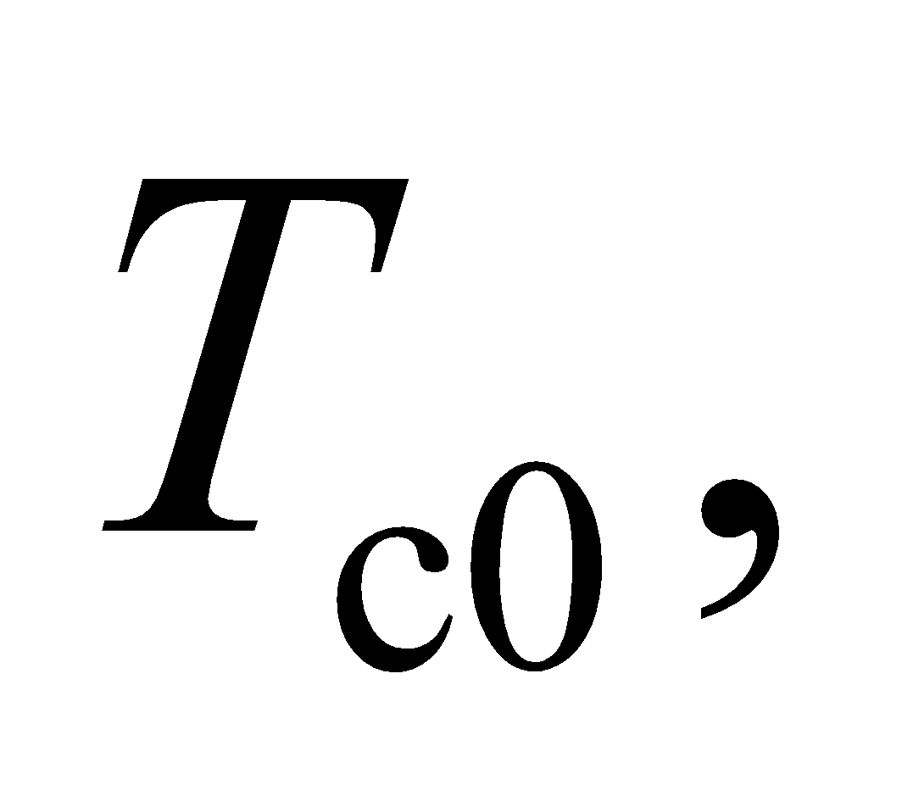as heat from the engine is expelled into it. The temperature will rise in the cool reservoir according to 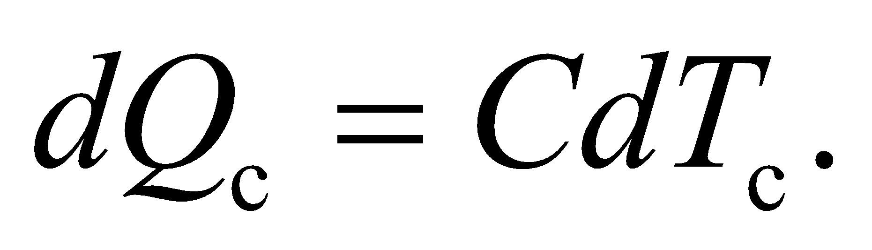 But once the cool reservoir temperature is equal to no more work can be extracted.

**Evaluate** You can assume that the engine cycles fast enough that during a single cycle the cool reservoir temperature is approximately constant. To maximize the amount of work that you extract, place a Carnot engine between the reservoirs so that the work extracted during one cycle is:

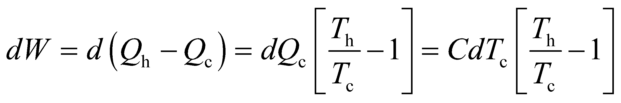

where 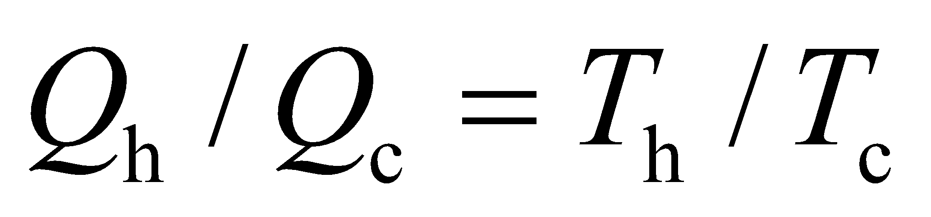 for a Carnot engine. To find the total work, integrate this expression from 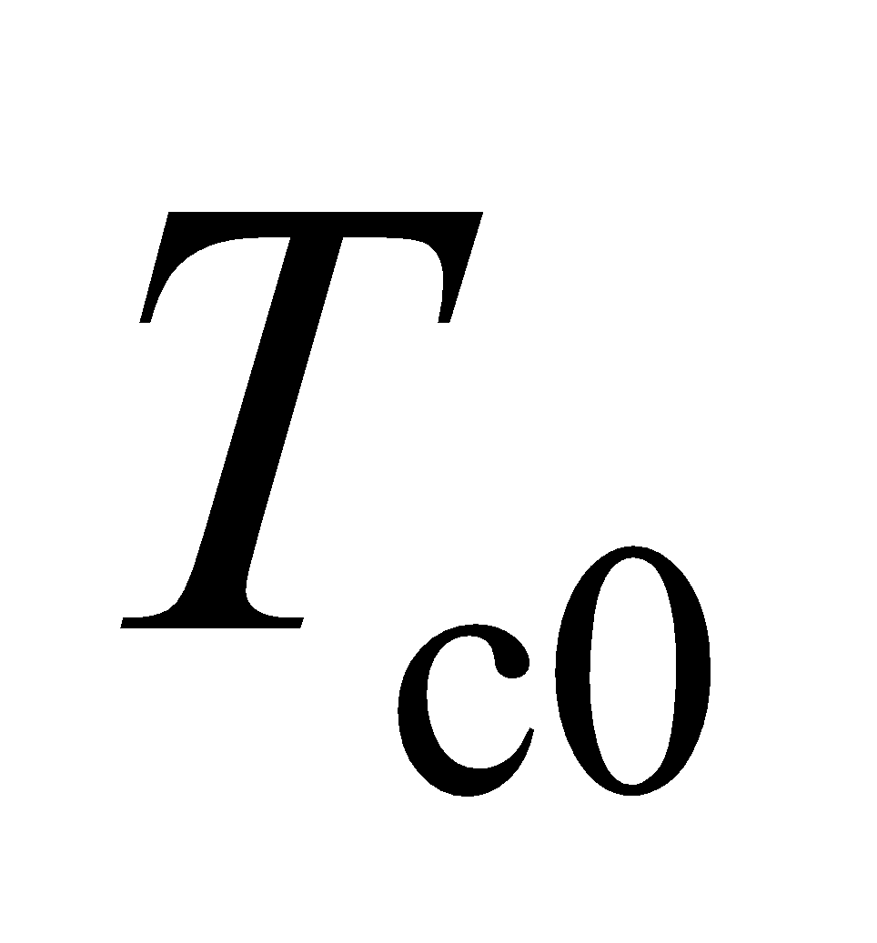 to 

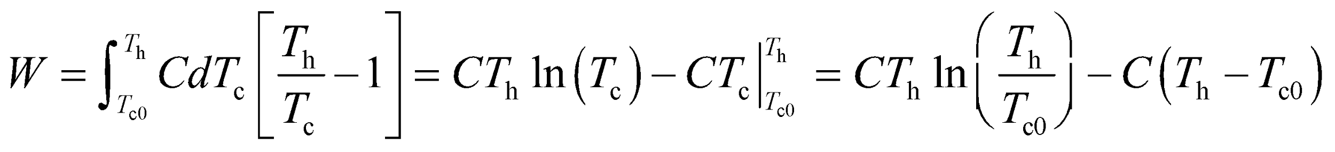

If we let 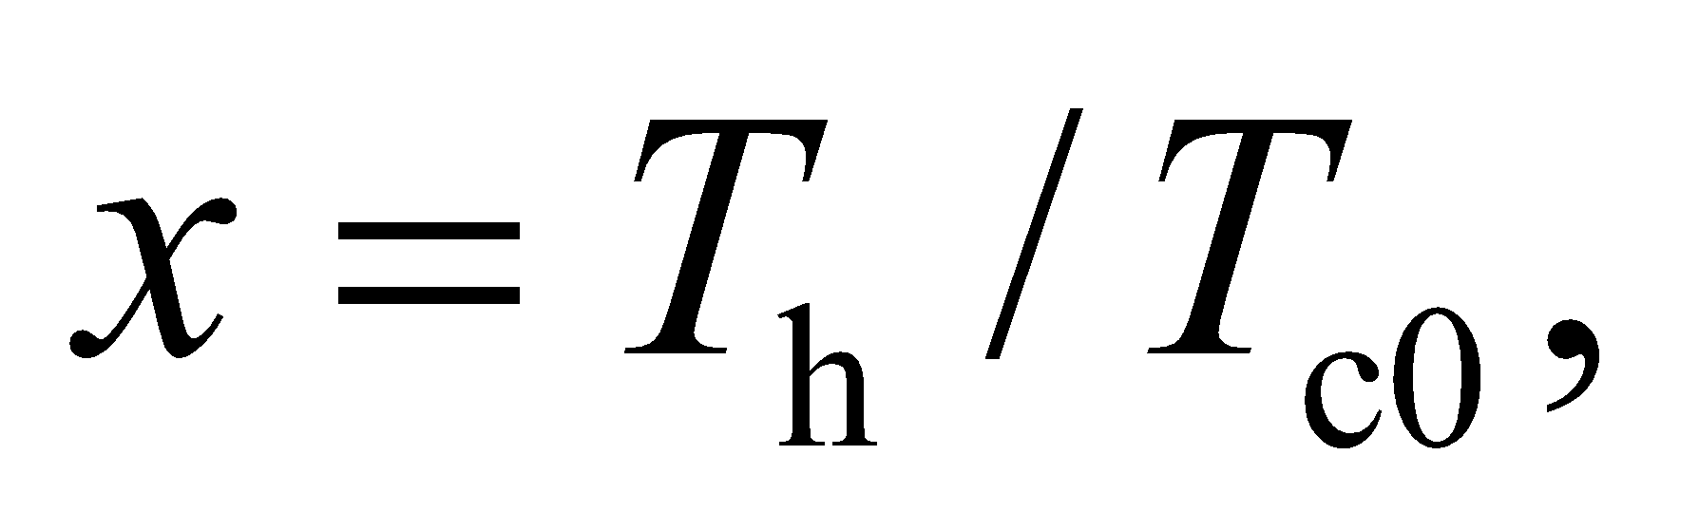then 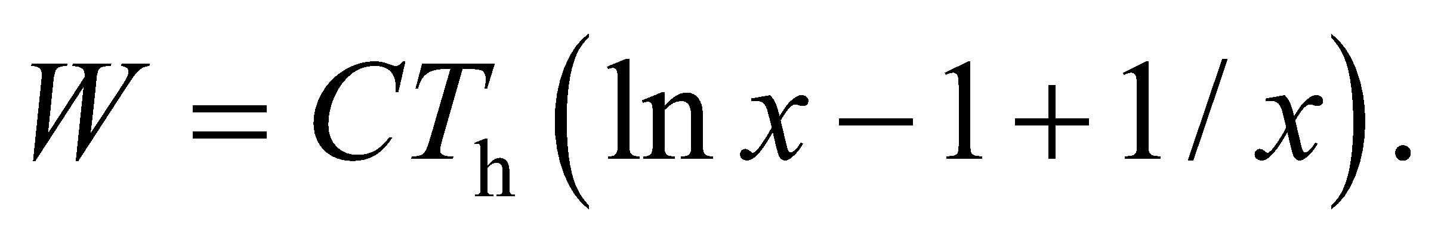

**Assess** The work is proportional to the heat capacity, as you might expect. The heat capacity is a measure of how much heat the cool reservoir can accept, so the larger the heat capacity, the more work that can be extracted. You might worry that the work could be negative for some value of 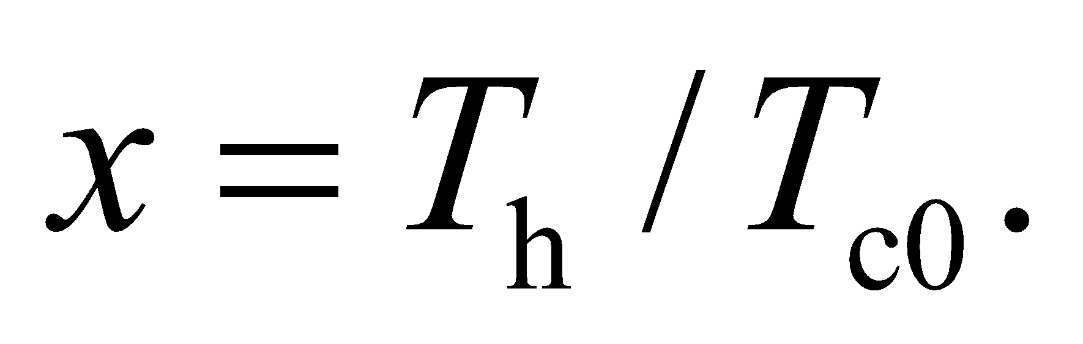 For 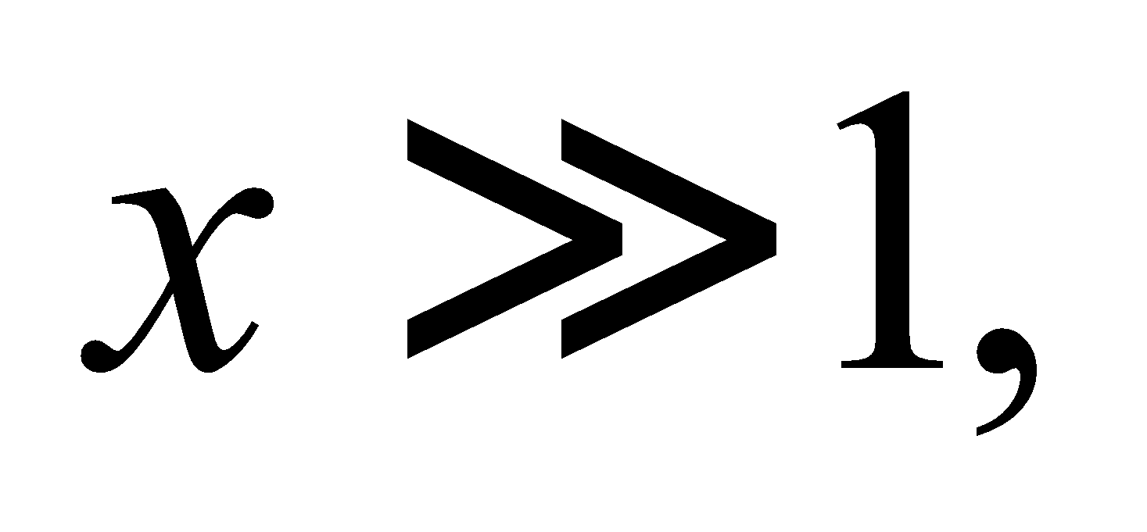the work is approximately 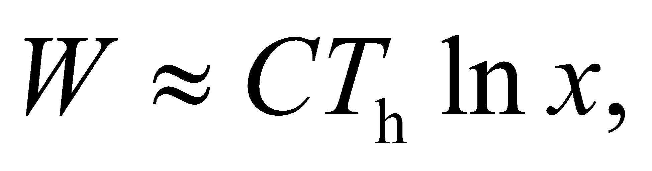 which is positive. For 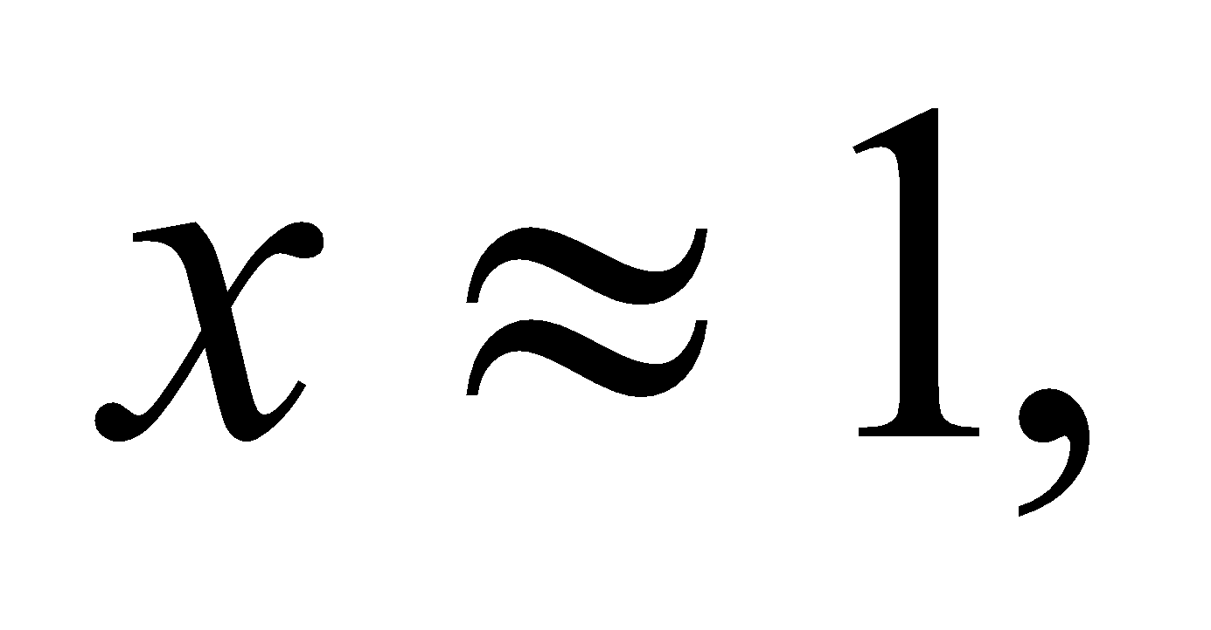 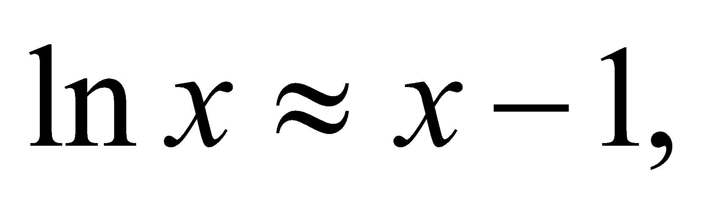and the work is approximately 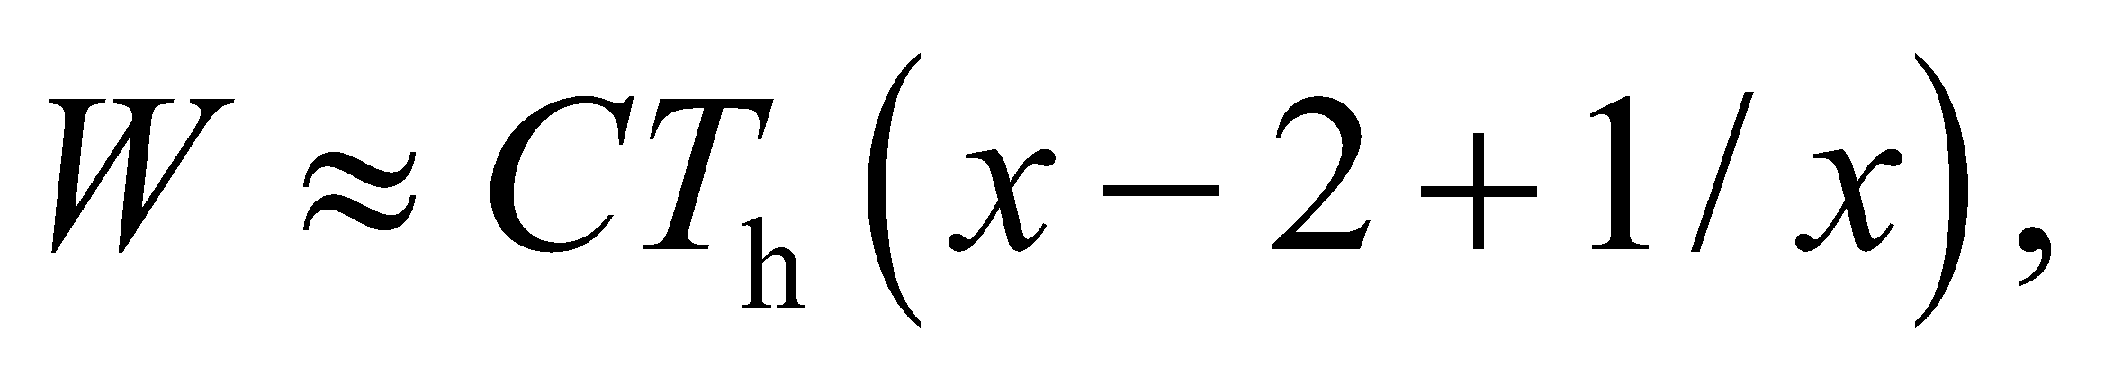which is positive as well. Therefore, the work extracted is positive for all possible temperature differences.

**60. Interpret** You want to know how much the temperature of a river will increase when heat exhaust from a power plant is absorbed by the water.

**Develop** Since the plant has an efficiency of 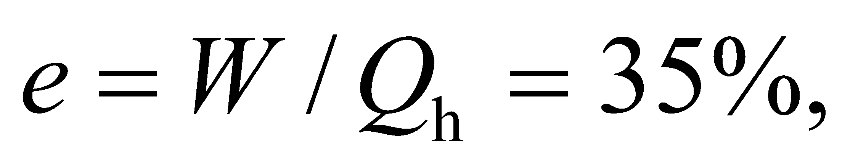 the rate at which it is generating waste heat must be:

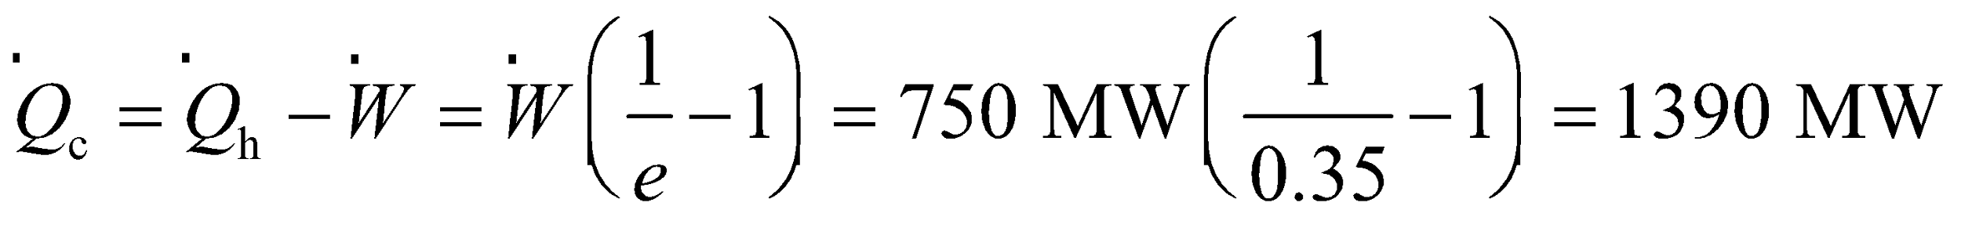

where the dots here signify that these are rates, e.g. 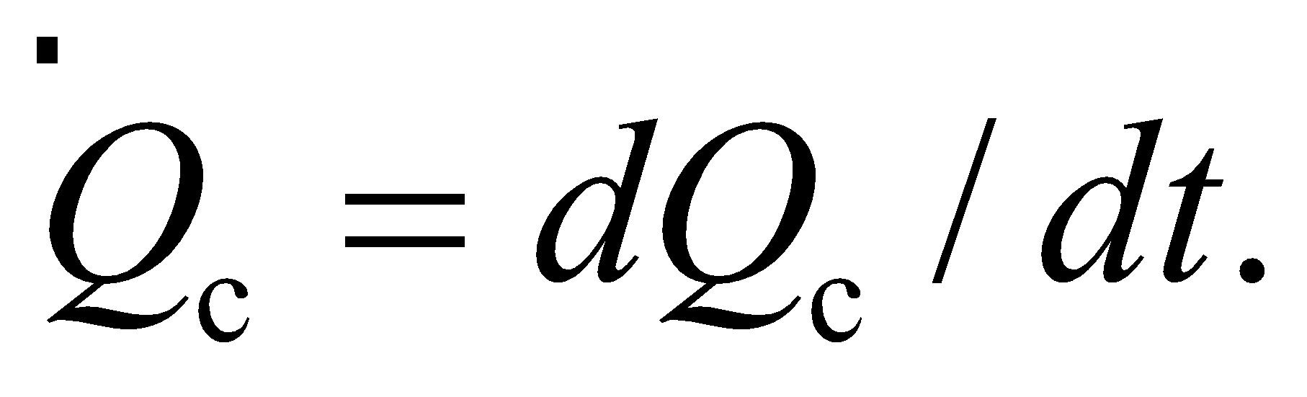 The rate at which water is flowing past the plant is given by the volume rate: 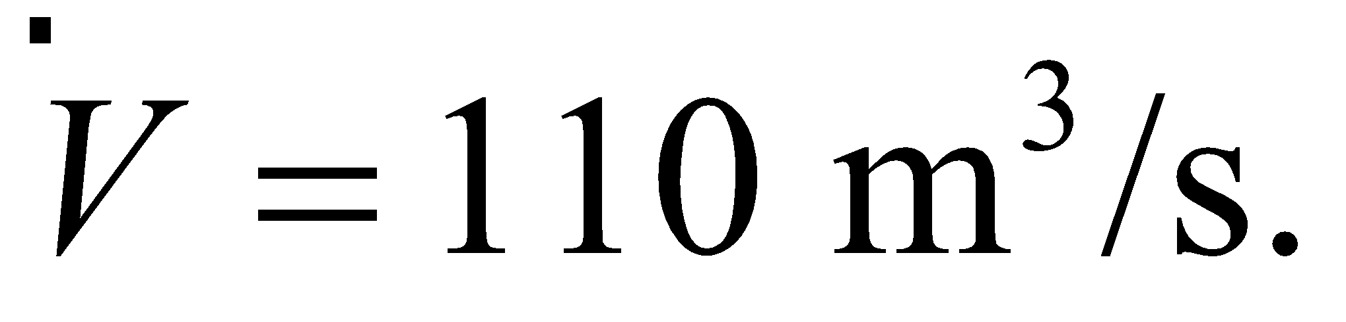 To better understand how the heat flows into the flowing water, it might help to "freeze" both flows and just imagine what is happening over a short period of time, 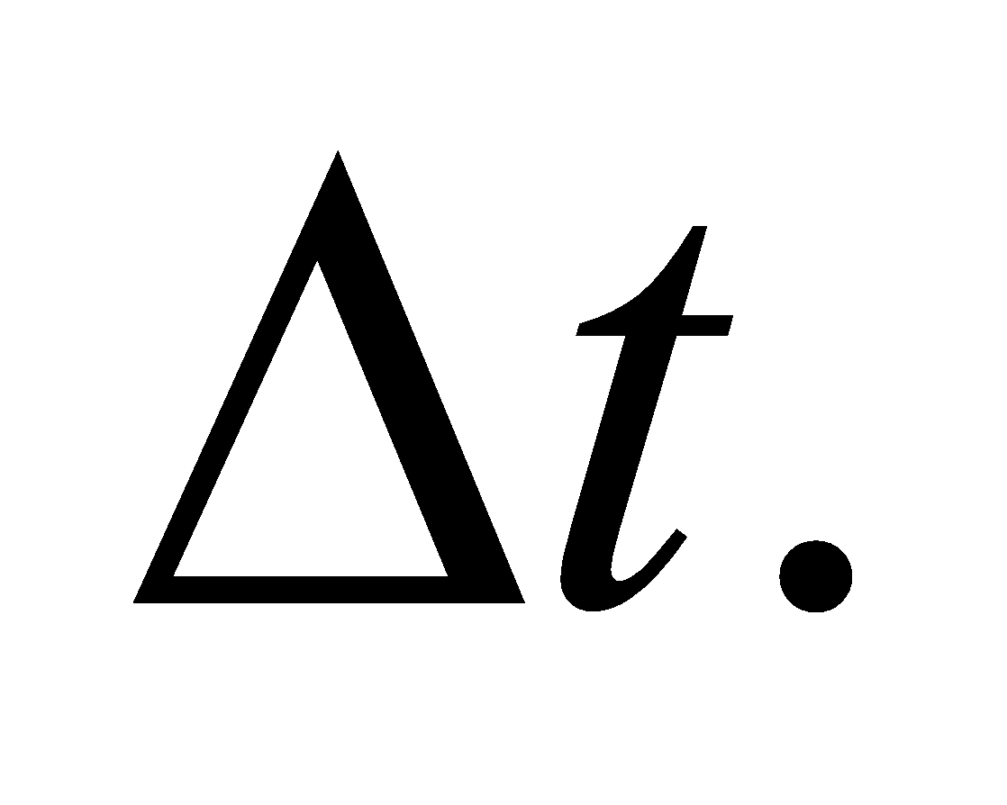In this case, the plant expels a finite amount of heat, 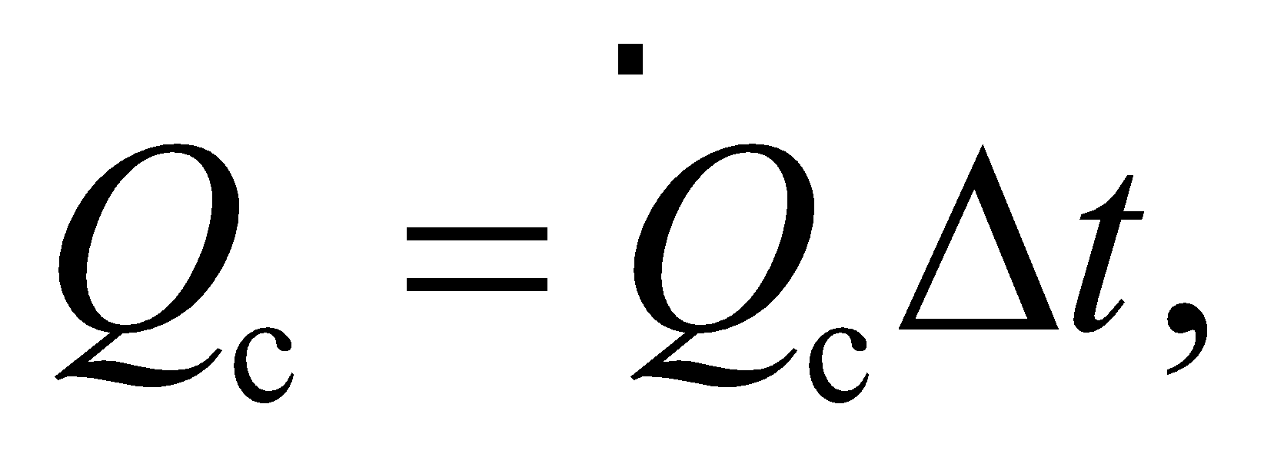into a volume of water 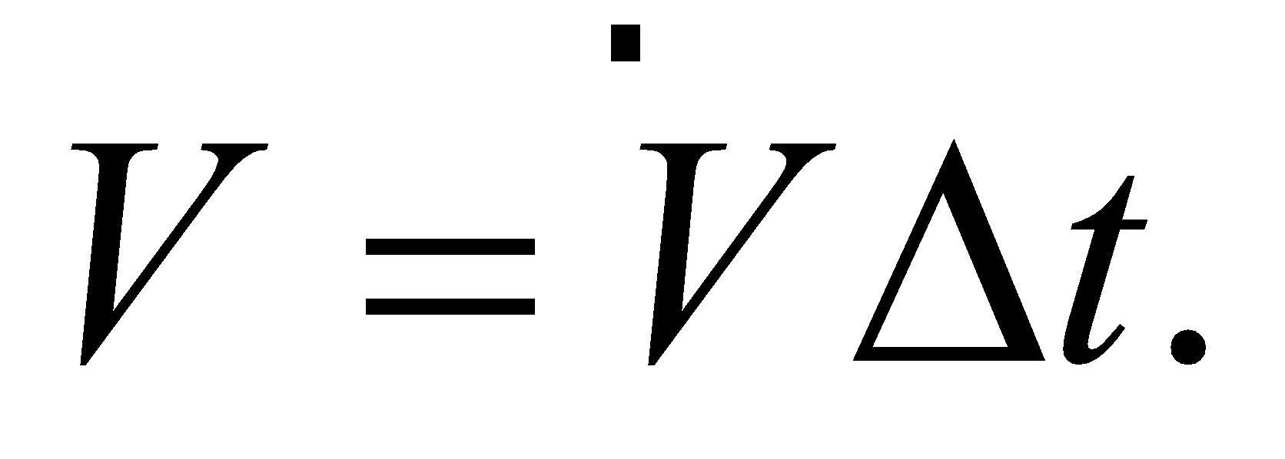See the figure below.



This volume of water will rise in temperature according to: 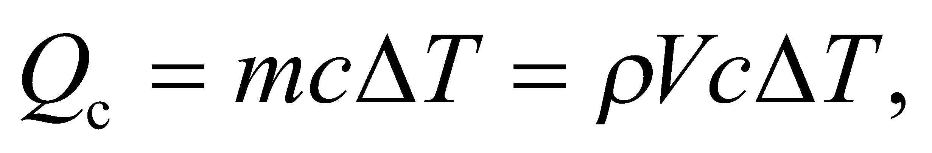where 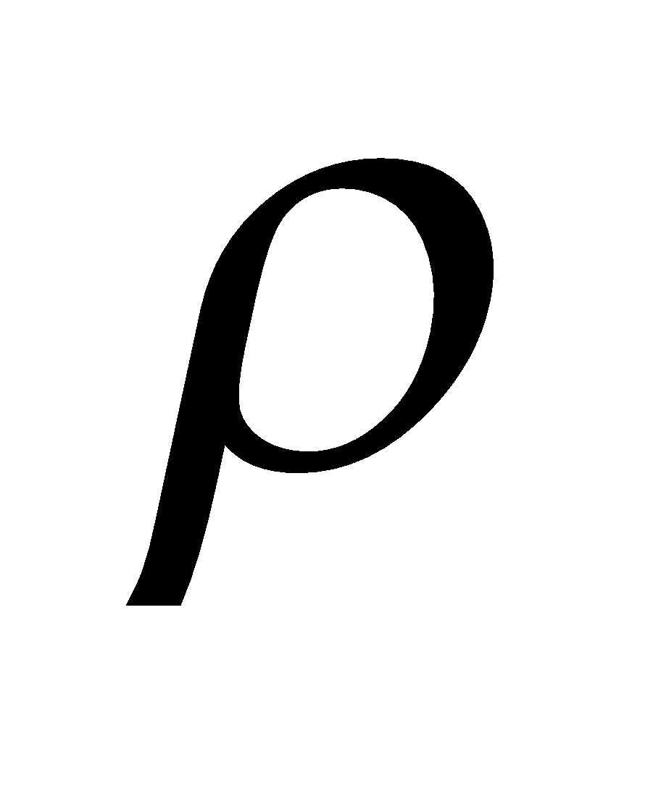is the density of water and *c* is the specific heat. You can use the equations formulated here to check that the temperature rise is below the environmental regulation.

**Evaluate** Solving for the temperature change of the water:

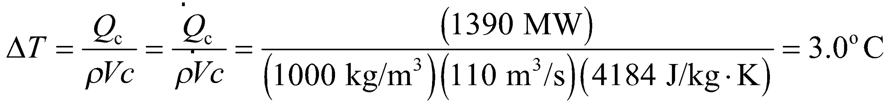

The temperature rise is below the regulated limit.

**Assess** The river makes for a good reservoir, since the flow will constantly bring cool water that has yet to be heated by the plant's exhaust.

**61. Interpret** We're asked to find the entropy change when hot and cold water are mixed together. Since the hot and cold water can't be unmixed, Equation 19.6 doesn't apply directly, but you can find a reversible process that mimics this irreversible mixing.

**Develop** Before mixing, imagine cooling the hot water and warming the cold water until they are both at 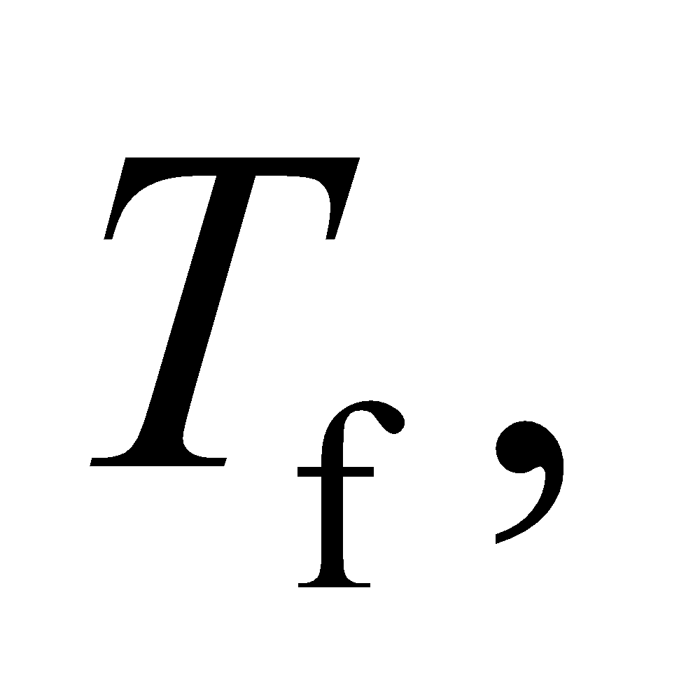which is the final temperature when the water volumes are irreversible mixed. After the temperatures are equilibrated, the two water samples can simply be added together. This is a reversible process, since we could easily divide the mixed water in half and re-warm one sample and re-cool the other to the original temperatures. But as the final state is the same as in the irreversible mixing case, we claim that the entropy change applies to both system paths.

**Evaluate** The differential heat flow in both the warming and cooling processes is 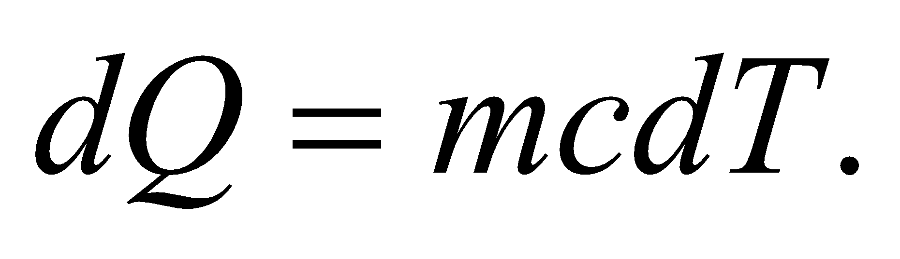The entropy change, therefore, in cooling the hot water from  to 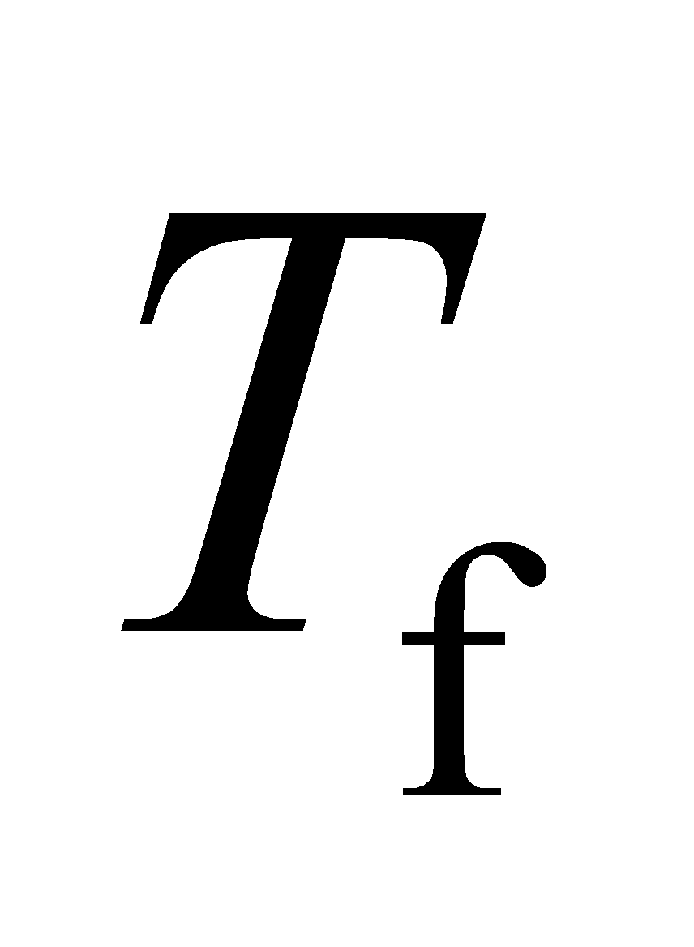 is

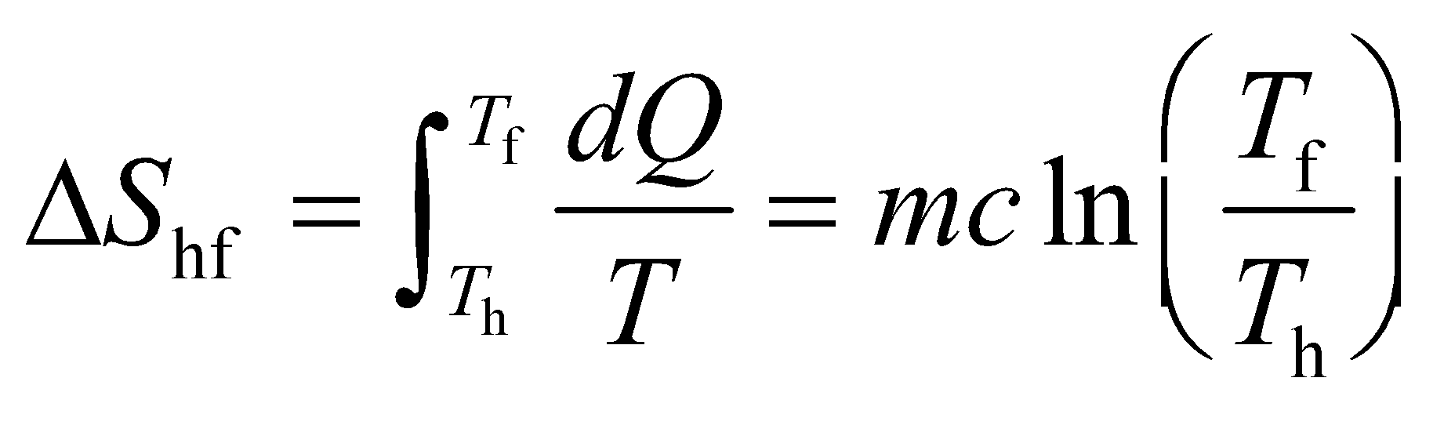

Similarly, the entropy change in warming the cold water from 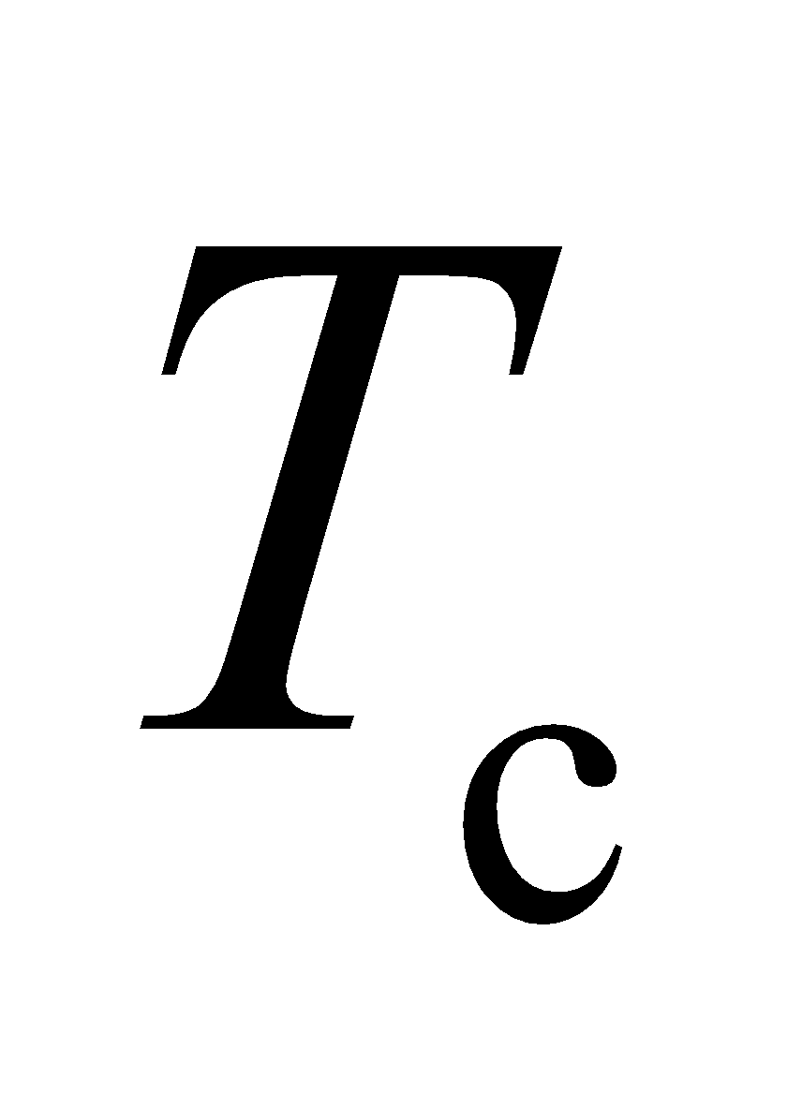 to  is

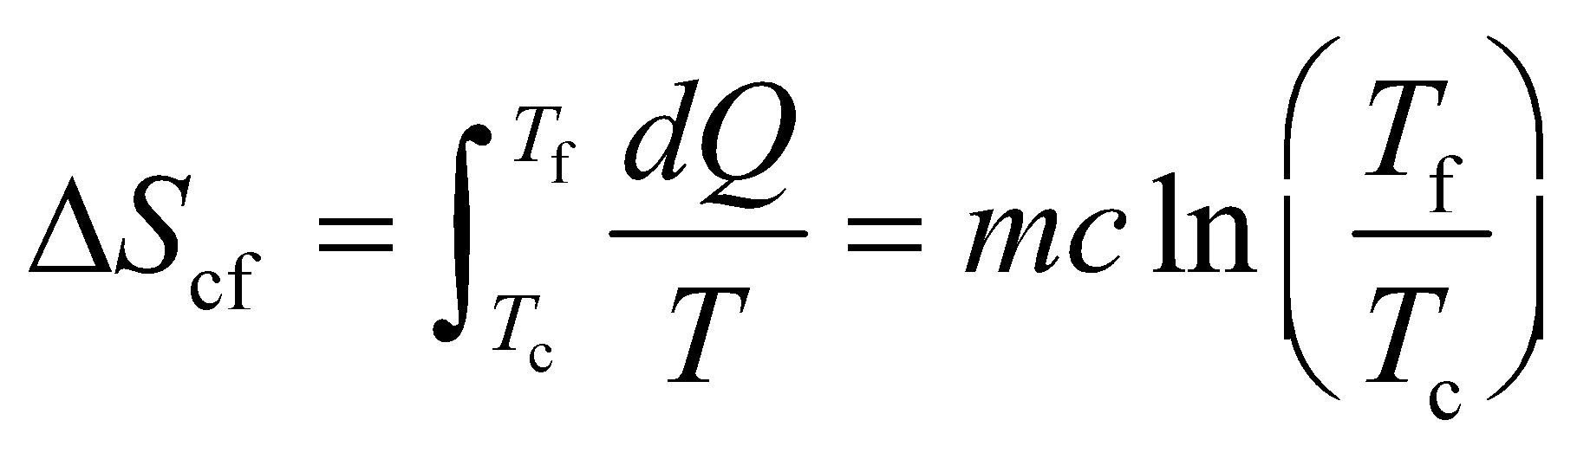

Adding these entropy changes together for the total gives:

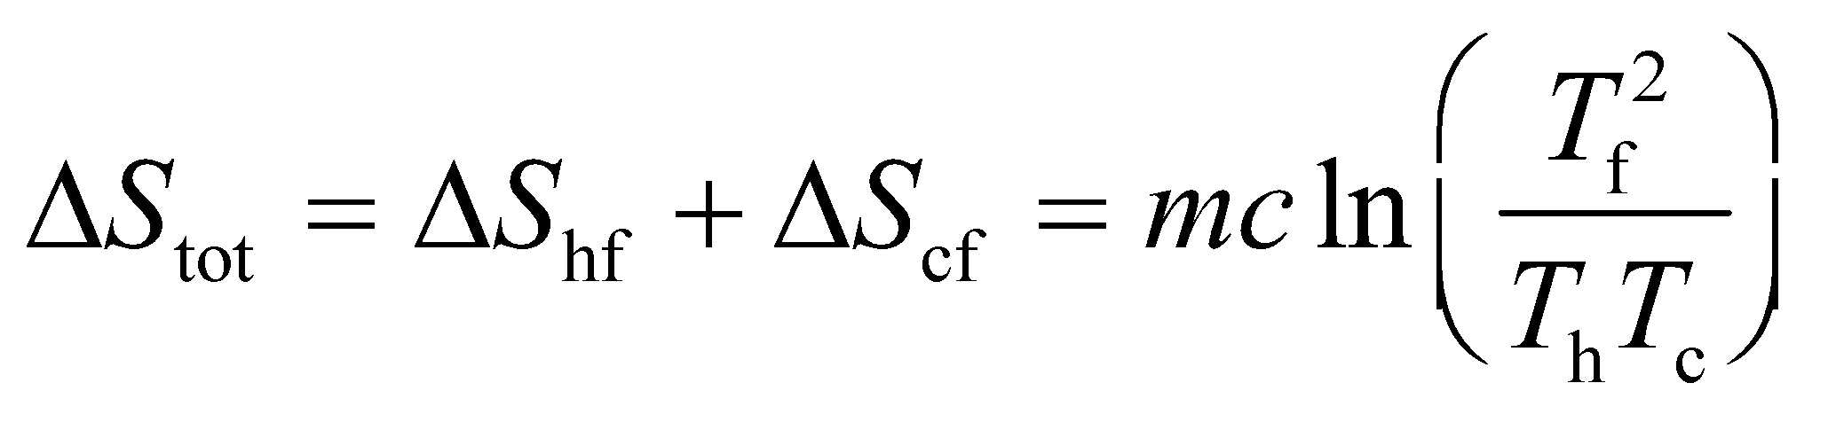

This is positive when 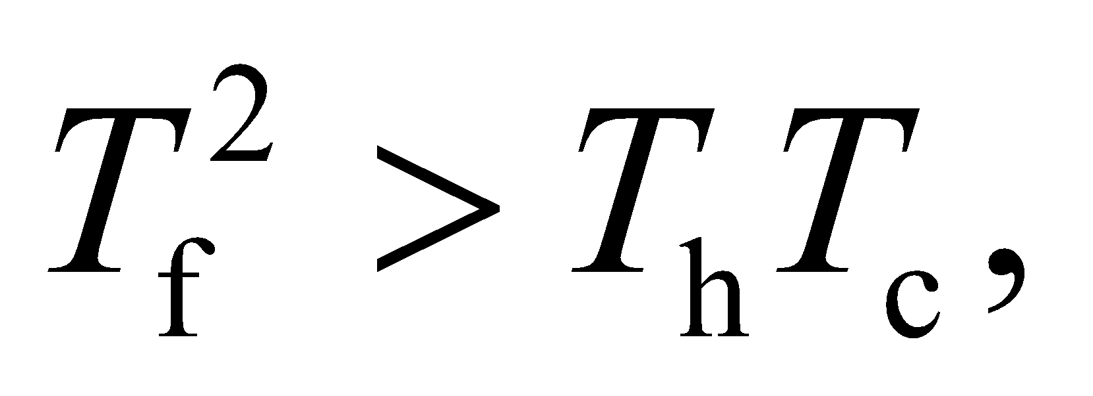 or equivalently when 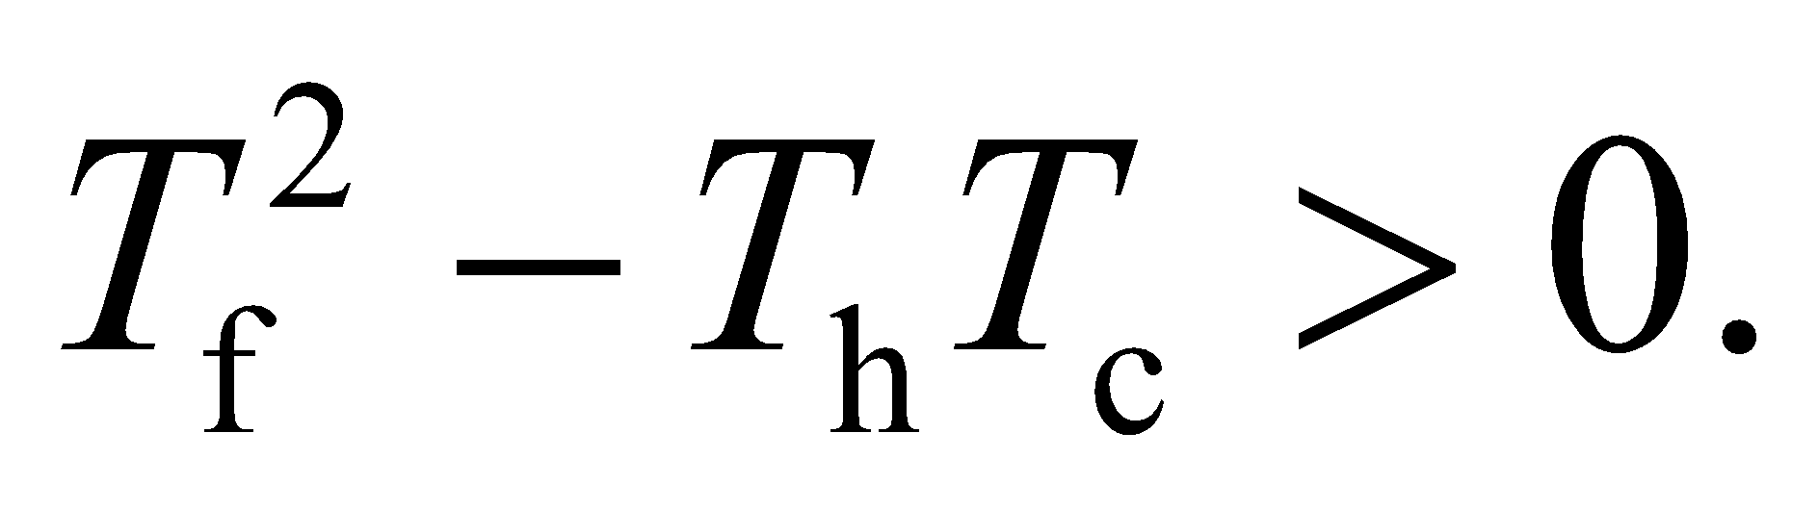Since the sample masses are equal, the final temperature will be at the midpoint between the temperature extremes: 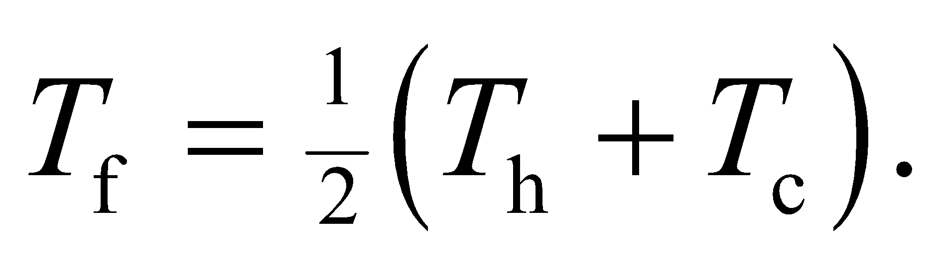Therefore,



This shows that the total entropy change is positive, as we would expect.

**Assess** Using the final equation above, we can rewrite the total entropy as:

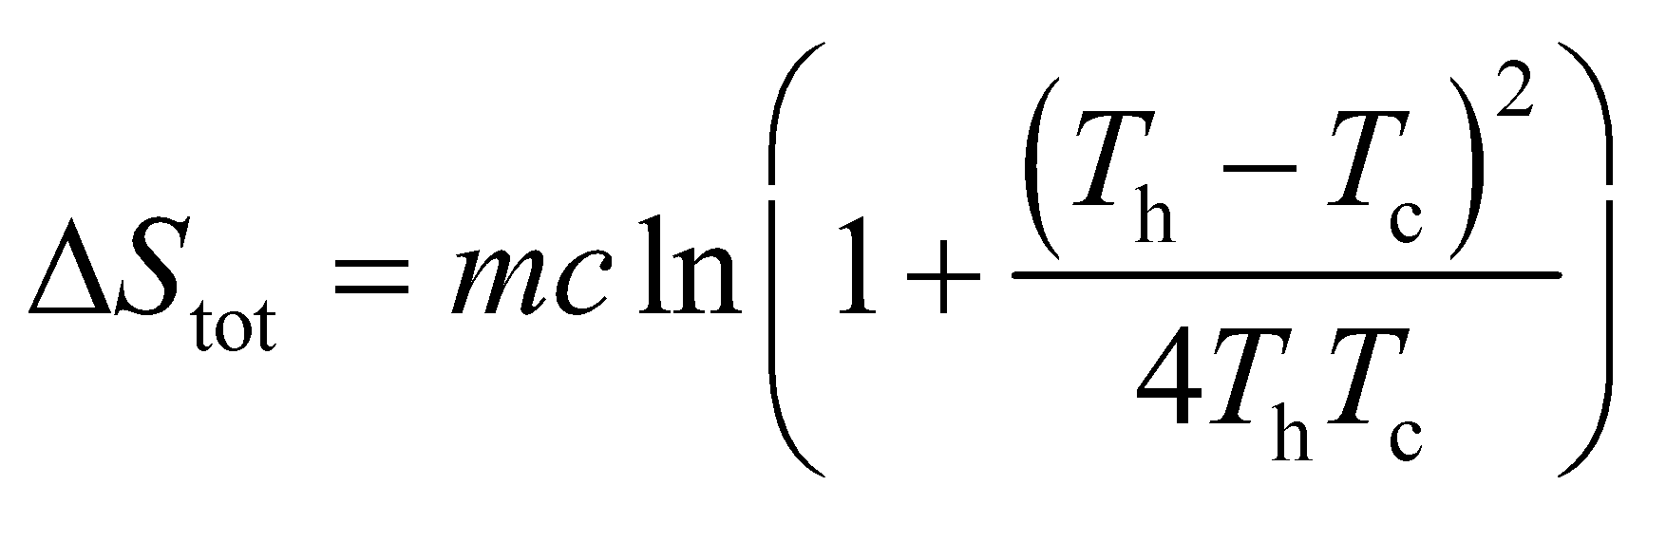

What this shows is that for a given  the entropy change will be greater the smaller that  is. In other words, the entropy change is greater when the initial temperature difference is made greater. This is what we would expect.

**62. Interpret** We are to find the change in entropy for a sample of copper at low temperatures, where the specific heat changes with temperature.

**Develop** The specific heat of copper at low temperatures is given as 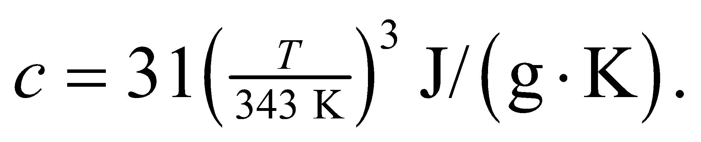 From Equation 19.6, we have 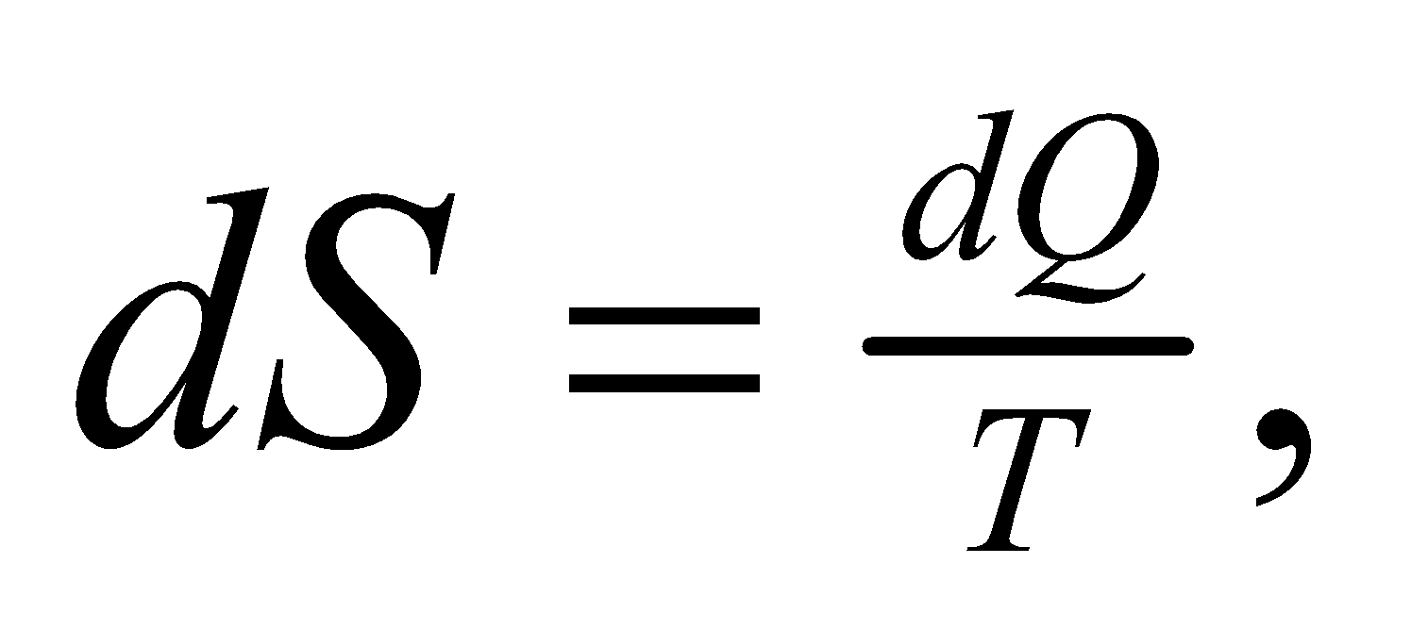and from Equation 16.3 we have  We find the change in entropy by integrating from *T*1 = 25 K to *T*2 = 10 K. The mass of the copper is *m* = 40 g.

**Evaluate**

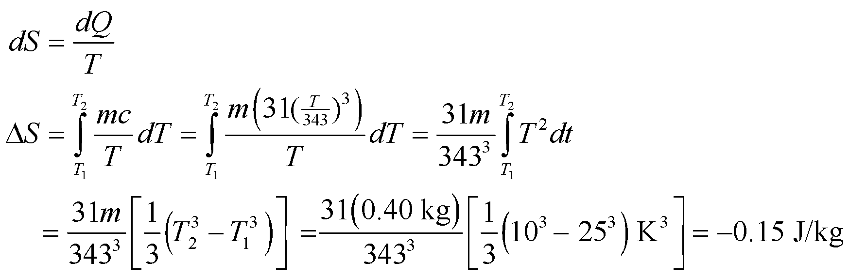

**Assess** This change is negative because the temperature goes down. To satisfy the second law of thermodynamics, somewhere in this cooling process, the entropy of something else must have gone up by more than 0.15 J/kg.

**63. Interpret** We are to find the entropy change for a sample of gas with the given temperature change, where the specific heat of the gas changes with temperature.

**Develop** We are given an equation for the molar specific heat: 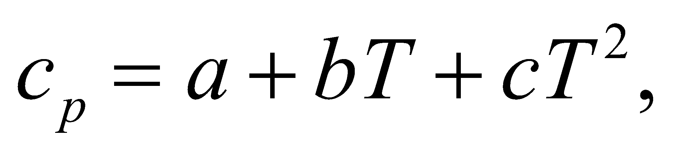 where 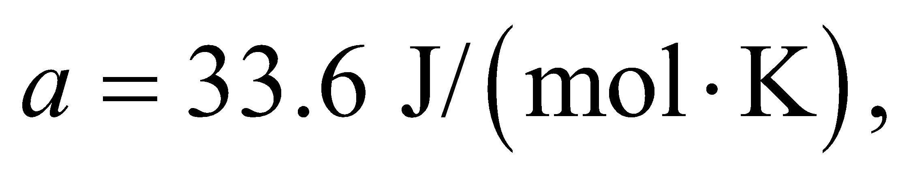 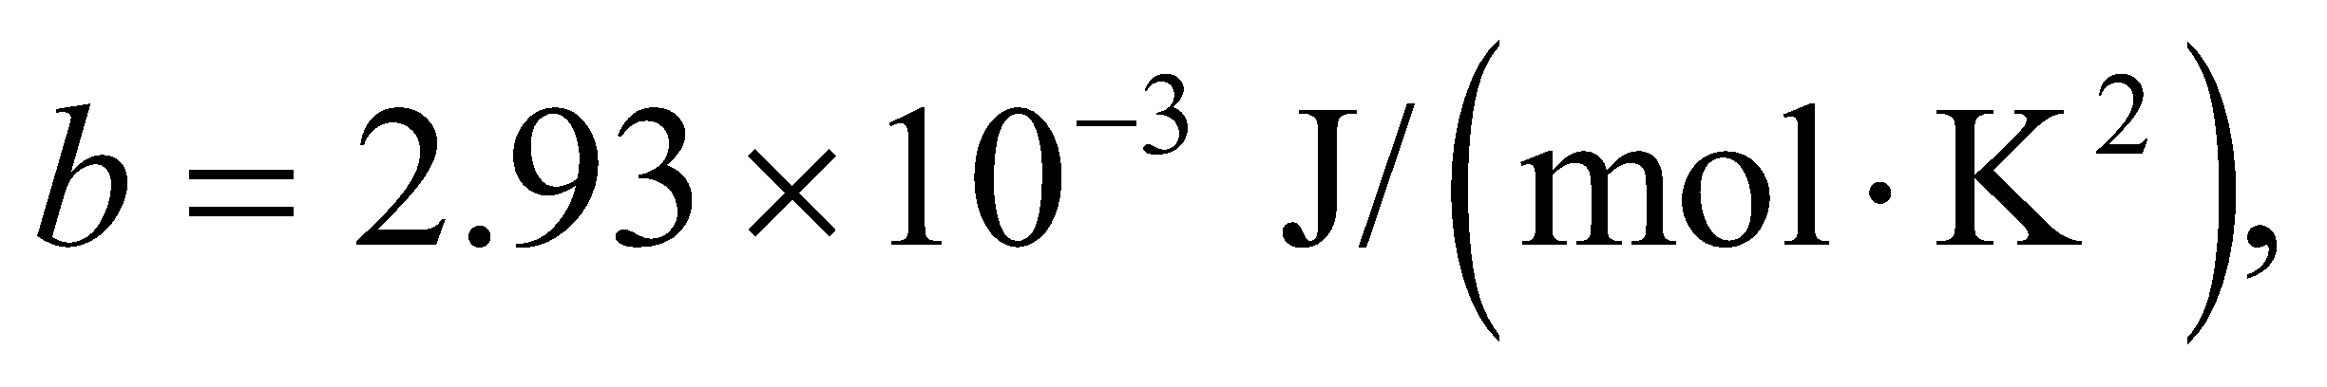 and 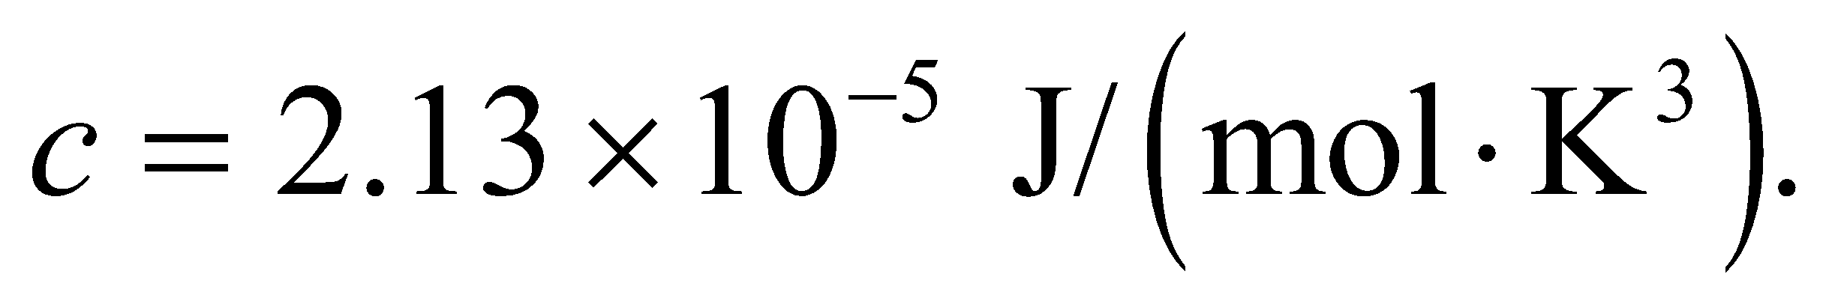 The amount of gas is 2 moles, and the temperature changes from 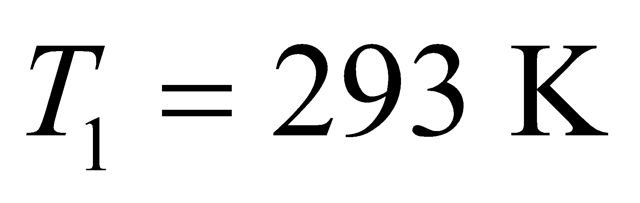 to 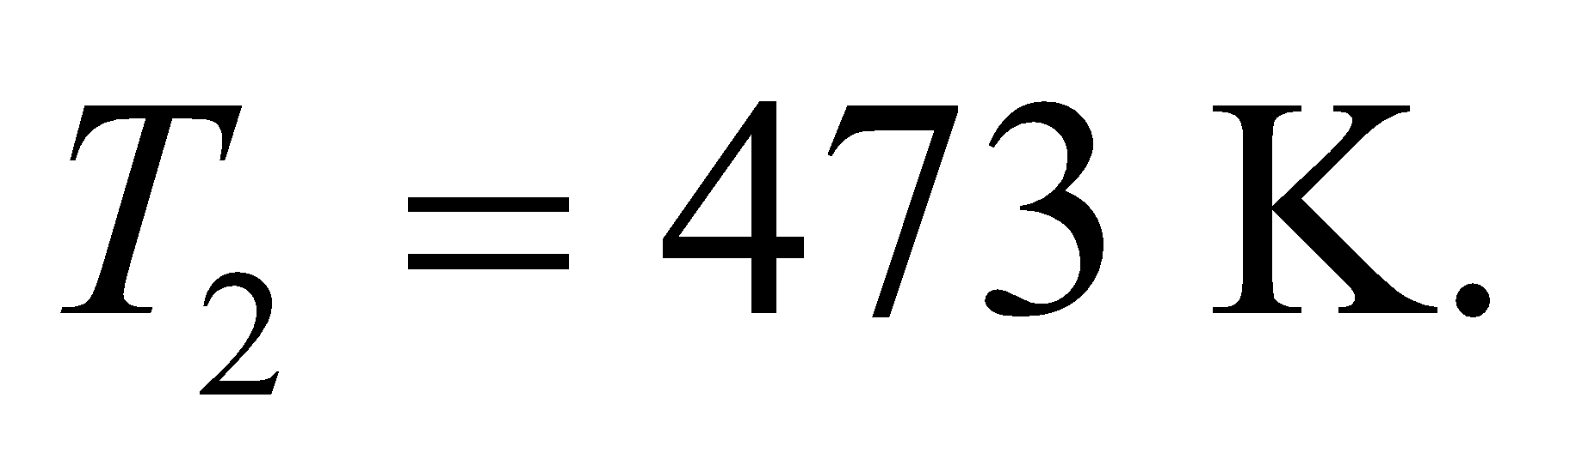 From the definition of the molar specific heat (see discussion preceding Equation 18.3), *Q* = *nCpΔT*, which we use to express the heat change in terms of temperature and specific heat. Insert this into Equation 19.6 to find the entropy change.

**Evaluate**

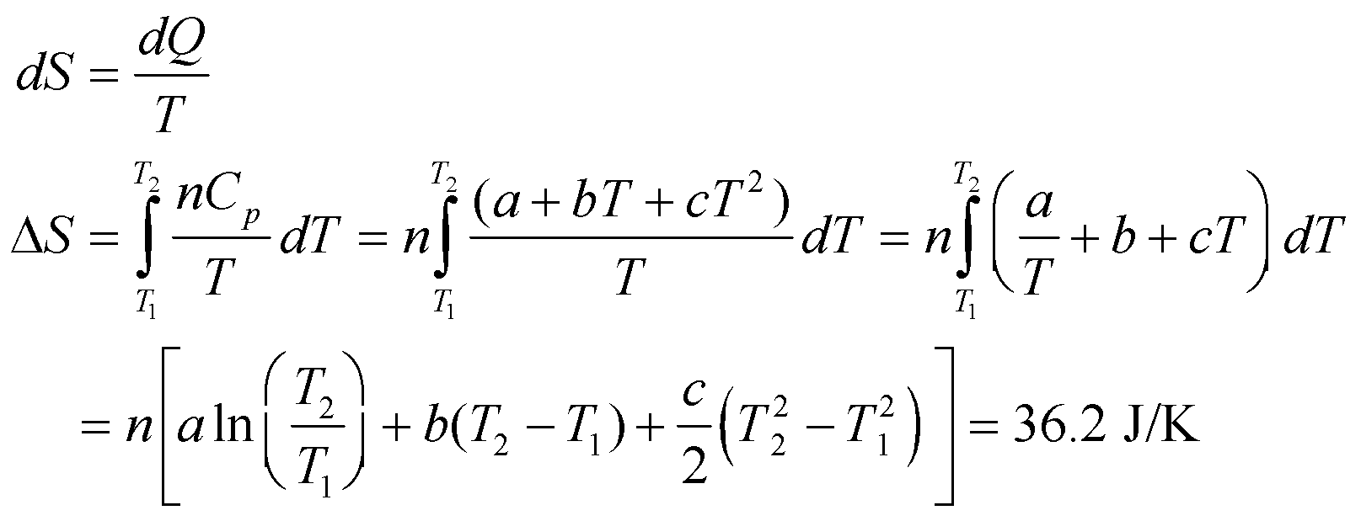

**Assess** The entropy increases as the temperature increases, as we would expect.

**64. Interpret** We're asked to consider the statistics of *N* molecules distributed among two halves of a closed box. This is the general case of Figures 19.18 and 19.19, as well as Problem 19.25.

**Develop** The molecules have equal probability of being in the left-side or right-side of the box. If each molecule were different from the rest, then we could distinguish each arrangement (or microstate) of the molecules in the box. But the molecules are identical, so they can be switched (or permutated), and the overall macrostate will be the same.

**Evaluate**  **(a)** Let's assume that 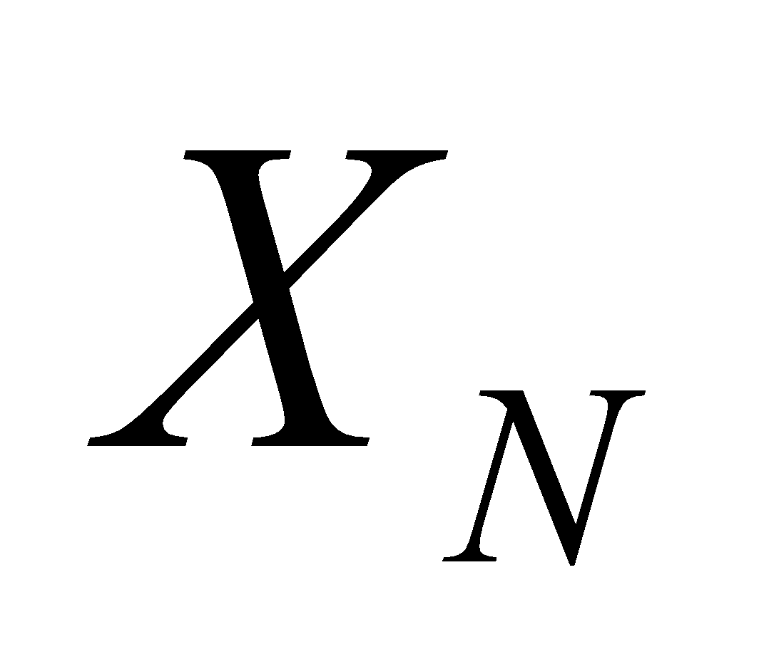 is the number of microstates for *N* molecules. If we now add one more molecule to the box, then for each of the microstates, the new molecule can either be put in the left-hand or right-hand side of the box. That means the new number of microstates is 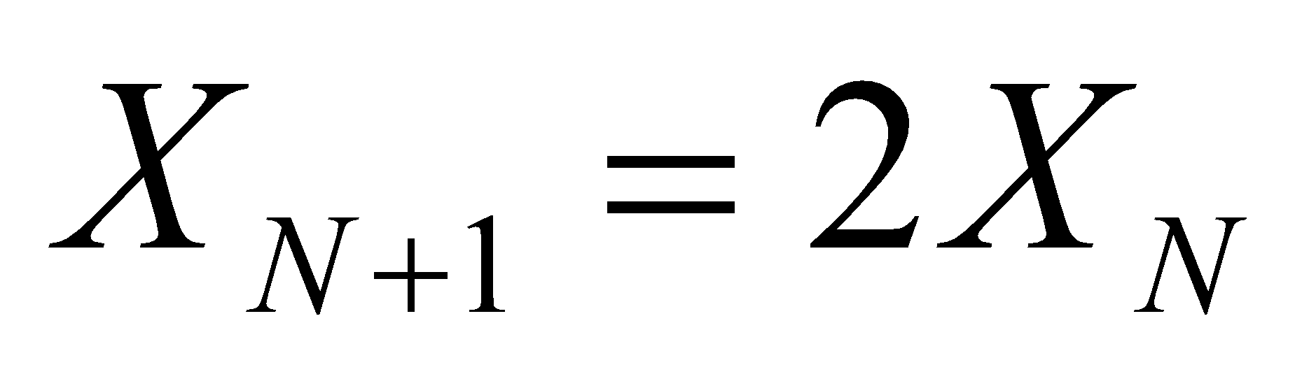. Since a single molecule in the box has 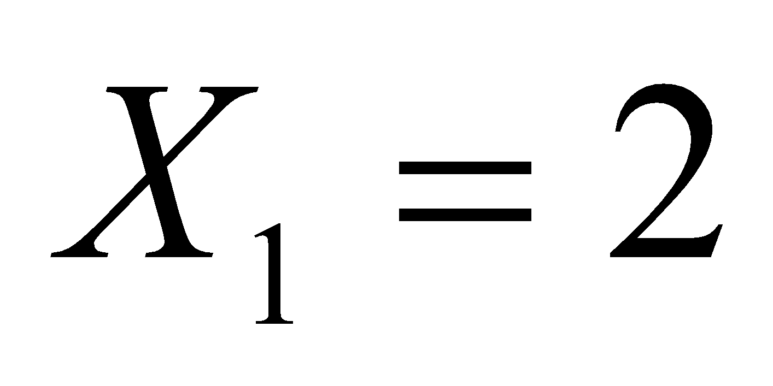 microstates, the number of microstates for any *N* must be 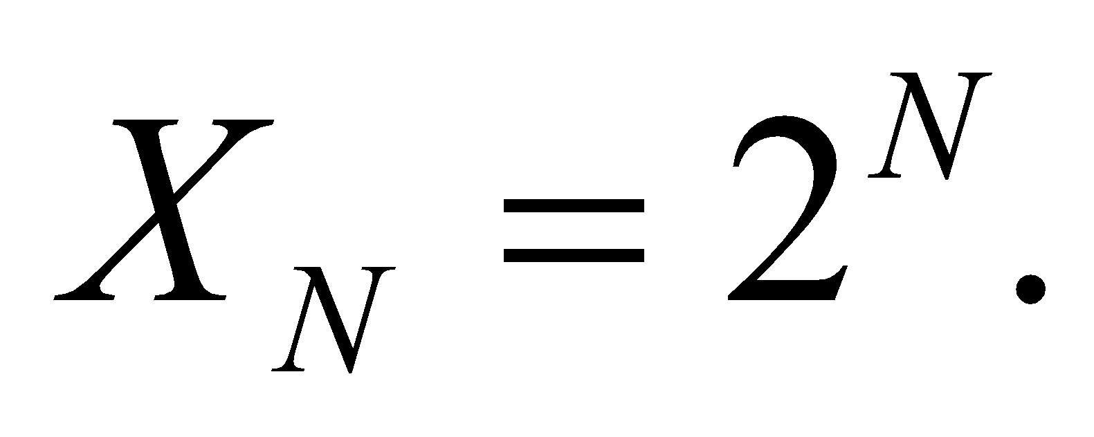

**(b)** Of the 2*N* microstates, we'll call 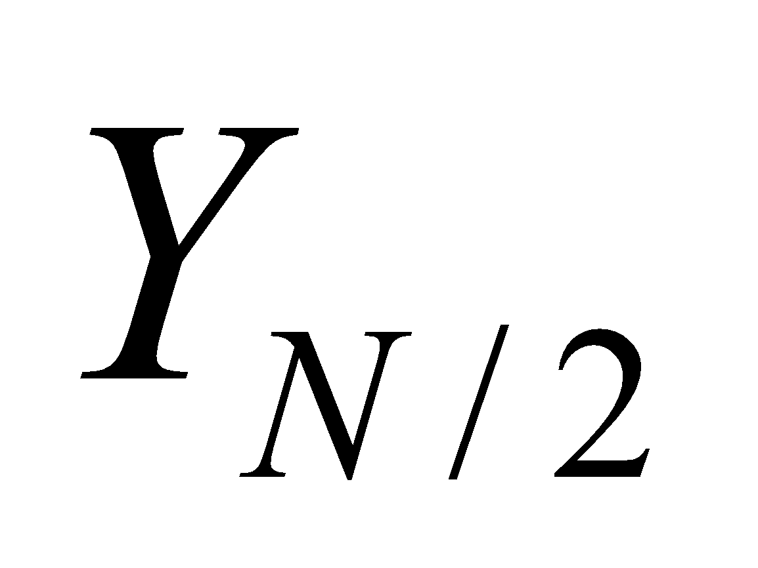the number that have half of the molecules on one side of the box. We showed in Problem 19.25 for *N*=6 how one can do permutations of the molecules to find all the combinations where the molecules are split equally between the two sides. For any even *N*, the number of combinations that will have *N*/2 on one side of the box is given by the coefficients from the binomial theorem:

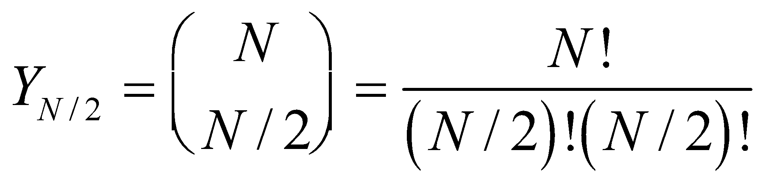

**(c)** The probability of a given macrostate is the number microstates that match the macrostate divided by the total number of microstates. So, the probability of having an equal number of molecules on each side of the box is:

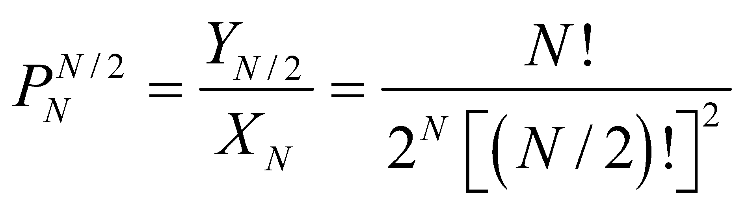

There's only one microstate with all of the particles on one side of the box 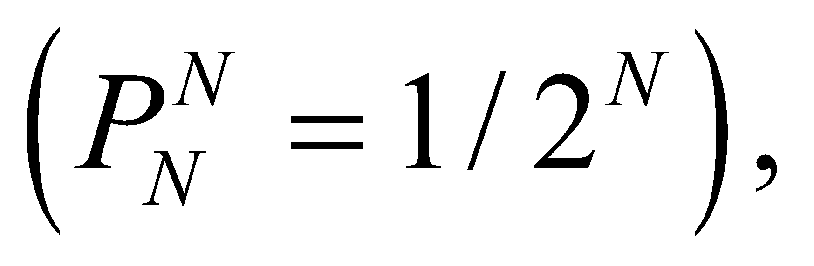so the ratio of these probabilities is:

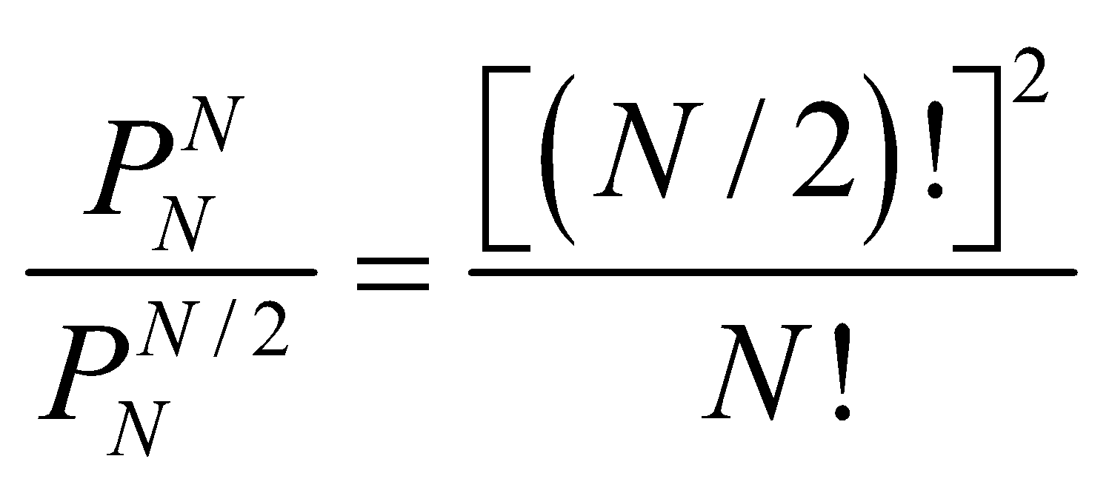

**(d)** For *N*=4, this probability ratio is

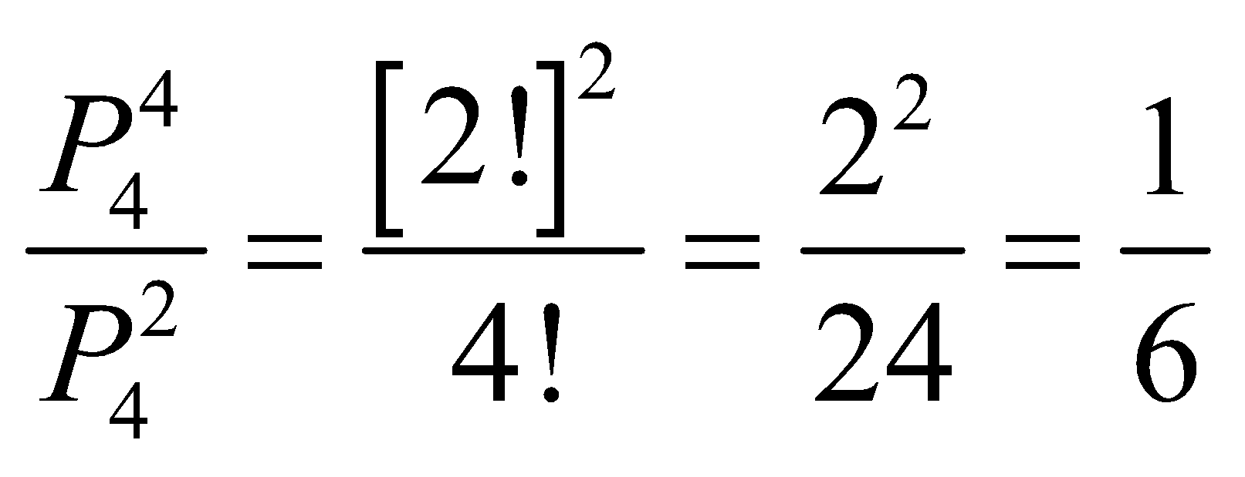

For *N*=100, the factorials become unwieldy. We can use Stirling's approximation for large *n*: 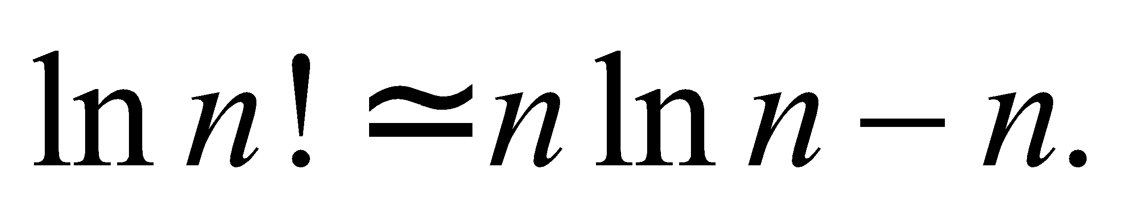

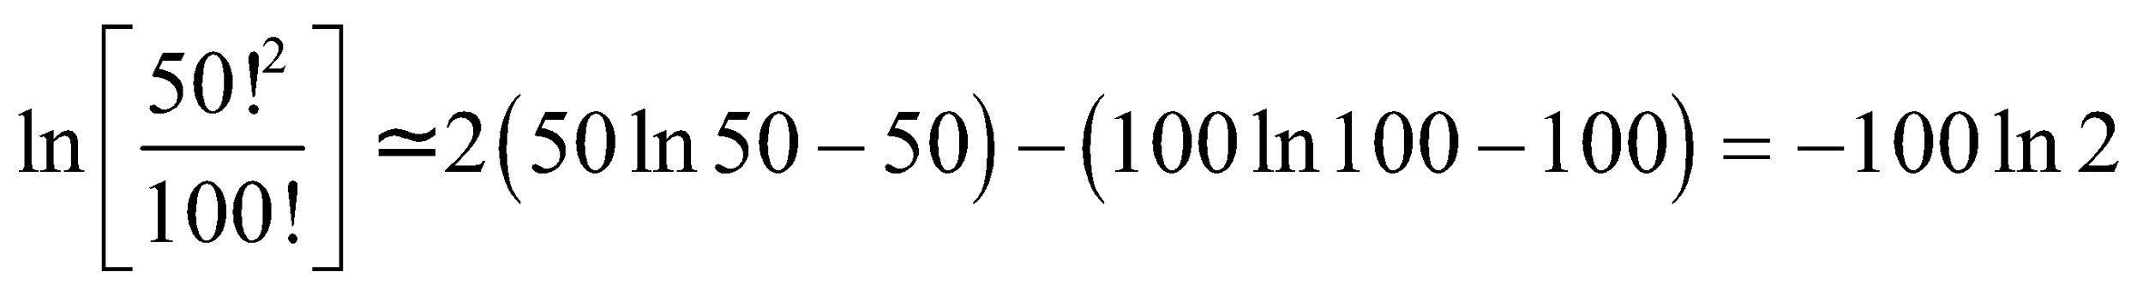

So the probability ratio is approximately

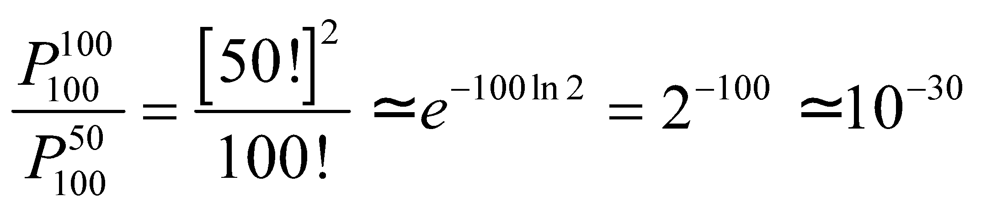

**Assess** This says that for 100 molecules, it's 1030 times more likely that the molecules will be evenly distributed in the box versus all of them on one side. One can imagine how impossible it would be for a room full of 1023 molecules to suddenly evacuate one side for the other.

**65. Interpret** We will consider the energy consumption of a typical refrigerator.

**Develop** To get a sense of how the refrigerator works, we can look at Figure 19.6. In the course of a day, an amount of heat, 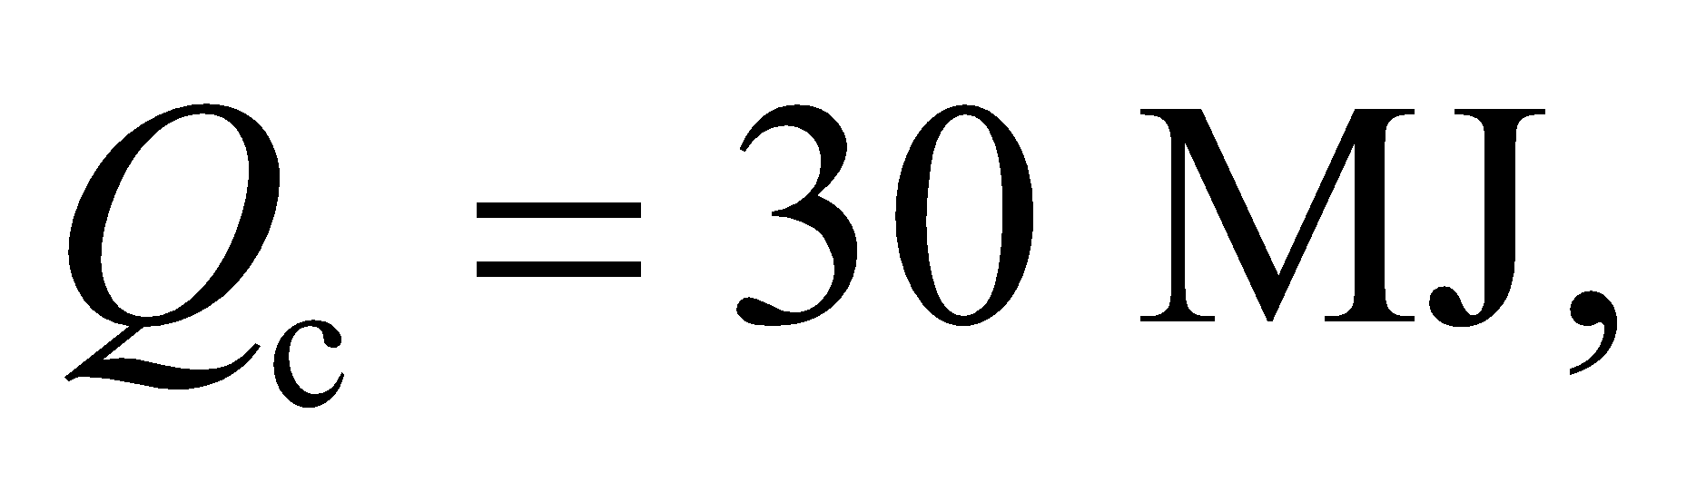 is drawn from the fridge's cold interior. But this requires work to be done,  Specifically, electricity is needed to pump refrigerant through the system.

**Evaluate** Both the heat drawn from the fridge interior and the work done by the electrical energy are expelled as heat: 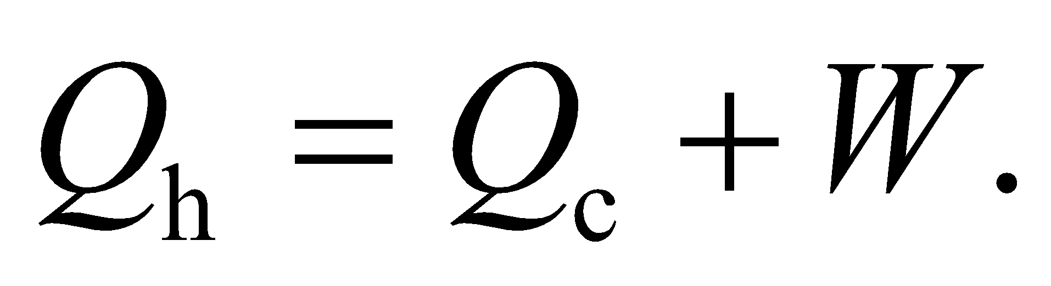 So, the work effectively ends up as waste heat rejected to the kitchen environment.

The answer is (d).

**Assess** This might sound wasteful: turning high quality electrical energy into heat that gets dumped out of the backside of your fridge. But according to Clausius' statement of the second law of thermodynamics, it's impossible to construct a perfect refrigerator whose sole effect is to transfer heat from a cooler object to a hotter one. An external energy source is needed. However, it's not necessary to use electrical energy. For example, solar refrigerators use sunlight to evaporate water and thus draw heat from the fridge interior.

**66. Interpret** We will consider the energy consumption of a typical refrigerator.

**Develop** The COP for a refrigerator is defined as what we want (heat drawn from fridge contents) divided by what we put in (work from electricity), i.e., 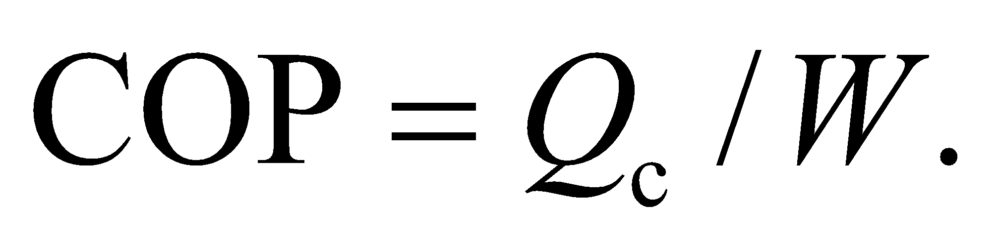

**Evaluate** We're told that it takes 10 MJ of electrical energy to draw 30 MJ of heat from the fridge contents, so 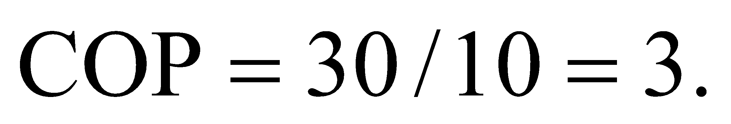

The answer is (c).

**Assess** This is a typical COP for a refrigerator. However, refrigerators are often rated not by COP, but by the average amount of electrical energy, *W*, they use in a year. Guidelines are adjusted for the volume of the fridge interior, which is easier to measure than, say, the amount of heat drawn from the fridge contents, which probably varies widely.

**67. Interpret** We will consider the energy consumption of a typical refrigerator.

**Develop** We're told the coal-fired power plant has an efficiency of 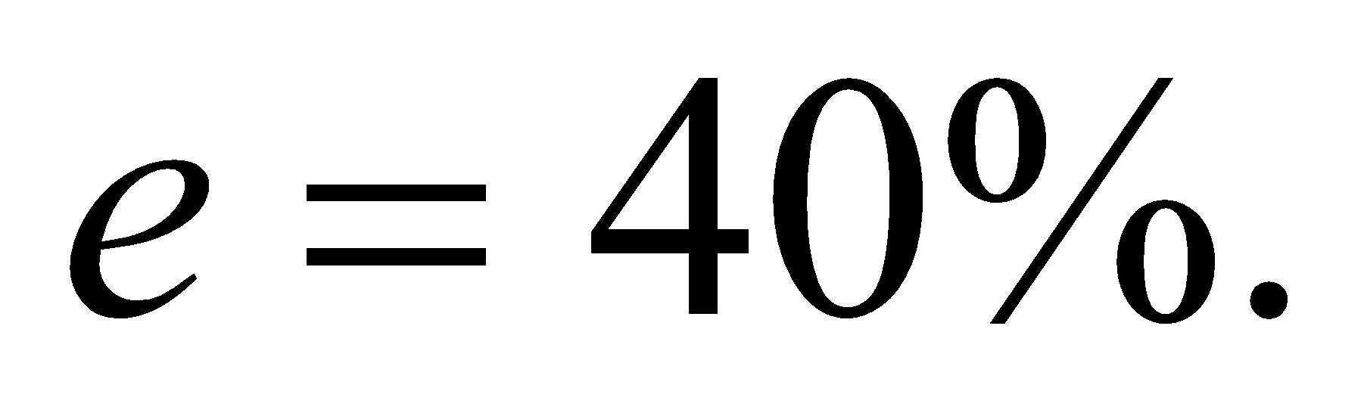 In contrast to the COP, the efficiency is defined as what we want (electrical energy to do work) divided by what we put in (heat from the burning of coal), i.e., 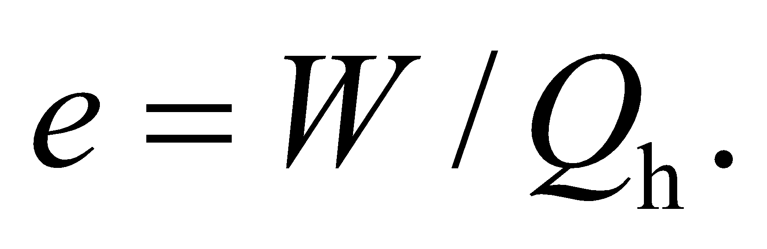

**Evaluate** To make 10 MJ of electrical energy, the power plant has to burn enough fuel to generate 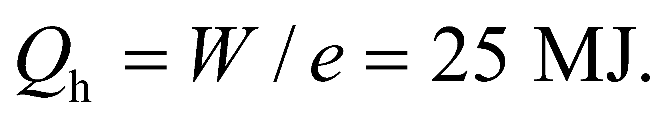

The answer is (b).

**Assess** Notice what this says: it takes 25 MJ of heat from coal burning to extract 30 MJ of heat from the fridge contents.

**68. Interpret** We will consider the energy consumption of a typical refrigerator.

**Develop** As we argued in Problem 16.5, the heat drawn from the fridge interior and the work from the electricity are both expelled as heat into the relatively warmer environment: 

**Evaluate** Over the course of a day, the refrigerator expels 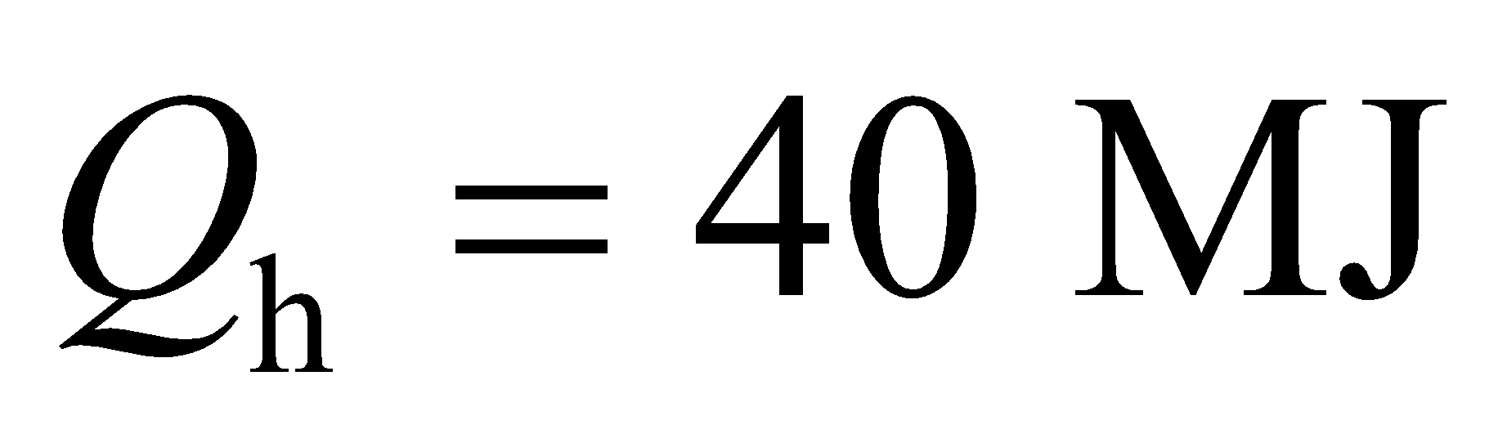of heat into the surrounding kitchen.

The answer is (c).

**Assess** It might be interesting to compare this to the waste heat expelled by the power plant in order to supply the 10 MJ of electricity the refrigerator needs. In the plant's case, the exhaust is 